NAME: P.Kavya Sai
ROLL NUMBER: 2420030322
SECTION-9
Task: 3
Create a Trello board with project boards, user stories, task assignments, and sprint workflows to demonstrate Agile project management and team collaboration.

Step 1: Open the Trello website
👉 Official website: https://trello.com

Step 2: Create a free account
- Click Sign up.
- You can use Google account (easiest) or email.
- After signing in, Trello will open your Home page.

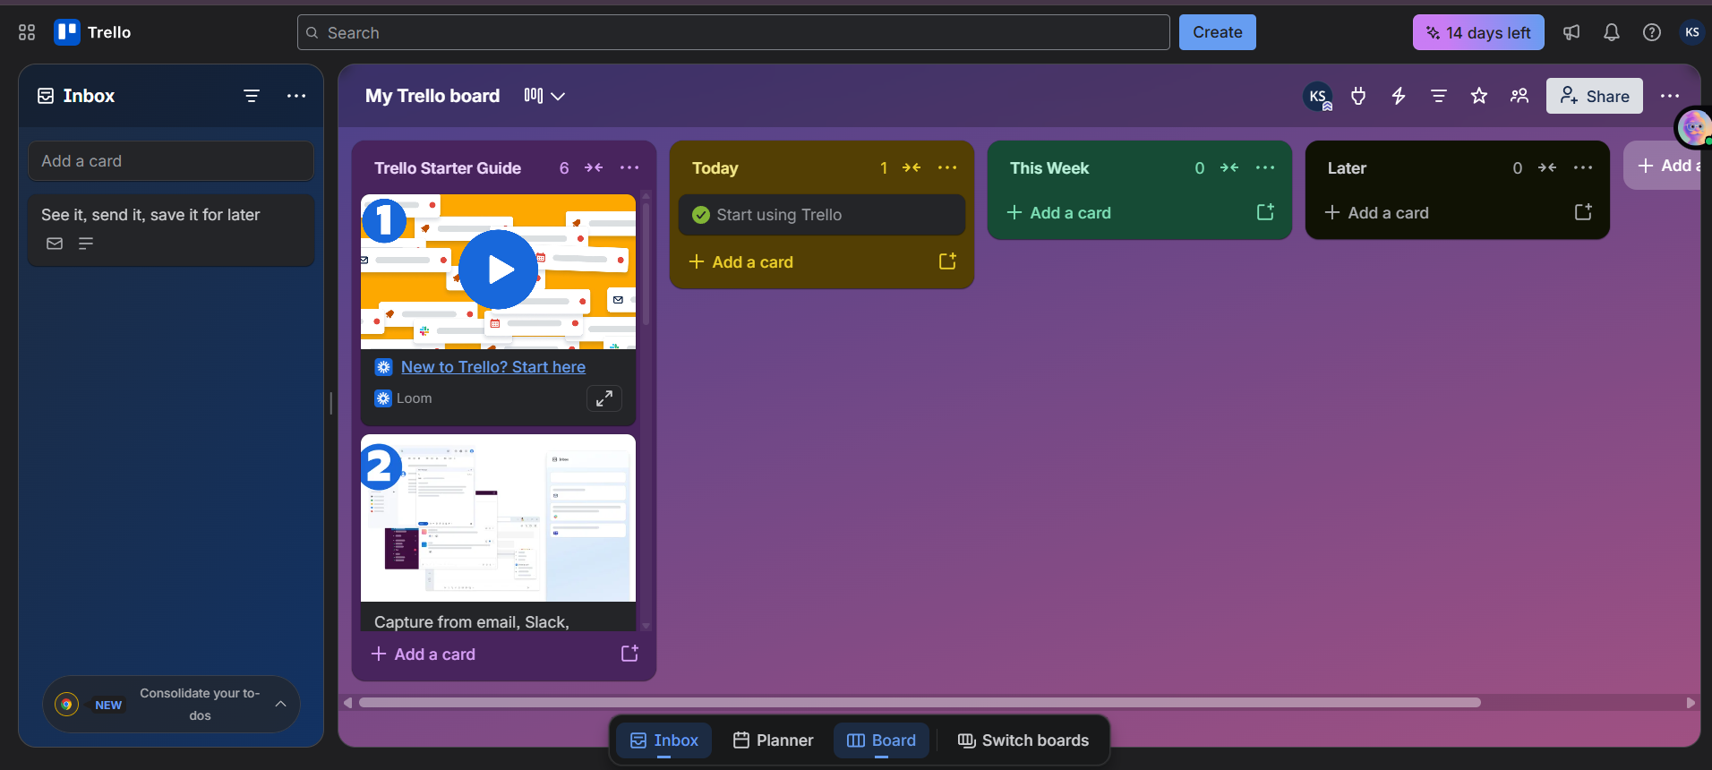

Step 3: Create your first Workspace
A Workspace is like a folder that contains multiple boards.

Do this
- Click Create (top-right).
- Select Create Workspace.
- Enter:
  - Workspace name: Agile Case Study
  - Type: Education
- Click Continue.
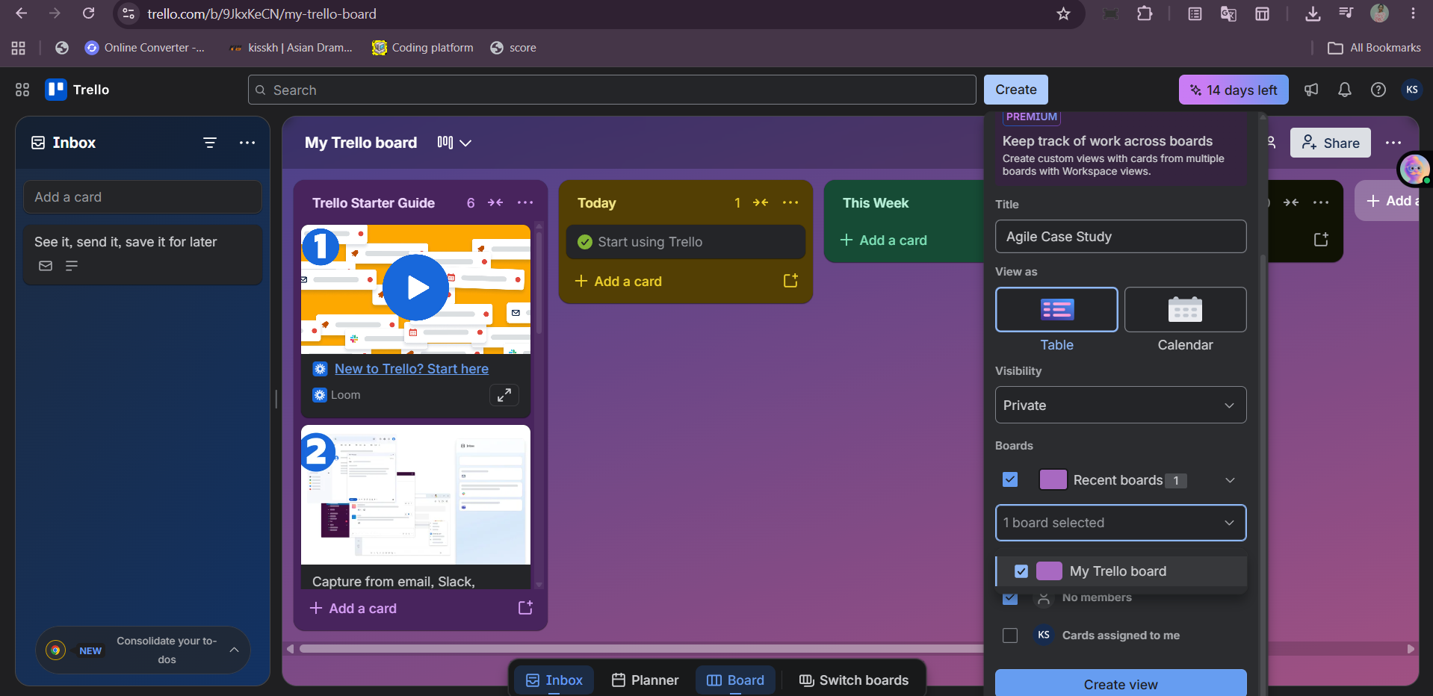

Step 4: Create the Project Board
Now create the board where all Agile activities will happen.
• Board name: College Event Management System
• Workspace: Agile Case Study
• Visibility: Workspace
Click Create.
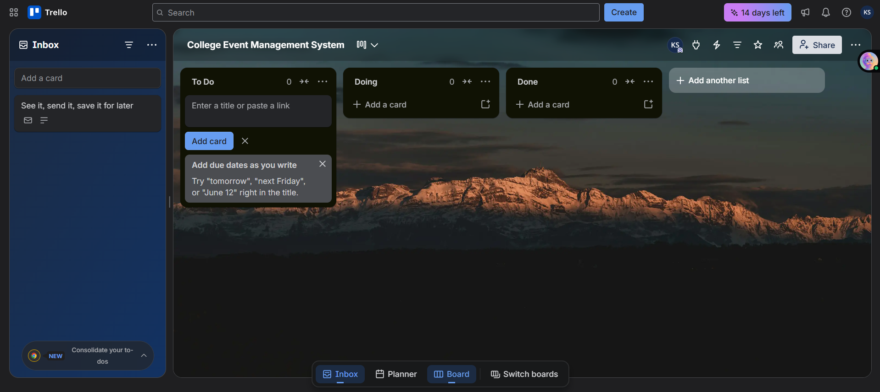

Step 5: Create Agile workflow lists
These lists represent the sprint workflow.

Create these lists in order
- Product Backlog
- Sprint Backlog
- To Do
- In Progress
- Testing
- Done

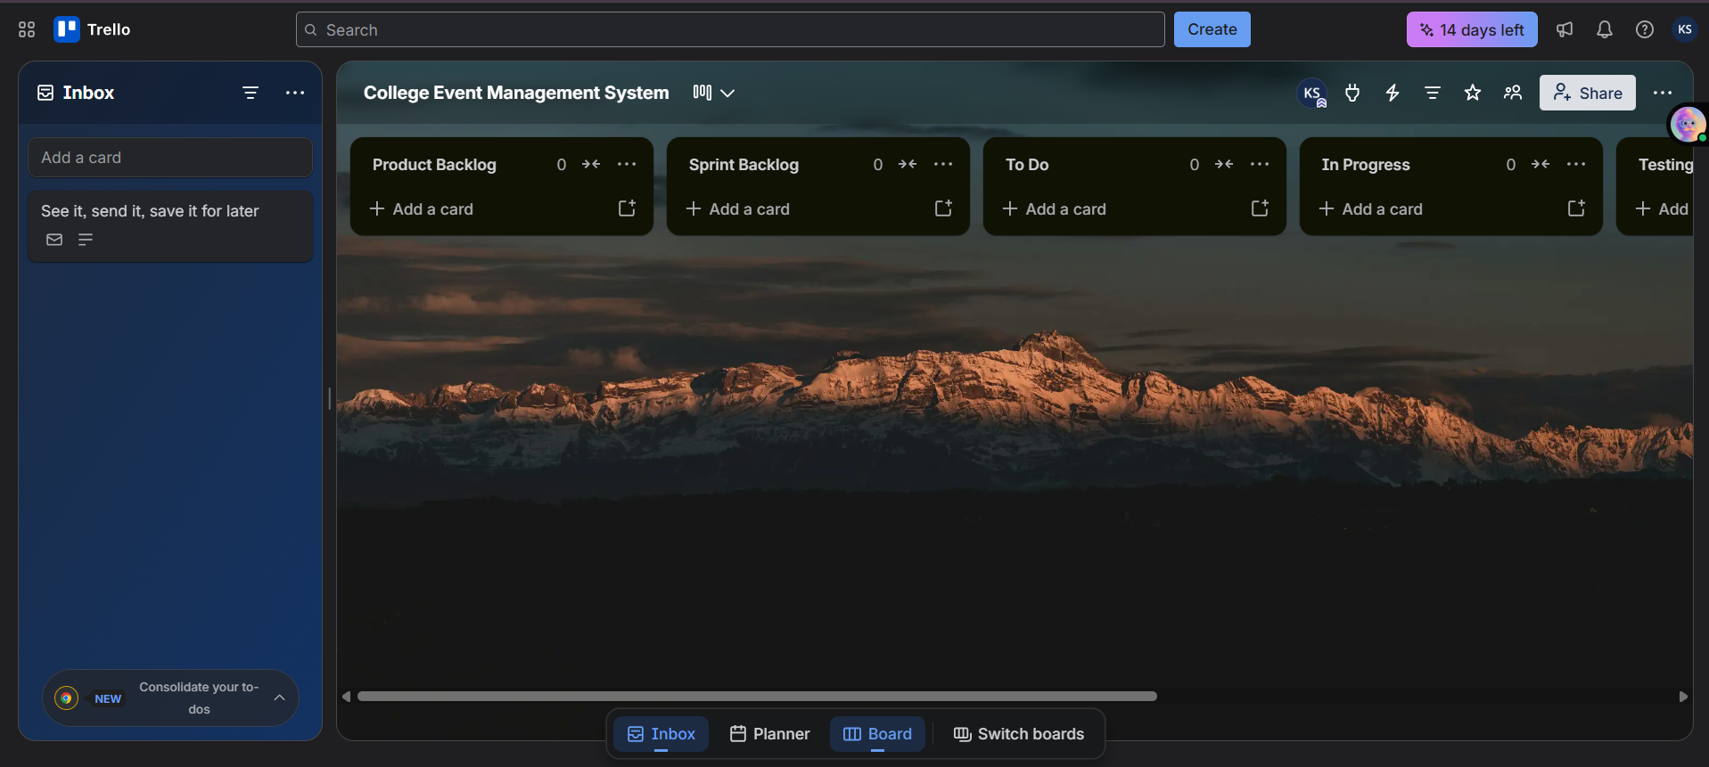

Step 6: Add User Stories (important for your assignment)
Click Add a card under Product Backlog and create these cards.

User stories
US-01: User Registration
As a student, I want to register for the event so that I can participate.
US-02: Event Schedule
As a participant, I want to view the event schedule so that I can attend sessions on time.
US-03: Admin Login
As an admin, I want to log in securely so that I can manage the event.
US-04: Email Notifications
As a participant, I want to receive confirmation emails after registration.
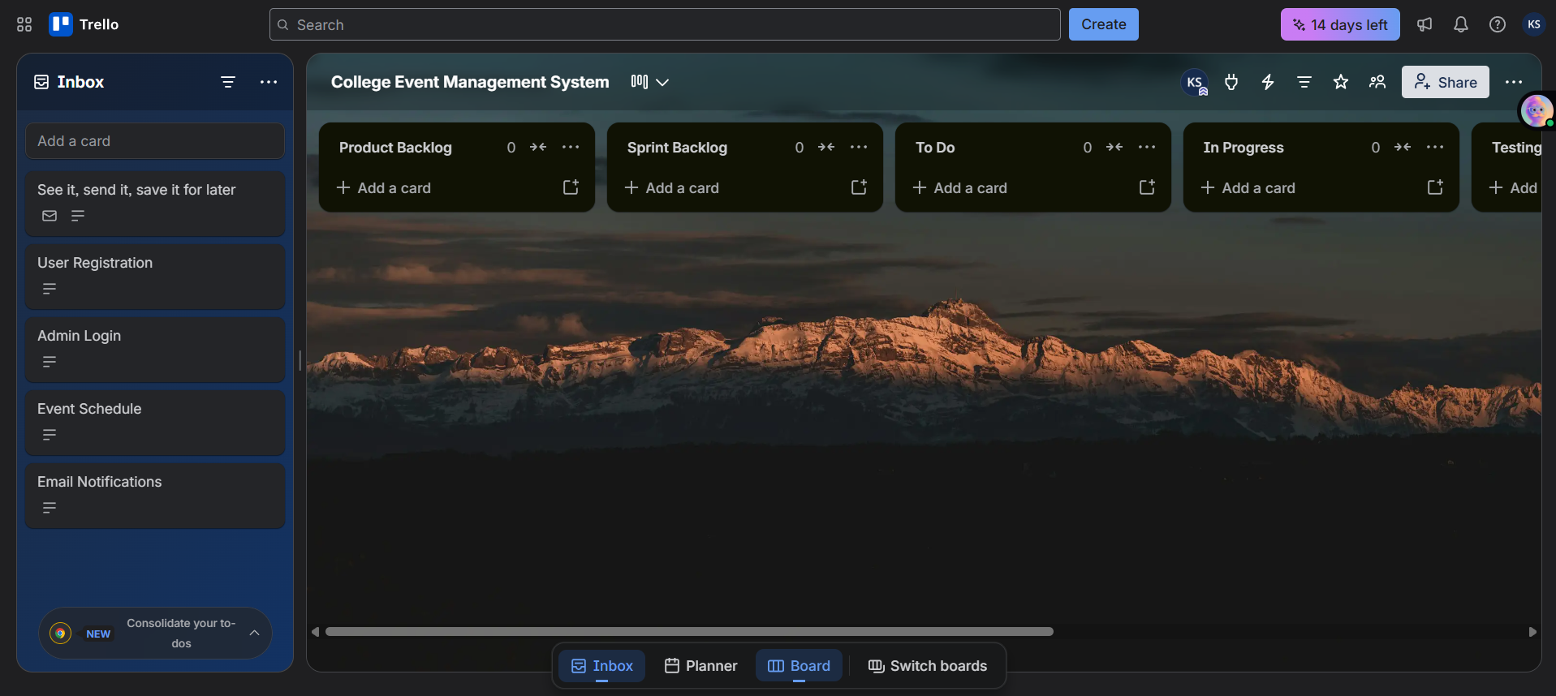
Drag Card (US) to product Backlogs)
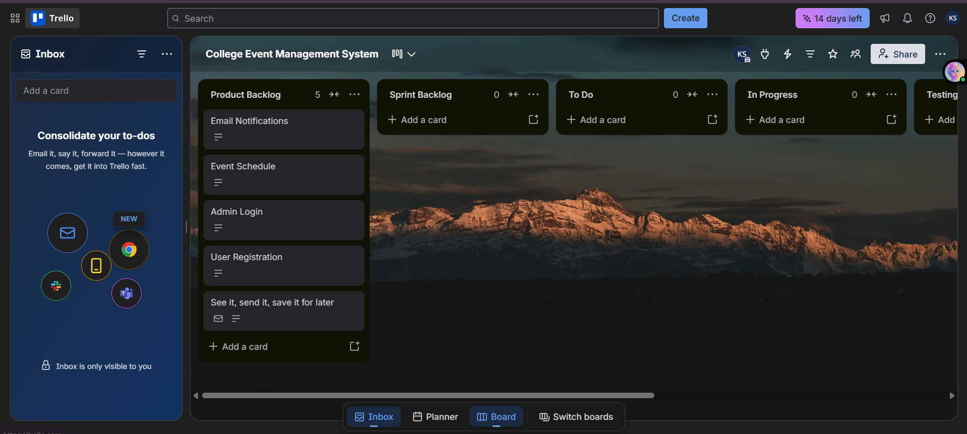

Step 7: Create Sprint 1
Drag these cards from Product Backlog to Sprint Backlog:
- US-01 User Registration
- US-02 Event Schedule
This means these features are selected for Sprint 1.
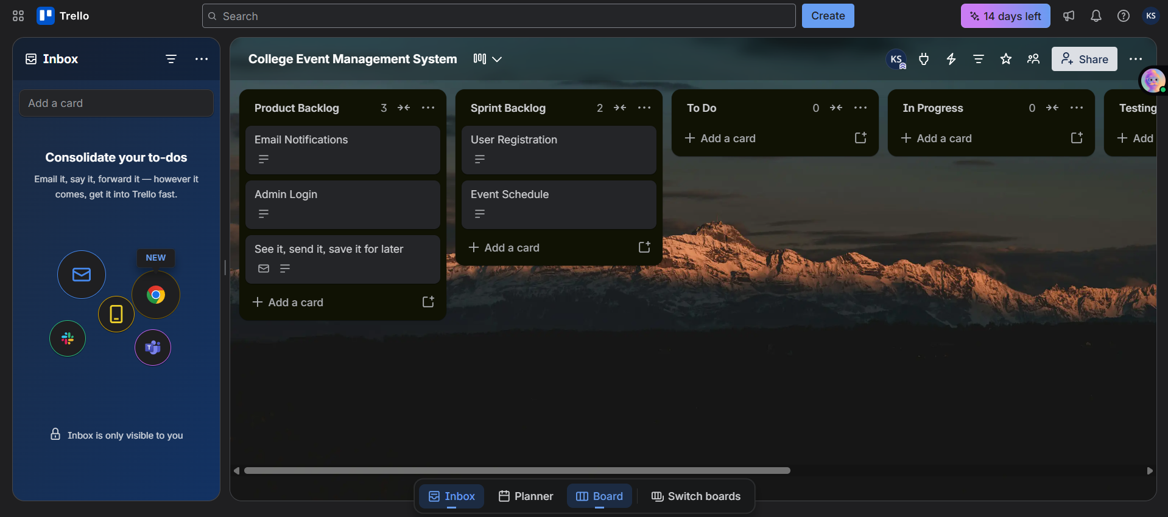

Step 8: Break a user story into tasks
Open US-01 User Registration and add a Checklist.

Checklist items
Design registration form
Create database table
Validate input fields
Save user data
- Display success message
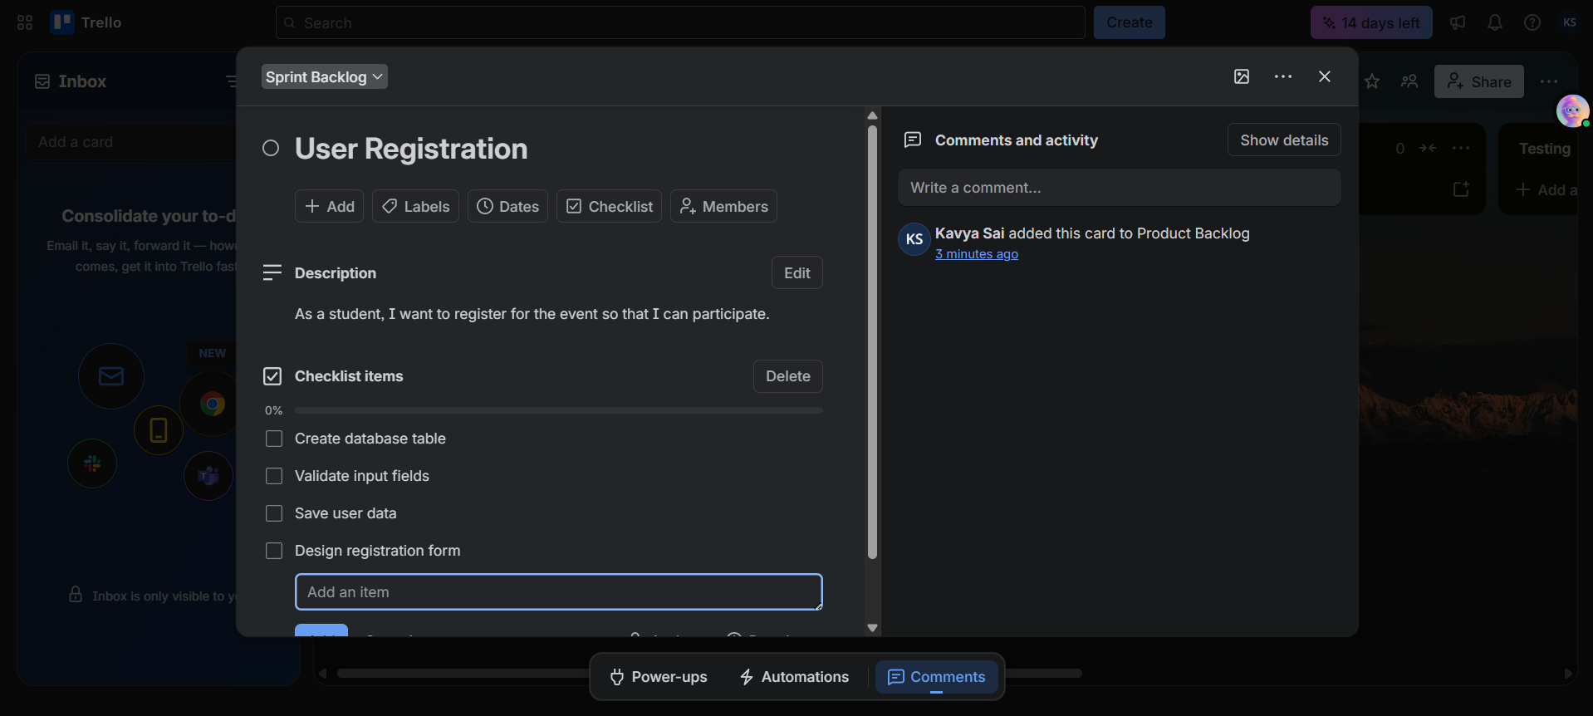
You can even add all options which are needed

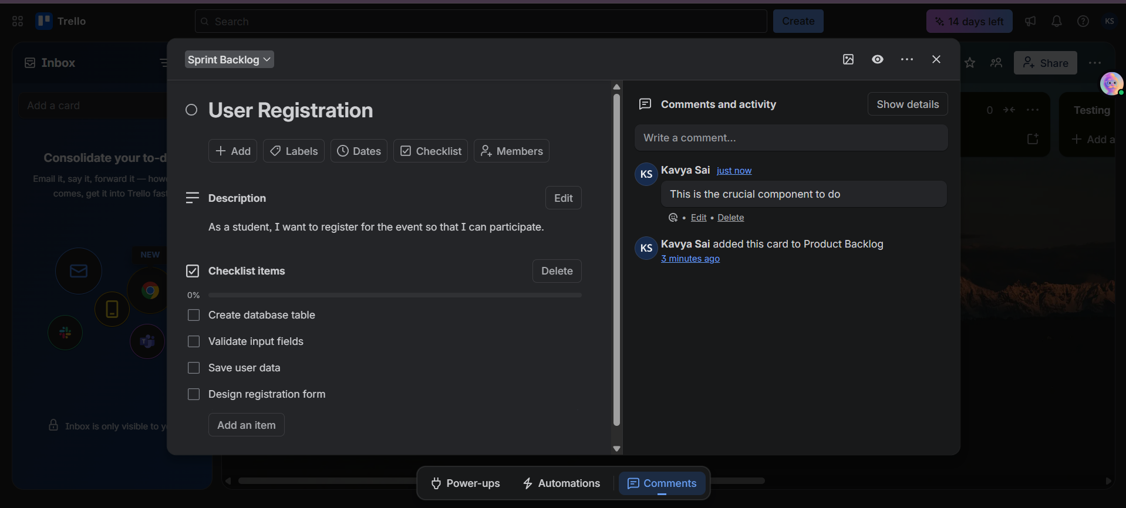

You can do similarly to all Agile workflow lists

Step 9: Assign team members
Inside the card:
- Click Members.
- Add yourself.
- If you have classmates, invite them using Share → Invite.

Example
Task | Assigned To
Registration form | Archana
Database setup | Rahul
Validation | Sneha

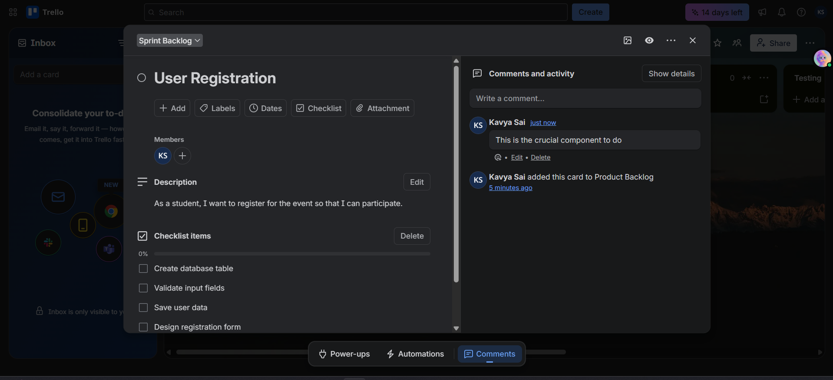

Step 10: Add Labels (priority)
Create these labels:
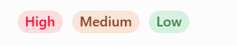
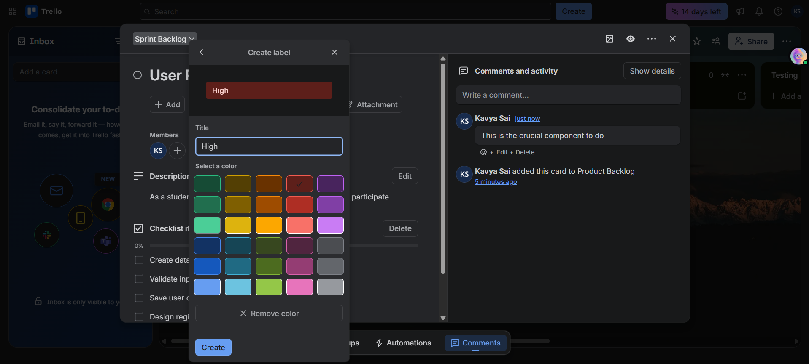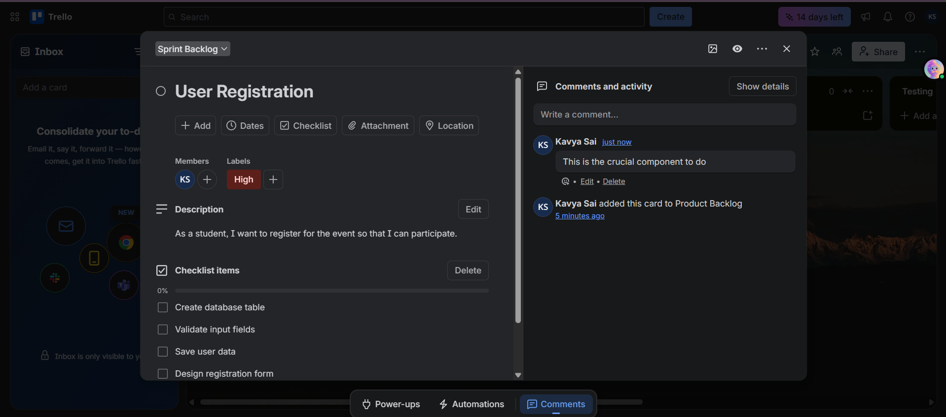

Step 11: Set Due Dates
Inside the card:
- Click Dates.
- Select a due date (for example, 20 July 2026).
- Enable Reminder.
- 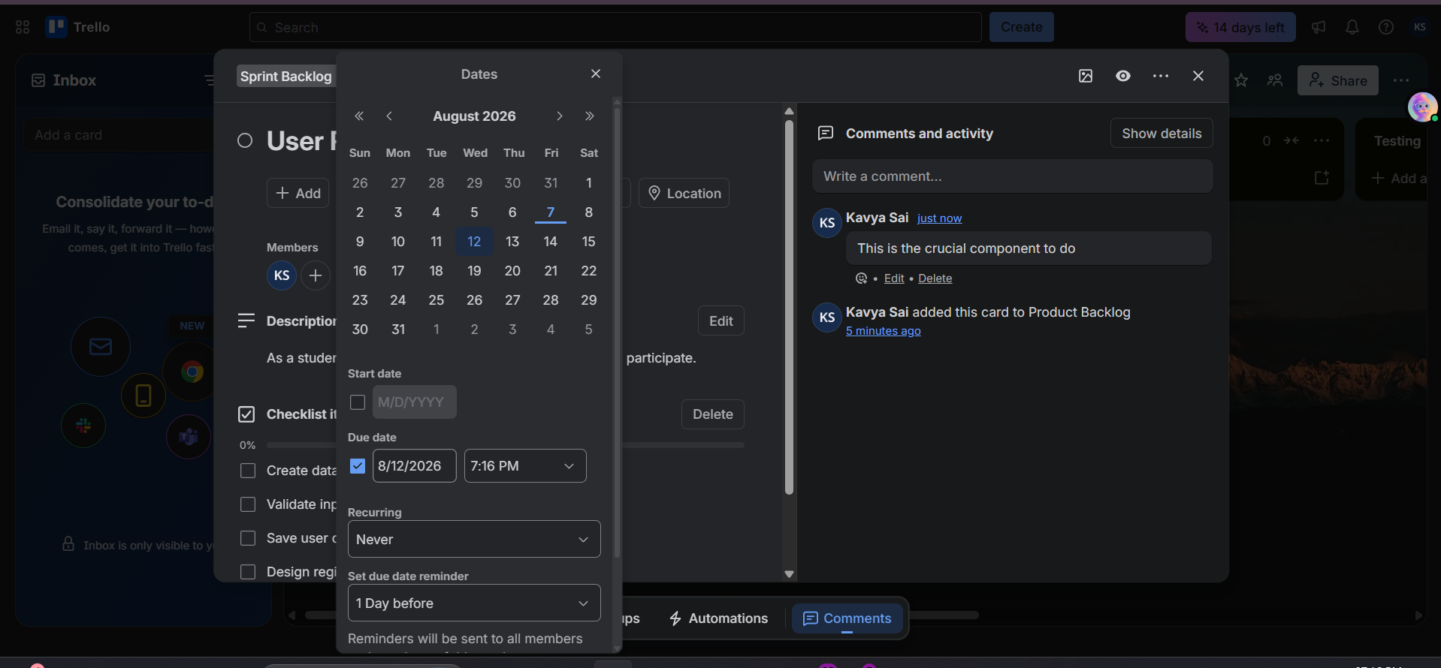
- 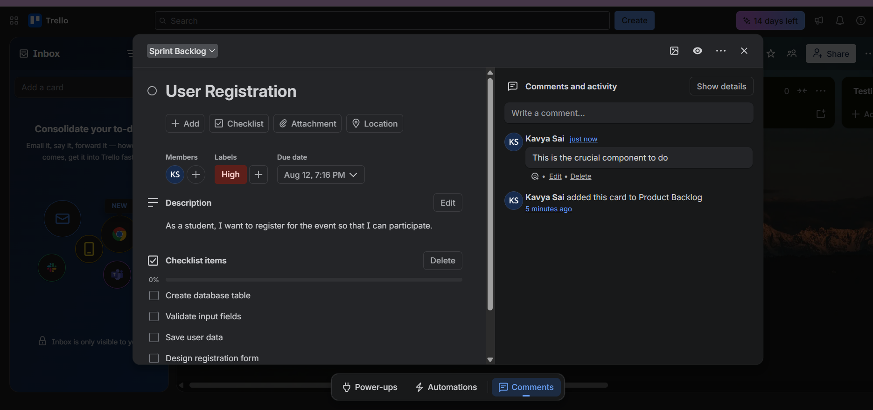

Step 12: Start the Sprint
Move cards through the workflow as work progresses.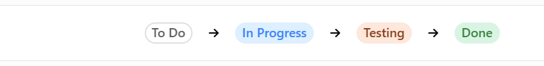
Output:
