**DESIGN OF MUSIC RECOMMENDATION SYSTEM**

**Name: Kavya Goudar**

**Usn: 01FM19MCA025**

**Project Title: Music Recommendation System.**

1. **Use case**

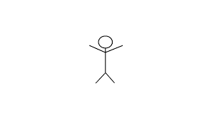

User

**Use case descriptions using scenarios**

**User**

* User initially generates data by listening to the songs.
* User will classify the songs based on his/her interested genres.
* Later the songs are classified by year.
* Based on the types of songs he/she has listened to, the user will get the recommendations.
* Recommended results are of similar genres to the users have most listened to.

1. **Block Diagram**

Fig 2.1 describes the block diagram of Music Recommendation System. Initially the Music dataset is taken into consideration for the songs clustering and music classification. Here the music clustering includes the music classification system and the songs which are commonly listened by the users. The similar music listeners along with content-based filtering helps to build a Music Recommendation System providing the recommended results.

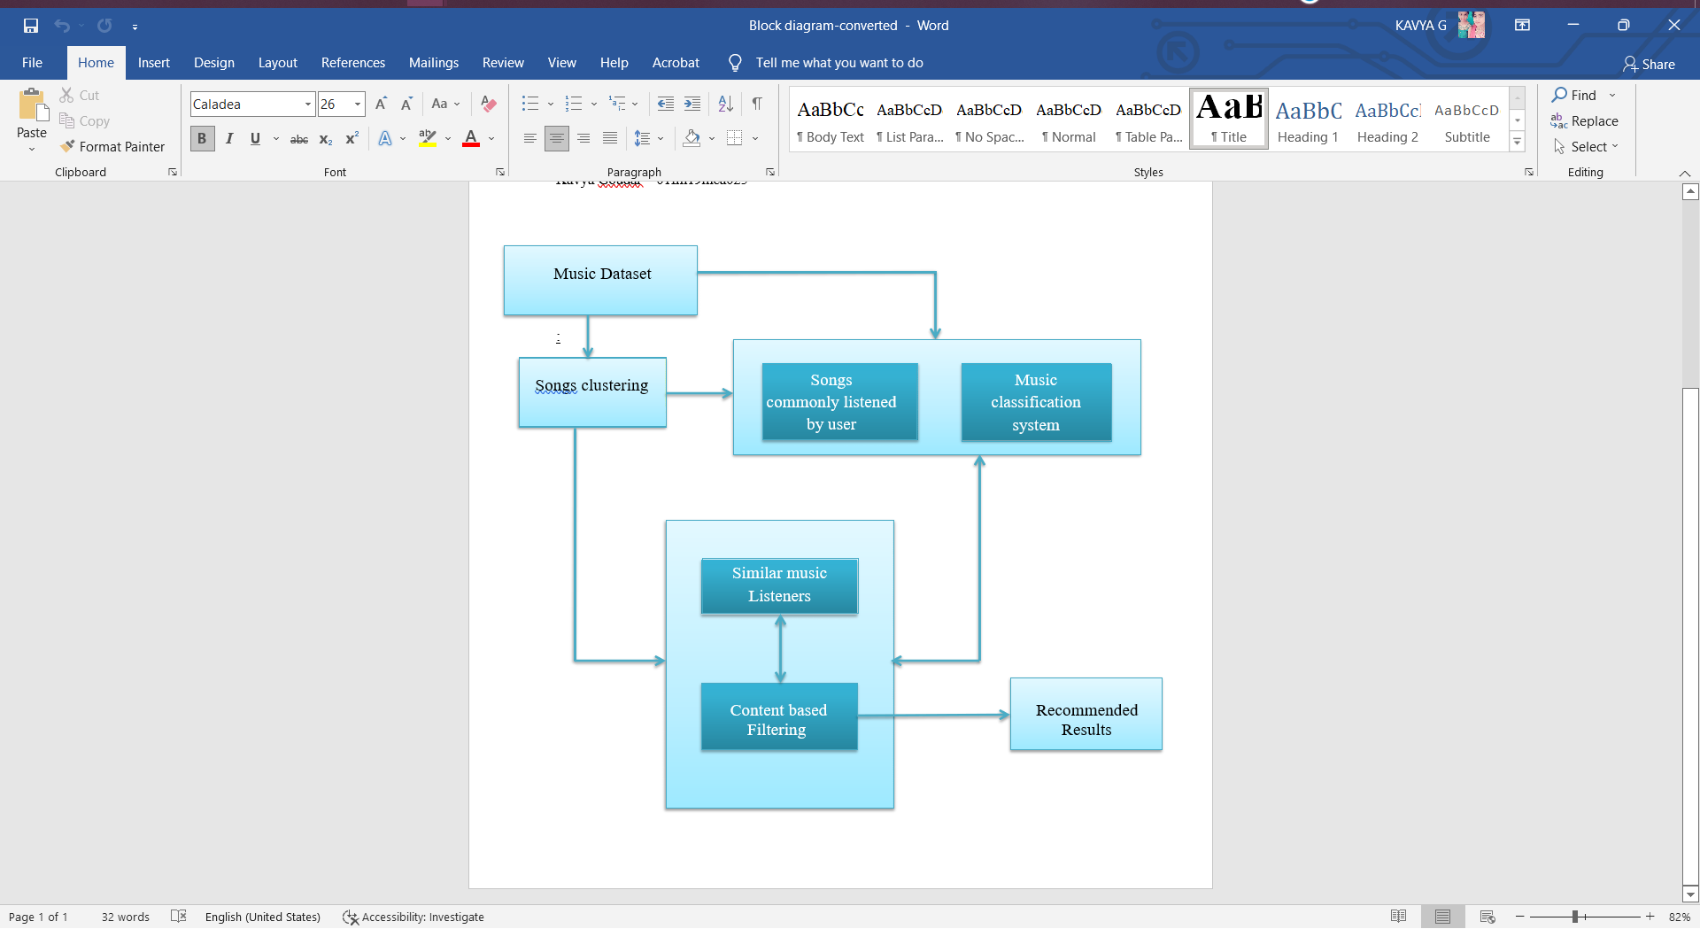

Fig 2.1