BLUESTOCK FINTECH

MUTUAL FUND ANALYTICS PLATFORM

CAPSTONE PROJECT REPORT

Submitted By

Potnuru Kavya Rupini

Submitted To

Bluestock Fintech

June 2026

TABLE OF CONTENTS
1. Executive Summary
2. Project Objective
3. Dataset Description
4. ETL Pipeline
5. Data Cleaning & Preprocessing
6. Exploratory Data Analysis
7. Fund Performance Analytics
8. Advanced Analytics & Risk Metrics
9. Power BI Dashboard
10. Key Findings
11. Recommendations
12. Limitations
13. Future Enhancements
14. Conclusion

- Executive Summary
This project focuses on developing a comprehensive Mutual Fund Analytics Platform to analyse fund performance, investor behavior, SIP trends, and portfolio risk metrics. The solution integrates multiple mutual fund datasets, performs data cleaning and preprocessing, stores processed data in SQLite, conducts exploratory and advanced analytics, and presents insights through an interactive Power BI dashboard.
The platform enables evaluation of mutual fund schemes using performance indicators such as returns, Sharpe Ratio, Sortino Ratio, Alpha, Beta, and Maximum Drawdown. Advanced analytical techniques including Value at Risk (VaR), Conditional Value at Risk (CVaR), Rolling Sharpe Ratio, Investor Cohort Analysis, SIP Continuity Analysis, and a Fund Recommendation Engine were implemented.
The final dashboard provides a user-friendly interface for exploring mutual fund trends, risk-return relationships, investor patterns, and market benchmarks, supporting data-driven investment decision-making.

- Project Objective
The primary objective of this project is to develop a comprehensive Mutual Fund Analytics Platform that enables efficient analysis of mutual fund performance, investor behavior, portfolio risk, and market trends. The platform aims to integrate multiple datasets, automate data processing workflows, generate meaningful analytical insights, and provide interactive visualizations for decision-making.
The specific objectives are:
• Analyse mutual fund performance using return and risk metrics.
• Compare schemes based on Sharpe Ratio, Sortino Ratio, Alpha, Beta, and Maximum Drawdown.
• Study SIP growth trends and investor participation patterns.
• Perform advanced risk analysis using VaR and CVaR techniques.
• Conduct investor cohort and SIP continuity analysis.
• Develop an interactive Power BI dashboard for data exploration.
• Build a simple recommendation engine for fund selection based on risk appetite.

  - Technology Stack
Category | Technology
Programming Language | Python
Data Processing | Pandas, NumPy
Database | SQLite
Visualization | Matplotlib, Seaborn
Dashboard | Power BI
Development Environment | Jupyter Notebook
Version Control | Git & GitHub

- Dataset Description
The Mutual Fund Analytics Platform utilizes multiple datasets representing various aspects of the mutual fund ecosystem. These datasets include scheme details, NAV history, SIP inflows, investor transactions, portfolio holdings, benchmark indices, and fund performance metrics.
The datasets were collected, cleaned, validated, and integrated into a centralized SQLite database to support analytical processing and dashboard visualization.
The following datasets were used in the project:
Dataset File | Description
01_fund_master.csv | Master information of mutual fund schemes
02_nav_history.csv | Historical NAV records for all schemes
03_aum_by_fund_house.csv | Assets Under Management by fund house
04_monthly_sip_inflows.csv | Monthly SIP inflow statistics
05_category_inflows.csv | Category-wise investment inflows
06_industry_folio_count.csv | Industry folio distribution
07_scheme_performance.csv | Performance and risk metrics
08_investor_transactions.csv | Investor transaction records
09_portfolio_holdings.csv | Portfolio allocation details
10_benchmark_indices.csv | Benchmark market index data

- ETL Pipeline
The project follows a structured ETL (Extract, Transform, Load) pipeline to process mutual fund datasets and prepare them for analytics and visualization.
Extract:
Data was collected from multiple CSV files containing mutual fund scheme information, NAV history, SIP inflows, benchmark indices, portfolio holdings, and investor transactions.
Transform:
Data cleaning and preprocessing activities included handling missing values, standardizing column names, correcting data types, removing duplicates, creating derived metrics, and validating data quality.
Load:
The cleaned datasets were loaded into a SQLite database. This centralized storage layer enabled efficient querying, analysis, and dashboard development.
The ETL pipeline ensures data consistency, reliability, and scalability throughout the project lifecycle.

- Data Cleaning & Preprocessing
The raw datasets contained information from multiple sources and required preprocessing before analysis. Data cleaning activities were performed to improve data quality, consistency, and reliability.
The following preprocessing steps were carried out:
• Checked datasets for missing values and handled incomplete records appropriately.
• Removed duplicate entries to ensure data integrity.
• Standardized column names and data formats across datasets.
• Converted date fields into proper datetime formats for time-series analysis.
• Validated numerical fields such as NAV values, returns, AUM, and transaction amounts.
• Created derived variables including daily returns, rolling Sharpe Ratio, Value at Risk (VaR), Conditional Value at Risk (CVaR), and investor cohort groups.
• Integrated multiple datasets using common identifiers such as AMFI Code.
• Loaded cleaned datasets into a SQLite database for efficient querying and analysis.
The preprocessing stage ensured that the datasets were accurate, consistent, and suitable for exploratory analysis, performance evaluation, and dashboard visualization.
Key Outputs
• cleaned_nav_history.csv
• cleaned_investor_transactions.csv
• mutual_fund.db
• fund_scorecard.csv
• alpha_beta.csv

- Exploratory Data Analysis
Exploratory Data Analysis (EDA) was performed to understand investor behavior, fund distribution patterns, SIP trends, and category-wise investment activity. Various visualizations were created to identify trends, distributions, and relationships within the data.
The analysis provides insights into demographic participation, fund inflows, folio growth, and category preferences across the mutual fund ecosystem.

  - Age Group Distribution
The age group distribution analysis was conducted to understand the demographic composition of investors participating in mutual fund investments. The visualization highlights the relative contribution of different age segments and helps identify the primary investor population.
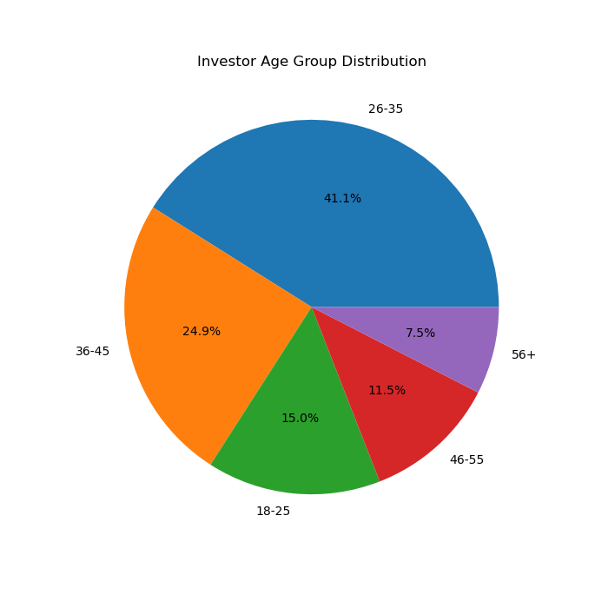
Figure 1 : Age Group Distribution of Investors
  - Gender Distribution
Gender distribution analysis was performed to understand participation levels across different investor groups. This analysis helps identify the representation of investors and provides insights into demographic diversity within mutual fund investments.
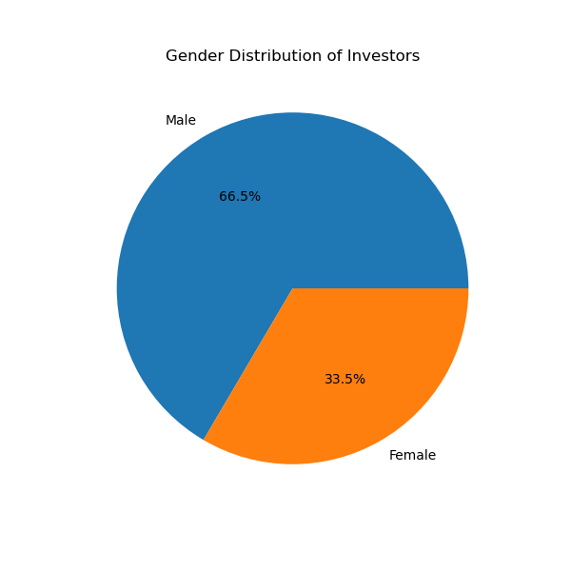
Figure 2 : Gender Distribution of Investors

6.3 City Tier Distribution
City tier analysis was conducted to understand the geographic distribution of mutual fund investors. The visualization categorizes investors based on city tiers and highlights the contribution of metropolitan, urban, and semi-urban regions to mutual fund participation.
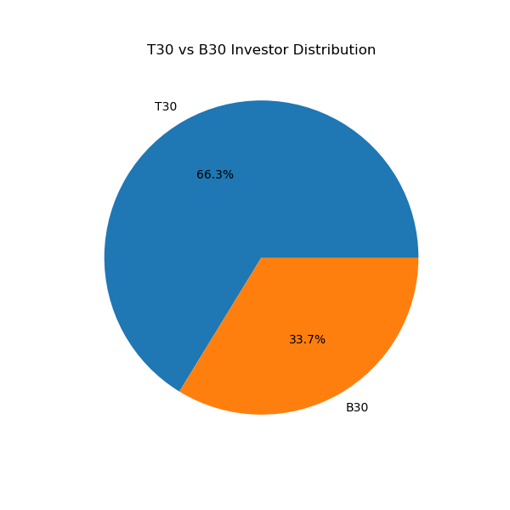
Figure 3 : City Tier Distribution of Investors
6.4 Monthly SIP Inflow Trend
Monthly SIP inflow analysis was conducted to evaluate systematic investment participation over time. The trend provides insights into investor confidence, market sentiment, and the growth of disciplined investment behavior through SIPs.
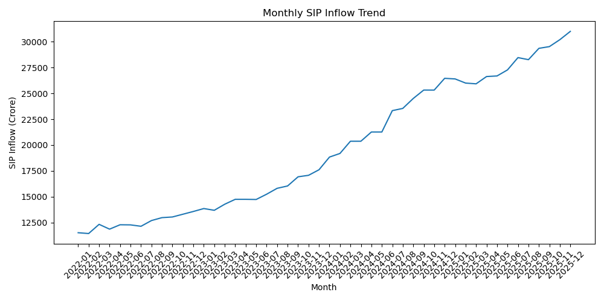
Figure 4 : Monthly SIP Inflow Trend

6.5 Category-wise Investment Inflows
Category-wise inflow analysis was performed to identify investment preferences across different mutual fund categories. The analysis highlights variations in investor allocation patterns and category popularity.
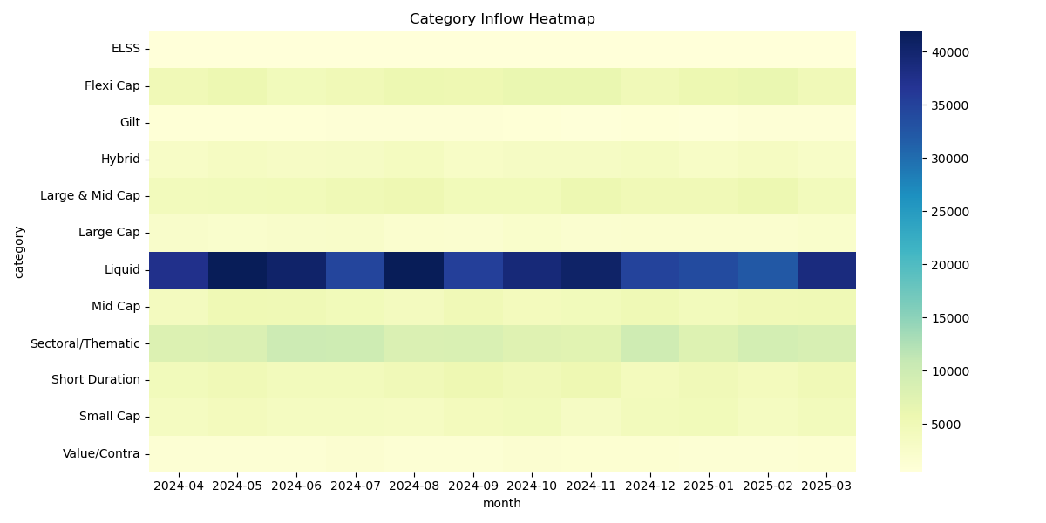
Figure 5 : Category-wise Investment Inflows
Observation: Certain fund categories attract significantly higher inflows, indicating stronger investor preference and market demand.

6.6 Industry Folio Growth
Industry folio growth analysis was conducted to evaluate the expansion of mutual fund participation over time. Increasing folio counts indicate growing investor awareness and market penetration.
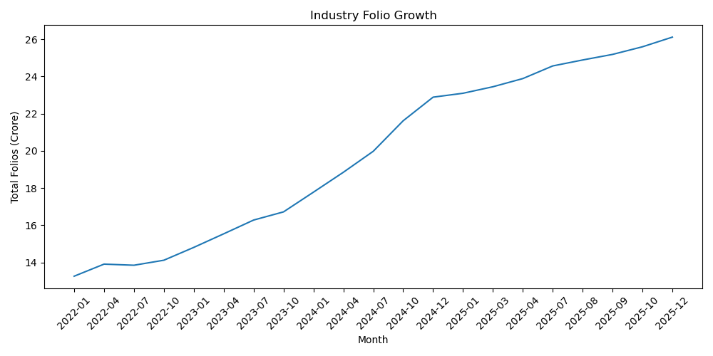
Figure 6 : Industry Folio Growth Trend
Observation: The mutual fund industry demonstrates sustained growth in folio counts, reflecting increased retail investor participation.

The exploratory analysis revealed important patterns in investor demographics, SIP participation, category preferences, and industry growth. These findings provide a foundation for deeper performance evaluation and risk analysis conducted in the subsequent sections.
- Fund Performance Analytics
Fund Performance Analytics was performed to evaluate mutual fund schemes using key risk and return metrics. The analysis focuses on return generation, risk-adjusted performance, benchmark comparison, expense efficiency, and fund quality indicators.
  - Benchmark Comparison
Benchmark comparison analysis was conducted to evaluate how mutual fund schemes perform relative to market benchmarks. This comparison helps identify funds that consistently outperform or underperform the broader market.
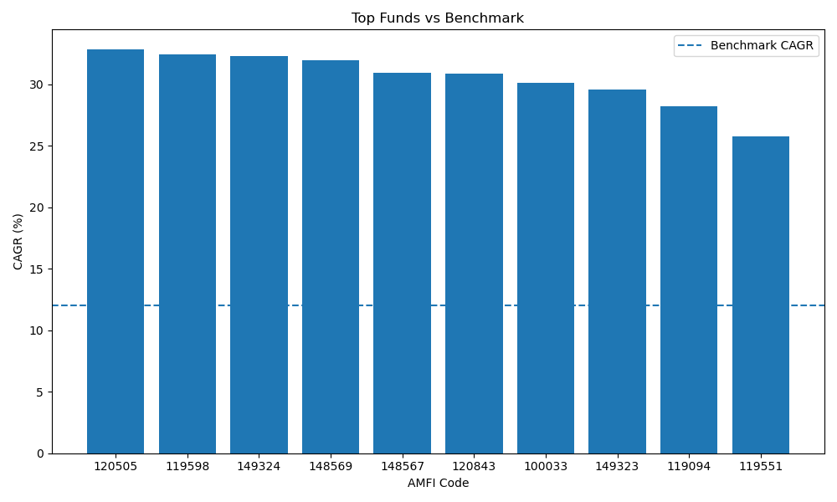
Figure 7 : Fund Performance versus Benchmark
Observation: Several schemes demonstrate performance above benchmark levels, indicating effective fund management and superior return generation.

  - Risk vs Return Analysis
Risk-return analysis examines the relationship between portfolio risk and achieved returns. This visualization helps identify funds delivering optimal returns relative to their risk exposure.

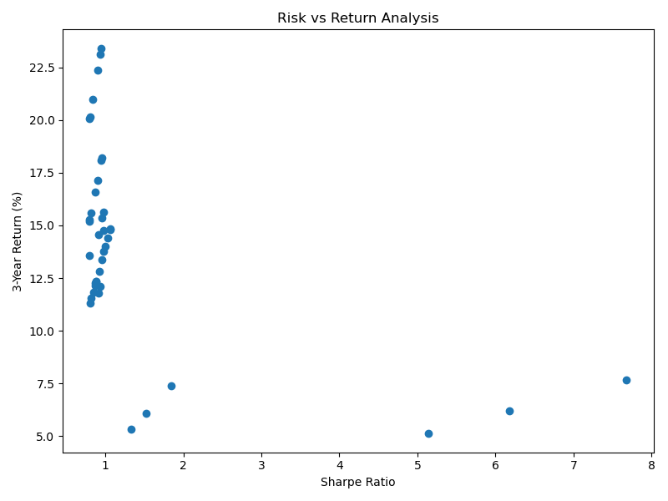
Figure 8: Risk versus Return Analysis
Observation: Higher returns are generally associated with increased risk; however, certain funds achieve favourable risk-adjusted performance.
  - Expense Ratio vs Returns
Expense ratio analysis evaluates the impact of fund management costs on investment performance. The comparison helps determine whether higher expenses translate into superior returns for investors.
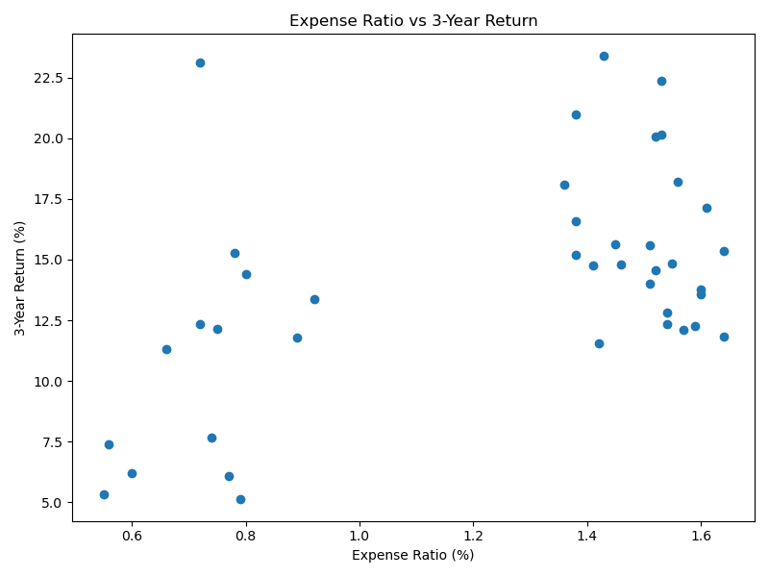
Figure 9 : Expense Ratio versus Returns
Observation: Lower expense ratios do not always guarantee higher returns; however, cost-efficient funds generally provide better long-term value to investors.

  - Top Performing Funds
Top-performing funds were identified based on return metrics and overall performance indicators. This analysis highlights schemes that consistently delivered strong returns during the evaluation period.
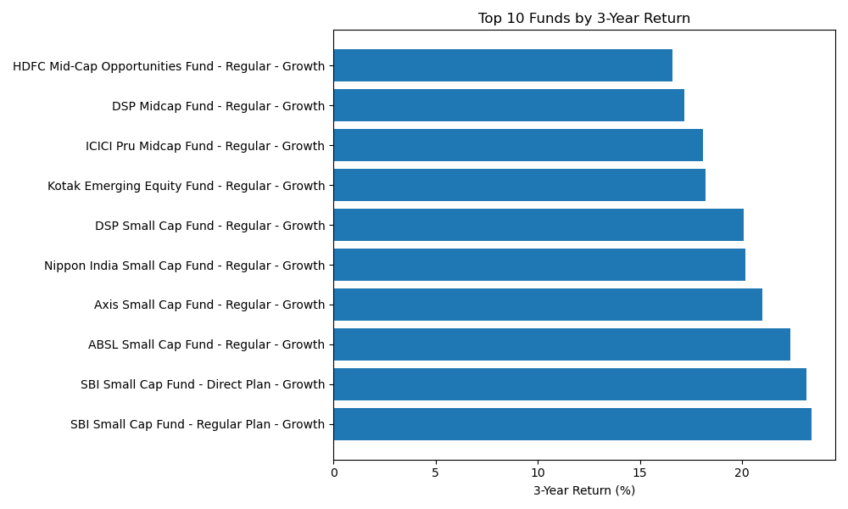
Figure 10 : Top Performing Mutual Funds
Observation: A small group of funds significantly outperformed peers, demonstrating strong portfolio management and investment strategy.

  - Morningstar Rating Distribution
Morningstar ratings provide an independent assessment of fund quality and historical performance. The distribution helps understand the overall quality profile of the analysed schemes.
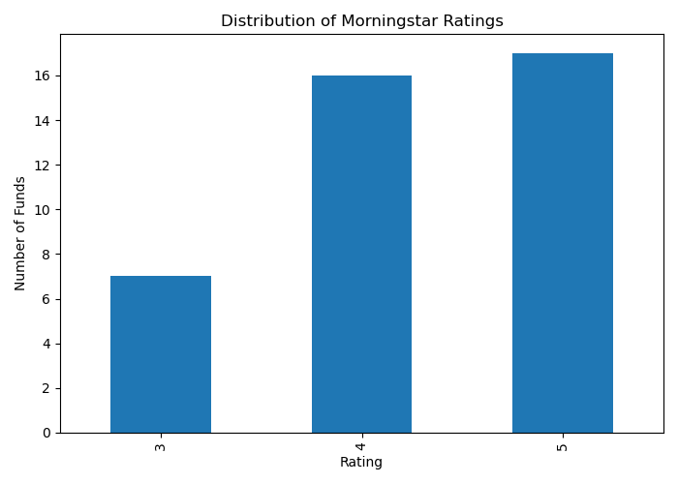
Figure 11 : Morningstar Rating Distribution
Observation: Most funds are concentrated within mid-to-high rating categories, indicating generally acceptable performance standards.

  - Risk Grade Distribution
Risk grade distribution analysis categorizes funds according to their risk levels. This classification assists investors in selecting schemes that align with their risk tolerance.
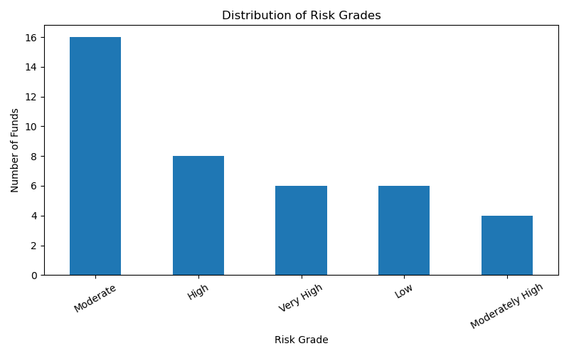
Figure 12 : Risk Grade Distribution
Observation: The dataset contains a balanced mix of low, moderate, and high-risk funds, supporting diverse investor preferences.
The performance analysis demonstrates significant variation across mutual fund schemes in terms of returns, risk exposure, expenses, and ratings. These findings provide a basis for the advanced risk analytics discussed in the next section.

- Advanced Analytics & Risk Metrics
  - Value at Risk (VaR)
Value at Risk (VaR) estimates the maximum potential loss that may occur within a specified confidence level over a given investment horizon. VaR is widely used by financial institutions to measure downside risk exposure.
AMFI Code | VaR (95%) | CVaR (95%)
100016 | -0.014364 | -0.018060
100025 | -0.003793 | -0.004994
100033 | -0.019034 | -0.023456
101206 | -0.013282 | -0.017439
101207 | -0.026021 | -0.032459
Table 1: Sample VaR and CVaR Results
Observation: VaR analysis indicates the estimated maximum loss that investors may experience under normal market conditions at a 95% confidence level.
  - Conditional Value at Risk (CVaR)
Conditional Value at Risk (CVaR) extends VaR by estimating the average loss beyond the VaR threshold. It provides a deeper understanding of extreme downside scenarios.
Observation: CVaR values highlight tail-risk exposure and provide a more conservative measure of portfolio risk compared to VaR.

  - Rolling Sharpe Ratio Analysis
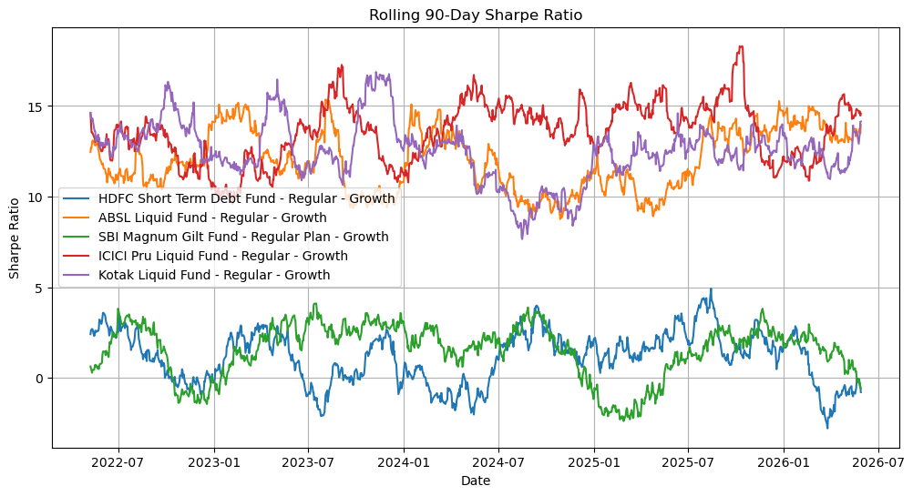
Figure 13 : Rolling Sharpe Ratio Trend
Rolling Sharpe Ratio analysis evaluates risk-adjusted performance over time. Unlike a static Sharpe Ratio, the rolling approach captures changes in fund efficiency across different market conditions.
Observation: Periodic fluctuations in rolling Sharpe Ratios indicate changing market environments and varying effectiveness of fund management strategies.

  - Cohort Analysis
Investor cohort analysis groups investors based on their onboarding period and evaluates their investment behavior over time. This approach helps identify retention and participation trends.
Cohort Year | Avg Investment | Total Invested | Investors | Preferred Fund
2024 | 107422.54 | 3491125187 | 4803 | 120504
2025 | 109158.58 | 30455243 | 197 | 119551
Table 2: Investor Cohort Analysis Results
Observation: Investors onboarded in 2024 contributed the majority of investment volume, reflecting stronger participation and longer investment horizons.

  - SIP Continuity Analysis
SIP continuity analysis was performed to evaluate investor engagement and identify potential churn risk. Investors were classified as Active or At Risk based on their contribution continuity patterns.
SIP Status | Count
Active | 695
At Risk | 4305
Table 3: SIP Continuity Analysis Results
Observation: A large proportion of investors fall under the At Risk category, suggesting opportunities for targeted retention and engagement initiatives.

  - Fund Recommendation Engine
A rule-based recommendation engine was developed to suggest mutual fund schemes according to investor risk preferences. Funds are filtered by risk grade and ranked using Sharpe Ratio to identify suitable investment options.
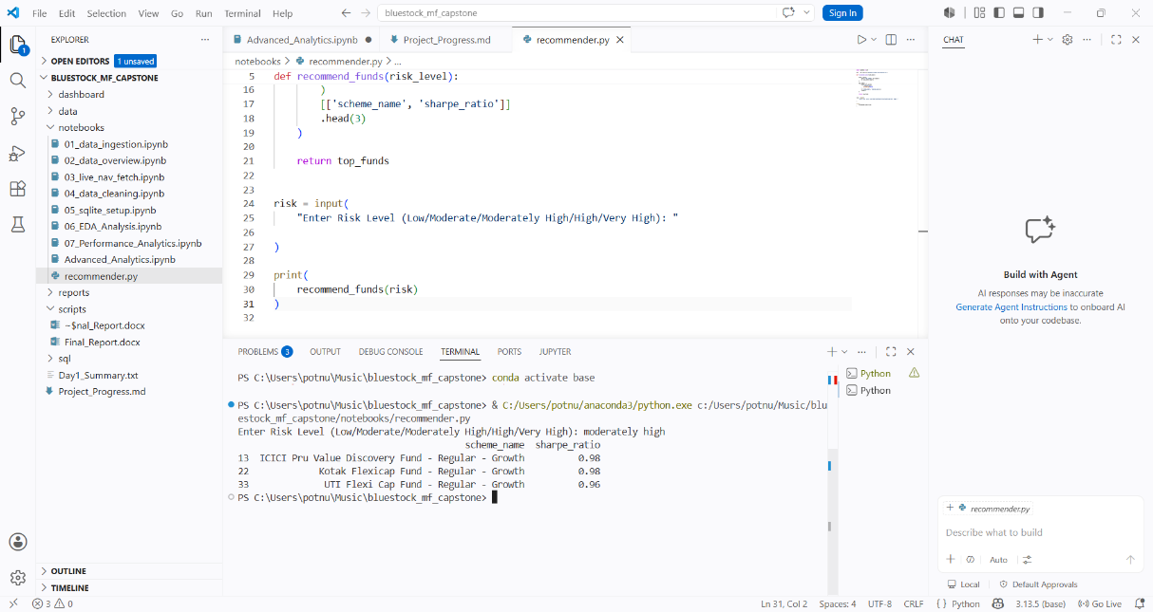

A rule-based fund recommendation engine was developed to assist investors in selecting suitable mutual fund schemes based on their risk appetite. The system categorizes investors into Low, Moderate, and High risk profiles and filters eligible schemes accordingly. Recommended funds are ranked using risk-adjusted performance metrics such as the Sharpe Ratio, enabling more informed investment decisions.

Key Features:
Risk-profile based fund filtering
Top fund selection using Sharpe Ratio
Simple command-line implementation
Supports Low, Moderate, and High risk categories

- Power BI Dashboard
An interactive Power BI dashboard was developed to visualize mutual fund performance, investor behavior, SIP trends, and market analytics. The dashboard enables users to explore data through filters, drill-through functionality, and dynamic visualizations.
The dashboard consists of the following pages:
• Industry Overview
• Fund Performance
• Fund Performance Details
• Investor Analytics
• SIP & Market Trends

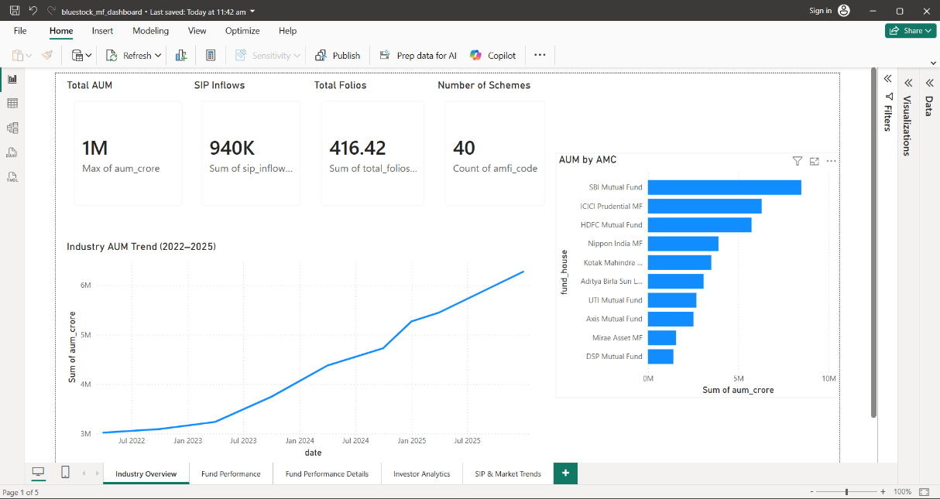
Figure 14 : Industry Overview Dashboard
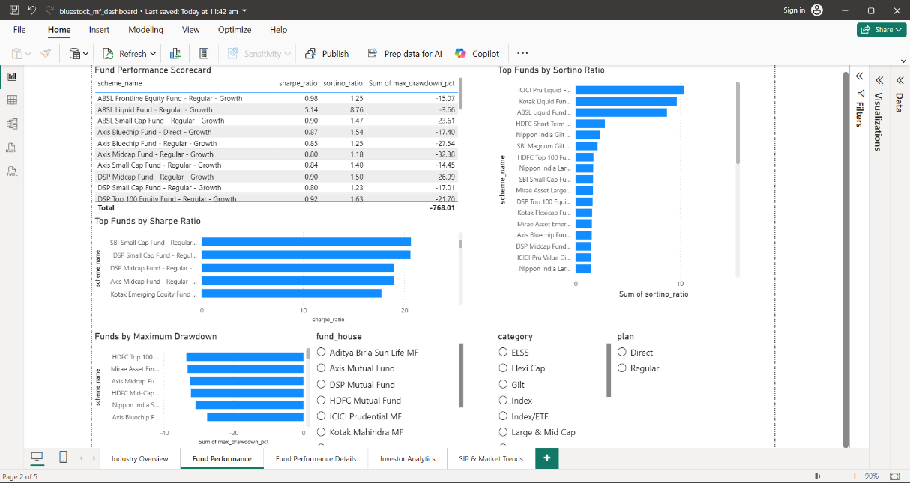
Figure 15 : Fund Performance Dashboard

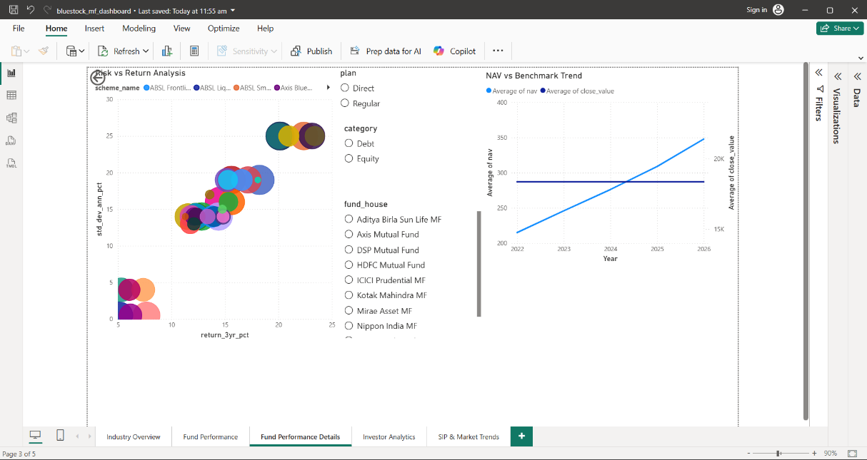
Figure 16 : Fund Details Dashboard
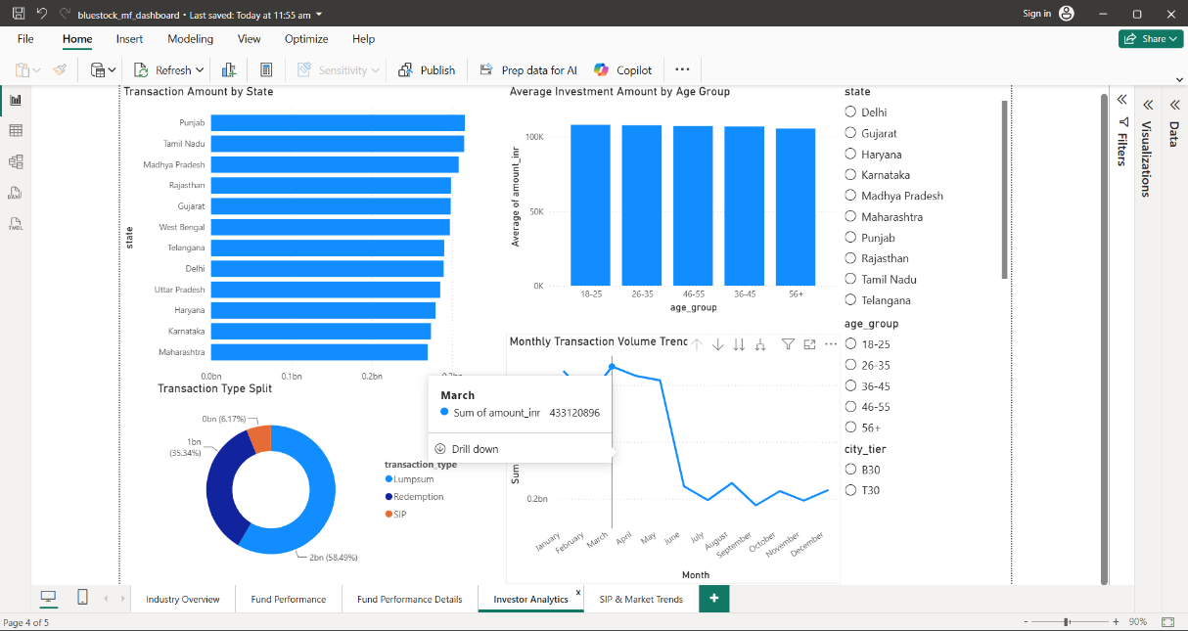
Figure 17 : Investor Analytics Dashboard
The Power BI dashboard provides a consolidated view of mutual fund performance, investor analytics, SIP trends, and risk metrics. Interactive filters, drill-through functionality, and dynamic visualizations enable users to explore data efficiently and derive actionable insights.

10. Key Findings
• Mutual fund participation has grown steadily, as reflected by increasing folio counts and SIP inflows.
• Investor activity is concentrated within a few key demographic segments.
• Several schemes consistently outperformed benchmark indices.
• Risk-adjusted performance varied significantly across schemes.
• Cohort analysis revealed stronger participation from earlier investor groups.
• SIP continuity analysis identified a substantial number of investors categorized as At Risk.
• Advanced risk metrics provided deeper insights into downside exposure and portfolio stability.

11. Recommendations
• Encourage investor retention through targeted engagement programs.
• Expand analytics with real-time NAV and market data integration.
• Introduce predictive models for investor churn and SIP discontinuation.
• Enhance recommendation capabilities using machine learning techniques.
• Deploy dashboards through cloud-based business intelligence platforms for wider accessibility.

12. Limitations
• The project uses historical datasets and does not include live market feeds.
• Investor transaction data is limited to available records.
• Recommendation logic is rule-based and does not consider investor-specific preferences beyond risk level.
• Market conditions and macroeconomic factors were not explicitly incorporated into predictive analysis.

13. Future Enhancements
• Real-time data integration.
• AI-powered recommendation systems.
• Predictive investor churn modeling.
• Mobile dashboard deployment.
• Portfolio optimization and scenario analysis.
• Automated reporting and alert generation.

14. Conclusion
The Mutual Fund Analytics Platform successfully integrates data engineering, exploratory analysis, advanced risk analytics, and business intelligence visualization into a unified solution. The project demonstrates the application of data analytics techniques to mutual fund datasets and provides actionable insights for investors and analysts.

The combination of ETL processing, performance evaluation, risk assessment, investor analytics, and dashboard visualization creates a comprehensive framework for mutual fund analysis and decision support.

15. References
- Association of Mutual Funds in India (AMFI) – Mutual Fund Industry Data.
- National Stock Exchange (NSE) India – Market Benchmark Information.
- Bluestock Fintech Capstone Project Dataset.
- Python Documentation – Pandas, NumPy, Matplotlib Libraries.
- Microsoft Power BI Documentation.
- SQLite Documentation.
Tools Used
Python
Jupyter Notebook
SQLite
Power BI
GitHub
Microsoft Word

