**TODO APP**



**Team ID : LTVIP2023TMID02310**

**Team Size : 5**

**Team Leader : BANDE KAVYA ANNAPURNESWARI**

**Team member : MUTHYALA SRILAKSHMI**

**Team member : SODAGAM REVATHI**

**Team member : SIGIREDDY VEERAMANI**

**Team member : NARLA ISWARYA AMBIKA**

**1.INTRODUCTION**

* 1. **Overview**

Todo List App is a kind of app that generally used to maintain our day-to-day tasks or list everything that we have to do, with the most important tasks at the top of the list, and the least important tasks at the bottom. It is helpful in planning our daily schedules. We can add more tasks at any time and delete a task that is completed.

To-do list is a list of tasks that need to be completed, typically organized in order of priority. It is one of the simplest solutions for task management and provides a minimal and elegant way for managing tasks a person wishes to accomplish. Our aim is to design a simple and elegant website for people to keep a track of the status of their tasks. Making a to-do list is an easy and important task that everyone should do. The immense satisfaction that one gets when completing the task and marking it on the list are incomparable. Moreover, creating a list of tasks ensure you don’t miss out on anything. It’s a scientific fact that when you write the tasks that you need to complete, you are even more motivated to complete it. With this in mind, we come to build a platform which will help people create their own task list

**1.2** **Purpose**

The concept of to-do list has existed for a very long time and it is one of the primary methods for management of tasks, use of a to-dos as a reminder system, to-dos as a system for note management, etc. In the simplest and most primitive form, a to-do list can be implemented on a pen and paper as a checklist of items which can be crossed of or ticked against when complete

This can be further extended to calendars, by writing tasks against dates where the dates can also act as deadlines for particular tasks. Other possible extensions of to-do lists can be on whiteboards, journals, text editors , etc.

The functionalities of to-do lists naturally evolve to perfectly fit web applications and applications on digital devices. Equipped with modern tools and technologies, engineers can build an application to create a minimal and powerful application that can help boost productivity without loss of focus and attention

**2.LITERATURE SURVEY**

**1 Existing problem**

Social media and other easily accessible online distractions make it hard for us to stay focused on our tasks and make it difficult for us to do our work efficiently.

Also, constantly switching between tasks may give us the false feeling that we are being productive when we are, in fact, not. It’s more important for us to prioritize tasks and work on those that are most important, rather than focusing on deleting small items from our todo list just for the sake of appearances.

**2.2 Proposed solution**

The goal of this app is to help us become more aware of how we spend time in the process of doing those tasks and how productive that time is. It can help set some constraints on social media to reduce distraction and track the time we spend working on the todo items. When we have a better sense of the estimated time we’ll need to spend on our tasks, along with the validated time spent on the items for reference or personal and team reviews, we are able to manage our daily routines more efficiently.

**3.THEORETICAL ANALYSIS**

**3.1 Block diagram**

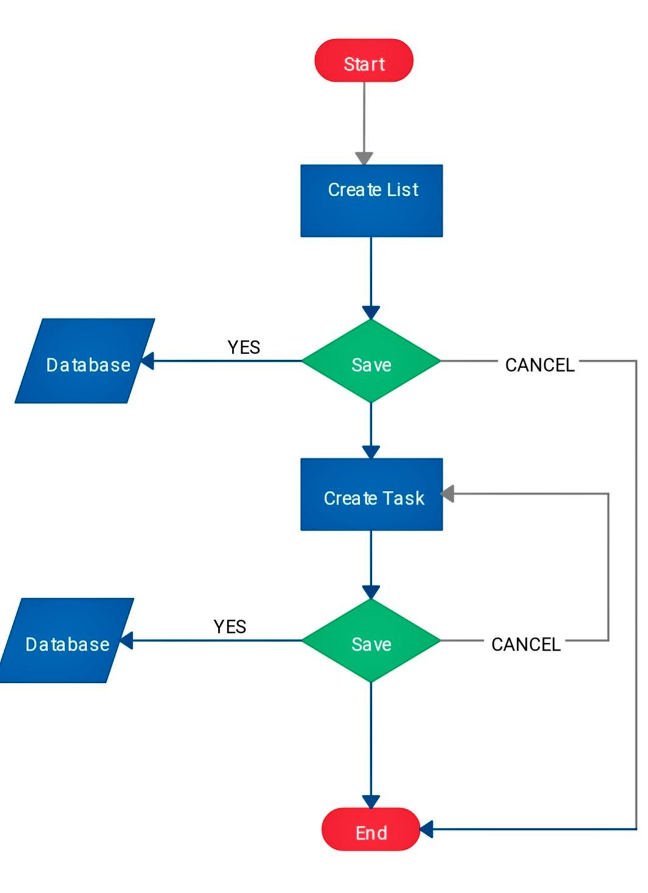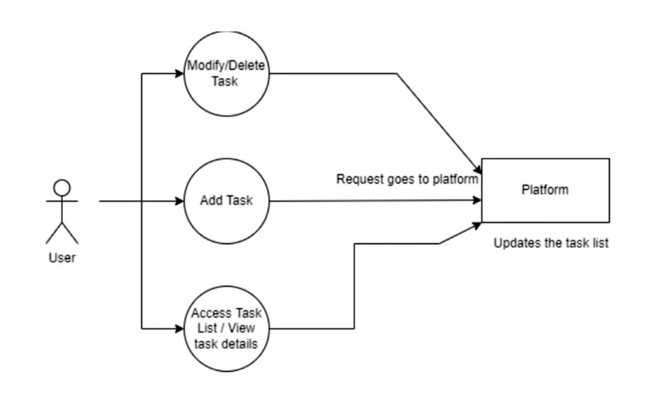

**3.2 Hardware/Software designing**

*Hardware* :

Hardware refers to the external and internal devices and equipment that enable you to perform major functions such as input, output, storage, communication, processing, and more. There are two types of computer hardware: external and internal. External hardware devices include monitors, keyboards, printers, and scanners, whereas internal hardware devices include motherboards, hard drives, and RAM.

*Software:*

VS Code supports many programming languages, for which a developer does not require Web Support. Everything can be found in its built-in multi-language support. A developer can rely on Visual Studio Code for all kinds of development, as long as they pair it with the right tools

Google Chrome is a cross-platform web browser developed by Google. It’s software application. Chrome is used to run the code it’s show the output of our project

**4.RESULT**

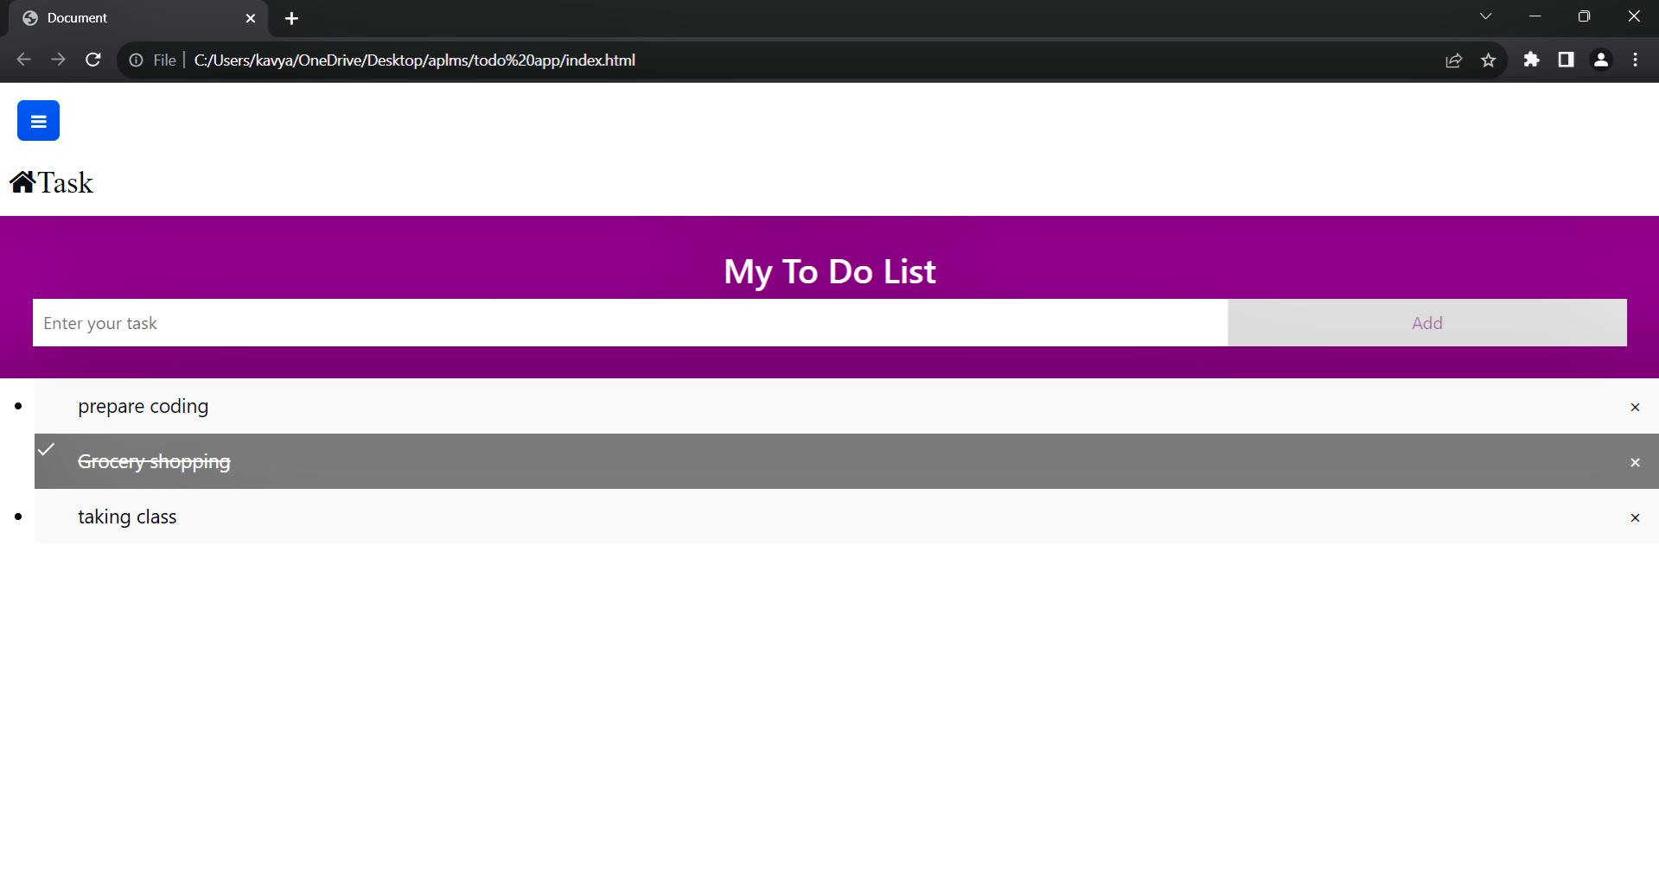

**5.ADVANTAGES & DISADVANTAGES**

**Advantages**

**1.Improves your memory:** A to do list acts as an external memory aid. It’s only possible to hold a few pieces of information at one time. Keep a to do list and you’ll be able to keep track of everything, rather than just a few of the tasks you need to do. Your to do list will also reinforce the information, which make sit less likely you’re going to forget something.

**2. Increases productivity:** A to do list allows you to prioritize the tasks that are more important. This means you don’t waste time on tasks that don’t require your immediate attention. Your list will help you stay focused on the tasks that are the most important.

**3. Helps with motivation:** To do lists are a great motivational tool because you can use them to clarify your goals. You can divide your long-term goal into smaller, more achievable short-term goals and as you tick each one off your list , your confidence will increase.

**Disadvantages**

But as good as the advantages sound, there is, as always, a downside. If you already have very little time for a project, writing a to-do list is an additional factor that costs time. The resulting time pressure can lead to unconscious or even conscious stress. This usually leads to a negative performance. If it lasts too long, it can have further negative consequences. So as soon as you notice that keeping the list only puts you under pressure, then it is better not to keep a to-do list.

In addition, you may also set yourself unrealistic goals. This is mainly because you have too high expectations of yourself. When you look at your list, you see all the unfinished tasks and are demotivated – but in doing so, you overlook everything that you have already achieved and checked

**6.APPLICATIONS**

**Personal task management:** A todo list application can help individuals keep track of their daily tasks and manage their time more effectively. ToDo List App is a kind of app that generally used to maintain our day-to-day tasks or list everything that we have to do, with the most important tasks at the top of the list, and the least important tasks at the bottom. It is helpful in planning our daily schedules. We can add more tasks at any time and delete a task that is completed.

**Team task management:** A todo list application can be used by teams to assign tasks and keep track of project progress. The concept of to-do list has existed for a very long time and it is one of the primary methods for management of tasks, use of a to-dos as a reminder system, to-dos as a system for note management, etc. In the simplest and most primitive form, a to-do list can be implemented on a pen and paper as a checklist of items which can be crossed of or ticked against when completed

**Educational purposes:** A todo list project can be a good way for beginners to learn HTML, CSS, and JavaScript . We can also create by using basic programming languages like C, Pyth

**7.CONCLUSION**

App todo-list-app performs very efficient comparing to competitor. There is a space for further developments with regards of keeping app small and quick. It would be optimal to use dedicated CSS and continuing using vanilla JavaScript.

To-do-app can be developed as a sole application as well as a very efficient module to be combined in a larger project. One of the key challenges is to chose appropriate storage solution, that will allow to maintain its biggest advantages:

* Simplicity
* Speed
* Low recourses demand

**8.FUTURE SCOPE**

To-do lists are personal and for short-term goals. It only organises your activities for a day or a specific duration. Its presence keeps you organised and becomes an everyday external memory. To-do lists also eliminate unnecessary activities and prevent wasted time.

The task list generally includes weekly, monthly or timeline activities for a project. This means that anyone and more than one person can use this list. The task list can also be a milestone in a project that signifies each project’s phase has been completed. However, some task lists can contain a list of daily tasks but in a collaborative version.

Managers generally make task lists in digital versions through project management tools that are more accessible to others. On the task list, you can group which tasks are prioritised through the Eisenhower Matrix. Another function of the task list is to track the project’s progress.

