EB.EXTERNAL.USER IMPLEMENTATION FOR IRIS

STEP1

Go to jboss deployment folder, right click on your IRIS war file , go to 7-Zip and click on open archive.

Go to ***WEB-INF/lib*** and click on name to sort lib files alphabetically.

STEP2

Open ***t24-EB_AuthenticationService-tafj-provider-201701.0.0.jar***  
right click on ***authenticationServiceContext.xml*** and open in **edit** mode.

In ***<entry key="OFS_SOURCE" value="GCS"/>***

Replace “GCS” with “TCIB” as shown and save the file.

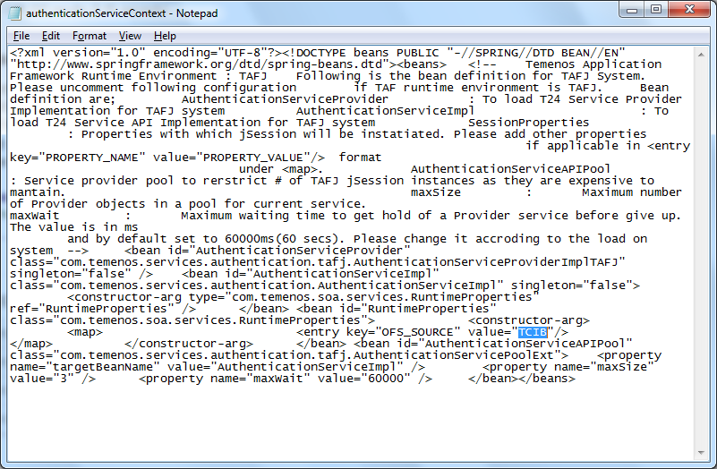

STEP3

Next open ***t24-EB_CatalogService-tafj-provider-201701.0.0.jar\***   
right click on ***catalogServiceContext.xml*** and open in**edit** mode

In ***<entry key="OFS_SOURCE" value="IRISPA"/>***

Replace “IRISPA” with “IRISPAARCIB” as shown and save the file.

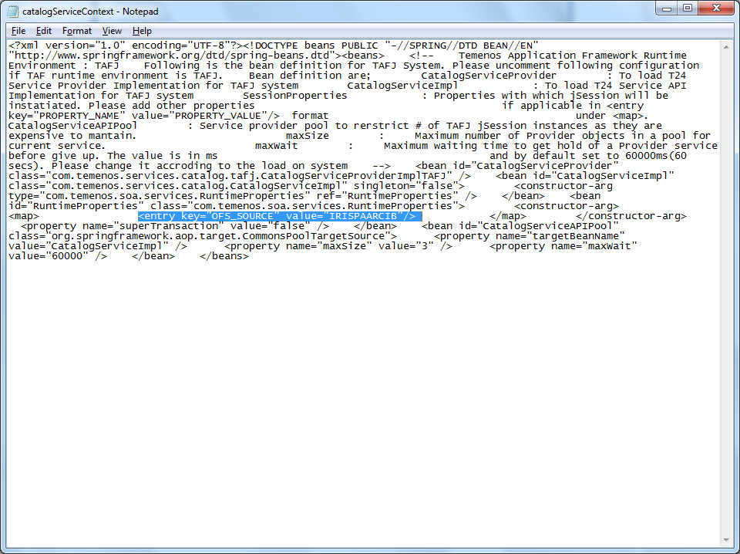

STEP 4

Next open ***t24-EB_ResourceProviderService-tafj-provider-201701.0.0.jar\***

Right click on ***resourceProviderServiceContext.xml*** and open in **edit** mode

In ***<entry key="OFS_SOURCE" value="IRISPA"/>***

Replace “IRISPA” with “IRISPAARCIB” as shown and save the file.

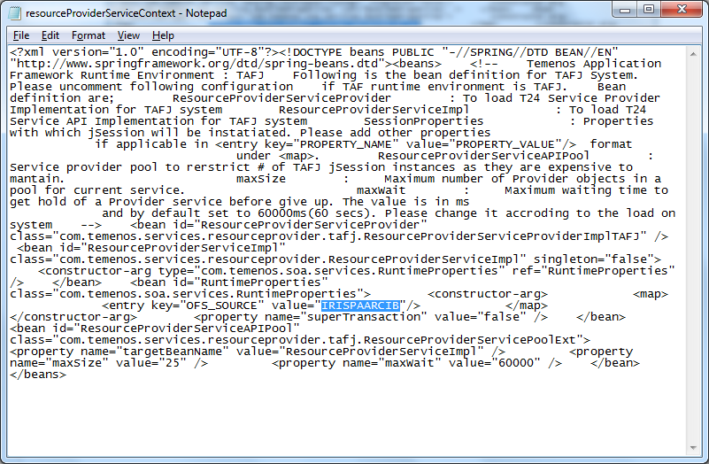

STEP 5

Next open ***t24-EB_Sms-tafj-provider-201701.0.0.jar\***

Right click on ***smsContext.xml*** and open in edit mode

In ***<entry key="OFS_SOURCE" value="GCS"/>***

Replace “GCS” with “TCIB” as shown and save the file.

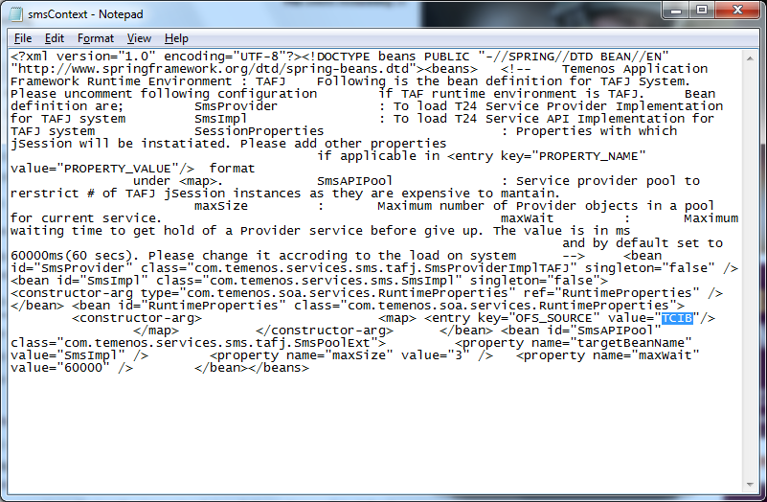

STEP 6

Next open ***T24Authenticator-201701.0.0-tafj.jar\***

Right click on ***authenticationServiceContext.xml*** and open in **edit** mode

In ***<entry key="OFS_SOURCE" value="IRISPA"/>***

Replace “IRISPA” with “IRISPAARCIB” as shown and save the file.

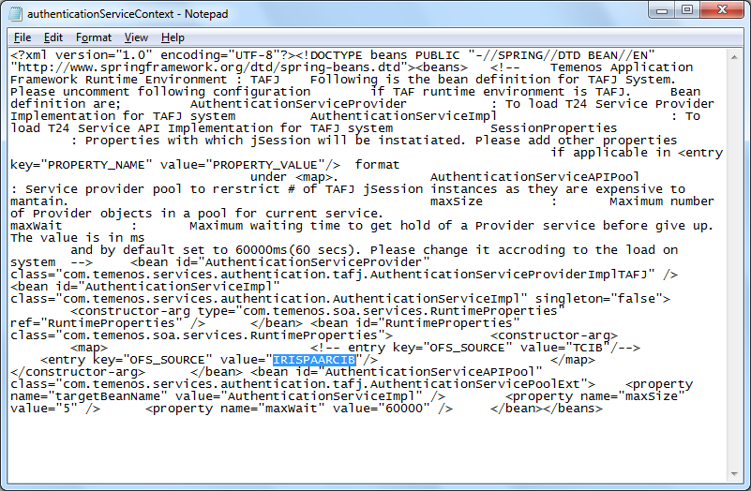

Now, IRIS services can be accessed by **external user** login.