  - LAB-1

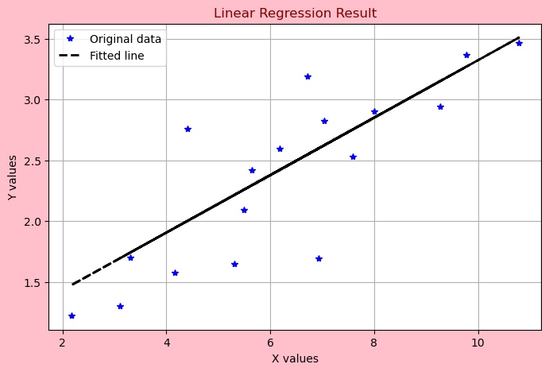

LAB-2

The Accuracy of the Model is “0.948”.
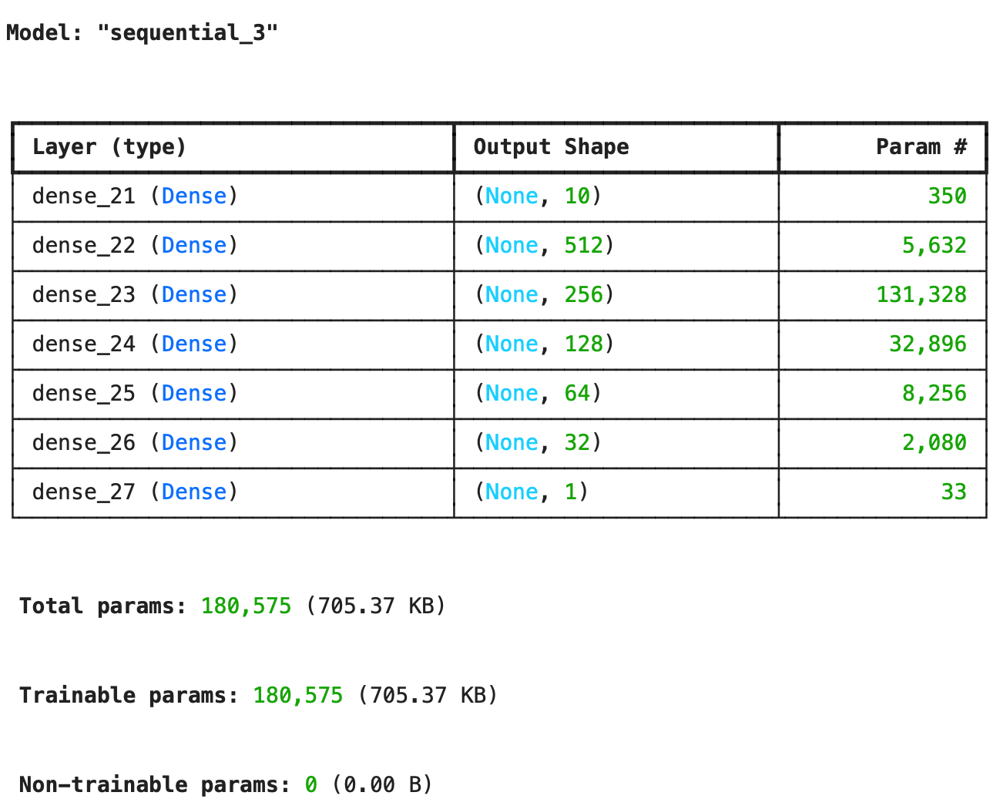

TASK-2:

Output1(O1)=1.548
Output2(O2)=1.548

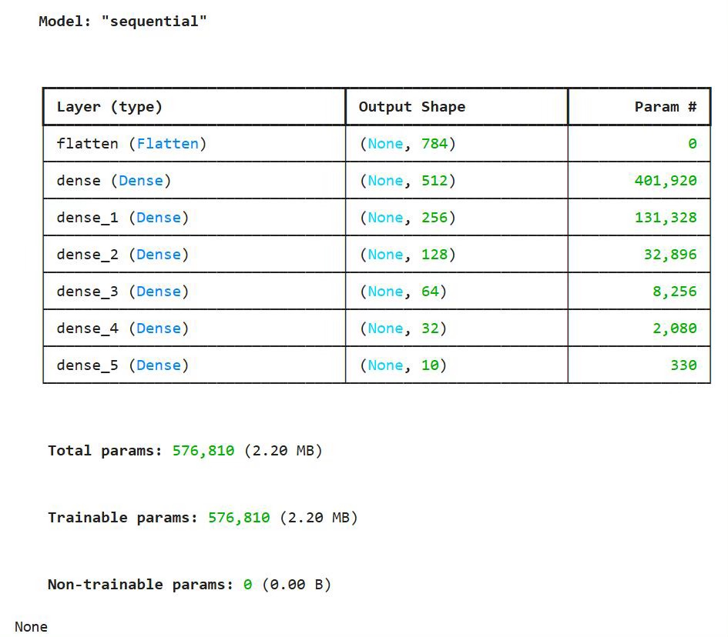
LAB-3

The Test Accuracy of the Model is 0.87

LAB-4
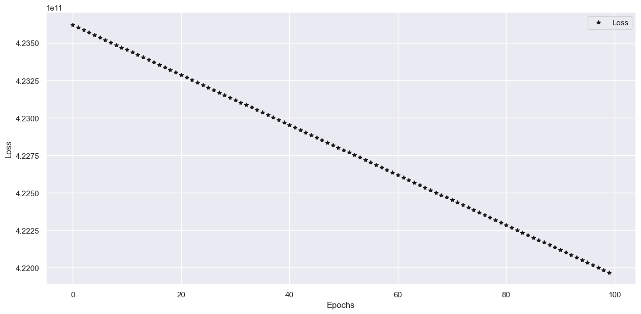

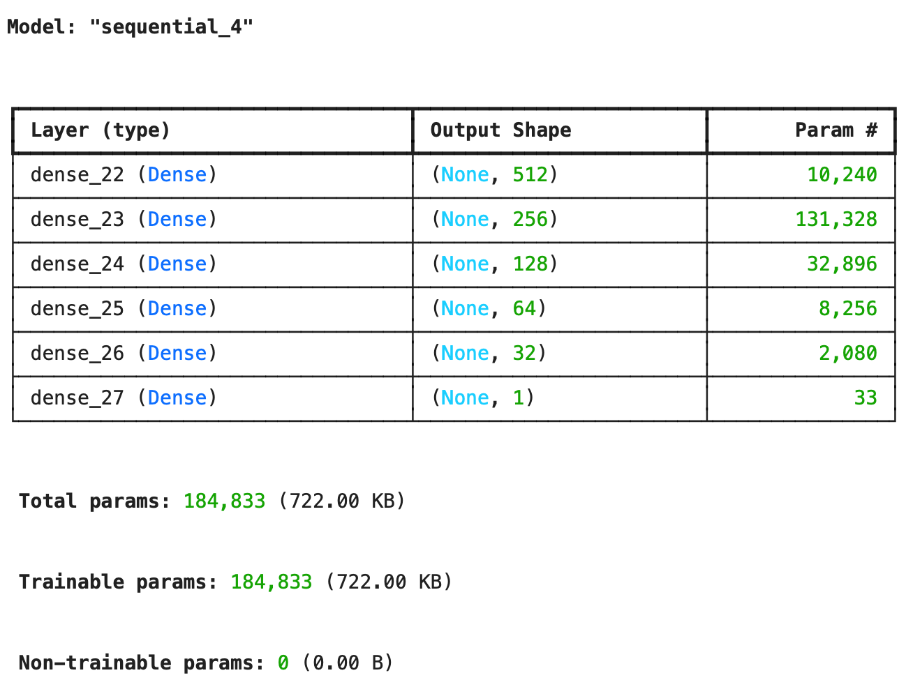
LAB-5

Model building code:
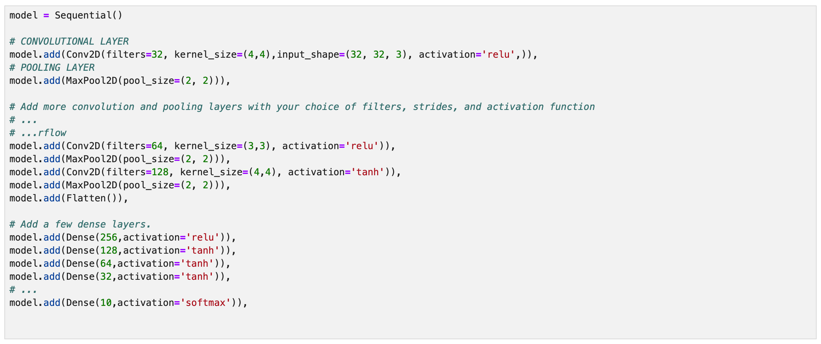
summary:
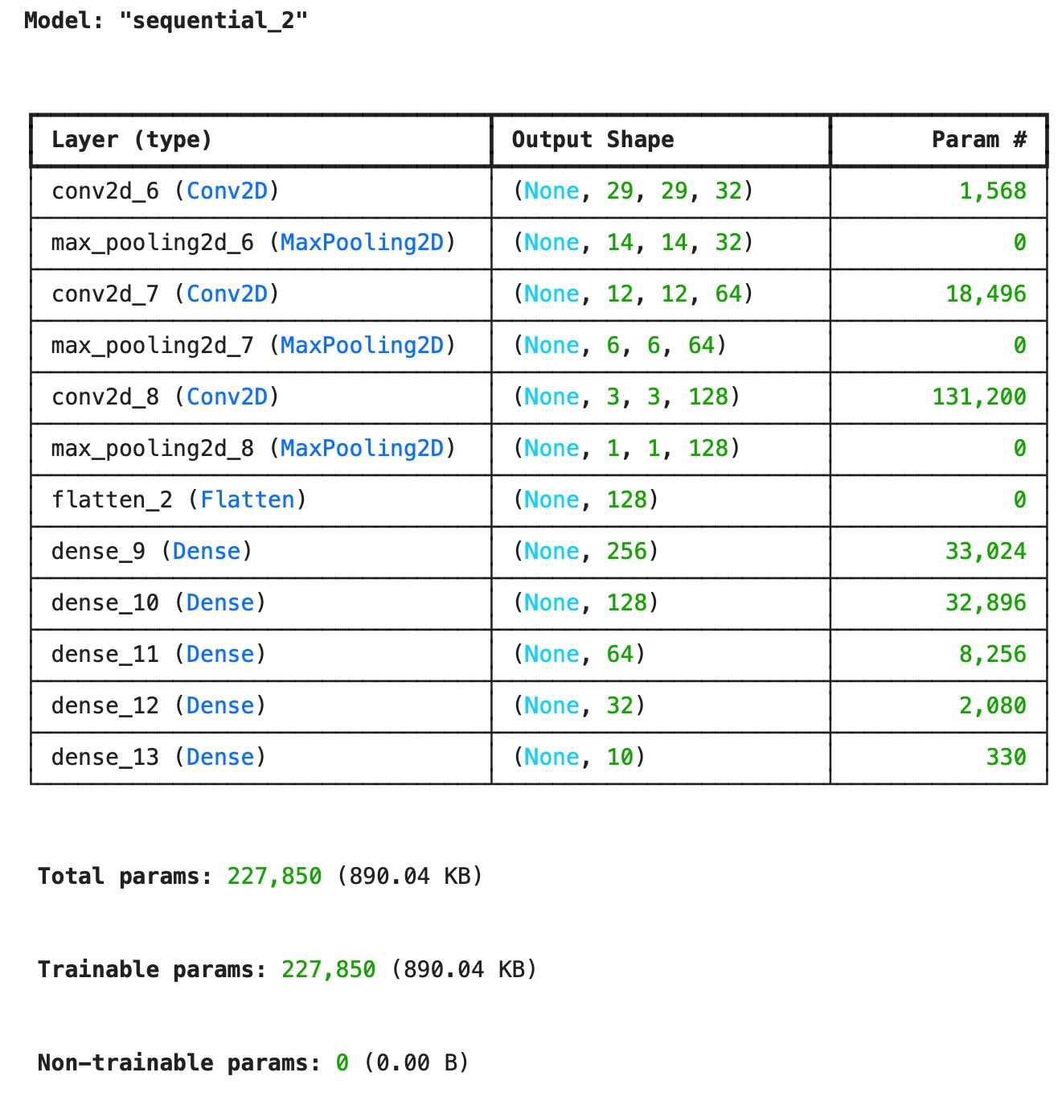
Graphs:

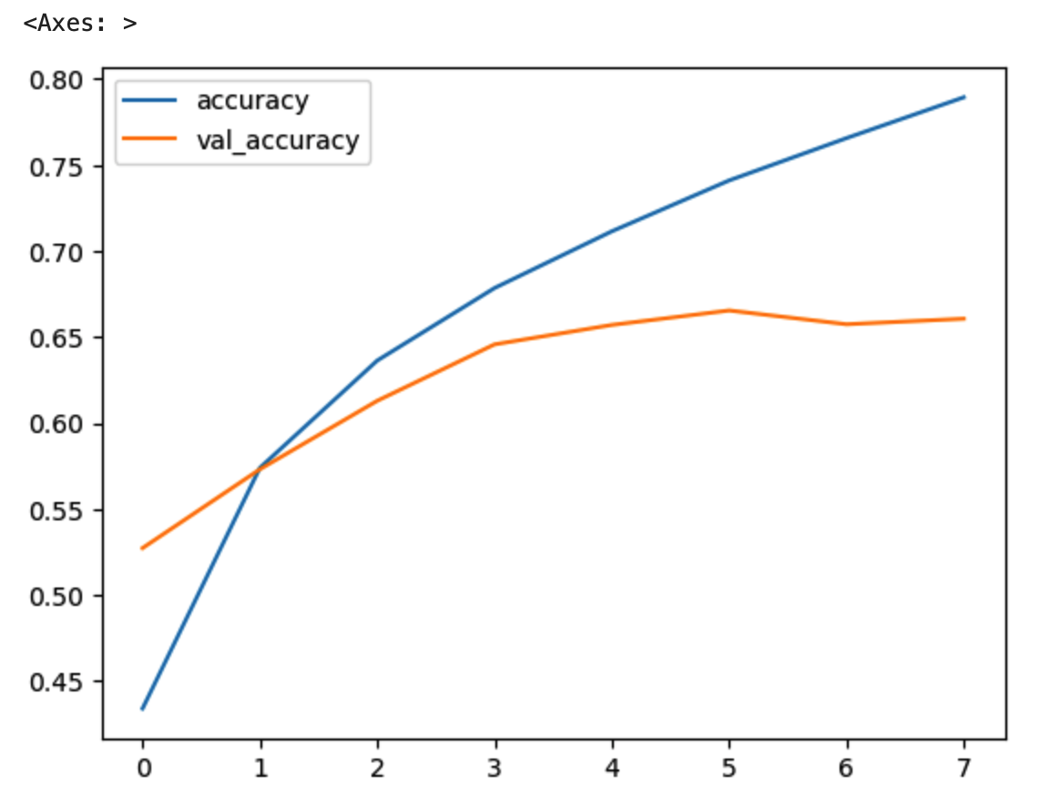

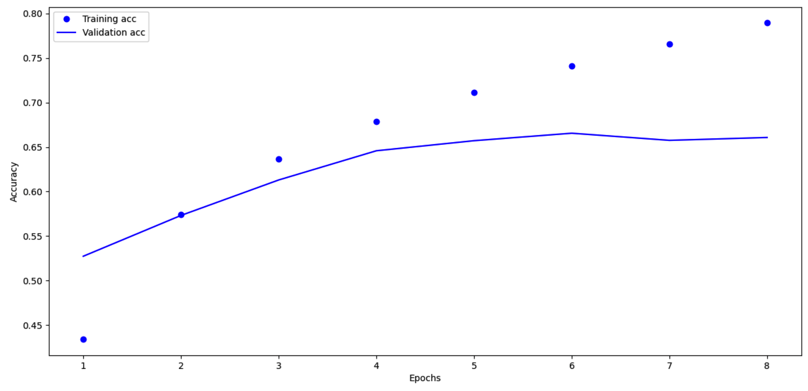

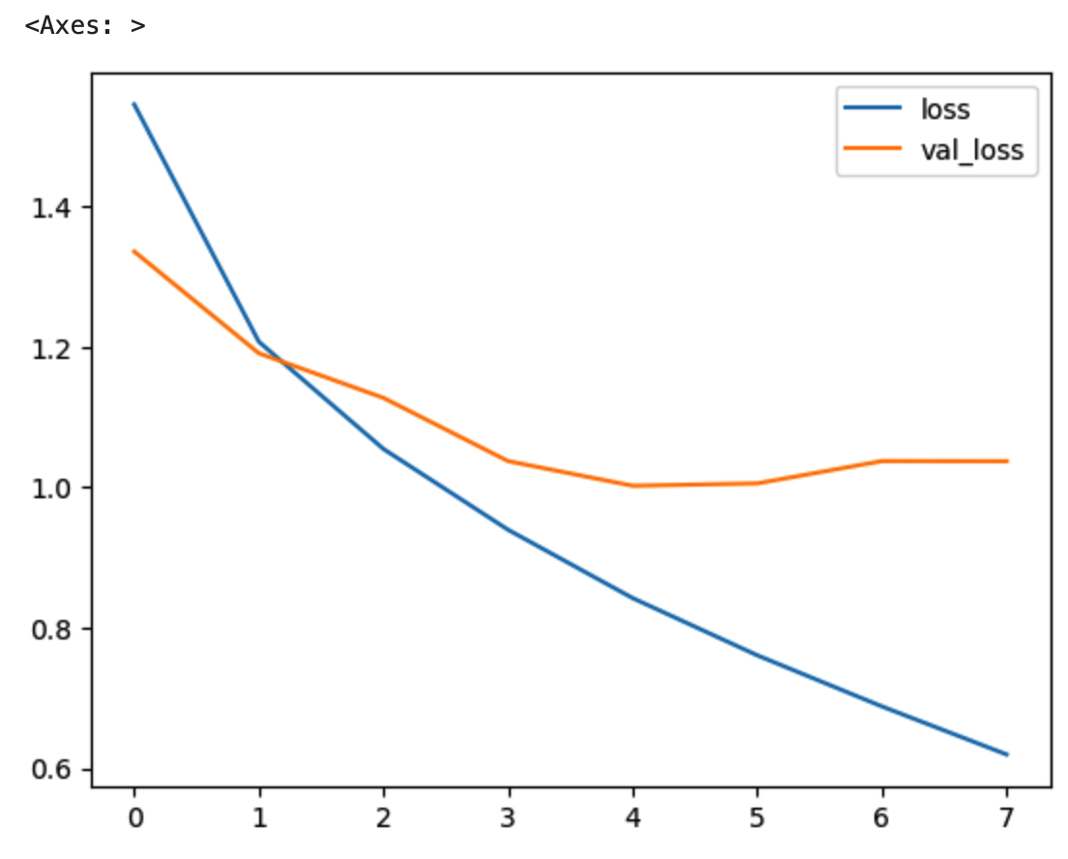

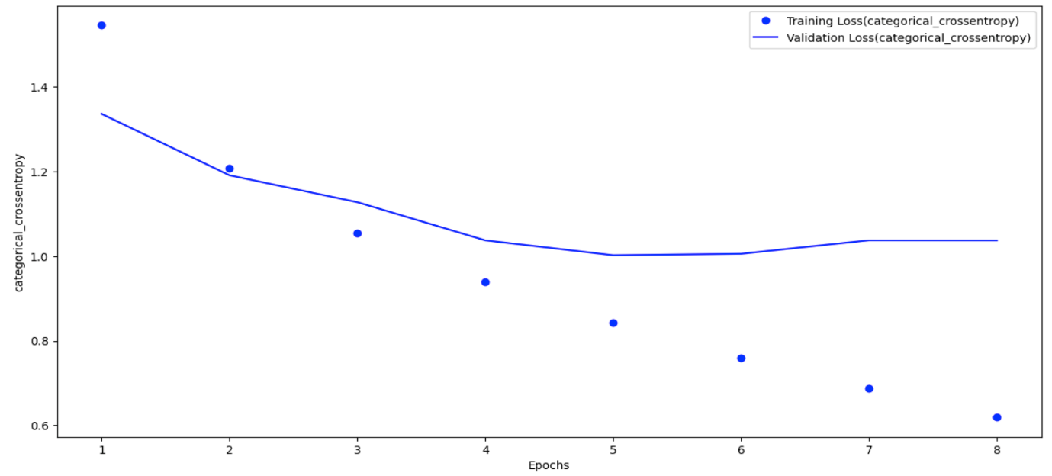

The optimal number of epochs for training the model = 4

LAB-6
2nd model's code:
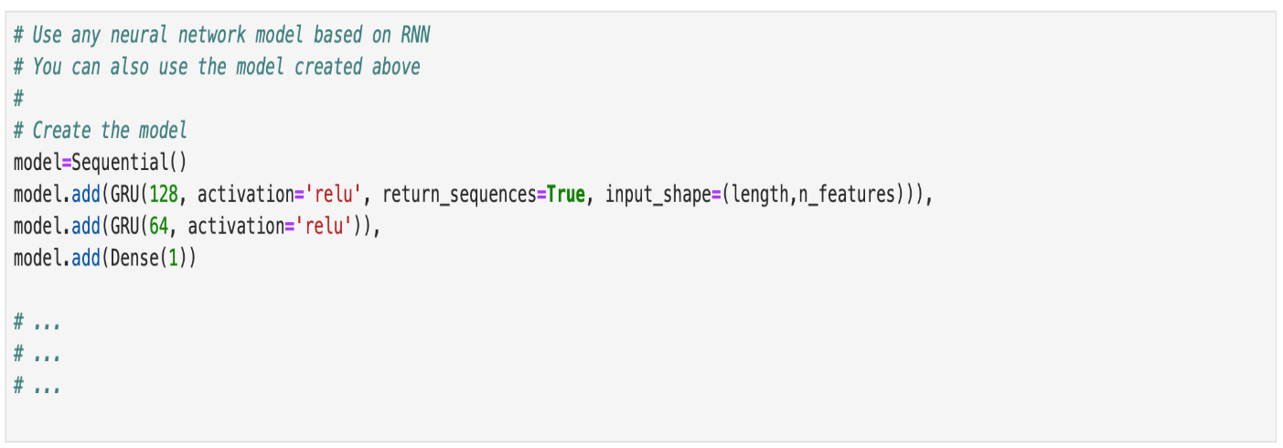
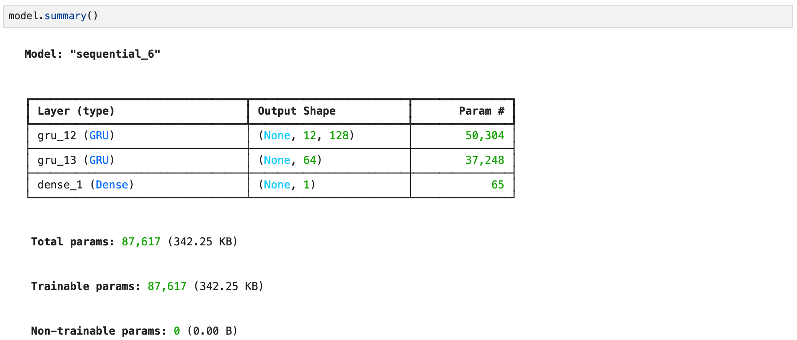
summary:
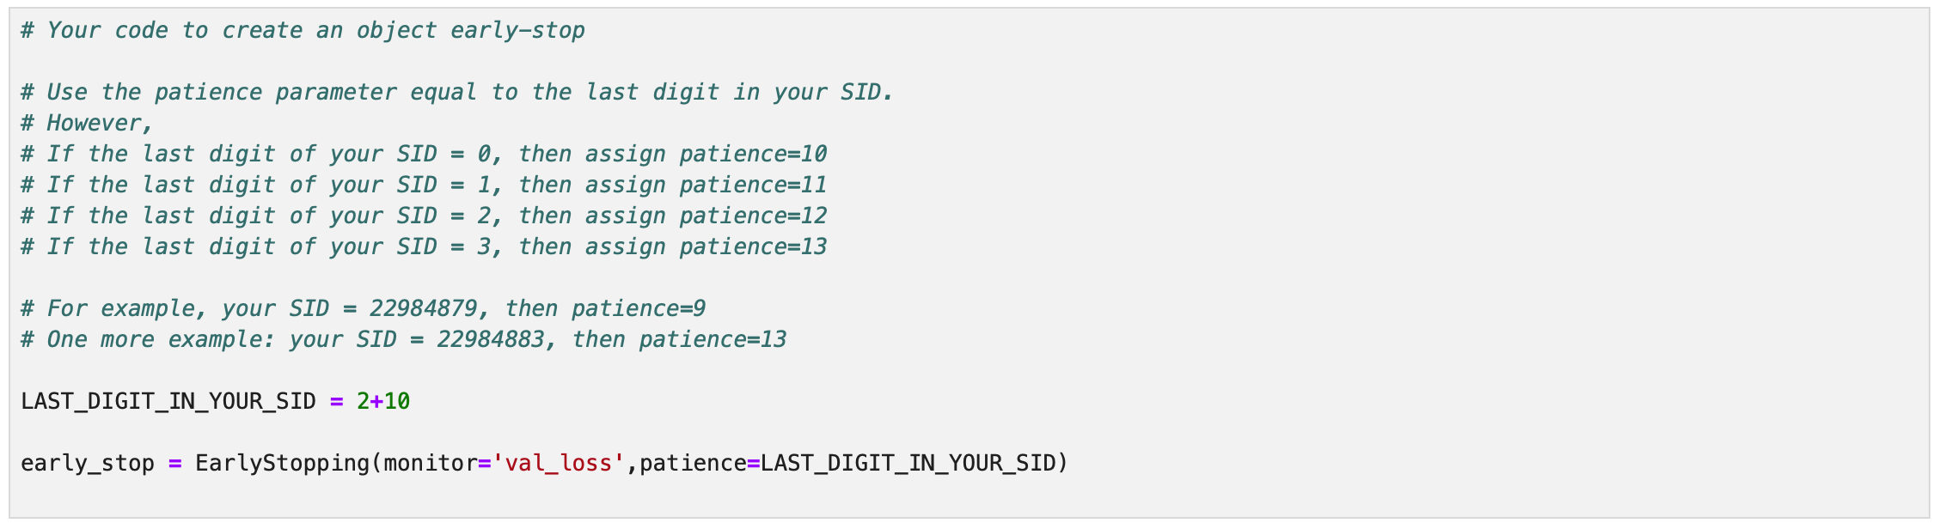
early-stop code:

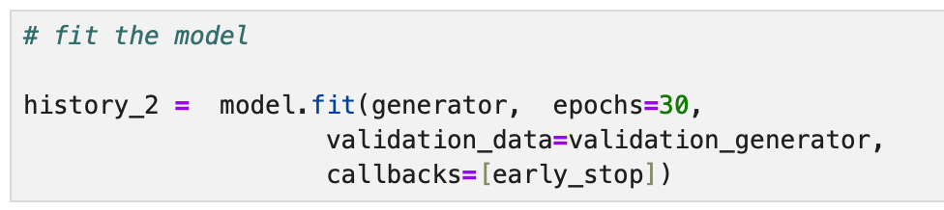
history_2 fit-training-process:
Epoch 1/30
384/384 ━━━━━━━━━━━━━━━━━━━━ 4s 5ms/step - loss: 0.0199 - val_loss: 0.0364
Epoch 2/30
384/384 ━━━━━━━━━━━━━━━━━━━━ 2s 5ms/step - loss: 0.0156 - val_loss: 0.0434
Epoch 3/30
384/384 ━━━━━━━━━━━━━━━━━━━━ 2s 5ms/step - loss: 0.0140 - val_loss: 0.0249
Epoch 4/30
384/384 ━━━━━━━━━━━━━━━━━━━━ 2s 5ms/step - loss: 0.0099 - val_loss: 0.0123
Epoch 5/30
384/384 ━━━━━━━━━━━━━━━━━━━━ 2s 5ms/step - loss: 0.0046 - val_loss: 0.0010
Epoch 6/30
384/384 ━━━━━━━━━━━━━━━━━━━━ 2s 5ms/step - loss: 0.0033 - val_loss: 0.0016
Epoch 7/30
384/384 ━━━━━━━━━━━━━━━━━━━━ 2s 5ms/step - loss: 0.0034 - val_loss: 0.0016
Epoch 8/30
384/384 ━━━━━━━━━━━━━━━━━━━━ 2s 5ms/step - loss: 0.0029 - val_loss: 0.0010
Epoch 9/30
384/384 ━━━━━━━━━━━━━━━━━━━━ 2s 5ms/step - loss: 0.0025 - val_loss: 0.0015
Epoch 10/30
384/384 ━━━━━━━━━━━━━━━━━━━━ 2s 5ms/step - loss: 0.0025 - val_loss: 6.1455e-04
Epoch 11/30
384/384 ━━━━━━━━━━━━━━━━━━━━ 2s 5ms/step - loss: 0.0022 - val_loss: 0.0031
Epoch 12/30
384/384 ━━━━━━━━━━━━━━━━━━━━ 2s 4ms/step - loss: 0.0027 - val_loss: 0.0019
Epoch 13/30
384/384 ━━━━━━━━━━━━━━━━━━━━ 2s 5ms/step - loss: 0.0023 - val_loss: 0.0020
Epoch 14/30
384/384 ━━━━━━━━━━━━━━━━━━━━ 2s 5ms/step - loss: 0.0026 - val_loss: 0.0029
Epoch 15/30
384/384 ━━━━━━━━━━━━━━━━━━━━ 2s 6ms/step - loss: 0.0023 - val_loss: 0.0045
Epoch 16/30
384/384 ━━━━━━━━━━━━━━━━━━━━ 2s 5ms/step - loss: 0.0023 - val_loss: 0.0019
Epoch 17/30
384/384 ━━━━━━━━━━━━━━━━━━━━ 2s 5ms/step - loss: 0.0020 - val_loss: 6.5888e-04
Epoch 18/30
384/384 ━━━━━━━━━━━━━━━━━━━━ 2s 6ms/step - loss: 0.0018 - val_loss: 9.8169e-04
Epoch 19/30
384/384 ━━━━━━━━━━━━━━━━━━━━ 2s 5ms/step - loss: 0.0017 - val_loss: 0.0030
Epoch 20/30
384/384 ━━━━━━━━━━━━━━━━━━━━ 2s 5ms/step - loss: 0.0018 - val_loss: 0.0011
Epoch 21/30
384/384 ━━━━━━━━━━━━━━━━━━━━ 2s 4ms/step - loss: 0.0016 - val_loss: 0.0010
Epoch 22/30
384/384 ━━━━━━━━━━━━━━━━━━━━ 2s 5ms/step - loss: 0.0018 - val_loss: 0.0011
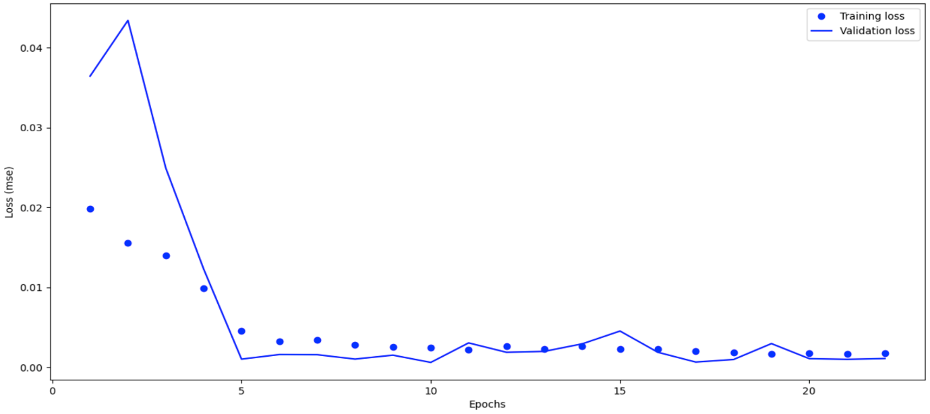
The optimal number of epochs = 10

The plot of the Checking Forecast for the last 12 months:

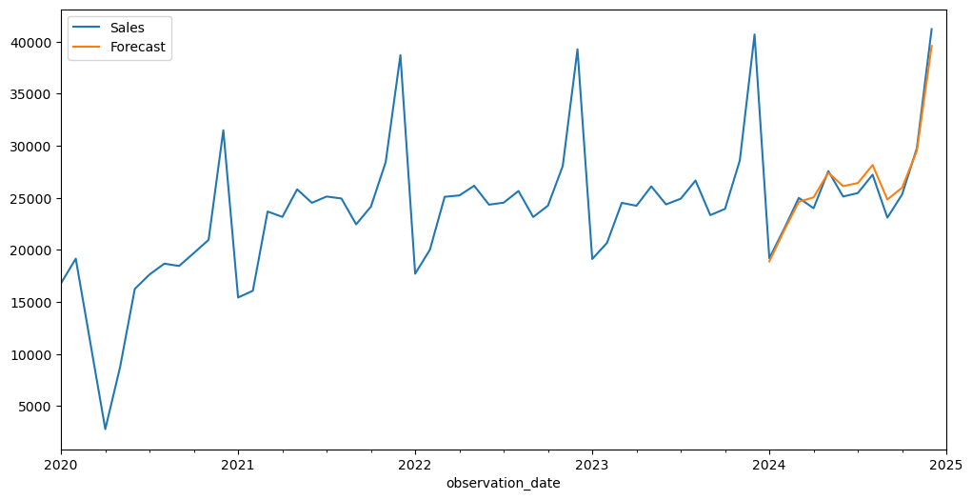

LAB-7

Graphs for Accuracy and Loss Function for VGG16

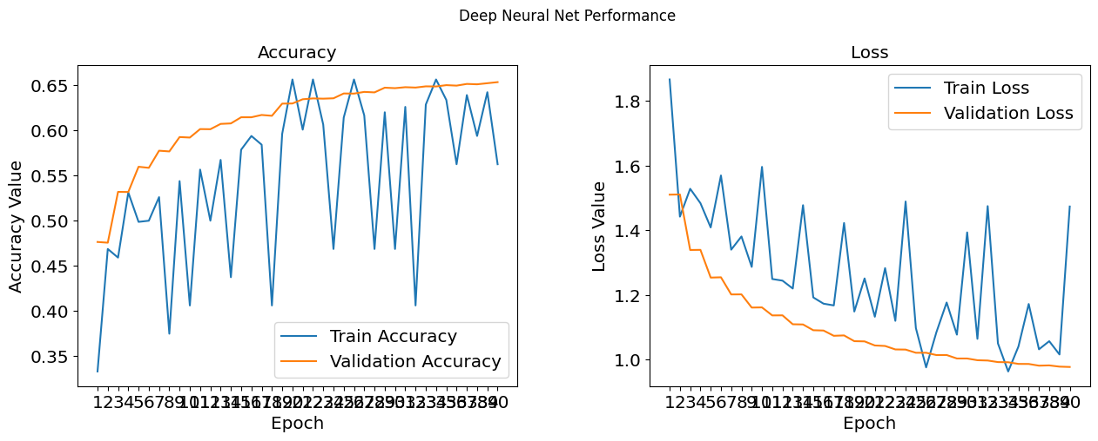
Graphs for Accuracy and Loss Function for VGG19

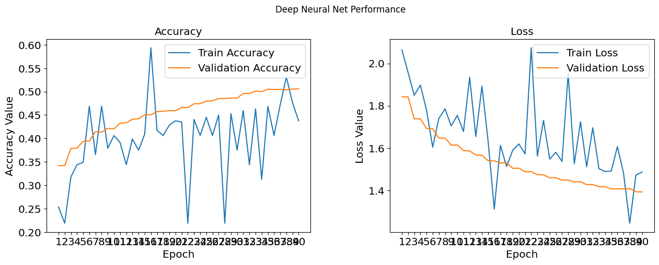

The optimal number of epochs for training the VGG16 model = 24
The optimal number of epochs for training the VGG19 model = 32

Early-stop code:
from tensorflow.keras.callbacks import EarlyStopping
LAST_DIGIT_IN_YOUR_SID = 12
early_stop = EarlyStopping(monitor='val_loss',patience=LAST_DIGIT_IN_YOUR_SID)

The final Performance Table:

 | VGG-16 | VGG_19
Accuracy | 0.106600 | 0.498300
Precision | 0.094369 | 0.492742
Recall | 0.106600 | 0.498300
F1_Score | 0.057995 | 0.492444

The performance comparing histogram of VGG16 and VGG19:

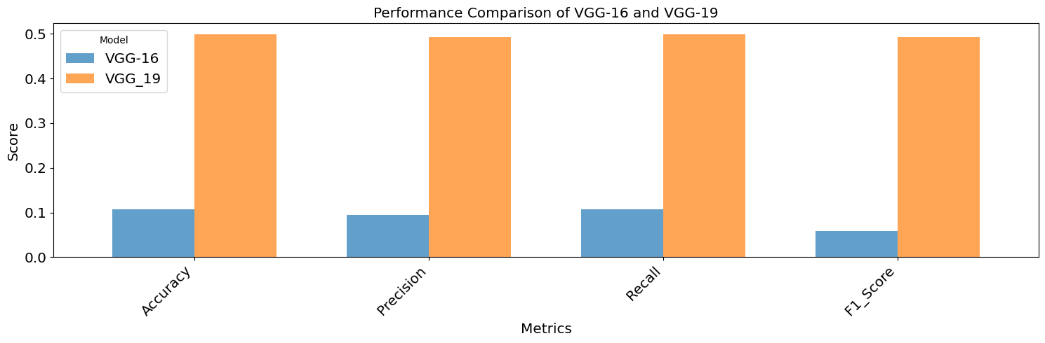

LAB-8

