WEEK-1

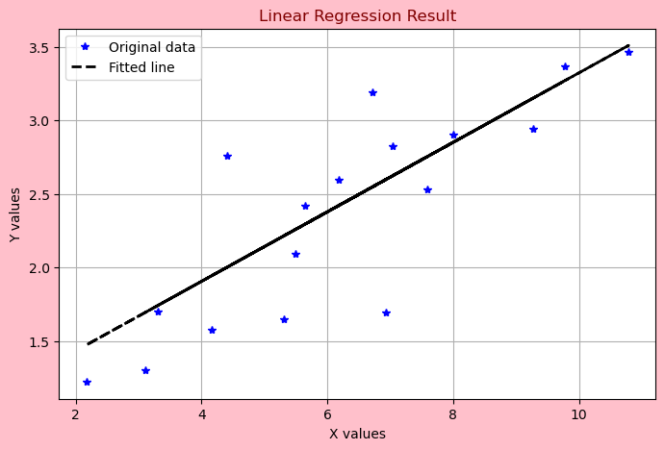

WEEK-2

The Accuracy of the Model is “0.948”.
