LAB-1

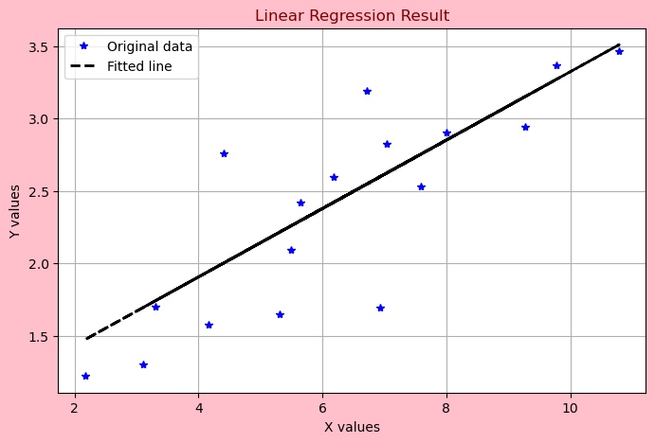

LAB-2

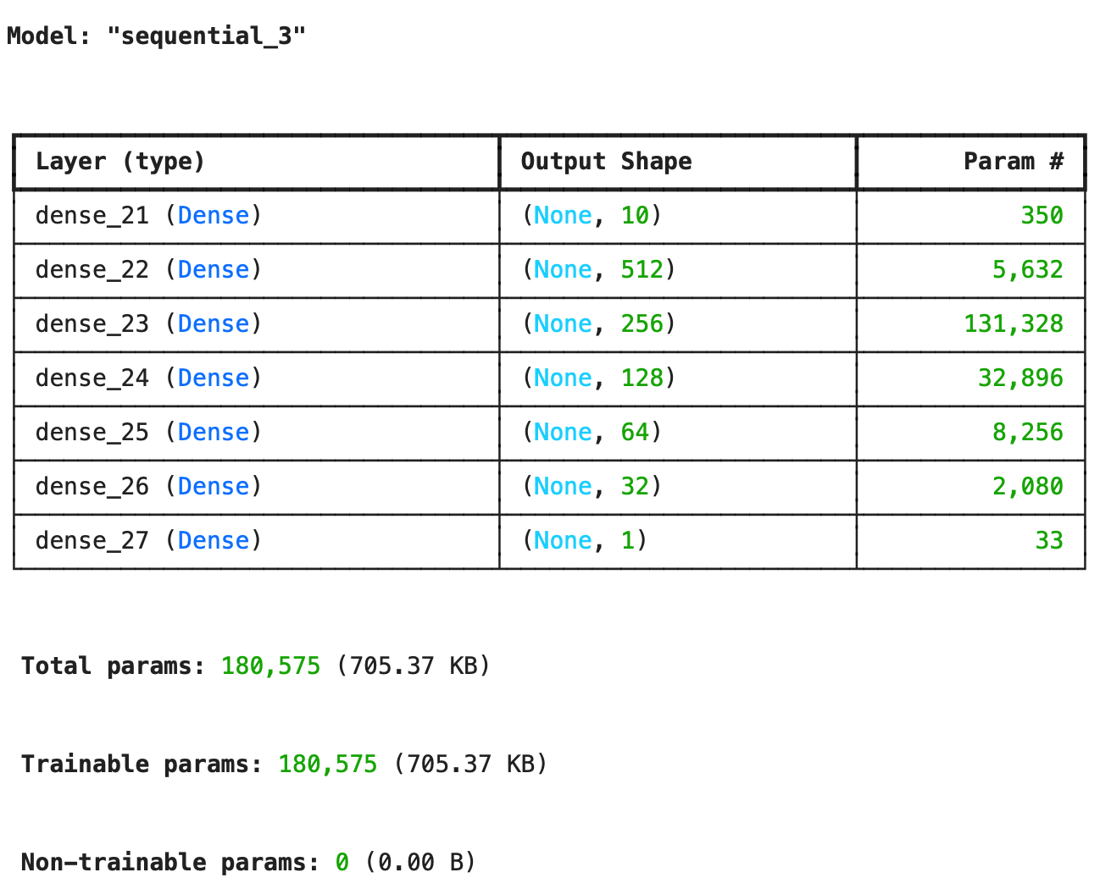
The Accuracy of the Model is “0.948”.

TASK-2:

Output1(O1)=1.548
Output2(O2)=1.548

LAB-3

The Test Accuracy of the Model is 0.876

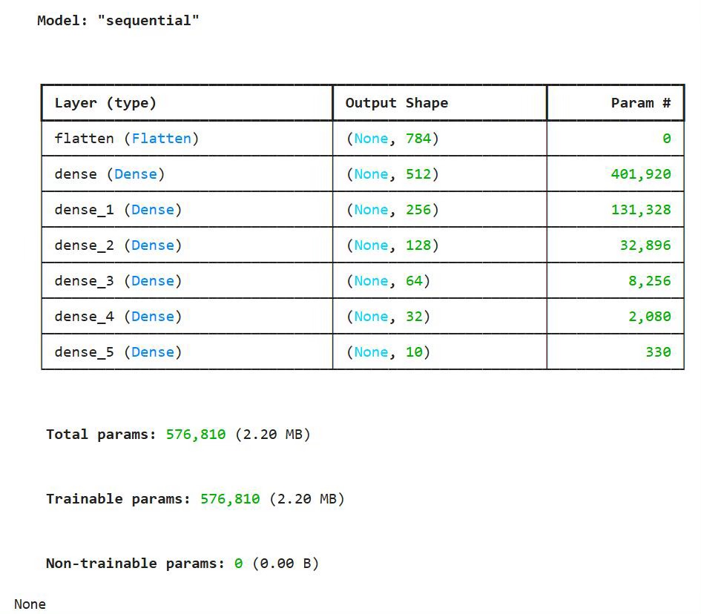

LAB-4
