ASSIGNMENT-1

ANSWER 1:
Frontend Development | Backend Development | Full-Stack Development
Deals with the user interface (UI) that users can see and interact with. | Handles the server, database, and business logic behind the application. | Works on both frontend and backend.
Technologies: HTML, CSS, JavaScript, React, Angular | Technologies: Java, Python, Node.js, PHP, Spring Boot | Uses both frontend and backend technologies
Focuses on user experience. | Focuses on data processing and server communication. | Develops complete web applications.

Real-World Example (Amazon)
- Frontend
  - Displays product images.
  - Shows "Add to Cart" button.
  - Displays prices and reviews.
- Backend
  - Checks product availability.
  - Processes payments.
  - Stores order details in the database.
- Full-Stack Developer
  - Creates the shopping page.
  - Connects it to the server.
  - Stores data in the database.

ANSWER 2:
Client (Browser)
|
HTTP Request
|
V
Web Server
|
Process Request
|
Database (if needed)
|
HTTP Response
|
V
Client (Browser)

ANSWER 3:

Steps:
- User enters a website URL in the browser.
- Browser asks the DNS server for the website's IP address.
- DNS returns the IP address.
- Browser sends an HTTP/HTTPS request to the web server.
- The web server processes the request.
- If required, the server retrieves data from the database.
- The server sends back HTML, CSS, JavaScript, and images.
- Browser downloads the files.
- Browser renders the webpage.
- User sees the webpage.

ANSWER 4:
Tool | Purpose
Visual Studio Code | Code editor for writing HTML, CSS, JavaScript
Google Chrome | Testing and debugging websites
Node.js | Runs JavaScript outside the browser
npm | Installs JavaScript packages
Git | Version control system
GitHub | Stores project code online
Live Server Extension | Automatically refreshes webpage after changes
Web Browser DevTools | Debug HTML, CSS, JavaScript

ANSWER 5:
A web server is software (or hardware) that receives requests from clients (browsers), processes them, and returns web pages or data.
Functions
- Stores website files
- Handles client requests
- Sends web pages
- Communicates with databases
Common Web Servers
- Apache HTTP Server
- Nginx
- Microsoft IIS (Internet Information Services)
- LiteSpeed
- Apache Tomcat (mainly for Java web applications)

ANSWER 6:
Frontend Developer
Responsibilities:
- Designs web pages
- Creates responsive layouts
- Improves user experience
- Uses HTML, CSS, JavaScript
Backend Developer
Responsibilities:
- Writes server-side code
- Creates APIs
- Handles authentication
- Connects the application with the database
Database Administrator (DBA)
Responsibilities:
- Creates databases
- Maintains database performance
- Performs backups
- Ensures security
- Manages user access

ANSWER 7:
Steps
- Download Visual Studio Code.
- Install VS Code.
- Install the following extensions:
  - Live Server
  - Prettier
  - HTML CSS Support
  - JavaScript (ES6) Code Snippets
- Create a project folder.
- Add files:
  - index.html
  - style.css
  - script.js
- Open index.html.
- Click Go Live to run the webpage.
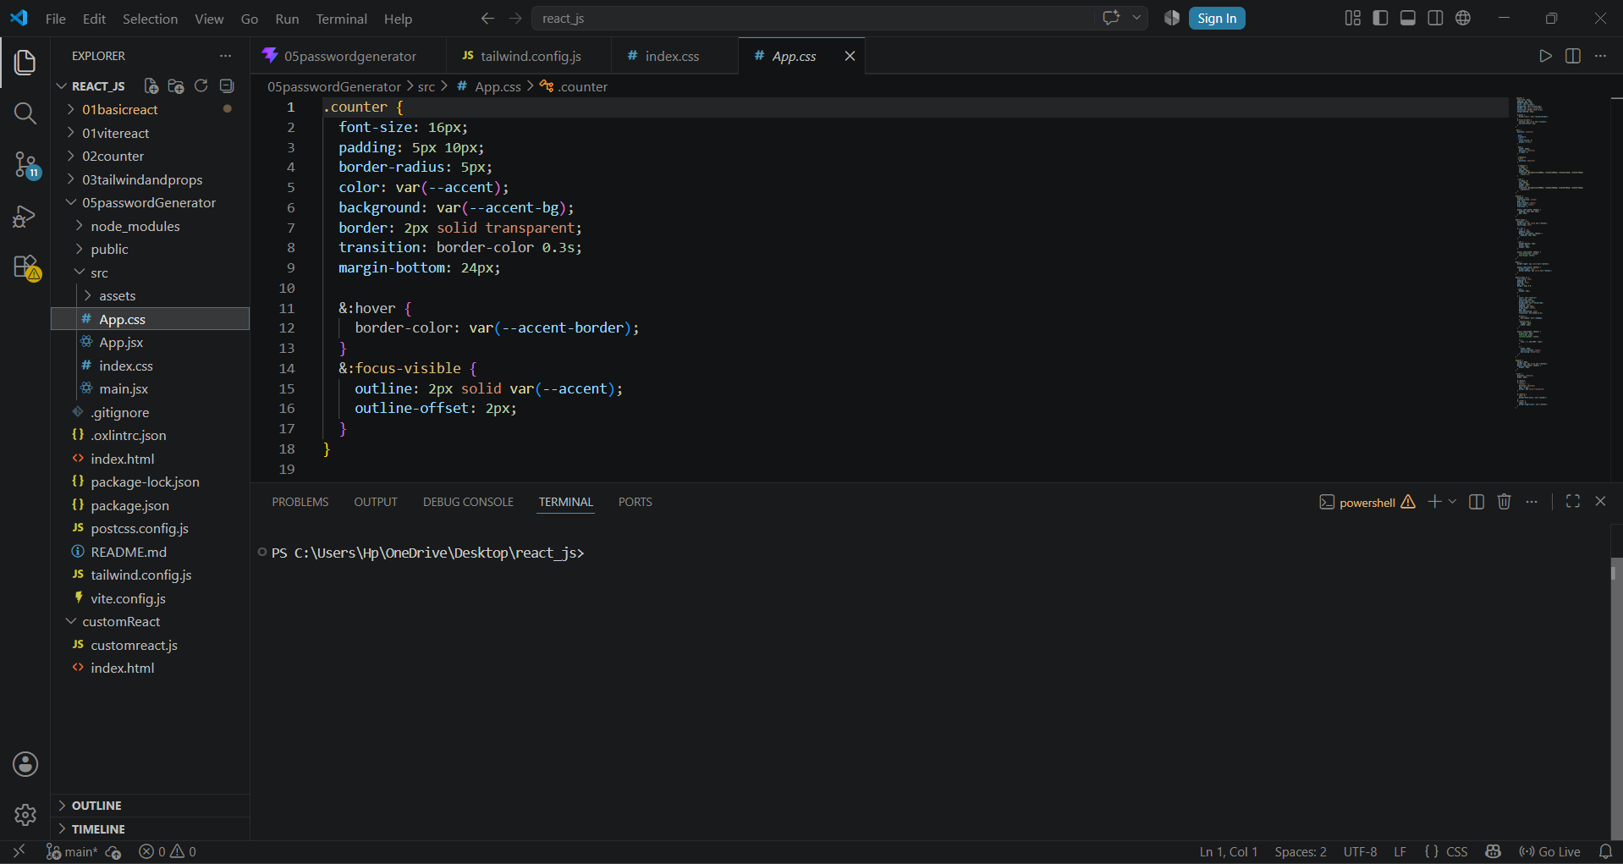

ANSWER 8:
Static Website | Dynamic Website
Content remains the same until manually updated. | Content changes based on user interaction or database data.
Uses HTML, CSS | Uses HTML, CSS, JavaScript, PHP, Java, Python, Node.js
No database required | Database usually required
Faster | Slightly slower
Examples
Static Website
- Portfolio website
- Company information page
Dynamic Website
- Facebook
- Amazon
- Instagram
- Online banking

ANSWER 9:

Browser | Rendering Engine
Google Chrome | Blink
Microsoft Edge | Blink
Mozilla Firefox | Gecko
Apple Safari | WebKit
Opera | Blink
Rendering Engine
A rendering engine converts HTML, CSS, and JavaScript into the webpage you see on the screen.
Differences
- Blink: Fast performance, used by Chrome, Edge, and Opera.
- Gecko: Used by Firefox, focuses on web standards and customization.
- WebKit: Used by Safari, optimized for Apple devices.

ANSWER 10:
+----------------------+
| Client |
| (Browser/Mobile App) |
+----------+-----------+
|
HTTP Request
|
V
+----------------------+
| Web Server |
| (Backend Application)|
+----------+-----------+
|
+------------+------------+
| |
| |
V V
+---------------+ +----------------+
| APIs | | Database |
| External Data | | MySQL/MongoDB |
+-------+-------+ +-------+--------+
| |
+------------+------------+
|
Process Response
|
V
+----------------------+
| Client |
| Displays Web Page |
+----------------------+

Working
- Client sends an HTTP request.
- The web server receives the request.
- The server may call APIs or query the database.
- APIs/database return data.
- The server processes the data.
- The server sends an HTTP response.
- The browser renders and displays the webpage

