SMSPRSM MULTIMODAL DATA PLATFORM
Technical Implementation Report
Architecture, module design, algorithms, performance and reliability of the ingestion, AI enrichment, search, download and audit services
Document version 1.0
Date 24 September 2026
Codebase smsprsm-2026, branch Feature/Integration
Classification Internal — technical
Intended readers Engineering, architecture and technical review stakeholders

Contents

List of figures
Figure 1. Logical architecture: gateway, service APIs, workers and infrastructure
Figure 2. End-to-end sequence across services
Figure 3. Session authentication and signed service assertions
Figure 4. Frontend layers: routes, shared components and service layer
Figure 5. Ingestion worker decision flow for a single source object
Figure 6. AI enrichment: intake, eight pipeline stages and hand-off
Figure 7. Enrichment task state machine
Figure 8. Hybrid search pipeline
Figure 9. Download job admission, execution lanes, packaging and delivery
Figure 10. Schemas, principal tables and the shared document identity
Figure 11. Transactional outbox

1. Executive summary
SMSPRSM is a multimodal data platform that catalogues licensed media held in vendor storage, enriches it with machine-generated tags and descriptions, makes it discoverable through hybrid keyword and semantic search, and delivers selected assets as forensically watermarked archives. Every significant action is recorded in a central audit ledger.
The platform is built as five cooperating backend services behind a single authenticated gateway. Each service owns its own PostgreSQL schema and migrations, and the services communicate through three mechanisms: synchronous HTTP calls carrying short-lived signed identities, Kafka topics for high-volume work distribution, and a transactional outbox that guarantees no event is lost between a database commit and its downstream effect.
Table 1. Modules at a glance
Module | Primary responsibility | Key technologies | Key algorithms and techniques
Ingestion | Discover source objects, validate and fingerprint them, create one canonical document per unique content | FastAPI, Kafka, boto3, smbprotocol, libmagic, Vault | Streaming SHA-256, content-addressed deduplication, checkpointed pagination, advisory-lock serialisation
AI tag and description generation | Produce tags, captions, extracted text, quality and safety labels, and a CLIP embedding for each document | PyTorch, 15 model components, Celery, Kafka, Qdrant | Open-vocabulary tagging, multi-model fusion, weighted confidence scoring, multi-frame consensus
Search | Hybrid retrieval, facets, suggestions, trending, similar items and download planning | FastAPI (async), PostgreSQL, Qdrant, Redis, OpenCLIP | Weighted word-start matching, cosine ANN with relevance margin, Reciprocal Rank Fusion, bounded re-ranking
Download | Package selected documents into verified, watermarked, multi-part ZIP archives | FastAPI, Celery, Redis, pypdf, jpeglib, native codecs | HMAC-SHA256 tokens, QIM coefficient watermarking, keyed position sampling, greedy part packing
Audit | Durable, idempotent ledger of platform activity with query, analytics and CSV export | PostgreSQL, FastAPI streaming | Salted pseudonymisation, idempotent inserts, SQL-side pagination, formula-injection defence

Current maturity. The integrated system has passed end-to-end acceptance on real S3 and SMB sources with actual model inference across images, PDFs, video, audio and CSV. Measured search latency fell by 27–69% after targeted optimisation. Model accuracy, production-scale throughput and sustained concurrent load have not been certified; these are listed with other limitations in Section 15.

2. Scope and conventions

2.1 Basis of this report
This report describes the implementation as it exists in the smsprsm-2026 repository on the Feature/Integration branch. Statements about behaviour are derived from source code; statements about measured results are taken from the project's own acceptance reports dated 20–21 September 2026 (INTEGRATION_REPORT.md, docs/DATASET_ACCEPTANCE_20260921.md, docs/PUBLIC_DATASET_ACCEPTANCE_20260921.md, docs/NAS_AND_WATERMARK_ACCEPTANCE_20260921.md and docs/MONITORING.md). No new benchmarks were executed for this report.

2.2 Components in and out of scope
Table 2. Code locations covered
Path | Role | Status
server.py | API gateway, authentication, audit middleware, SPA hosting | Active
services/ingestion | Ingestion service (API, enumerator, worker, retention, reconciliation) | Active
modules/ai_tag_description_generation | AI enrichment service (API, Kafka consumer, Celery worker, pipeline) | Active
services/search/backend | Search service | Active
services/download | Download and forensic watermarking service | Active
modules/shared | Cross-cutting contracts: identity, outbox, indexer, audit, catalogue gate, limits | Active
frontend/src | React single-page application | Active
deploy/integration | Docker Compose topology, monitoring, low-memory profile | Active
modules/ingestion, modules/searching, modules/download_auditing | Early prototypes with in-memory stubs | Not wired into the gateway; excluded
frontend/js, frontend/app.js | Pre-redesign static frontend | Not served; excluded

2.3 Conventions
- Sizes use binary units: 1 MiB = 1,048,576 bytes; 1 GiB = 1,073,741,824 bytes.
- Configuration values are quoted as their code defaults unless the integration Compose file overrides them, in which case the deployed value is given.
- “Document” means a canonical content record (one per unique SHA-256). “Source asset” means one physical location of that content.

3. System architecture

3.1 Architectural overview
The platform follows a service-oriented architecture with a single entry point. The browser only ever talks to the gateway. The gateway authenticates the user, then forwards the request to the owning service with a freshly minted, audience-scoped identity token. Services never trust browser credentials directly.
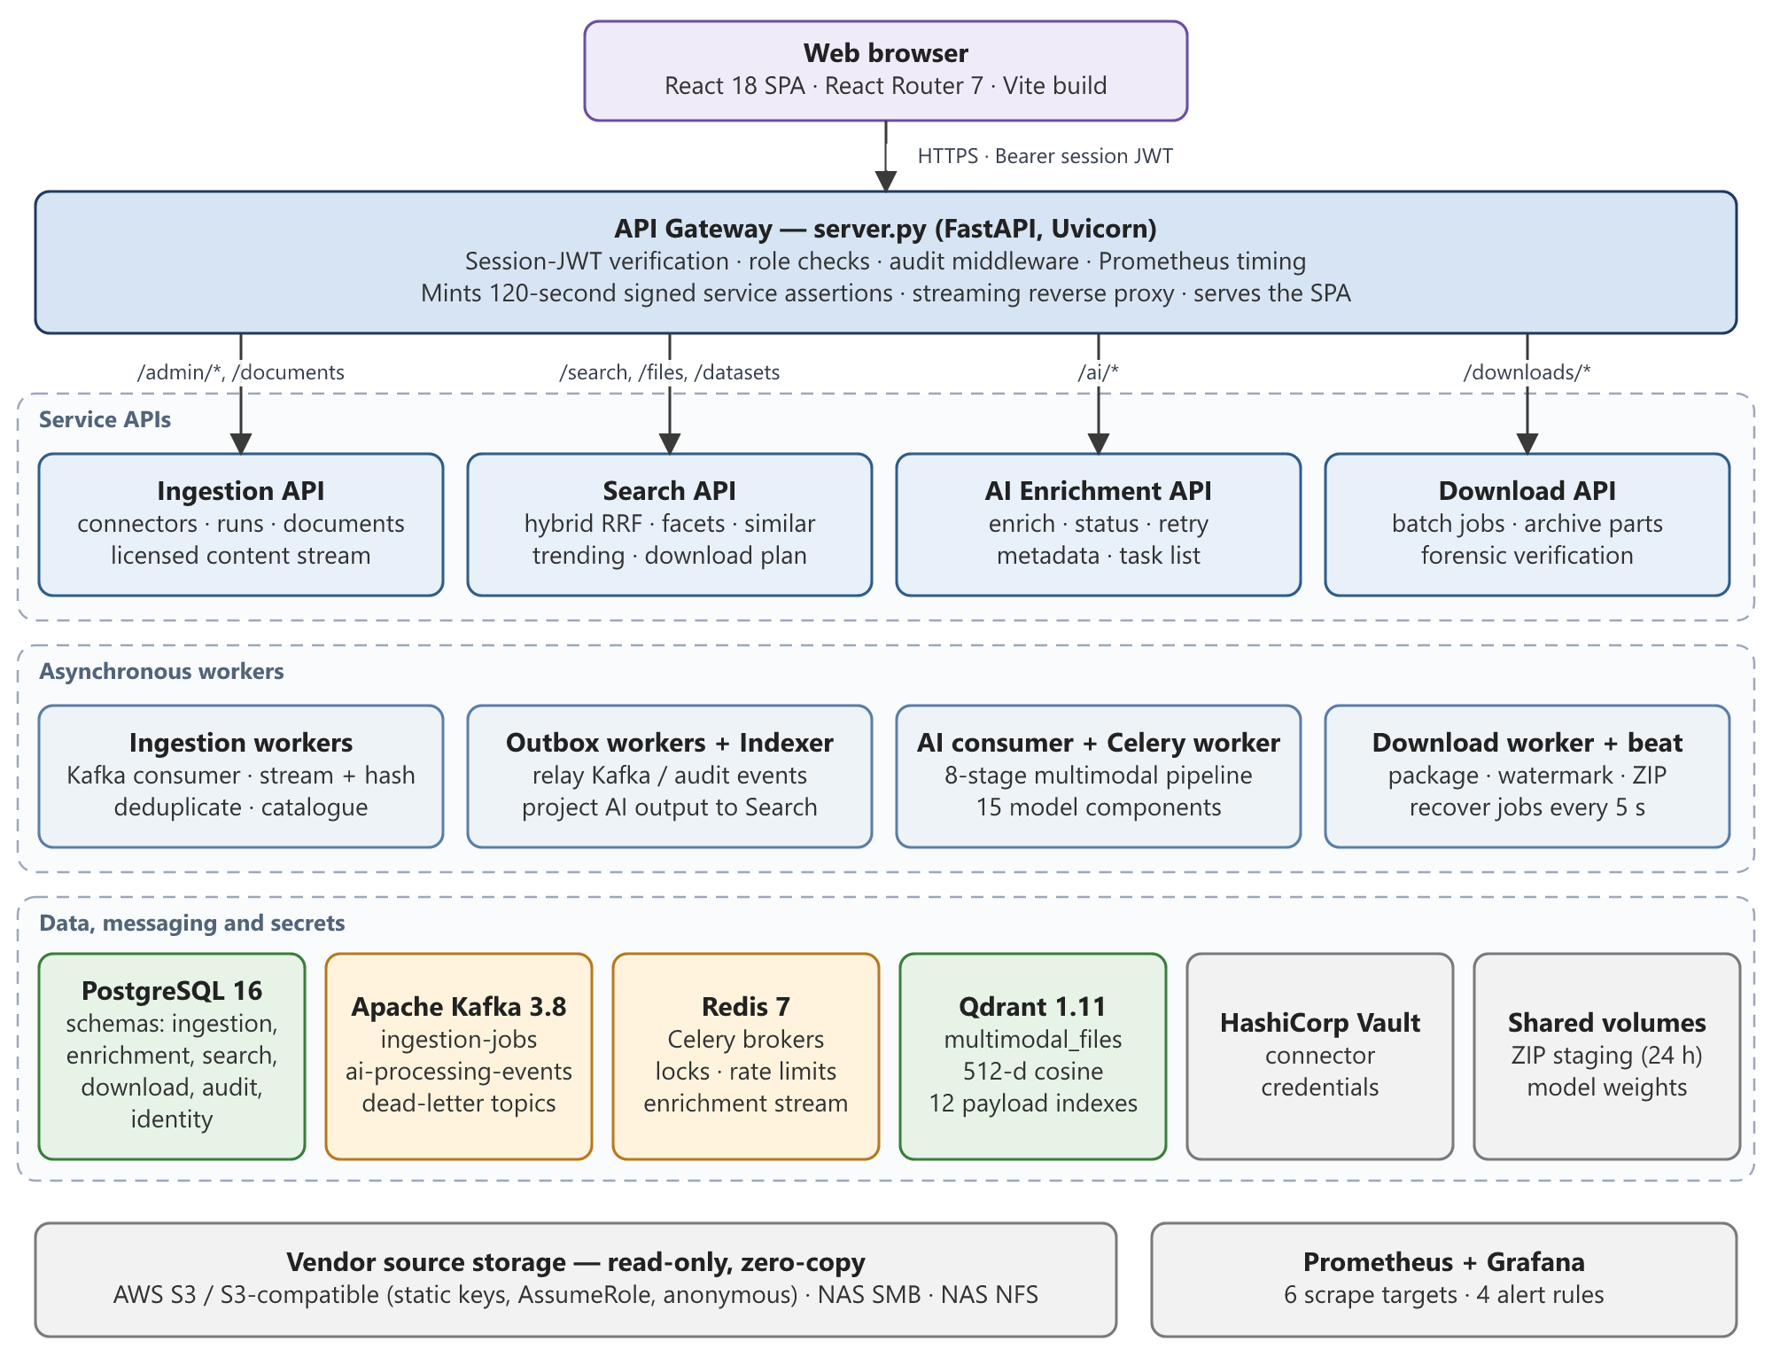
Figure 1. Logical architecture: gateway, service APIs, asynchronous workers and shared infrastructure
Three design principles shape the architecture:
- Zero-copy source handling. Vendor bytes stay in vendor storage. The platform stores fingerprints, metadata and derived AI output, and streams source bytes on demand through a licence-checked endpoint in the ingestion service.
- Schema-per-service ownership. All services share one PostgreSQL database, but each connects with search_path set to its own schema and runs its own migrations. Cross-schema reads are confined to three well-defined places (Section 10.1).
- Durable asynchronous hand-offs. Any work triggered by a database change is written to an integration_outbox table in the same transaction and relayed by a separate worker. A crash can cause a replay but never a lost event.

3.2 Deployment topology
The integration stack is defined in deploy/integration/compose.yml. All Python services are built from one runtime image, with the AI, search and download images adding their specialised dependencies (PyTorch CPU wheels, OpenCLIP, codec libraries).
Table 3. Deployed containers
Container | Command / image | Purpose
gateway | uvicorn server:app | Authentication, routing, audit middleware, frontend hosting (host port 18000)
ingestion | uvicorn ingestion.main:app | Connector, run, document and content APIs
ingestion-worker | run_worker.py | Kafka consumer processing ingestion-jobs (max poll interval 2 h)
ingestion-outbox | outbox_worker ingestion | Relays ai-processing and audit events
search / search-outbox | uvicorn app.main:app / outbox | Search API and its audit relay
ai / ai-worker / ai-consumer | FastAPI / Celery / Kafka consumer | Enrichment API, retry queue worker, primary event consumer
indexer | outbox_worker enrichment | Projects AI results into Search and Qdrant
download / download-worker / download-outbox | FastAPI / Celery + beat / outbox | Batch API, packaging worker with recovery schedule, audit relay
postgres, redis, kafka, qdrant, vault-persistent | PostgreSQL 16, Redis 7 (AOF), Kafka 3.8 KRaft, Qdrant 1.11.5, Vault 1.18 | Stateful infrastructure with named volumes
migrate, vault-init | One-shot jobs | Schema creation/migration and Vault bootstrap; services start only after migrate succeeds

An optional low-memory.yml profile constrains AI containers to 4 GiB, processes one document per process, and serialises inference with a shared file lock. rds.yml points the stack at Amazon RDS, and monitoring.yml adds Prometheus and Grafana.

3.3 End-to-end workflow
Figure 2 traces one asset from administrator-triggered ingestion to delivery of a watermarked archive.
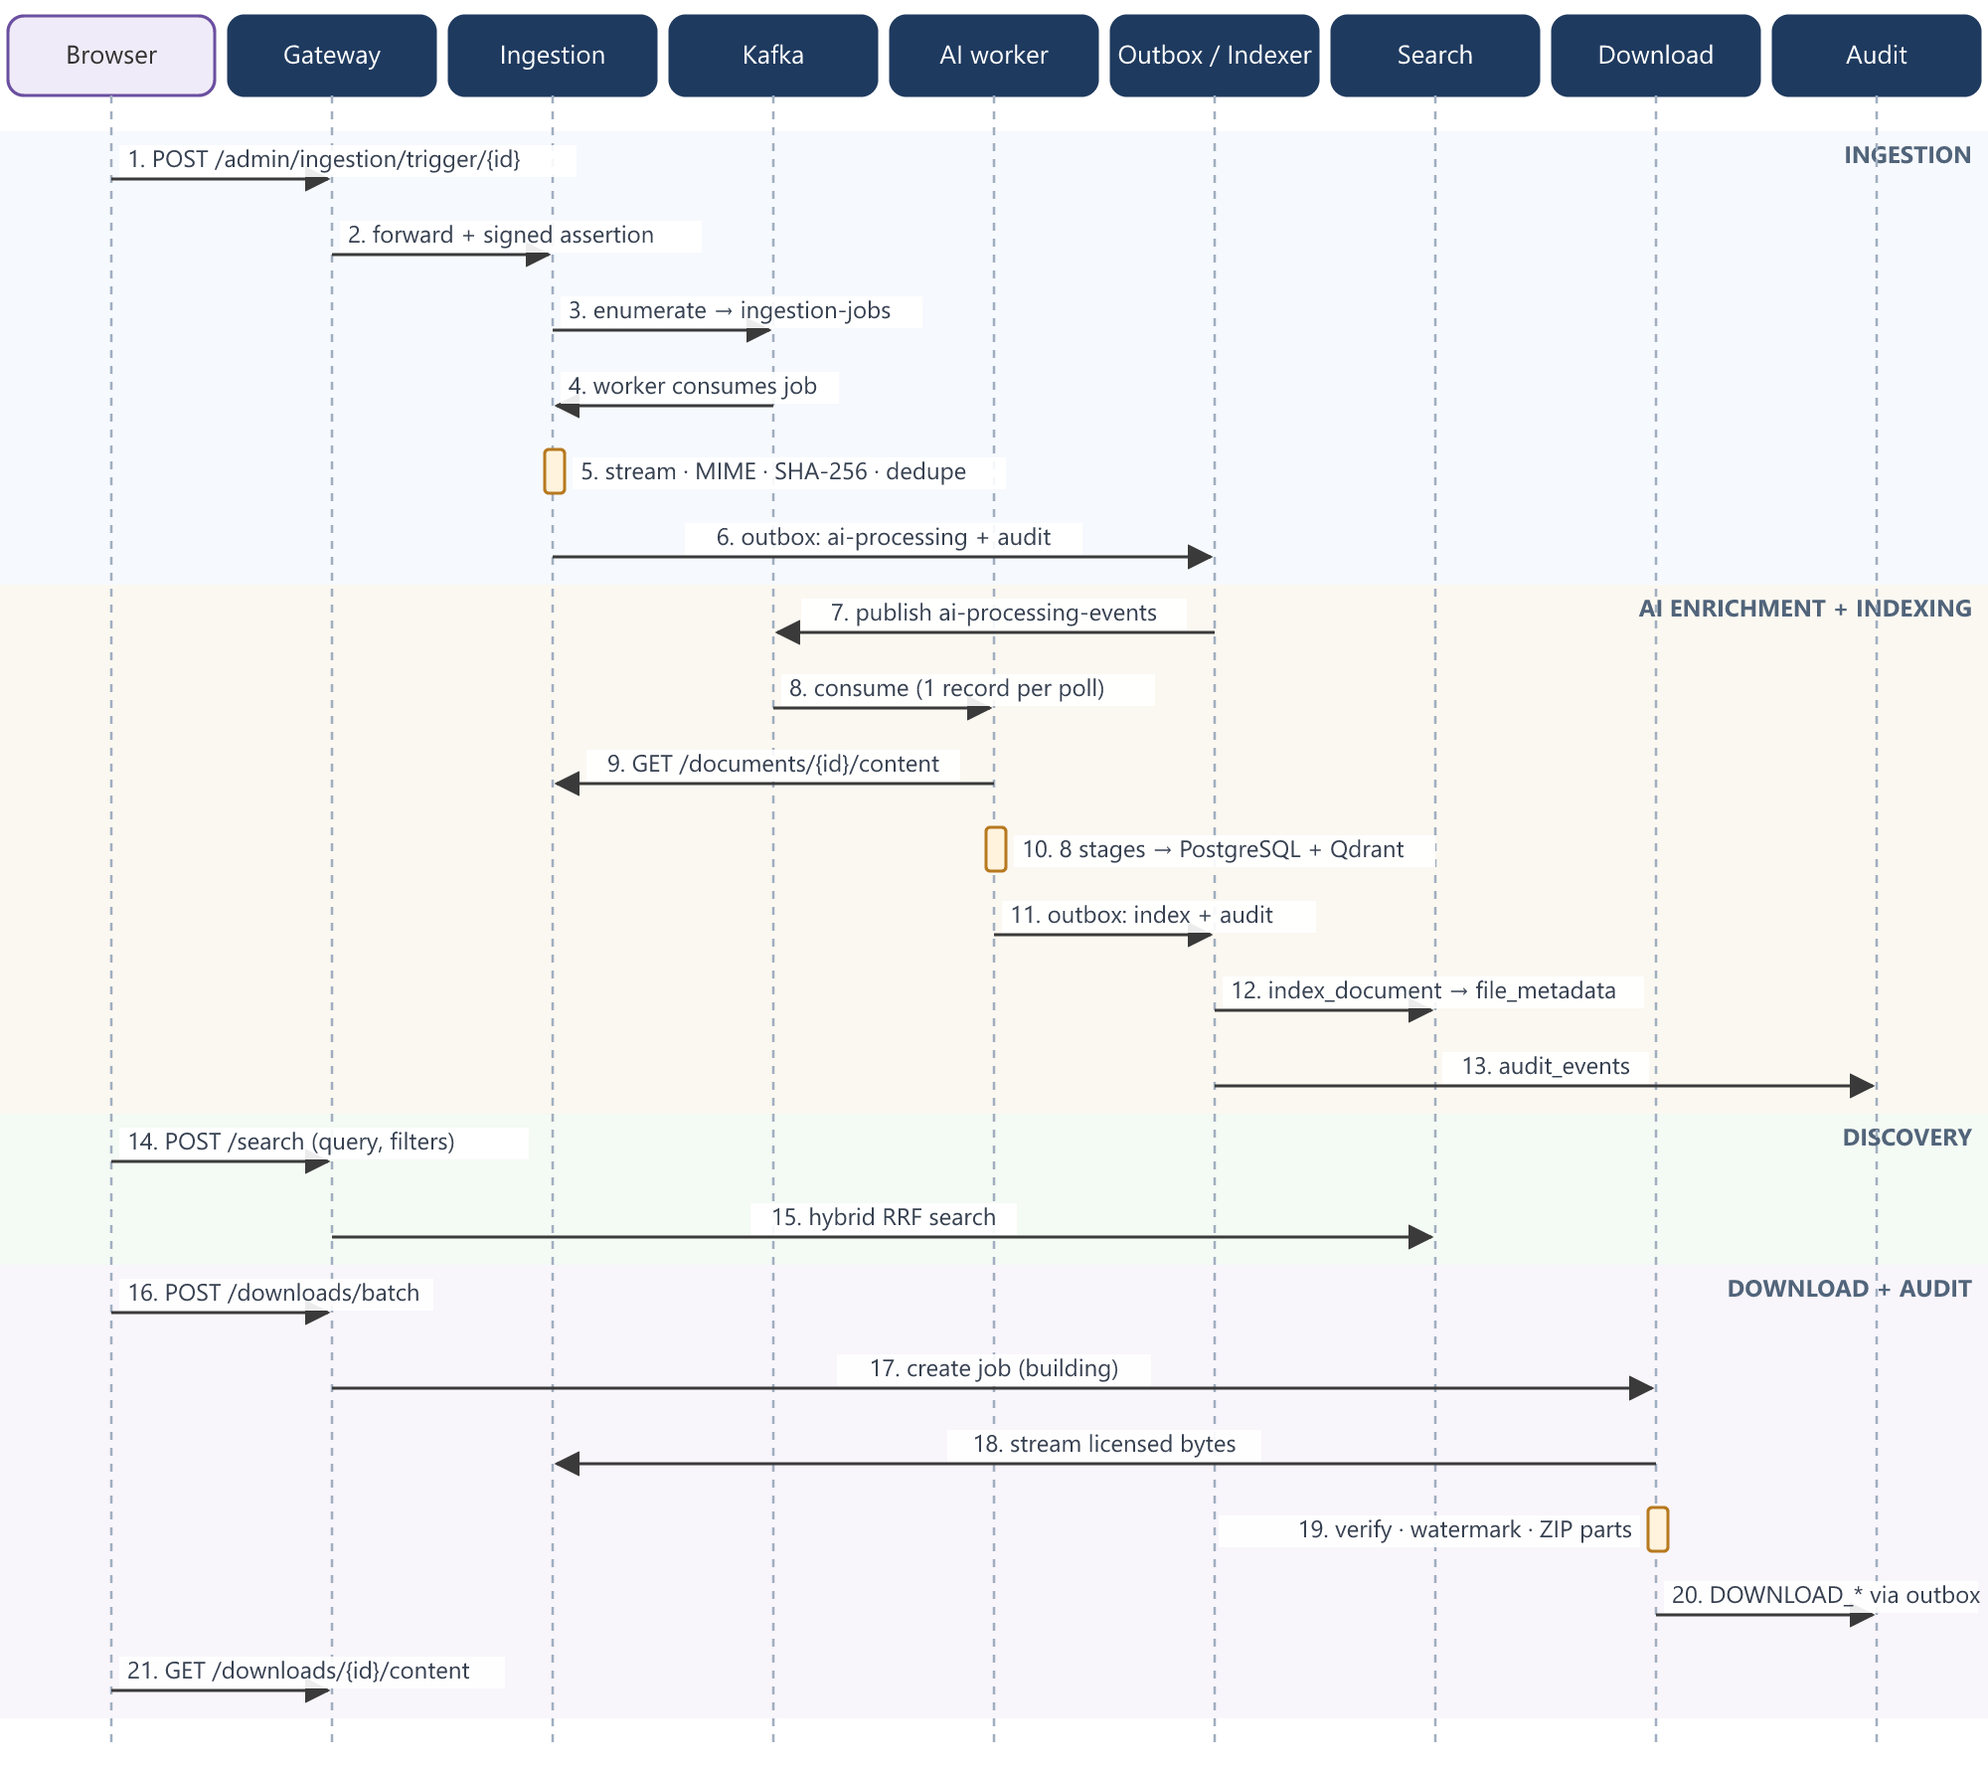
Figure 2. End-to-end sequence across services (numbered steps referenced in the text)
- Ingestion (steps 1–6). An administrator triggers a run for a verified connector. The ingestion API creates an ingestion_runs row and starts enumeration, which publishes one job per source object to Kafka. Workers stream each object once, validate its type, hash it, and either link it to an existing document or create a new one. The AI event is written to the outbox in the same transaction.
- Enrichment (steps 7–10). The ingestion outbox worker publishes the event to ai-processing-events. The AI consumer fetches the bytes through the licence-checked content endpoint, verifies the checksum, runs the eight-stage pipeline, stores results in PostgreSQL and upserts a 512-dimensional vector to Qdrant.
- Indexing (steps 11–13). When the task reaches a terminal state, an index outbox row triggers the indexer, which joins ingestion and enrichment data into the denormalised search.file_metadata table and applies the publication decision to the Qdrant payload.
- Discovery (steps 14–15). Users search through the gateway. Only published documents with an active licence are ever visible.
- Download (steps 16–21). A batch request is admitted, persisted and packaged by a worker that re-streams and re-verifies each source, watermarks it and writes ZIP parts. Delivery re-checks ownership and licence status.

3.4 Inter-service communication
Table 4. Communication paths and delivery guarantees
From → To | Mechanism | Contract | Guarantee
Browser → Gateway | HTTPS, JSON, streamed binaries | Bearer session JWT (24 h, revocable) | Synchronous
Gateway → any service | httpx async streaming proxy (60 s timeout, 5 s connect) | Service assertion JWT (120 s, audience-bound) | Synchronous; 503/504 on transport failure
Ingestion enumerator → workers | Kafka ingestion-jobs (idempotent producer, acks=all) | JSON JobDescriptor, key = provisional id | At-least-once; checkpoint only after flush
Ingestion → AI | Outbox → Kafka ai-processing-events (key = document id) | Document id, checksum, MIME, size, provenance, vendor metadata snapshot | At-least-once; idempotent task creation
AI → Ingestion | HTTP GET /documents/{id}/content | Service identity with data:download | Size and SHA-256 verified by caller
AI → Search / Qdrant | Outbox index → indexer | Document id | At-least-once; idempotent upserts
Search/Download → Audit | Outbox audit → audit_events | Event with stable id | Exactly one row (ON CONFLICT DO NOTHING)
Download → Ingestion | HTTP metadata + content stream | Service identity download-worker | Integrity verified per file
Download API → worker | Redis/Celery queue + PostgreSQL job row | Job id | Durable via DB; beat recovery every 5 s
AI → other consumers | Redis stream enrichment_events | Typed enrichment event | Best-effort notification (DB is authoritative)

3.5 Identity, security and access control
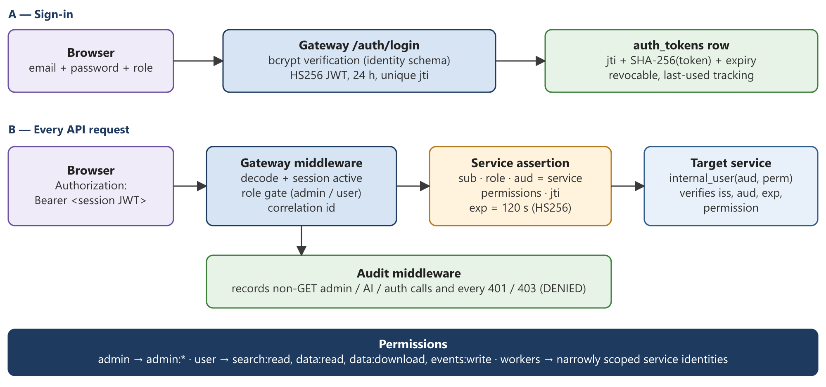
Figure 3. Session authentication at the gateway and signed service assertions between services
User sessions. Passwords are hashed with bcrypt. Login issues an HS256 JWT valid for 24 hours with a unique jti. The token's id, SHA-256 hash and expiry are stored in identity.auth_tokens, so a session can be revoked server-side and every request confirms the session is still active.
Service assertions. For every forwarded request the gateway strips browser authorisation, cookies and hop-by-hop headers, and attaches a new JWT containing the subject, role, e-mail, display name, client IP and permission list. The token is bound to the target service through the aud claim, carries issuer smsprsm, a unique jti, and expires after 120 seconds. Each service validates it with internal_user(audience, permission). Background workers mint their own narrowly scoped assertions (for example download-worker with only data:read and data:download).
Table 5. Role and permission model
Principal | Permissions | Gateway routes
Administrator | admin:* | All routes including /admin/*, /ai/*, audit, monitoring, user management
Standard user | search:read, data:read, data:download, events:write | /search, /files, /datasets, /events, own /downloads; /documents/{id} and /content only for downloadable documents
Service identity | Explicit list per worker | Internal calls only

Additional controls. Connector credentials live only in Vault and are never returned by the API. The gateway blocks path traversal when serving static files. The ingestion content endpoint rate-limits each subject to 120 requests per minute. Download archives are owner-scoped: another user's job returns 404 rather than 403 to avoid disclosing its existence.

4. Frontend architecture
The frontend is a React 18 single-page application built with Vite and styled with Tailwind CSS. The gateway serves the production build from frontend/dist and falls back to index.html for client-side routes, while returning 404 for unknown API paths so that API mistakes never render as HTML.
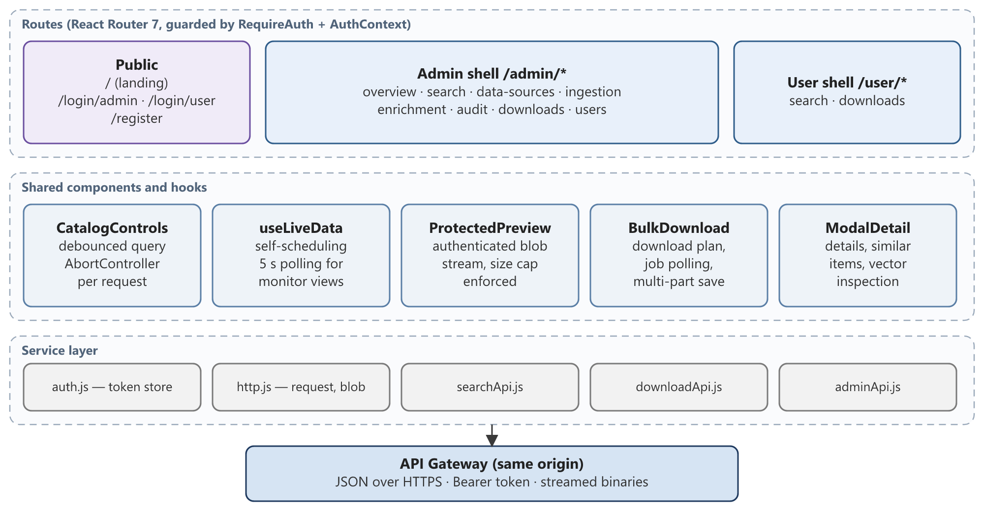
Figure 4. Frontend layers: routes, shared components and the service layer

4.1 Routing and role separation
Routes are split into three tracks. Public pages cover landing, the two login screens and registration. The administrator shell (/admin/*) provides Overview, Search, Data Sources, Ingestion, Enrichment, Audit, Downloads and User Management. The user shell (/user/*) provides Search and Downloads. RequireAuth enforces the role for each shell using AuthContext; the backend enforces the same rules independently.

4.2 Data access patterns
- Single HTTP layer. http.js attaches the bearer token, parses error details into readable messages, and exposes protectedBlob() for authenticated binary downloads.
- Cancellation. Every search, suggestion, detail and similar-items request uses an AbortController, so superseded requests are cancelled rather than racing to update the screen.
- Debounced search. CatalogControls debounces typing before querying, resets pagination and selection when the query, mode or filters change, and keeps selections across pages.
- Live monitoring. The useLiveData hook schedules the next poll only after the previous one finishes (default 5 s), avoiding request pile-up on slow endpoints.
- Bounded binary handling. Previews and archives are streamed into blobs with an enforced maximum (32 MiB for previews; 2 GiB + 64 MiB per archive part). A declared oversize Content-Length is rejected before any body is read.

4.3 Download experience
Before starting a bulk download, the UI calls /search/download-plan to show how many files, how many bytes and how many archive parts a “download top N” request will produce, and whether it fits within limits. After submission it polls job status and saves each part separately.

5. Data ingestion module

5.1 Responsibilities and features
- Register, test, scope, archive and delete source connectors (S3, NAS SMB, NAS NFS).
- Enumerate sources with bounded memory and resumable checkpoints.
- Validate file type by content, fingerprint content with SHA-256, and deduplicate across all sources.
- Attach vendor-supplied descriptive metadata from CSV manifests or sidecar files.
- Assign an immutable licence clock to each unique content item and reconcile expiry.
- Track every run and every object outcome with per-stage timings.
- Serve source bytes to other services and users through a licence-checked, rate-limited stream.

5.2 Connectors and source handling
All connectors implement one interface: test_connection, enumerate(checkpoint), open_stream(job) and open_stream_from_offset(job, offset). A factory builds the correct connector from the database row and Vault credentials. Errors are classified at the connector boundary as permanent (authentication, missing bucket or key, bad region) or transient (everything else), which drives all later retry decisions.
Table 6. Source connectors
Connector | Authentication | Enumeration | Resilience features
S3 / S3-compatible | Static keys, AWS STS AssumeRole (with optional external id), or anonymous (unsigned) for public buckets | ListObjectsV2, one page (≤ 1,000 keys) at a time, optional prefix and object cap | Adaptive botocore retries (8), 32 pooled connections, TCP keep-alive; STS refreshed 5 min before expiry; Range-request resume up to 5 times with capped exponential back-off
NAS SMB | Username/password (optional domain) per connector | Recursive directory walk under a validated UNC path | Per-connector session cache (no cross-connector reuse), 10 s connection timeout, blocking calls moved off the event loop
NAS NFS | Mount-level | Recursive walk of mount path | Traversal checks, read-only streams

Credential lifetime bounded by licence. For AssumeRole connectors, client_for_entitlement() requests an STS session no longer than the remaining licence period, and refuses access if less than the 15-minute STS minimum remains.

5.3 Enumeration and checkpointing
The enumerator is started as a background task when a run is triggered. It loads the connector and credentials, resumes from any stored continuation token, and publishes one Kafka job per object.
- Request one listing page. Only this page is held in memory, so memory is O(page size) rather than O(bucket size), and the first job is published after one list call rather than after listing the whole bucket.
- Skip vendor metadata control files (metadata.csv, .tags, .desc and similar) so they are not catalogued as content.
- Publish each job; on transient failure retry up to 5 times with exponential delay (2 s × 2ⁿ).
- Every 10 pages, flush the Kafka producer and only then persist the continuation token. A crash can replay at most one checkpoint interval; it can never skip objects.
- On completion flush again, clear the checkpoint, and record enumerated count, list time, first-page latency and peak memory on the run.
Note S3 continuation tokens are strictly sequential, so a single prefix cannot be listed in parallel. The scale guide recommends S3 Inventory plus event notifications, or disjoint prefix shards with their own checkpoints, for estates in the hundreds of terabytes.

5.4 Worker processing algorithm
Workers consume ingestion-jobs with manual offset commits and the cooperative-sticky assignment strategy. Each worker processes messages sequentially; parallelism comes from running several workers against a multi-partition topic. Figure 5 shows the decision flow for one object.
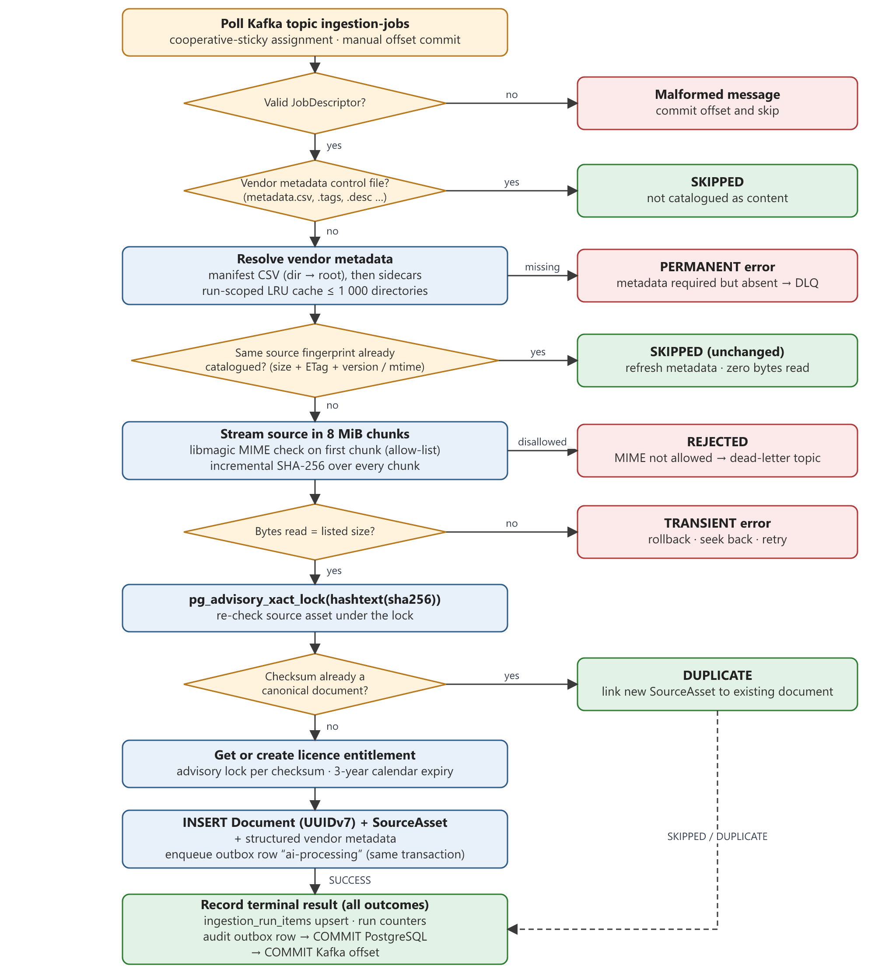
Figure 5. Ingestion worker decision flow for a single source object
Key points of the algorithm:
- Change detection without reading bytes. If an available source asset already exists at the same location with the same fingerprint (size + ETag + version id for S3; size + modification time for NAS), the worker refreshes metadata and returns SKIPPED. Re-scanning an unchanged source reads zero content bytes.
- Single pass over content. Bytes are streamed in 8 MiB chunks. The first chunk is classified with libmagic against a 14-type allow-list, and every chunk updates a running SHA-256. Nothing is written to intermediate storage.
- Size consistency. If the bytes read differ from the listed size, the object changed during processing and the job is retried as transient.
- Concurrency-safe deduplication. A transaction-scoped PostgreSQL advisory lock keyed on hashtext(sha256) serialises workers that finish the same content simultaneously. Under the lock the worker re-checks the asset and the unique checksum index. Existing content yields DUPLICATE: a new source asset is linked to the existing document.
- Atomic creation. A new document (UUIDv7 id), its source asset, its structured vendor metadata and the outbox row for AI processing are written in one transaction.
Table 7. Accepted content types (default allow-list)
Category | MIME types
Images | image/jpeg, image/png, image/gif, image/webp
Documents | application/pdf, DOCX, text/plain, text/csv
Audio | audio/mpeg, audio/wav, audio/x-wav
Video | video/mp4, video/x-msvideo, video/quicktime

5.5 Vendor metadata resolution
Descriptive metadata comes from the vendor, never from guesswork. For each object the resolver searches for manifests (metadata.csv, metadata11.csv) from the object's directory up to the root, matching rows either by filename or by target_path. If no manifest matches, it reads sidecar files (.id, .desc, .tags, .lab, .cate). Tags and categories are merged case-insensitively without duplicates; unrecognised columns are type-coerced and kept as additional_metadata.
- Manifests are cached per run and directory in an LRU cache of up to 1,000 directories, so a folder of thousands of images reads its manifest once.
- Guards: 32 MiB per metadata file, UTF-8 only, at most 64 additional keys and 64 KiB encoded.
- Per-connector mode: required (missing metadata is a permanent error), optional, or none (files-only; a CSV named metadata.csv is treated as ordinary content).

5.6 Licence entitlements and retention
Each unique content item receives one licence entitlement keyed by sha256:<checksum>. The clock starts at the first successful ingestion and expires on the calendar anniversary three years later (29 February maps conservatively to 28 February). Re-ingesting the same content from another location reuses the original clock; it cannot be reset. Creation is serialised with an advisory lock on the licence subject.
A retention reconciler (disabled and dry-run by default) selects due entitlements in batches of 500 with FOR UPDATE SKIP LOCKED and marks them expired. It never deletes vendor content. Expiry takes effect everywhere through the shared catalogue gate (Section 7.9).

5.7 Run tracking and reconciliation
ingestion_run_items holds one row per (run, source reference). Terminal results are written with an upsert guarded by completed_at IS NULL, so redelivered messages cannot double-count. Run counters (succeeded, duplicate, skipped, rejected, failed, bytes) are incremented in the same transaction, and the run is closed as completed or completed_with_errors once the terminal count reaches the enumerated count. Per-stage timings are aggregated in SQL for the run report.
A reconciliation sweep (API-triggered or via a systemd timer) re-enumerates connectors, compares with catalogued source assets, and re-publishes any object that was listed but never catalogued.

5.8 Protected content streaming
GET /documents/{id}/content is the only path to source bytes for the AI service, the download service and user previews. It requires data:download, an available source asset and an active entitlement; rejects documents larger than 5 GiB; and enforces a per-subject limit with an atomic Redis Lua script (INCR, set 60 s expiry on first use, 429 with Retry-After above 120). The source is opened before response headers are sent, so authorisation and I/O failures become real HTTP errors instead of empty successful downloads. The stream aborts if the source grows beyond its catalogued size, and responses carry Cache-Control: no-store and X-Content-Type-Options: nosniff.

5.9 API surface
Table 8. Ingestion endpoints
Endpoint | Purpose
POST /admin/connectors | Create connector; credentials stored in Vault
POST /admin/connectors/{id}/test | Test connectivity; sets status to VERIFIED
PATCH /admin/connectors/{id}/s3-scope, /s3-auth, /archive | Adjust prefix/cap/page size, authentication mode, archival
POST /admin/ingestion/trigger/{connector_id} | Start a run (connector must be verified and not archived)
GET /admin/ingestion/runs, /runs/{id}, /runs/{id}/items | Run history, throughput (MiB/s, objects/s) and stage timings
POST /admin/ingestion/reset-checkpoint/{id}, /reconcile | Restart enumeration from the beginning; reconciliation sweep
GET /documents/{id}, /sources, /source, /content | Document metadata, source locations, access descriptor, protected stream

6. AI tag and description generation

6.1 Responsibilities and triggers
The AI module turns each canonical document into structured, searchable metadata: open-vocabulary and object tags, short/long/search/accessibility descriptions, OCR and speech transcripts, quality labels, privacy and safety labels, a confidence score and a 512-dimensional CLIP embedding. The primary trigger is the ai-processing-events Kafka topic. POST /ai/enrich and POST /ai/retry/{id} provide manual and retry paths through Celery.

6.2 Execution model
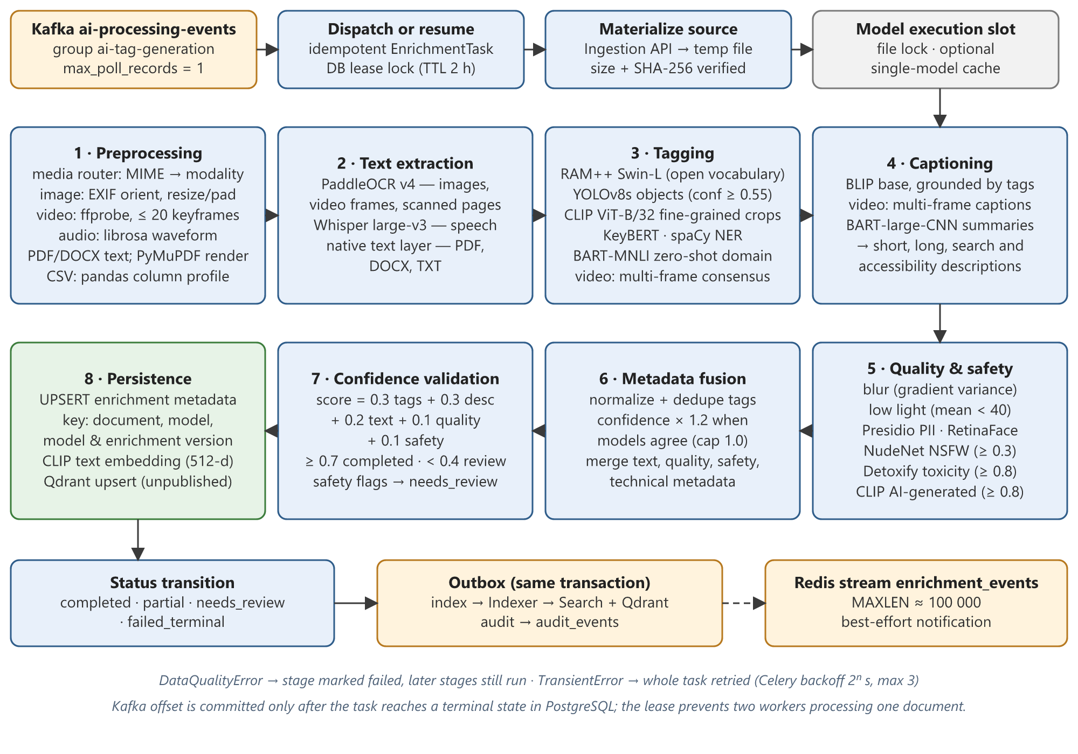
Figure 6. AI enrichment: intake, the eight pipeline stages with their models, and result hand-off
- One record at a time. The consumer uses max_poll_records = 1, manual commits, a 2-hour maximum poll interval and a 120-second session timeout with 10-second heartbeats, which tolerates long CPU model-loading pauses.
- Idempotent task record. dispatch_or_resume() creates or refreshes one enrichment_tasks row per document. Tasks already in a terminal state are skipped, so redelivered events are harmless.
- Database lease. A conditional UPDATE acquires locked_by / lock_expires_at (TTL 2 hours) and the lease is renewed before every stage. A second worker receiving the same document backs off (the consumer seeks back and waits 5 seconds) instead of consuming a retry.
- Verified materialisation. Source bytes are streamed from the ingestion service into a temporary file (5 GiB maximum), size and SHA-256 are checked against the event, and the file is deleted in a finally block. The AI service never holds vendor credentials.
- Memory discipline. On constrained hosts, a shared file lock serialises inference between the Kafka consumer and Celery worker, a single-model cache policy releases models (including malloc_trim) after each document, and the process can recycle after N documents.

6.3 Pipeline stages and algorithms

Stage 1 — Preprocessing and media routing
The media router maps the validated MIME type (falling back to file extension) to one of five modalities and a processing policy. Each modality has a dedicated preprocessor:
Table 9. Preprocessing by modality
Modality | Processing
Image | EXIF-based orientation, EXIF extraction, resize with padding to 224 × 224 for model input; original retained
Video | ffprobe metadata; keyframes via ffmpeg fps=1/interval (1 s for clips ≤ 30 s, otherwise 2 s), interval stretched so no more than 20 frames are extracted; audio track extracted; middle frame kept as thumbnail
Audio | librosa load resampled to 16 kHz mono (Whisper's input rate)
Document | Native text from PDF (pdfplumber), DOCX or TXT; if fewer than 20 characters per page on average, pages are rendered with PyMuPDF for OCR; text chunked at 4,000 characters with 200 overlap
CSV | pandas column profile: inferred types and sample rows

Stage 2 — Text extraction
PaddleOCR v4 reads images, video keyframes and rendered pages. Whisper large-v3 transcribes speech (FP16 on GPU, FP32 on CPU). Native document text is passed through with its source recorded. OCR, transcription and native text are stored separately so downstream consumers never confuse their origins.

Stage 3 — Tagging
- RAM++ (Swin-L, 14M) provides open-vocabulary tags with no fixed label list. Because its inference helper does not expose calibrated scores, accepted labels are assigned a fixed confidence of 0.75. Generic labels (“image”, “photo”) are removed; labels are categorised as scene, action, style, attribute or open vocabulary.
- YOLOv8s adds object tags with bounding boxes at confidence ≥ 0.55.
- Conditional fine-grained classification. Only when RAM++ or YOLO reports a trigger label (dog, cat, bird, car, flag and others) does CLIP classify the best-confidence YOLO crop (or the full image) against a curated sub-label list. A result is accepted only if it clears both a per-trigger probability threshold and a minimum margin over the runner-up. Stylised images (cartoons, drawings) skip this step because such scores are unreliable on them.
- Text tagging for text, audio, document and CSV modalities: KeyBERT keywords (top 10), spaCy named entities, and BART-large-MNLI zero-shot classification over 15 domain categories (score > 0.1).
- Video consensus. Per-frame tags are accepted only if they are temporally stable: confirmed by two different models; or by RAM++ on at least two frames; or by YOLO on at least two frames covering ≥ 40% of frames (not for stylised video). RAM++ clothing/accessory attributes are dropped for stylised video, where they are frequently false.

Stage 4 — Captioning and descriptions
BLIP (base) produces an unconditional short caption (≤ 20 new tokens) and a longer caption grounded by a prompt built from confirmed tags (≤ 60 tokens). Video captions are built from several representative frames rather than one thumbnail. For text modalities, BART-large-CNN summarises content longer than 60 words; shorter text is used directly because a generative summariser cannot improve it. The stage emits four descriptions: short, long, search-optimised and accessibility (alt text). Where no extracted text exists for a non-visual file, vendor context is used and the description is explicitly prefixed “Vendor context”.

Stage 5 — Quality, privacy and safety
Table 10. Quality and safety checks
Check | Model / method | Rule
Blur | Variance of image gradient on greyscale | Blurry if variance < 100
Low light | Mean pixel intensity | Low light if mean < 40; overall quality good / acceptable / poor
PII in text | Microsoft Presidio (spaCy engine) | Annotation and filter; does not block publication
Faces / PII in images | RetinaFace (ResNet-50); OCR text passed to Presidio | Annotation
NSFW | NudeNet v3 explicit classes | Flagged at score ≥ 0.3 → review
Toxicity | Detoxify (unbiased) | Score ≥ 0.8 → review
AI-generated imagery | CLIP zero-shot: image similarity to averaged “AI-generated” vs “real photograph” prompt centroids, two-way softmax | Flagged at ≥ 0.8 (informational)

If a check cannot run (for example only the first frame of an animated GIF was analysed), the record is marked analysis_incomplete, which routes it to review and prevents publication.

Stage 6 — Metadata fusion
Tags from all models are normalised (case-folded, whitespace collapsed) and merged by label, keeping the highest confidence. When more than one model produced the same label, its confidence is multiplied by 1.2 (capped at 1.0), rewarding cross-model agreement. Descriptions, extracted text, quality, safety and technical metadata (width, height, duration) are combined into one record.

Stage 7 — Confidence validation
An aggregate confidence score is computed as a weighted sum:
aggregate = 0.3 × mean(tag confidence)
+ 0.3 × description score (1.0 if > 10 chars, 0.5 if shorter, 0 if absent)
+ 0.2 × max(extracted-text confidence)
+ 0.1 × quality score (0.5 if overall quality is poor, else 1.0)
+ 0.1 × safety score (0 if analysis incomplete, else 1.0)
Table 11. Final status rules
Condition | Status | Published?
Any safety flag (NSFW, toxicity ≥ 0.8, analysis incomplete) or aggregate < 0.4 | needs_review | No
Aggregate < 0.1, or no tags and no description | failed_terminal | No
Aggregate < 0.7 or a required field missing | partial | Yes, if safety cleared
Otherwise | completed | Yes, if safety cleared

Stage 8 — Persistence and embedding
Results are upserted into enrichment.document_enrichment_metadata under the idempotency key (document, model name, model version string, enrichment version), so reprocessing with the same models updates rather than duplicates. A text representation (“Tags: … | Description: … | Details: …”) is encoded with CLIP ViT-B/32 (OpenAI weights, QuickGELU), L2-normalised, and upserted into Qdrant with published = false. The indexer sets the final publication flag. Persistence failures are retried three times and then surface as a transient error so the whole task is retried.

6.4 Model specifications
Table 12. Model inventory (from MODEL_VERSIONS)
Component | Model / version | Used in | Purpose
RAM++ | ram-plus-swin-l-14m | Tagging | Open-vocabulary image tags
YOLO | YOLOv8s | Tagging | Object detection and crops
CLIP | ViT-B-32, OpenAI, QuickGELU | Tagging, safety, embedding, search | Fine-grained classes, AI-image detector, 512-d vectors
BLIP | blip-image-captioning-base | Captioning | Image and frame captions
Whisper | large-v3 | Text extraction | Speech-to-text
PaddleOCR | v4 | Text extraction, safety | OCR on images, frames, scans
BART-MNLI | bart-large-mnli | Tagging | Zero-shot domain classification
Summariser | bart-large-cnn | Captioning | Long-text summaries
KeyBERT | keybert-base | Tagging | Keyword extraction
spaCy | en_core_web_sm | Tagging, PII | Named entities; Presidio NLP engine
Presidio | presidio-analyzer 2.2 | Safety | PII detection in text
Face detector | RetinaFace ResNet-50 | Safety | Face presence
NudeNet | v3 explicit classes | Safety | NSFW scoring
Detoxify | unbiased | Safety | Toxicity scoring
AI-image detector | CLIP zero-shot | Safety | Synthetic-image likelihood

All 15 components pass initialisation checks recorded in a readiness manifest. Measured peak memory during real runs: Whisper large-v3 on a WAV file, 4,463 MiB RSS; RAM++ loading, 1,839 MiB after switching to memory-mapped checkpoint loading; BART classification, 1,800 MiB after low-memory loading (down from 3,490 MiB).

6.5 Task lifecycle
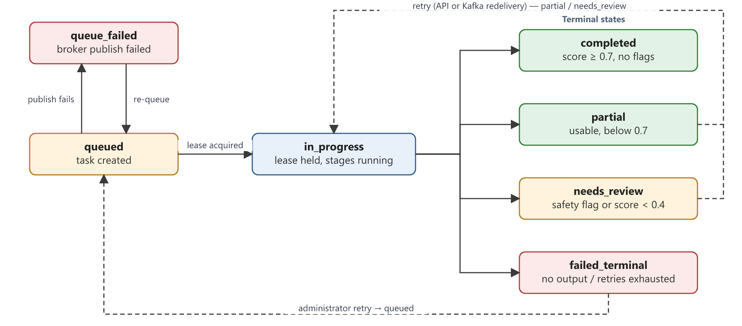
Figure 7. Enrichment task state machine (transitions enforced by transition_status)
Transitions are validated against an explicit table; invalid transitions are logged and ignored. Every accepted transition to a terminal state enqueues an index outbox row and an audit outbox row in the same transaction, and a typed event is appended to the Redis stream enrichment_events (capped at roughly 100,000 entries) for any other listener.

6.6 Publication policy
Publication is decided by one shared function, safety_cleared(), used by the indexer. A document is published only if its task is completed or partial and its safety labels are present, not NSFW-flagged, not incomplete, and have a finite toxicity score below the configured threshold (0.8). PII is recorded and filterable but does not by itself block publication.

7. Search and retrieval

7.1 Features
- Three modes: hybrid (default), text (keyword only) and vector (semantic only).
- Filters: file type, category, dataset, tags, AI-generated flag, PII flag, date range, resolution tier, size bucket and byte range.
- Facet counts that stay meaningful when filters are applied.
- Autocomplete suggestions, 24-hour trending queries, popular datasets.
- Similar-item search from any document.
- Download planning for “top N results” with size and part estimates.
- Search, preview and dataset-open events feeding analytics, popularity and audit.

7.2 Index projection
Search reads from its own denormalised table, search.file_metadata, rather than joining across schemas at query time. The indexer builds each row from the canonical document, connector, licence, latest enrichment metadata and vendor metadata. It unions AI and vendor tags without duplicates, maps MIME types to file types, and prefers pixel dimensions and duration measured by the AI pipeline over vendor-supplied values. It then updates the Qdrant payload with the filterable fields and the publication flag, and refreshes dataset file counts and sizes. If a document is publishable but its vector is not yet visible in Qdrant, the indexer raises an error so the outbox retries later. All writes are upserts, so replays are safe.

7.3 Query pipeline
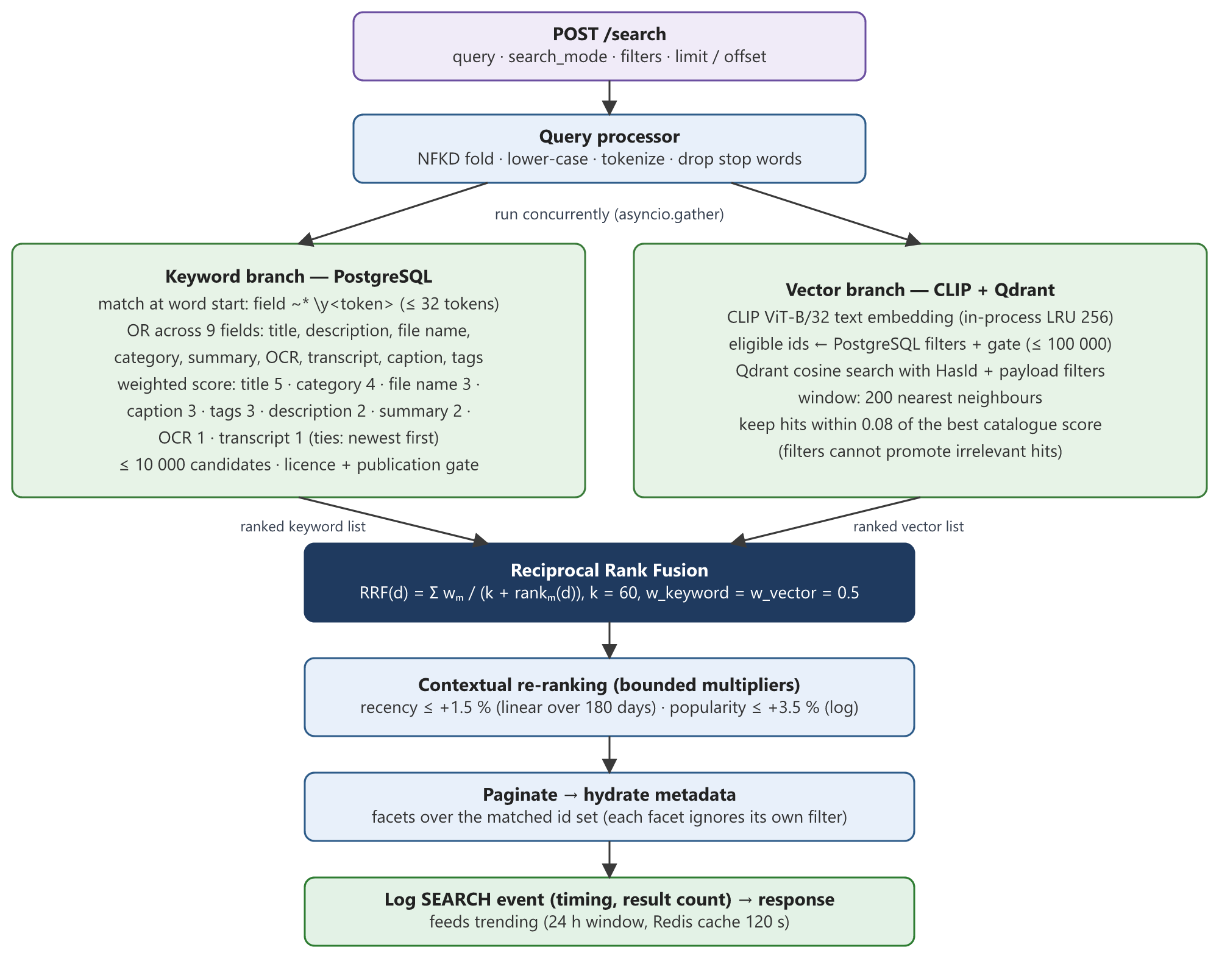
Figure 8. Hybrid search pipeline: concurrent keyword and vector retrieval, rank fusion and bounded re-ranking

7.4 Keyword retrieval
The query is Unicode-normalised (NFKD, ASCII-folded), lower-cased and tokenised; English stop words are removed unless the query consists only of stop words, and at most 32 tokens are used. Each token must match at the start of a word using PostgreSQL's case-insensitive regular expression ~* '\y<token>'. This deliberately differs from substring matching: “ai” must not match “detail” or “email”, and “4k” must not match “24k”, while the prefix “satell” still finds “satellite”.
A document matches if any token matches any of nine fields. Its relevance score is the sum of field weights for every (token, field) match:
Table 13. Keyword field weights
Field | Weight | Field | Weight
Title | 5 | Tags | 3
Category | 4 | Description | 2
File name | 3 | Content summary | 2
Caption | 3 | OCR text / transcript | 1 each

Ties are broken by newest ingestion, then by file id, giving a deterministic order. The same scoring expression is used for results and for download planning, so “top N” always means the same files.

7.5 Vector retrieval
- Encode the query with the same CLIP ViT-B/32 text encoder used for documents (shared modules/shared/embeddings.py), L2-normalised. Embeddings are cached in-process (LRU, 256 entries) and the model is warmed at startup so the first request does not pay model-loading time.
- Compute the eligible id set in PostgreSQL by applying the same filters and the licence/publication gate. If more than 100,000 documents are eligible, the request is rejected with 422 and the user is asked to narrow filters.
- Query Qdrant by cosine similarity restricted to those ids (HasIdCondition) plus payload filters, over a window of 200 nearest neighbours.
- Relevance margin. Keep only hits whose similarity is within 0.08 of a reference score. Without filters the reference is the best hit. With filters, the reference is the best score across the whole visible catalogue, so a filter that excludes every relevant document returns nothing rather than promoting the least-bad irrelevant ones.

7.6 Reciprocal Rank Fusion
Hybrid mode runs both branches concurrently with asyncio.gather and fuses the full candidate lists with Reciprocal Rank Fusion:
RRF(d) = Σ over branches m of w_m / (k + rank_m(d)) k = 60, w_keyword = w_vector = 0.5
RRF uses ranks rather than raw scores, so the keyword branch's integer weights and the vector branch's cosine similarities never need to be calibrated against each other. A document found by both branches accumulates both contributions and rises above documents found by only one. For example, a document ranked 1st by keywords and 3rd by vectors scores 0.5/61 + 0.5/63 ≈ 0.01613, while a document ranked 1st by only one branch scores 0.5/61 ≈ 0.00820.

7.7 Contextual re-ranking
After fusion, two bounded multipliers are applied to the entire candidate set before pagination, so boosts cannot reorder results across page boundaries:
- Recency: up to +1.5%, decaying linearly to zero over 180 days since ingestion.
- Popularity: up to +3.5%, proportional to log(1 + 2 × downloads + previews) and saturating at 100 events.
Because neighbouring RRF scores differ by roughly 1%, these multipliers can only reorder results of near-equal relevance. The code documents that an earlier additive scheme was replaced because it allowed popular files to outrank far better matches.

7.8 Facets, suggestions, trending, similar items and download planning
- Facets are counted in SQL over exactly the set of ids the search matched (hybrid and vector) or over the keyword query (text). File-type, resolution and size facets each ignore their own filter, so selecting “image” does not hide the counts of other types. Top tags are expanded with json_array_elements_text inside PostgreSQL (top 15); no records are loaded into Python.
- Suggestions combine matching trending queries with distinct visible titles found by a prefix match on lower(title), which uses a text_pattern_ops expression index.
- Trending aggregates normalised queries from the last 24 hours and caches the result in Redis for 120 seconds.
- Similar items reuse the document's stored vector from Qdrant (or re-embed its metadata if absent) and run a filtered vector search excluding the document itself.
- Download planning walks up to 30,000 ranked results, excludes files over the per-file limit, and packs the remainder greedily in rank order to estimate part count, total bytes and the largest selection that fits within the request limits.

7.9 Licence and publication gate
Every search path, detail lookup, preview and download admission applies one shared SQL predicate, VISIBLE_SQL: the document's licence must be active and unexpired, its enrichment task must be completed or partial, and its catalogue row must be published. Because this check reads the authoritative tables at request time, a stale Qdrant payload or cached value can never grant access to an expired or unpublished document.

7.10 API surface
Table 14. Search endpoints
Endpoint | Purpose
POST /search | Hybrid, text or vector search with filters and pagination
POST /search/text, /search/vector | Single-branch search
POST /search/similar | Similar documents
GET /search/facets, /search/trending, /search/suggestions | Facets, trending queries, autocomplete
POST /search/download-plan | Size, part count and fit for a “top N” download
GET /files/{id}, GET /datasets/popular | Document details, popular datasets
POST /events/search | Record preview, dataset-open and similar interaction events

8. Download and package generation

8.1 Features
- Batch download of up to 10,000 selected documents as one or more ZIP parts.
- Admission checks with clear, actionable errors before any work is queued.
- Two execution lanes: an immediate lane for tiny requests and a durable Celery queue for everything else, with automatic recovery.
- Per-file integrity verification against the catalogue checksum.
- Per-file forensic watermarking tied to the requesting user, job and document.
- Download history, per-file progress and forensic verification of suspect files.

8.2 Admission and limits
Limits are defined once in modules/shared/download_limits.py and read by both the search service (for planning) and the download service (for enforcement), so the estimate a user sees always matches what will be accepted.
Table 15. Download limits
Limit | Default | Enforcement
Largest single file | 128 MiB | Rejected at admission (422) and re-checked during packaging
Archive part size | 2 GiB | Larger selections are split into several parts
Files per request | 10,000 | Request schema validation
Total source bytes per request | 20 GiB | Rejected at admission (413)
Free staging space | Selection size + 3 × 128 MiB | Rejected at admission (503) and re-checked before each file

8.3 Execution lanes and recovery
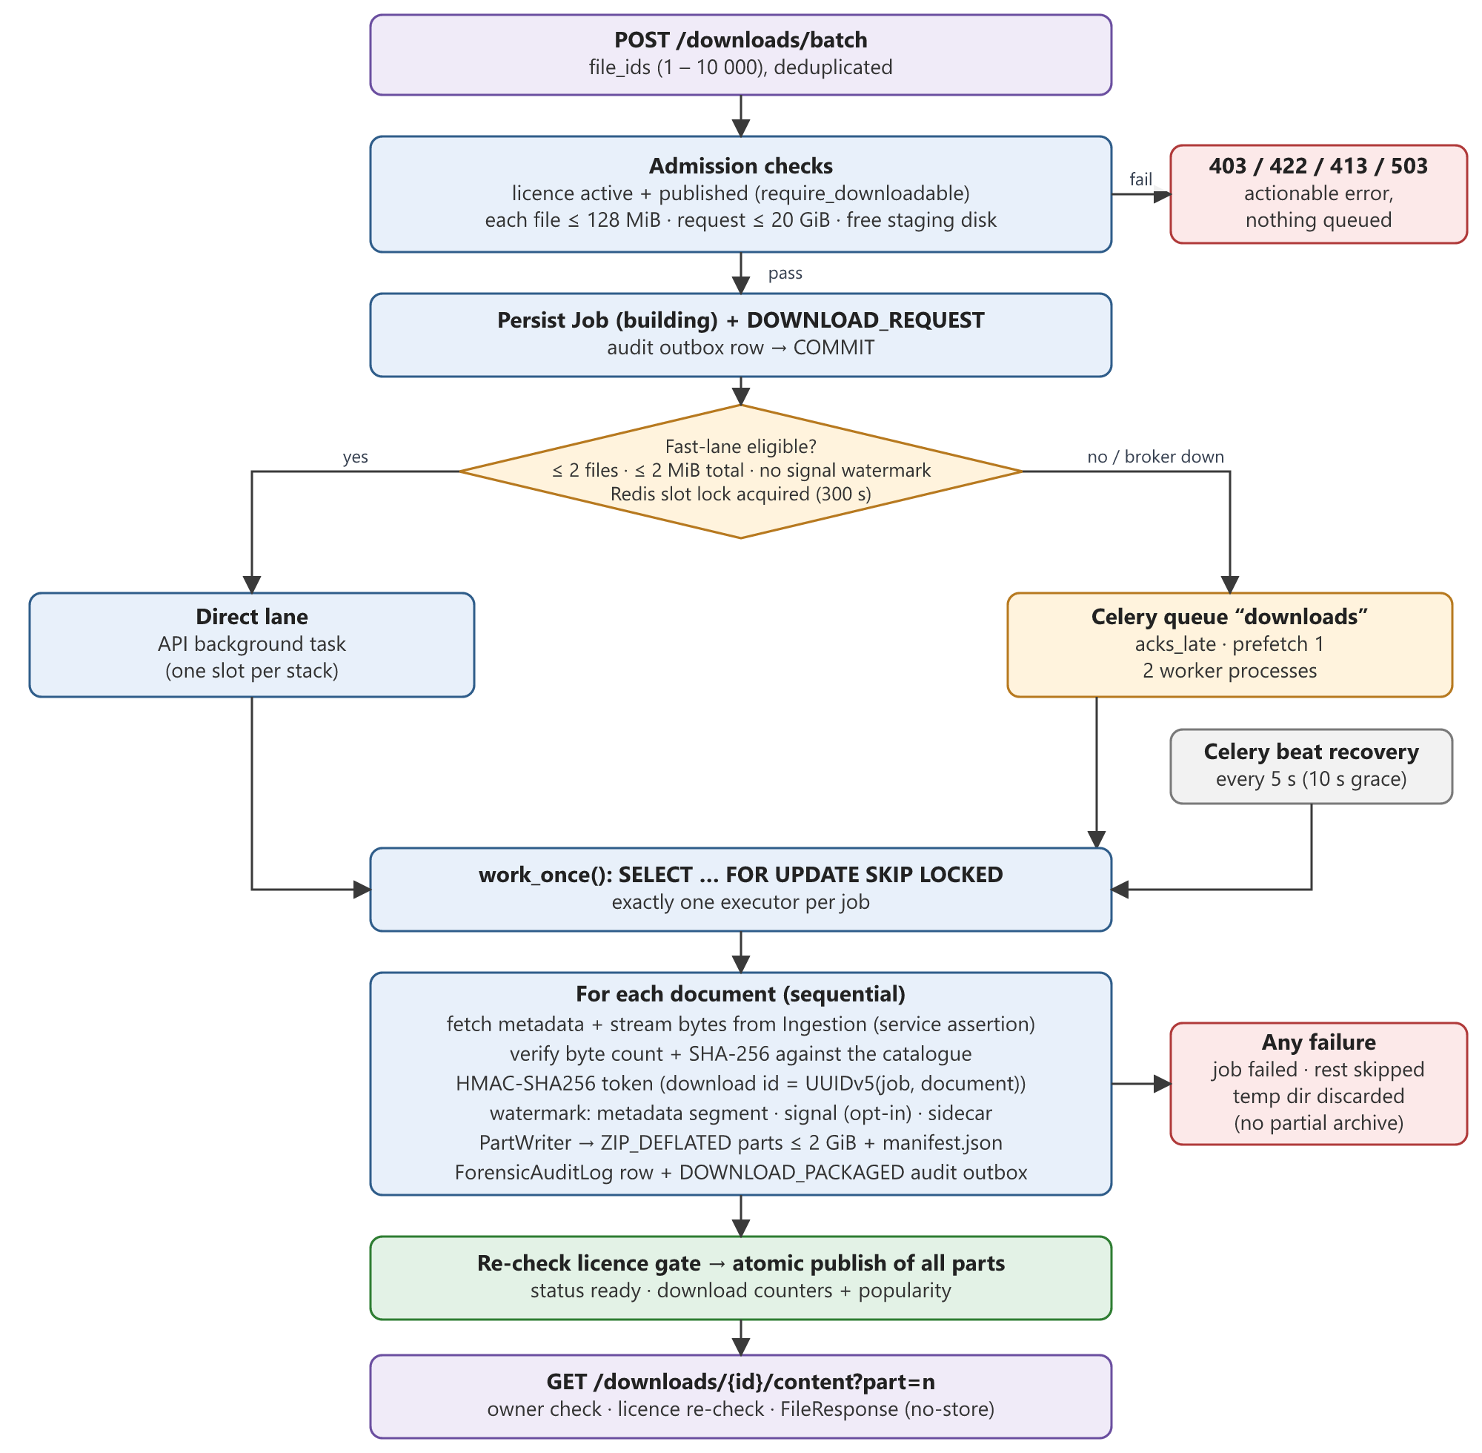
Figure 9. Download job admission, execution lanes, packaging and delivery
The job row and its audit outbox entry are committed before any work is dispatched. Dispatch then chooses a lane:
- Direct lane. Requests of at most two files and 2 MiB in total, with no signal watermark configured, run as an API background task if a Redis lock slot (300 s lease) is free. This gives near-immediate results for single-file downloads.
- Celery lane. All other requests go to the dedicated downloads queue (late acknowledgement, prefetch 1, 6-hour visibility timeout, two worker processes by default).
- Recovery. Celery beat runs every 5 seconds, picking up any committed job older than 10 seconds that is still building, including jobs whose broker publish failed. work_once() claims jobs with SELECT … FOR UPDATE SKIP LOCKED, so the direct lane, Celery and recovery can never package the same job twice.

8.4 Packaging algorithm
- Re-check the licence/publication gate for all selected documents.
- For each document in order: fetch metadata from the ingestion service; stream its bytes, aborting if they exceed the catalogued size; verify byte count and SHA-256 against the catalogue.
- Sanitise the file name (alphanumerics and ._- , at most 160 characters) and prefix it with the document id.
- Build a tracking payload and HMAC token (Section 8.5) and apply the watermark methods appropriate to the format.
- Write the result to a PartWriter, which starts a new ZIP_DEFLATED part whenever adding the file would exceed the part size. Each part is self-contained with its own manifest.json, so parts can be unpacked independently.
- Record a ForensicAuditLog row and a DOWNLOAD_PACKAGED audit outbox entry.
- After the last file, re-check the gate and publish all parts atomically by renaming them from a temporary directory. If any rename fails, already-moved parts are deleted so a partial archive set is never exposed.
- In the same transaction, mark the job ready and increment download counters and dataset popularity.
Any failure marks the job failed with a human-readable reason, marks the failing file, marks remaining files as skipped, and discards the temporary directory. Finished packages expire after 24 hours and orphaned temporary directories are cleaned by the recovery task.

8.5 Watermarking and forensic tracing
Tracking token. Each packaged file receives a payload containing the user id and e-mail, document id, client IP, timestamp and job metadata. Its download id is deterministic: UUIDv5(job id, document id). The payload is serialised as canonical JSON, base64url-encoded and signed:
token = "AGY-WM-" + base64url(canonical_json(payload)) + "." + hex(HMAC-SHA256(secret, base64_part))
Verification uses constant-time comparison, so any modification of the payload invalidates the token.
Table 16. Watermark methods by format
Format | Default method | Optional signal method
JPEG | COM (0xFFFE) metadata segment with the token | JPEG-DCT-v1: QIM on one mid-frequency luminance AC coefficient per keyed block, no pixel re-encode
PNG | tEXt chunk inserted after IHDR (pixel data untouched) | PNG-DWT-DCT-v1: Haar DWT + block DCT + QIM on luminance, alpha preserved
WAV / FLAC / MP3 / OGG | Container metadata, samples bit-exact | Audio-STFT-v1 (WAV/FLAC); native MDCT hooks in patched LAME (MP3) and FFmpeg AAC
MP4 / MOV / MKV | Container metadata | Native H.264/H.265 quantised-coefficient editing (experimental all-intra re-encode)
PDF | /NexusWatermark document-info entry via pypdf | —
CSV, JSON, text, other | Original bytes unchanged; <file>.watermark.json sidecar with token and SHA-256 | —

Signal payload design. Signal methods embed only an identifier, never personal data. The payload is a 3-byte version prefix, the 16-byte download id and a 16-byte truncated HMAC-SHA256 over a domain-separated message: 35 bytes (280 bits). It is embedded three times. Embedding positions are chosen by a keyed partial Fisher–Yates shuffle whose indices are derived from HMAC outputs, so positions are secret, stable and use O(n) memory. Extraction takes a majority vote over the three copies and accepts the result only if the HMAC verifies, so random or tampered bits are never attributed to a user.
Quantisation Index Modulation (JPEG example). Each selected 8 × 8 luminance block carries one bit in its quantised AC coefficient at position (2, 3), using two interleaved lattices with spacing 4 (centres 0 and 2). Decoding reads round(c / 2) mod 2. The method requires at least 792 blocks and survives lossless metadata removal; recovery after recompression, cropping or resizing is not claimed.

8.6 Forensic verification
POST /downloads/forensic/verify (administrators only, 64 MiB limit) extracts any metadata token and any signal identifier from a suspect file, verifies both, and reports a conflict if they identify different downloads. A match returns the full trail: download id, document, user id and e-mail, display name, client IP, packaging time, request time, delivery start time, job id, execution lane and watermark methods. Every verification is itself audited.

9. Audit module

9.1 Event sources
Table 17. Audited actions
Source | Actions | Path to ledger
Gateway middleware | <METHOD> <path> for non-GET calls to /auth/, /admin/connectors, /admin/ingestion, /ai/, plus every 401/403 (DENIED) and failed request on those paths | Direct insert, correlation id attached
Ingestion worker | INGESTION_SUCCESS, _DUPLICATE, _SKIPPED, _REJECTED, _PERMANENT_ERROR | Outbox (ingestion schema)
AI service | AI_COMPLETED, AI_PARTIAL, AI_NEEDS_REVIEW, AI_FAILED_TERMINAL, AI_INDEXED | Outbox (enrichment schema)
Search service | Search and interaction events with execution time | Outbox (search schema)
Download service | DOWNLOAD_REQUEST, DOWNLOAD_PACKAGED, DOWNLOAD_READY / _FAILED, DOWNLOAD_DELIVERY_STARTED, FORENSIC_VERIFY | Outbox and direct insert
Other services | Arbitrary signed events | POST /internal/audit/events (requires audit:write)

9.2 Storage model and privacy
Events are stored in audit.audit_events with a primary key on event_id. Producers supply deterministic ids (for example download-<job id> or a SHA-256 of run and source reference), and inserts use ON CONFLICT DO NOTHING, so replayed outbox deliveries create exactly one row. Ids longer than 80 characters are replaced with a SHA-256 derived id. There is no update or delete API; the ledger is append-only.
Device, location and client IP values are pseudonymised before storage with a salted SHA-256 hash truncated to 16 hex characters. The same input always maps to the same code, so activity can be correlated without storing the raw value. Query text is truncated to 500 characters.

9.3 Query, analytics and export
- GET /api/audit/logs filters by action, actor and status with SQL-side pagination (page size ≤ 500) ordered by time, backed by an index on occurred_at.
- GET /admin/audit/analytics returns counts grouped by action and status over 1–720 hours.
- GET /downloads/audit/export.csv streams the ledger in 500-row pages, so memory stays constant regardless of size. Values beginning with =, +, - or @ are prefixed with an apostrophe to prevent spreadsheet formula injection.

10. Database infrastructure and technical components

10.1 Data layout
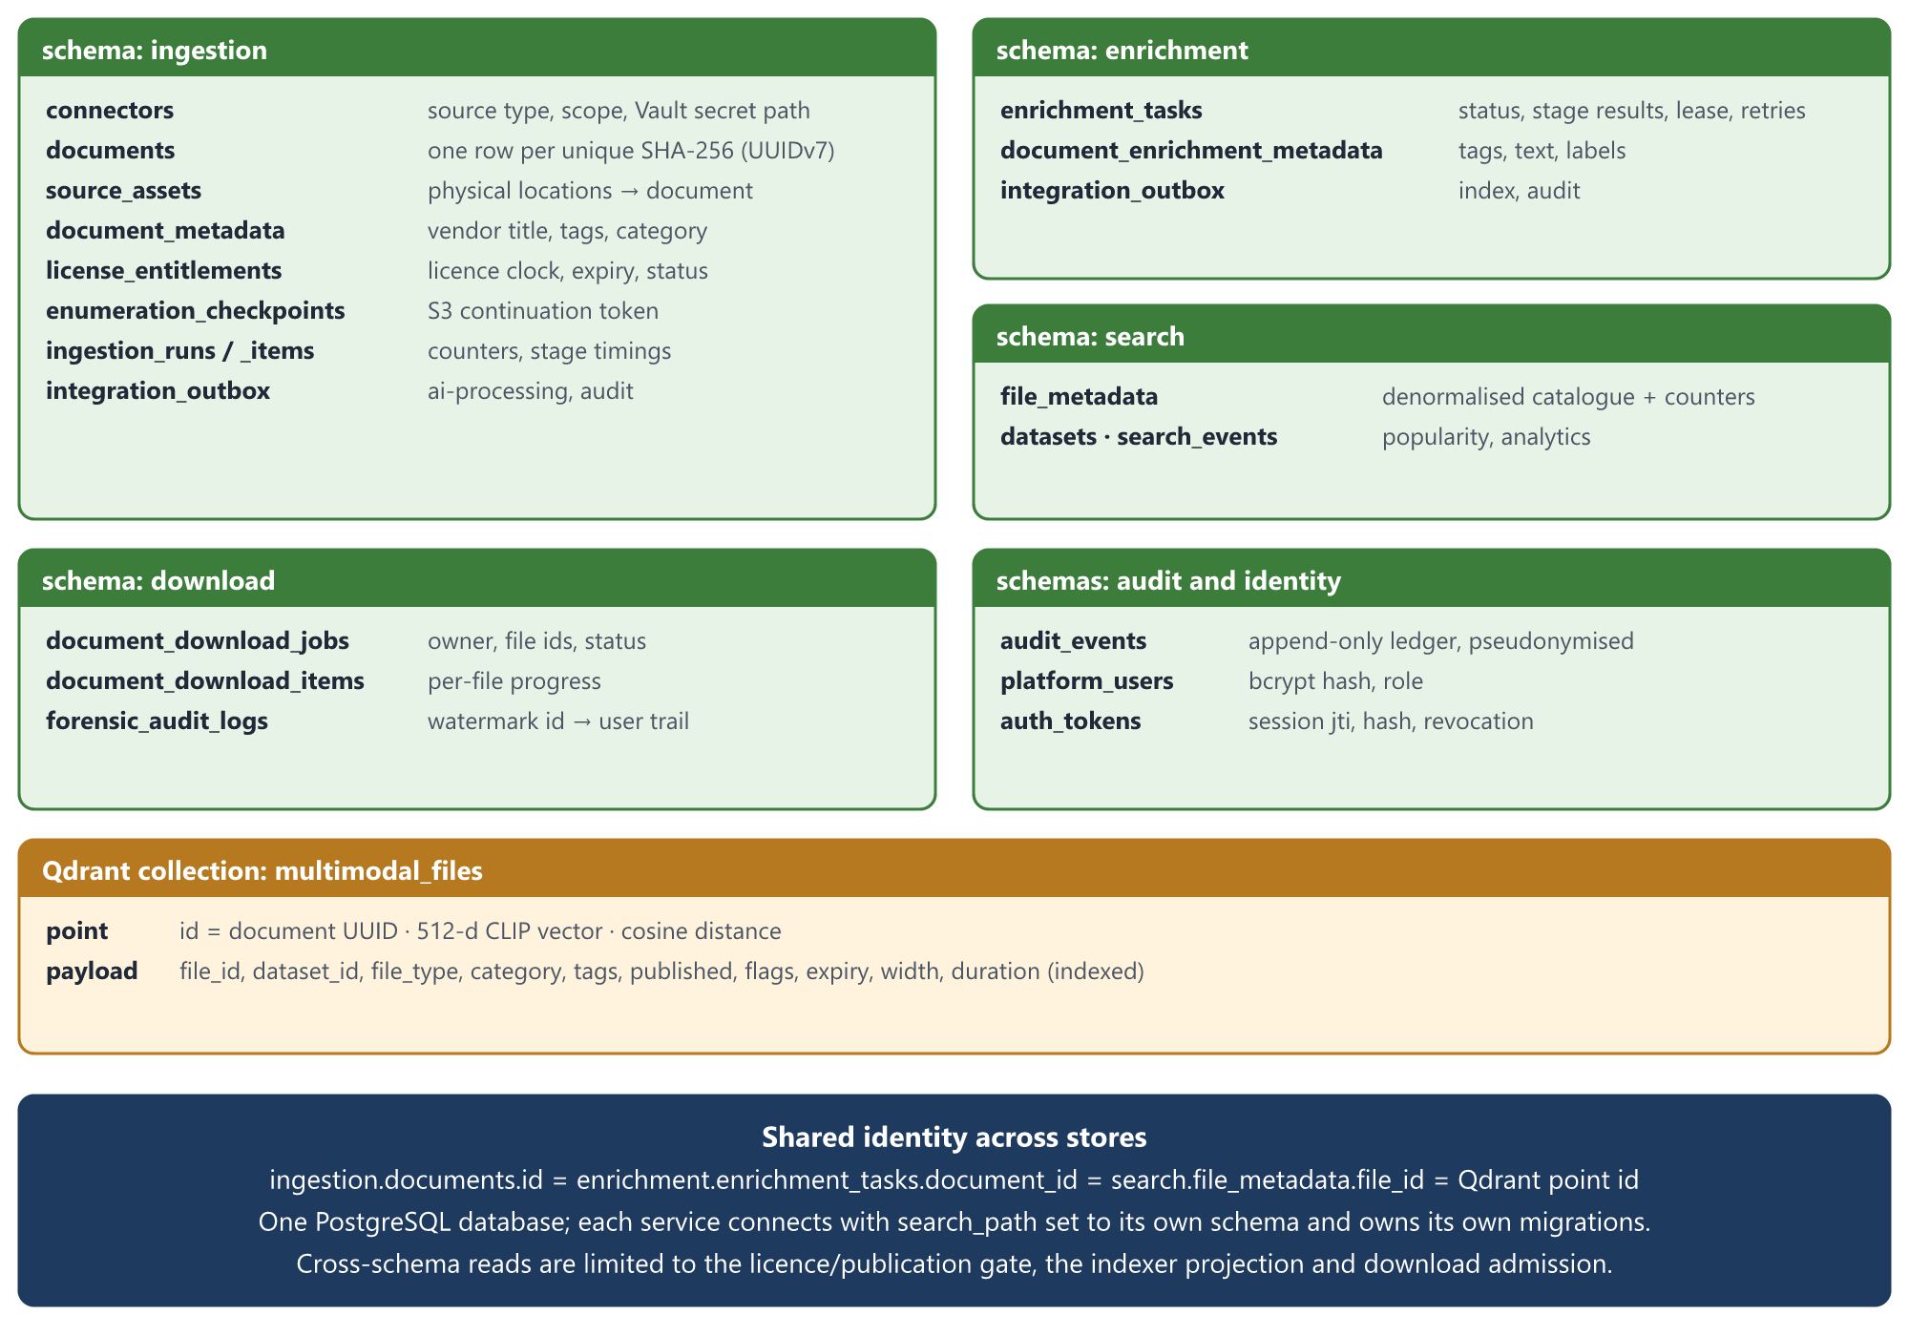
Figure 10. Schemas, principal tables and the shared document identity
The three sanctioned cross-schema reads are: the licence/publication gate (VISIBLE_SQL), the indexer projection, and download admission size checks. Each service otherwise works only within its own schema.

10.2 Indexes supporting the query paths
Table 18. Performance-relevant indexes
Index | Supports
documents(checksum_sha256) unique | Content deduplication and concurrent-insert safety
Partial unique index on available source_assets(connector, source_ref) | Change detection without reading bytes
ingestion_run_items (run_id, outcome), (document_id) | Run reports and pipeline drill-down
file_metadata (lower(title) text_pattern_ops) | Prefix suggestions
GIN on file_metadata ((tags::jsonb)) | Tag filters using JSONB containment
Partial file_metadata (dataset_id) WHERE published | Dataset counts and filters
search_events (event_type, dataset_id, created_at) | Popularity and trending windows
audit_events (occurred_at) | Time-ordered audit pagination
12 Qdrant payload indexes (keyword, bool, datetime, integer, float) | Filtered vector search without payload scans

Search indexes are created with CREATE INDEX CONCURRENTLY outside a transaction, so they can be built without blocking writes. The migrator detects an invalid index left by an interrupted build and rebuilds it rather than trusting IF NOT EXISTS.

10.3 Transactional outbox
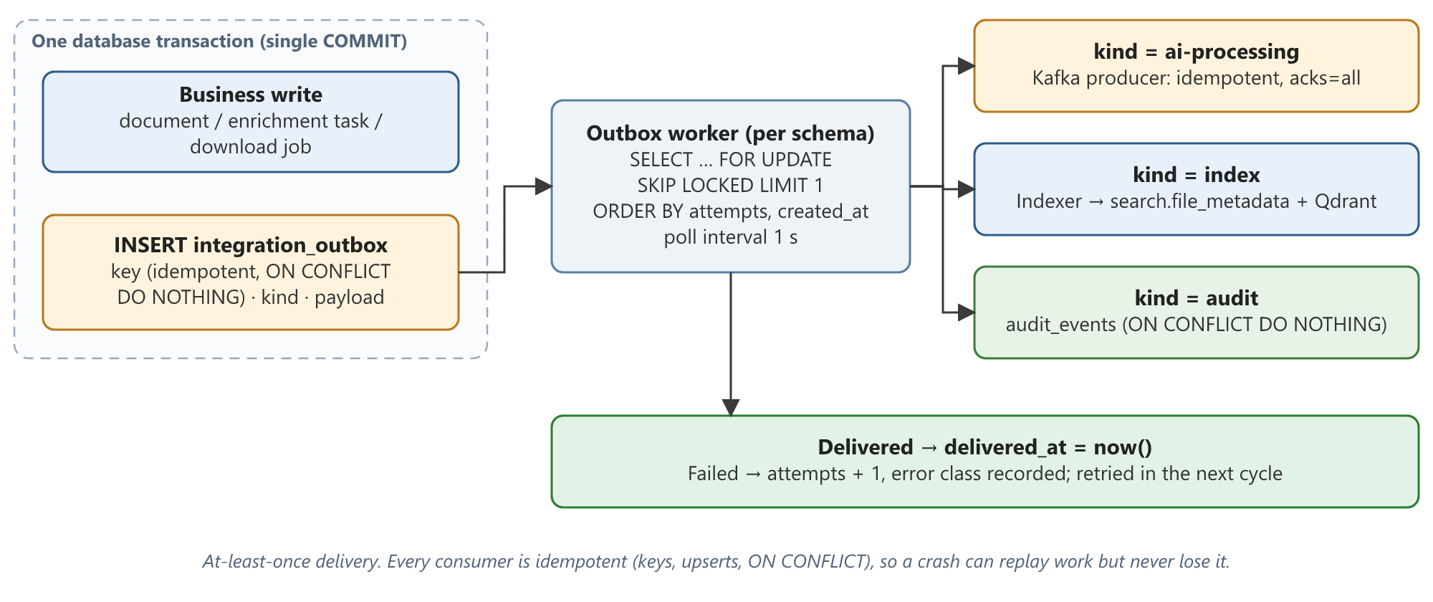
Figure 11. Transactional outbox: atomic enqueue with the business write and at-least-once relay
Outbox workers run one per schema (ingestion, enrichment, search, download). Each claims one undelivered row with FOR UPDATE SKIP LOCKED, ordered by attempts and age so a repeatedly failing row does not starve newer ones. Multiple workers per schema can therefore run concurrently. Kafka delivery waits up to 30 seconds for broker acknowledgement and treats any delivery error as a failure to retry.

10.4 Migrations
scripts/migrate_integration.py is an explicit, repeatable one-shot job. It creates the six schemas, adopts known legacy tables from public into their owning schema (refusing if ownership is ambiguous), runs each service's Alembic history with the correct schema, creates the search/download/audit/identity tables, builds query indexes concurrently, and provisions and validates the Qdrant collection (512 dimensions, cosine). Request-time code only validates the collection; it never creates it.

10.5 Supporting components
Table 19. Messaging, cache and secrets usage
Component | Usage
Kafka topics | ingestion-jobs, ingestion-dead-letter, ai-processing-events, ai-processing-events-dlq; consumer groups ingestion-workers and ai-tag-generation
Redis | Celery broker and result backend (AI), Celery broker (downloads), download fast-lane slot lock, content rate-limit counters, trending cache, enrichment_events stream; AOF persistence enabled
Qdrant | Collection multimodal_files, point id = document UUID, 512-d cosine vectors, payload used for filtering
Vault | Connector credentials by secret path; token auth in development, AppRole supported
Shared volumes | Package staging (ZIP parts), model weights and caches shared by AI and search containers

11. Performance, optimisation and scalability

11.1 Measured results
The following figures come from the project's acceptance runs on a development PC (Docker, 7.6 GiB allocation, CPU-only inference) against Amazon RDS. They establish behaviour on small catalogues and are not load-test service levels.
Table 20. Search latency on a 43-document catalogue (full HTTP time incl. authentication and audit)
Mode | Median before | Median after | Improvement
Text | 6,757.5 ms | 2,116.4 ms | 69%
Hybrid | 3,856.8 ms | 2,822.0 ms | 27%
Vector | 4,170.3 ms | 2,420.4 ms | 42%

A later natural-language run on a photo dataset measured most requests at about 0.7–0.9 s, and 21 final queries ranged from 698 to 1,568 ms. Startup model warm-up removed an 11.5 s cold first request; however, isolated tail requests of 3.5 s and 11.95 s were still observed.
Table 21. Ingestion and enrichment acceptance runs
Run | Result
S3 dataset (45 objects, 4.92 GB) | 41 content objects processed: 37 canonical documents, 4 duplicates, 0 failures; all 37 published after AI (16 completed, 21 partial)
Unchanged re-scan of the same dataset | All 41 objects skipped, zero content bytes read, no retries
NAS SMB run | 20 files, 23.7 MB: 18 new documents, 2 duplicates, 0 failures
Public dataset (Amazon Berkeley Objects) | 6 photographs + 1 PDF ingested, enriched and published; re-scan skipped all 7
Five-modality S3 workflow | JPG, PDF, MP4, MP3, WAV, CSV: all 8 stages completed with zero task retries

11.2 Optimisations implemented
Table 22. Performance and efficiency techniques
Area | Technique | Effect
Enumeration | Page-at-a-time listing instead of materialising the full paginator | First job after one list call; enumerator memory bounded by one 1,000-key page
Enumeration | Checkpoint every 10 pages after a Kafka flush | Avoids a flush and DB transaction per page while keeping at-least-once recovery
Ingestion worker | Fingerprint-based change detection | Unchanged re-scans read no content
Ingestion worker | Single streaming pass: MIME check, hashing and size check together | No temporary copies; one read per object
Ingestion worker | Run-scoped LRU manifest cache (≤ 1,000 directories) | One manifest read per folder instead of per file
Ingestion worker | Terminal-attempt stage timings instead of a shared hot row | Avoids lock contention on run statistics
Content streaming | Connection reuse, keep-alive, Range resume | Survives transient network errors without restarting large reads
AI | Conditional fine-grained CLIP pass | Most images never pay the extra classification cost
AI | Precomputed, cached CLIP text embeddings for label sets | Prompt embeddings computed once per process
AI | Memory-mapped RAM++ checkpoint; low-memory BART loading | Peak RSS reduced to ~1.8 GiB for each
AI | Keyframe cap (20) and short-video sampling | Bounded video cost regardless of length
Search | Concurrent keyword and vector branches (asyncio.gather) | Hybrid latency ≈ slower branch, not the sum
Search | Startup CLIP warm-up and LRU query-embedding cache | Removed 11.5 s cold request; repeated queries skip encoding
Search | Fewer database round trips; window-function totals | Contributed to the 27–69% latency reduction
Search | Facet and tag aggregation in SQL; payload indexes in Qdrant | No record loading in Python; no payload scans
Search | Trending cached in Redis for 120 s | Trending and suggestion requests avoid repeated aggregation
Download | Direct lane for tiny requests | Single small files avoid queue latency
Audit | Streaming CSV export and SQL pagination | Constant memory for any ledger size
Gateway | Streaming proxy (no request or response buffering) | Large archives and previews pass through without gateway memory growth

11.3 Scalability design
- Horizontal workers. Ingestion workers scale with Kafka partitions (the scale guide uses 12 partitions and four replicas as a starting point). Each worker is intentionally sequential so offset ordering stays simple and correct.
- Contention-free coordination. SKIP LOCKED row claiming (outbox, downloads, retention), advisory locks keyed by content, and database leases (AI) let multiple instances share work without a central coordinator.
- Stateless APIs. All service APIs keep state in PostgreSQL, Redis or Qdrant and can be replicated behind the gateway.
- Independent scaling. Because each service is a separate container with its own queue, expensive AI inference can be scaled or placed on GPU hosts without affecting search latency.
- Explicit bounds everywhere. Page sizes, candidate windows (10,000 keyword, 200 vector, 100,000 eligible ids), scan limits, file and archive sizes, and metadata sizes are all capped, so worst-case cost is known.

11.4 Capacity planning guidance
The ingestion scale guide defines staged qualification (10 GB → 50 GB → 100 GB → 1 TiB), advancing only when the previous stage shows no data loss, drained queue lag and stable resources. Required sustained throughput for 1 TiB is about 24.3 MiB/s for a 12-hour window, 12.1 MiB/s for 24 hours and 6.1 MiB/s for 48 hours. For estates around 450 TB, it recommends S3 Inventory as the baseline with event-driven deltas, and co-locating workers, Kafka and the database in the source region.

12. Error handling, retries and failure scenarios

12.1 Error taxonomy
Every module distinguishes errors that can succeed on retry from those that cannot:
Table 23. Error classes
Module | Transient (retried) | Permanent (not retried)
Ingestion connectors | Network, timeouts, throttling (SlowDown, 5xx), SMB protocol errors, database operational errors | Access denied, invalid keys, missing bucket or key, bad region, SMB logon failure
Ingestion worker | Source read failures, size changed during processing, unexpected exceptions | Disallowed MIME type, required metadata missing, malformed metadata, integrity violations
AI pipeline | TransientError: model loading, persistence, Qdrant, ingestion access | DataQualityError: unusable input for a stage (recorded, pipeline continues)
Download | Broker unavailable, worker crash | Size limits, integrity failure, encrypted PDF, unsupported signal input

12.2 Retry mechanisms
Table 24. Retry behaviour by component
Component | Mechanism | Limits
S3 client | botocore adaptive retry mode | 8 attempts
S3 streaming | Range-request resume from last byte, STS refresh on AssumeRole | 5 attempts, back-off min(2ⁿ, 30) s
Enumerator publishing | Exponential back-off | 5 attempts, 2 s × 2ⁿ
Ingestion Kafka consumer | No offset commit; seek back to the same offset; 2 s pause | Until success or permanent classification
Ingestion permanent failures | Dead-letter topic with error message, stack trace and original topic/partition/offset headers; offset committed | Once
AI Kafka consumer | Retry counter on task; offset uncommitted; process restart | 3 retries, then failed_terminal + DLQ
AI Celery tasks | self.retry with exponential countdown | base 2, max 3 retries
AI persistence | In-process retry wrapper | 3 attempts, then task-level retry
Outbox relay | Row left undelivered with incremented attempts and error class | Unlimited; ordered by attempts
Download jobs | Celery late ack + beat recovery every 5 s | Job fails permanently on validation errors

12.3 Failure scenarios
Table 25. Failure scenario matrix
Scenario | Detection | Behaviour and recovery
Ingestion worker crashes mid-object | Kafka rebalance | Offset uncommitted; job redelivered; transaction rolled back so no partial rows exist
Enumerator crashes | Run not completed | Next run resumes from the last checkpoint; at most one interval replayed; duplicates absorbed by fingerprints and checksums
Kafka unavailable during enumeration | Producer flush timeout | Checkpoint not advanced; run marked failed; safe to re-trigger
Kafka unavailable after document commit | Outbox delivery error | Outbox row retried until delivered; AI processing is delayed, never lost
Two workers process the same content | Advisory lock | Second worker waits, re-checks, and links as DUPLICATE
Source object changes during read | Size mismatch | Transient retry after re-read
Unsupported or malicious file type | libmagic content sniffing | REJECTED, sent to DLQ, counted in run
AI worker dies holding a lease | Lease expiry (2 h) | Another worker acquires the expired lease and resumes the task
Model fails to load | TransientError | Task retried with back-off; after 3 attempts marked failed_terminal and sent to DLQ
Unsafe or uncertain content | Safety labels / confidence | needs_review; not published; administrator can retry
Checksum mismatch on AI or download fetch | SHA-256 comparison | Processing or packaging fails; temporary files removed
Licence expires after indexing | Request-time VISIBLE_SQL | Immediately hidden from search, preview and download, even with stale caches
Redis unavailable at download dispatch | Exception in dispatch | Job stays committed as building; beat recovery packages it once available
Download fails part-way | Exception in packaging | Job failed, remaining files skipped, no partial archive published
Package expired | Missing file | 410 Gone with instruction to create a new batch
Database outage at gateway | OperationalError / timeout | 503 with correlation id and advice to refresh status before retrying
Upstream service timeout / unreachable | httpx exceptions | 504 or 503 with a user-friendly message; transport failure logged with correlation id
Browser navigates away mid-request | ClientDisconnect | Status 499 recorded (not counted as a server failure)

13. Validation and accuracy methodology

13.1 Test inventory
Table 26. Automated test coverage (latest recorded runs)
Suite | Scope | Result
Gateway and ingestion | Contracts, permissions, streaming, run tracking, observability | 66 passed
AI module | Pipeline correctness, recovery, content priority, Whisper loader | 28 passed + 8 subtests
Search | Facets, audit timing, stale-connection recovery (isolated SQL and Qdrant) | 11 passed in full suite
Download | Packaging, watermark recovery and compatibility | 28 passed, 11 native-codec tests skipped without native builds
Audit | Persistence in a disposable RDS database | 2 passed
Frontend | Service adapters and restoration regressions | 15–16 passed; production build passed
Integration (tests/integration) | 39 scripts: S3/NAS workflows, broker and AI recovery, security, PII publication, legacy upgrade, browser suites | See Section 13.2

13.2 End-to-end acceptance
Acceptance scripts exercise the real stack with real models and record evidence files. The 21 September dataset acceptance passed all 12 API check groups:
- Discovery by both roles in all three search modes, with filtered pagination and no missing or duplicate ids.
- For every document: protected content with original size and SHA-256, details and similar items.
- A 26-file archive passing ZIP CRC checks and forensic verification; rejection of another user's download; rejection of an oversized job.
- An unchanged re-scan reading zero bytes; revoked sessions rejected; all actions present in the persistent audit ledger.
Twenty live browser groups covered login, connectors, ingestion history, search designs, filters, previews, similarity, downloads, wrong-role denial, explicit outage messages, mobile layouts and audit export.

13.3 AI output accuracy
The platform does not yet have a labelled evaluation set, and model accuracy is not certified. Current evidence is:
- Internal confidence. The aggregate score (Section 6.3) and status routing. On a 43-document inspection, 19 were completed and 24 partial (aggregate roughly 0.57–0.66), with no failed stages.
- Retrieval spot-check. On seven manually chosen queries over the public dataset, the expected item ranked first in 6/7 text, 5/7 hybrid and 6/7 vector searches.
- Manual inspection. Reviewers found correct object tags alongside background and OCR noise, and some caption errors (for example BLIP describing a wrench set as “wrens”; wheels described as handles). No outputs were edited to pass tests.
The recommended next step is a representative, labelled corpus to measure tag precision/recall, caption quality, OCR and transcription error rates, safety false-positive rates, and search relevance metrics (for example nDCG@10), and to calibrate thresholds such as the 0.7/0.4 status boundaries and the 0.08 vector margin.

13.4 Integrity controls built into the runtime
- SHA-256 is computed at ingestion and re-verified by every consumer of source bytes (AI and download).
- Streams abort if a source exceeds its catalogued size.
- Watermark tokens and signal payloads are HMAC-authenticated; unverifiable data is never attributed.
- Qdrant collection dimension and distance are validated before use.

14. Observability and monitoring
- Metrics. Prometheus scrapes six targets every 15 seconds: Prometheus, an aggregate exporter, the gateway, the ingestion API, the ingestion worker and Qdrant. Ingestion exposes file outcomes, failure types, stage duration histograms, throughput bytes, enumeration pages and peak memory. The gateway exposes a response-time histogram labelled only by route template, method and status, so no ids, queries or identities enter metrics.
- Aggregate exporter. Every 30 seconds it reads document counts, AI outcomes, download outcomes, outbox backlogs, API readiness, stage durations and model initialisation evidence.
- Alerts. Four rules: target down (2 min), collection unavailable (2 min), service not ready (2 min), and outbox backlog persisting for 10 minutes. Alertmanager notifications are not yet configured.
- Dashboards. Grafana provides platform dashboards; the admin UI shows overview aggregates, ingestion pipeline state, vector inspection and extracted text.
- Health and readiness. Every service exposes /ready, which checks PostgreSQL and Redis plus, as applicable, Kafka, Vault, the Qdrant collection and model readiness. The gateway's /ready aggregates all four services in parallel.
- Tracing by correlation id. The gateway assigns an X-Correlation-ID to every request, forwards it, and records it in audit events. Ingestion run ids and document ids serve as correlation keys for asynchronous work, and structured JSON logs carry the same ids.

15. Current limitations and recommendations
Table 27. Known limitations
Area | Limitation | Recommendation
AI quality | No labelled evaluation; thresholds not calibrated; caption and OCR noise observed | Build a labelled corpus; measure per-model quality; calibrate thresholds
Scale | No sustained-load or production-scale certification; tail search latencies up to ~12 s observed | Run staged capacity qualification and concurrent load tests; add latency SLOs
Keyword search | Regex word-start matching with OR across fields; no stemming or full-text index, so cost grows with catalogue size | Add PostgreSQL full-text search (tsvector + GIN) or trigram indexes as the catalogue grows
Vector search | Eligible-id list capped at 100,000; larger unfiltered catalogues require narrowing | Move gate fields into Qdrant payload filters as the primary restriction, keeping the SQL gate as the final check
Hardware | CPU inference with serialised models on development hardware; Whisper peaks at ~4.4 GiB | Deploy GPU workers and parallel AI consumers
Downloads | Files > 128 MiB cannot be downloaded (11 large MP4s affected); package storage is a local volume | Raise limits with streaming packaging; use shared object storage for multi-host workers
Watermarking | Signal methods are experimental and opt-in; robustness to recompression, cropping and resizing not claimed | Robustness testing before enabling for high-value content
NAS | SMB verified on one run; NFS and full NAS download matrix pending | Complete NAS acceptance
Operations | No alert notifications; no dedicated host, GPU, RDS, Redis or Kafka exporters | Configure Alertmanager and infrastructure exporters
Audit | Timestamps stored as ISO-8601 text (ordering relies on consistent UTC format) | Migrate to timestamptz
Retries | Completed tasks cannot be re-run through the API; old enrichment versions stay until reprocessed | Add controlled bulk re-enrichment

Appendix A. Screen captures
Screen captures were not included in this version because the application stack was not running when the report was prepared. The following screens should be captured from a running environment (http://localhost:18000) and inserted here, each with a caption and the route shown.
Table 28. Recommended screen captures
# | Screen | Route | What it demonstrates
A1 | Administrator overview | /admin/overview | Document counts by modality, storage, AI outcomes, recent discoveries
A2 | Data sources and connector form | /admin/data-sources | S3 / SMB / NFS connector configuration and test
A3 | Ingestion monitor and run details | /admin/ingestion | Run counters, throughput, stage timings, per-item outcomes
A4 | Enrichment task list and detail | /admin/enrichment | Statuses, stage durations, tags, descriptions, extracted text
A5 | Search with facets (admin and user) | /admin/search, /user/search | Hybrid results, filters, facet counts, suggestions
A6 | Document detail and similar items | Search → open result | Protected preview, metadata, vector inspection, similar documents
A7 | Bulk download and history | /user/downloads | Download plan, job progress, multi-part archives
A8 | Forensic verification result | /admin/downloads | Recovered watermark and audit trail
A9 | Audit log and CSV export | /admin/audit | Filtered events, analytics, export
A10 | Grafana platform dashboard | http://localhost:13000/d/smsprsm-platform | Latency, error rate, backlogs, readiness

Appendix B. Gateway route map
Table 29. Gateway routing and authorisation
Route pattern | Target | Required role
/auth/* | Gateway (identity) | Public for login/registration; authenticated for others
/admin/connectors[/*], /admin/ingestion/* | Ingestion | Administrator
/documents[/*] | Ingestion | Administrator; users only for /{id} and /{id}/content of downloadable documents
/ai/* | AI | Administrator
/search[/*], /files/*, /datasets/*, /events/* | Search | Any authenticated user
/downloads[/*] | Download | Any authenticated user (owner-scoped)
/api/audit/logs, /downloads/audit/*, /admin/audit/analytics | Gateway (audit) | Administrator
/api/admin/overview, /ingestion-summary, /monitoring, /documents/{id}/index | Gateway (observability) | Administrator
/health, /ready | Gateway | Public
Any other path | SPA index.html or static asset | Public (API prefixes return 404)

Appendix C. Key configuration
Table 30. Principal configuration variables
Variable | Default / deployed value | Effect
INTERNAL_JWT_SECRET, NEXUS_JWT_SECRET | Required, ≥ 32 characters | Signing keys for service assertions and user sessions
WATERMARK_SECRET_KEY, CODEC_WATERMARK_SECRET | Required / optional, ≥ 32 characters | HMAC keys for tokens and signal payloads
WORKER_CHUNK_SIZE_BYTES | 8 MiB | Streaming read size
WORKER_CHECKPOINT_INTERVAL_PAGES | 10 | Pages between durable checkpoints
KAFKA_CONSUMER_MAX_POLL_INTERVAL_MS | 7,200,000 (deployed) | Allows long checksum reads
METADATA_REQUIRED, METADATA_MAX_FILE_BYTES | true, 32 MiB | Vendor metadata policy
RETENTION_ENABLED, RETENTION_DRY_RUN, RETENTION_POLICY_YEARS | false, true, 3 | Licence expiry reconciliation
SOURCE_REQUESTS_PER_MINUTE, MAX_SOURCE_BYTES | 120, 5 GiB | Content endpoint protection
CONFIDENCE_THRESHOLD_COMPLETED / _REVIEW | 0.7 / 0.4 | AI status boundaries
NSFW_THRESHOLD, TOXICITY_THRESHOLD, AI_GENERATED_THRESHOLD | 0.3, 0.8, 0.8 | Safety routing
MAX_RETRIES, TASK_LOCK_TTL_SECONDS | 3, 7,200 | AI retry limit and lease duration
AI_MODEL_CACHE_POLICY, AI_MAX_DOCUMENTS_PER_PROCESS, AI_MODEL_EXECUTION_LOCK | single, 1, lock file (low-memory profile) | Memory control
RRF_K, VECTOR_CANDIDATES, VECTOR_SCORE_MARGIN | 60, 200, 0.08 | Search fusion and relevance cutoff
DOWNLOAD_MAX_FILE_BYTES, _BATCH_BYTES, _FILES, _TOTAL_BYTES | 128 MiB, 2 GiB, 10,000, 20 GiB | Download limits (shared by search and download)
DOWNLOAD_DIRECT_MAX_BYTES | 2 MiB | Fast-lane eligibility
JPEG_CODEC_WATERMARK, LOSSLESS_SIGNAL_WATERMARK, NATIVE_AUDIO_WATERMARK, NATIVE_VIDEO_WATERMARK | false | Opt-in signal watermarking

Appendix D. Glossary
Table 31. Terms
Term | Meaning
Canonical document | One record per unique SHA-256 content, regardless of how many locations hold it
Source asset | One physical location (bucket/key or share/path) of a canonical document
Entitlement | The licence clock attached to a content checksum, with start, expiry and status
Outbox | A table written in the same transaction as business data and relayed by a worker, guaranteeing at-least-once delivery
Service assertion | A short-lived JWT minted by the gateway or a worker to call a specific service with specific permissions
RRF | Reciprocal Rank Fusion: combining ranked lists by summing weighted 1/(k + rank)
QIM | Quantisation Index Modulation: embedding bits by snapping a coefficient to one of two interleaved lattices
DLQ | Dead-letter queue: a Kafka topic holding messages that cannot be processed
SKIP LOCKED | A PostgreSQL row-locking option that lets concurrent workers claim different rows without waiting
Advisory lock | An application-defined PostgreSQL lock, used here to serialise work on the same checksum

