SMSPRSM
Search and Retrieval Module
Technical documentation — functionalities, data flow, algorithms and planned scalability
Item | Detail
Module | services/search/backend (FastAPI), with shared code in modules/shared
Sections | 7.0 module summary · 7.1–7.10 implemented and tested functionalities · 7.11 scalability changes
Status legend | Tested — verified on the project's test data. Implemented — needs to be tested with a real and large dataset.
Format | Each functionality: Prerequisite · Input · Process / activity · Datastore · Technology / tools · Output, with equations and pseudocode where an algorithm is involved

Contents

7. Search and retrieval
The search module lets analysts and administrators find licensed, published files across the catalogue by keywords, by meaning, or by both. It owns the searchable projection of each document, the ranking pipeline, facets, suggestions, similar-item search and download planning. Every result is checked against the same licence and publication rule used by preview and download.

7.0 Module summary

Data flow
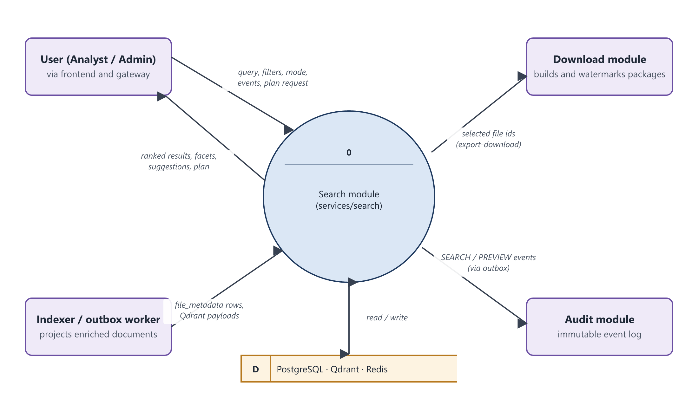
Figure 7.0a. Context data flow diagram (level 0) of the search module
Description: The search module (process 0) receives queries, filters and events from users through the gateway, and searchable rows and vector payloads from the indexer. It returns ranked results, facets, suggestions and download plans, hands selected file ids to the download module, and sends search and preview events to the audit module. All state lives in PostgreSQL, Qdrant and Redis.
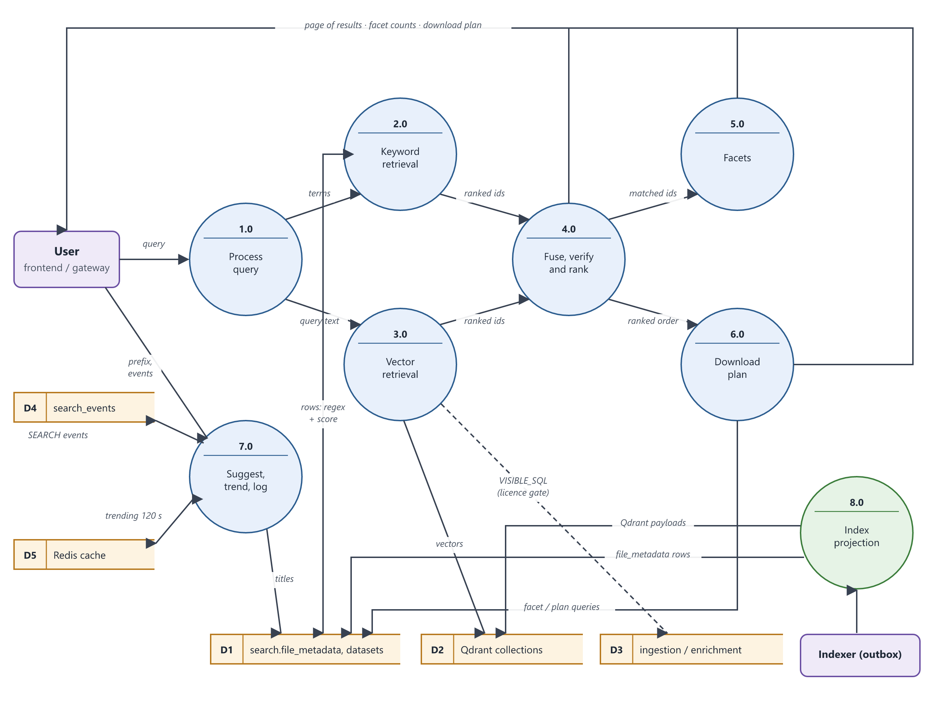
Figure 7.0b. Level-1 data flow diagram of the search module
Description: A query is normalised (1.0) and sent to keyword retrieval (2.0, PostgreSQL) and vector retrieval (3.0, Qdrant). Their ranked ids are fused and ranked (4.0). Facets (5.0) and download plans (6.0) are computed over the same matched set, and all three return to the user on one path. Suggestions, trending and event logging (7.0) use search_events and Redis. Index projection (8.0), driven by the indexer, keeps search.file_metadata and the Qdrant payloads current. The dashed flow is the licence gate (VISIBLE_SQL), which reads the ingestion and enrichment tables.

Data stores
Id | Data store | Technology | Contents and use
D1 | search.file_metadata, search.datasets | PostgreSQL | One denormalised searchable row per document (title, description, file name, category, summary, OCR, transcript, caption, tags, size, dimensions, flags, counters); dataset counts and popularity
D2 | multimodal_files and multimodal_files_v2 (Qdrant collections) | Qdrant | multimodal_files: one 512-d CLIP vector per document. multimodal_files_v2 (searched by Search): per document, “text” passage vectors (384-d MiniLM) and “visual” vectors (512-d CLIP), cosine, MAX_SIM multivector comparison, with the passages and filterable payload (file id, dataset, type, category, tags, flags, expiry, dimensions, representation version)
D3 | ingestion.documents, license_entitlements; enrichment.enrichment_tasks | PostgreSQL (read only) | Authoritative licence status and expiry, and enrichment status, read by the licence and publication gate (VISIBLE_SQL)
D4 | search.search_events | PostgreSQL | Search, preview and dataset-open events: query, normalised query, filters, result count, timing
D5 | Redis | Redis | Trending queries cache (120 s)
D6 | integration_outbox (search schema) | PostgreSQL | Durable audit deliveries written in the same transaction as events

Python libraries
Library | Used for
fastapi, uvicorn, starlette | HTTP API, dependency injection, thread pool for blocking work
pydantic, pydantic-settings | Request / response schemas, filter validation, configuration
sqlalchemy (async), asyncpg, psycopg2 | PostgreSQL access: keyword search, facets, licence gate, projection
qdrant-client | Vector search with HasId and payload filters, payload updates
open_clip_torch, torch | CLIP ViT-B/32 text encoder for query embeddings (modules/shared/embeddings.py)
transformers | all-MiniLM-L6-v2 query encoder for passage search; ms-marco-MiniLM-L6-v2 cross-encoder for relevance verification
redis (redis.asyncio) | Trending cache
httpx | Calls to the download and audit services
asyncio, functools.lru_cache, re, unicodedata, math | Concurrent branches, embedding cache, tokenisation and normalisation, ranking arithmetic

Equations used
Equation | Section
Keyword score: score(d) = Σₜ Σ_f w_f · 𝟙[t matches field f of d] | 7.4
Cosine similarity: sim(q, v) = (q · v) / (‖q‖ ‖v‖) | 7.5
Multivector MAX_SIM: sim(q, d) = max over vectors v of d of sim(q, v) | 7.5
Modality fusion: s(d) = Σ_{m ∈ {text, visual}} 1 / (60 + rank_m(d)) | 7.5
Relevance verification: keep d if logit ≥ −3 ∨ name match ∨ visual ≥ 0.28 ∨ semantic ≥ 0.42 | 7.7
Reciprocal Rank Fusion: RRF(d) = Σₘ wₘ / (k + rankₘ(d)), k = 60 | 7.6
Boost: final(d) = RRF(d) · (1 + 0.015 · max(0, 1 − age/180) + 0.035 · min(1, ln(1+e)/ln(101))) | 7.7

Algorithms
Algorithm | Technique | Section
Index projection | Idempotent upsert from canonical tables (outbox-driven) | 7.2
Query normalisation | NFKC normalisation, tokenisation, request-wording and exclusion handling, stop-word removal | 7.4
Keyword retrieval | Whole-term regular expression with plural variants, weighted field scoring | 7.4
Vector retrieval | Approximate nearest neighbour (HNSW, cosine, MAX_SIM multivectors) on text and visual vectors, restricted to eligible ids, fused by RRF | 7.5
Hybrid fusion | Reciprocal Rank Fusion | 7.6
Relevance verification | Cross-encoder scoring of (query, passage) pairs with acceptance rules | 7.7
Contextual re-ranking | Bounded multiplicative recency and popularity boosts | 7.7
Facets | SQL GROUP BY over the matched set; self-ignoring facet filters | 7.8
Download planning | Greedy in-order packing into archive parts | 7.8

7.1 Features
The functionalities below are implemented and tested. Each is documented in the mentor's format in the section shown.
Feature | Functionality | Section
Three modes: hybrid (default), text (keyword only) and vector (semantic only) | 4, 5, 6, 7, 8 | 7.4–7.7
Filters: file type, category, dataset, tags, AI-generated flag, PII flag, date range, resolution tier, size bucket and byte range | 2, 4, 5 | 7.3–7.5
Facet counts that stay meaningful when filters are applied | 9 | 7.8
Autocomplete suggestions, 24-hour trending queries, popular datasets | 10 | 7.8
Similar-item search from any document | 11 | 7.8
Download planning for “top N results” with size and part estimates | 12 | 7.8
Search, preview and dataset-open events feeding analytics, popularity and audit | 14 | 7.10

7.2 Index projection
Search reads from its own denormalised table, search.file_metadata, rather than joining across schemas at query time.
Functionality 1: Project a document into the search index
Prerequisite | • Document ingested with a licence entitlement  • Enrichment task completed or partial; CLIP vector stored in Qdrant  • An index delivery queued in the transactional outbox
Input | • document_id (from the outbox delivery)
Process / activity | 1. Read the canonical document, its connector, licence, latest enrichment metadata and vendor metadata in one query.  2. Union AI and vendor tags without duplicates.  3. Map the MIME type to a file type (image, video, audio, csv, document).  4. Prefer pixel dimensions and duration measured by the AI pipeline over vendor-supplied values.  5. Compute the publication flag (task completed or partial and safety checks cleared).  6. If the document is publishable but its vector is not yet visible in Qdrant, raise an error so the outbox retries later.  7. Update the Qdrant payload with the filterable fields and the publication flag.  8. Upsert the search.file_metadata row and refresh the dataset's file count and size.
Datastore | • Reads: ingestion.documents, connectors, license_entitlements, document_metadata; enrichment.enrichment_tasks, document_enrichment_metadata  • Writes: search.file_metadata, search.datasets, Qdrant payload (D2)
Technology / tools | • Python, SQLAlchemy (psycopg2), qdrant-client  • Outbox worker (modules/shared/outbox_worker.py), indexer (modules/shared/indexer.py)
Output | • One searchable row and an updated vector payload. All writes are upserts, so replays are safe.
Status | Tested

Algorithm (pseudocode): Project a document into the search index
procedure INDEX_DOCUMENT(document_id)
row ← SELECT document ⋈ connector ⋈ licence ⋈ latest enrichment ⋈ vendor metadata
if row = ∅ then raise NotFound
tags ← unique(ai_tags ∪ vendor_tags)
file_type ← MAP_MIME(row.mime_type)
width, height, duration ← measured values if present else vendor values
published ← row.task_status ∈ {completed, partial} ∧ SAFETY_CLEARED(row)
if published ∧ QDRANT_POINT(document_id) = ∅ then
raise NotDurable ▷ outbox retries later
QDRANT_SET_PAYLOAD(document_id, filterable fields, published)
UPSERT search.file_metadata(row, tags, file_type, …)
UPDATE datasets SET file_count, total_size_bytes FROM published rows
end procedure

7.3 Query pipeline
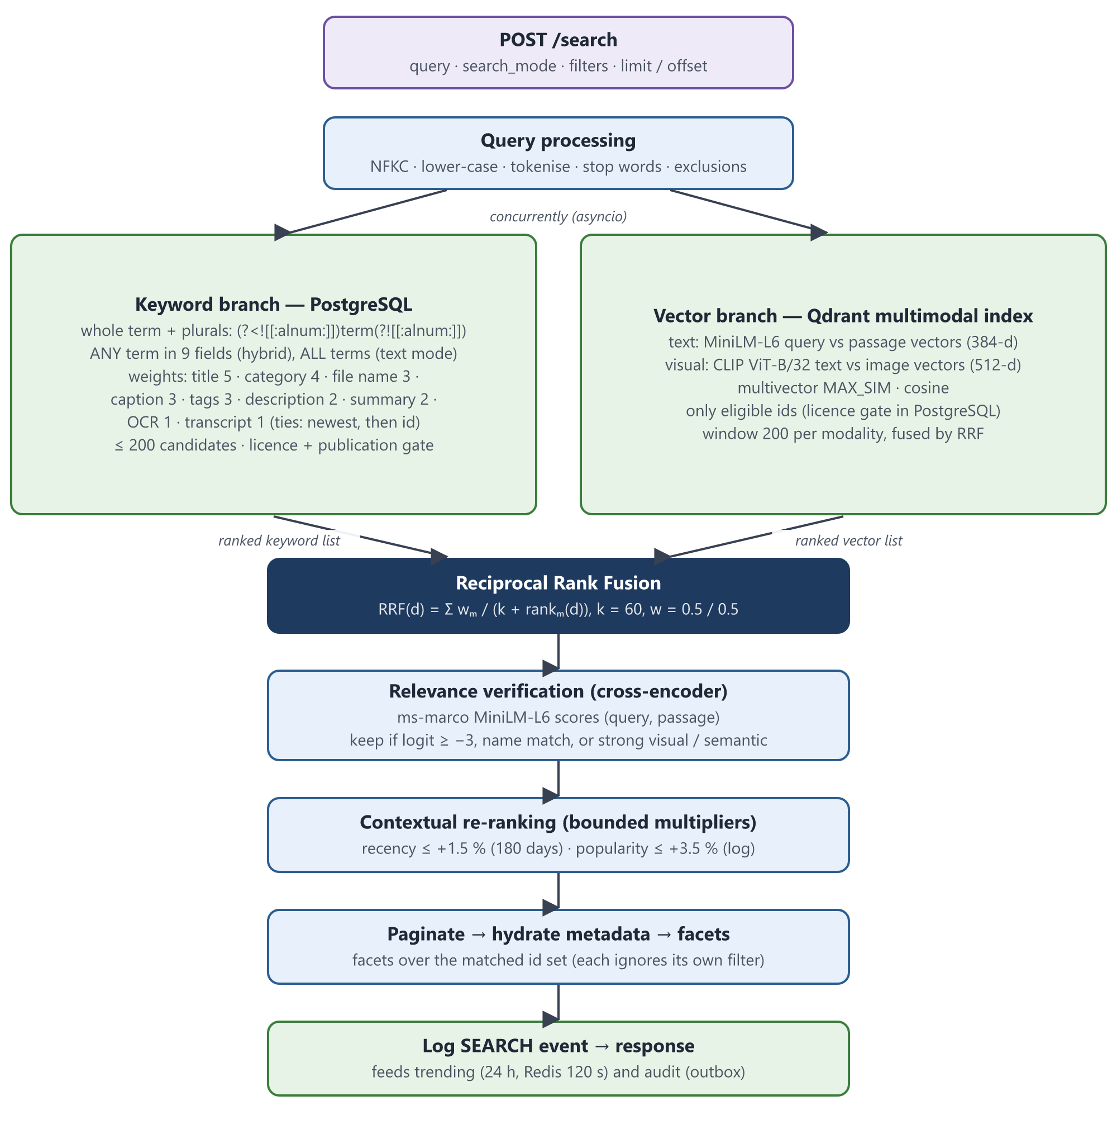
Figure 8. Hybrid search pipeline: concurrent keyword and vector retrieval, rank fusion, relevance verification and bounded re-ranking
Description: A POST /search request is normalised, then the keyword branch (PostgreSQL, whole terms with plurals) and the vector branch (Qdrant multimodal index: MiniLM text passages and CLIP visual vectors) run concurrently. Their ranked lists are combined by Reciprocal Rank Fusion, checked by a cross-encoder relevance model, adjusted by small bounded recency and popularity multipliers, paginated and hydrated with metadata. Facets are counted over the matched set, and the search is logged for trending and audit.
Functionality 2: Run a search request
Prerequisite | • User authenticated by the gateway with search:read  • Documents projected (Functionality 1)
Input | • query, search_mode (hybrid | text | vector), filters, limit (1–100), offset (0–10 000), optional rrf_k and branch weights
Process / activity | 1. Validate the request and normalise the query (Functionality 3).  2. Route by mode: text → keyword branch only; vector → vector branch only; hybrid → both branches concurrently.  3. In hybrid mode fuse the candidate lists with Reciprocal Rank Fusion (Functionality 6).  4. Verify relevance with the cross-encoder (Functionality 7), then apply contextual re-ranking to the whole candidate set (Functionality 8) and paginate.  5. Hydrate the page with metadata and compute facets over the matched set (Functionality 9).  6. Log a SEARCH event with timing and result count (Functionality 14) and return the response.
Datastore | • D1 search.file_metadata, D2 Qdrant, D3 licence tables (gate), D4 search_events
Technology / tools | • FastAPI, asyncio.gather, SQLAlchemy async (asyncpg), qdrant-client
Output | • SearchResponse: query, search_mode, total, limit, offset, execution_time_ms, results (with score information), facets
Status | Tested

7.4 Keyword retrieval
Functionality 3: Normalise and tokenise the query
Prerequisite | • A non-empty query string
Input | • Raw query text
Process / activity | 1. Remove request wording at the start of the query (“show me”, “find”, “search for”, “give me”).  2. Split off a trailing exclusion (“without”, “excluding”, “except”, “but not”, “not”); its terms are used to remove contradicting results during relevance verification (Functionality 7).  3. Unicode-normalise the text (NFKC), lower-case it and replace punctuation other than hyphens with spaces.  4. Split it into tokens: runs of letters and digits in any script.  5. Remove English stop words, unless the query consists only of stop words.  6. Keep at most 32 tokens.
Datastore | • None (in memory)
Technology / tools | • Python re, unicodedata (app/utils/query_normalizer.py)
Output | • Ordered token list used by the keyword branch; positive query text for the vector branch; exclusion terms
Status | Tested

Algorithm (pseudocode): Normalise and tokenise the query
function NORMALISE(query)
query ← REMOVE_PREFIX(query, {"show me", "find", "search for", "give me"})
positive, excluded ← SPLIT_AT(query, {"without", "excluding", "except", "but not", "not"})
text ← lower(NFKC(positive)); text ← replace [^\w\s-] with " "
tokens ← all runs of letters/digits in text
kept ← [t ∈ tokens | t ∉ STOP_WORDS]
if kept = ∅ then kept ← tokens ▷ query made only of stop words
return first 32 of kept, excluded
end function

Functionality 4: Retrieve and score keyword matches
Prerequisite | • Normalised tokens (Functionality 3)  • Projected rows in search.file_metadata
Input | • tokens, filters, limit, offset
Process / activity | 1. For each token build its word forms: the term plus conservative English plurals (ball ↔ balls, city ↔ cities, man ↔ men; person also covers people, man, woman, child). Identifiers and other scripts are kept as they are.  2. Match each form as a whole term, case-insensitively: PostgreSQL ~* '(?<![[:alnum:]])(forms)(?![[:alnum:]])'. So “ai” does not match “detail” or “email”, “4k” does not match “24k”, and “ball” does not match “balloon”.  3. Search nine fields: title, description, file name, category, content summary, OCR text, transcript, caption, tags. In text mode a document must match every token (AND); the keyword branch of hybrid search accepts any token (OR) and keeps the top 200 candidates.  4. Apply the user filters and the licence and publication gate (Functionality 13).  5. Score each document by the sum of field weights over every (token, field) match.  6. Order by score, then newest ingestion, then file id, giving a deterministic order.
Datastore | • D1 search.file_metadata; D3 through the gate
Technology / tools | • PostgreSQL regular expressions, SQLAlchemy CASE expressions (app/repositories/file_repository.py, query_normalizer.term_pattern)
Output | • Ranked (file, score) list and the total number of matches. The same scoring expression is used for results and for download planning, so “top N” always means the same files.
Status | Tested

Equations
score(d) = Σ_{t ∈ tokens} Σ_{f ∈ fields} w_f · 𝟙[ a form of t occurs as a whole term in field f of d ]
Field weights w_f: title 5, category 4, file name 3, caption 3, tags 3, description 2, content summary 2, OCR text 1, transcript 1.
Algorithm (pseudocode): Retrieve and score keyword matches
function KEYWORD_SEARCH(tokens, filters, limit, offset, mode)
W ← {title:5, category:4, file_name:3, caption:3, tags:3,
description:2, summary:2, ocr_text:1, transcript:1}
for t in tokens do P[t] ← "(?<![[:alnum:]])(" + JOIN("|", FORMS(t)) + ")(?![[:alnum:]])"
for each visible row d satisfying filters do
hit(t) ← ∃ f ∈ W : f(d) ~* P[t]
if (mode = text ∧ ∀t hit(t)) ∨ (mode = hybrid ∧ ∃t hit(t)) then
score(d) ← Σ_t Σ_f W[f] · [f(d) ~* P[t]]
add d to R
sort R by (score desc, ingested_at desc, file_id asc)
return R[offset : offset + limit], |R|
end function

Field | Weight | Field | Weight
Title | 5 | Tags | 3
Category | 4 | Description | 2
File name | 3 | Content summary | 2
Caption | 3 | OCR text / transcript | 1 each
Table 13. Keyword field weights

7.5 Vector retrieval
Functionality 5: Retrieve semantically similar documents
Prerequisite | • Documents indexed in the multimodal collection (multimodal_files_v2): text passage vectors and visual vectors  • Embedding models loaded at startup
Input | • positive query text (or a stored document vector for similar items), filters, window size
Process / activity | 1. Encode the query twice: with all-MiniLM-L6-v2 (mean-pooled, L2-normalised, 384-d) for the text passages, and with the CLIP ViT-B/32 text encoder (512-d, in-process LRU cache of 256 entries) for the visual vectors.  2. Compute the eligible id set in PostgreSQL by applying the same filters and the licence and publication gate. If more than 100 000 documents are eligible, reject the request with HTTP 422 and ask the user to narrow the filters.  3. Query Qdrant once per modality, restricted to those ids (HasIdCondition) and the current representation version, over a window of max(200, offset + limit). Each document has several vectors; its similarity is the best match among them (MAX_SIM). Visual hits must score at least 0.26.  4. Fuse the two modality lists by Reciprocal Rank Fusion (k = 60), keeping each document's text and visual similarity.  5. For text hits, record the passage that best matches the query; it is shown to the relevance check (Functionality 7).
Datastore | • D2 Qdrant (multimodal_files_v2); D1 and D3 for the eligible id set
Technology / tools | • transformers (MiniLM), open_clip_torch, torch, qdrant-client (HNSW cosine search, multivector MAX_SIM), functools.lru_cache
Output | • Ranked (file id, fused score) list with text similarity, visual similarity and matched passage
Status | Tested

Equations
sim(q, v) = (q · v) / (‖q‖ · ‖v‖)
sim_m(q, d) = max_{v ∈ vectors_m(d)} sim(q_m, v), m ∈ {text, visual}
s(d) = Σ_m 1 / (60 + rank_m(d))
Algorithm (pseudocode): Retrieve semantically similar documents
function VECTOR_SEARCH(query, filters, limit, offset)
q_text ← L2_NORMALISE(MEAN_POOL(MINILM(query))) ▷ 384-d
q_visual ← CLIP_TEXT(query) ▷ 512-d, LRU 256
E ← SELECT file_id WHERE filters ∧ VISIBLE_SQL LIMIT 100 001
if |E| > 100 000 then raise HTTP 422 "narrow the filters"
window ← max(200, offset + limit)
for m in {text, visual} do
H_m ← QDRANT(using = m, query = q_m, filter = HasId(E) ∧ version,
limit = window, comparator = MAX_SIM,
min_score = (m = visual ? 0.26 : 0))
for (rank, h) in enumerate(H_m, from 1) do
S[h] += 1 / (60 + rank); sim_m[h] ← h.score
if m = text then passage[h] ← best-matching passage of h
R ← documents of S sorted by S descending
return R[offset : offset + limit], |R|
end function

7.6 Reciprocal Rank Fusion
Functionality 6: Fuse keyword and vector results
Prerequisite | • Ranked lists from Functionality 4 and Functionality 5
Input | • keyword ranked list, vector ranked list, k (default 60), branch weights (default 0.5 / 0.5)
Process / activity | 1. Run both branches concurrently with asyncio.gather.  2. For each document add wₘ / (k + rankₘ(d)) for every branch m that returned it.  3. Sort by the fused score. A document found by both branches accumulates both contributions and rises above documents found by only one.
Datastore | • None (in memory)
Technology / tools | • Python (app/utils/rrf.py), asyncio
Output | • Fused candidate list with keyword rank, vector rank and fused score per document
Status | Tested

Equations
RRF(d) = Σ_{m ∈ {keyword, vector}} w_m / (k + rank_m(d)), k = 60, w_keyword = w_vector = 0.5
RRF uses ranks rather than raw scores, so the keyword branch's integer weights and the vector branch's cosine similarities never need to be calibrated against each other. For example, a document ranked 1st by keywords and 3rd by vectors scores 0.5/61 + 0.5/63 ≈ 0.01613, while a document ranked 1st by only one branch scores 0.5/61 ≈ 0.00820.
Algorithm (pseudocode): Fuse keyword and vector results
function RRF(keyword_list, vector_list, k, w_kw, w_vec)
S ← empty map
for (rank, d) in enumerate(keyword_list, from 1) do S[d] += w_kw / (k + rank)
for (rank, d) in enumerate(vector_list, from 1) do S[d] += w_vec / (k + rank)
return documents of S sorted by S[d] descending
end function

7.7 Contextual re-ranking
Hybrid and vector candidates pass two steps before pagination: a cross-encoder relevance check, then bounded recency and popularity boosts. Text-mode results are not re-ranked.
Functionality 7: Verify relevance with a cross-encoder
Prerequisite | • Candidates from fusion (Functionality 6) or vector retrieval (Functionality 5) with their metadata  • Cross-encoder model loaded at startup
Input | • query, exclusion terms (Functionality 3), candidates with text and visual similarity and matched passage
Process / activity | 1. If the query is a complete file name (for example photo_12.jpg), keep only files with exactly that name.  2. Remove candidates that contain all of the excluded terms in their title, file name, description, caption, OCR text or transcript.  3. Build up to four passages per candidate: the passage matched by vector search, the start of its title, description, caption and file name, and the windows of longer text (140 words) that contain the most query terms.  4. Score each (query, passage) pair with the ms-marco-MiniLM-L6-v2 cross-encoder in batches of 16; a candidate's score is its best passage score. Pair scores are cached in memory (4 096 pairs).  5. Keep a candidate if any one holds: its score is at least −3; its title or file name (and, for queries of up to two terms, its description or caption) contains every query term; its visual similarity is at least 0.28; its text similarity is at least 0.42.  6. Order kept candidates by relevance score, then by fused score; the boosts of Functionality 8 adjust the fused score, so they break ties among equally relevant results.
Datastore | • D1 (candidate text); model weights pinned to a fixed revision
Technology / tools | • transformers (AutoModelForSequenceClassification), torch inference mode (app/services/relevance_service.py)
Output | • Only candidates the model or direct evidence supports, each with a relevance score; the same check is used for results, facets and download plans
Status | Tested

Equations
logit(d) = max_{p ∈ passages(d)} CrossEncoder(query, p)
keep(d) ⇔ logit(d) ≥ −3 ∨ name_match(d) ∨ visual(d) ≥ 0.28 ∨ semantic(d) ≥ 0.42
relevance(d) = max( logit(d), 20 · (visual(d) − 0.28), 12 · (semantic(d) − 0.42), 0 if name_match(d) )
The visual and text-similarity terms count only when that similarity passes its threshold; otherwise they do not contribute. A cross-encoder logit is not a probability, so it is used only for ordering and filtering, never shown to users.
Algorithm (pseudocode): Verify relevance with a cross-encoder
function VERIFY(query, excluded, C)
if query is a complete file name then C ← [d ∈ C | d.file_name = query]
if excluded ≠ ∅ then C ← [d ∈ C | ¬ ALL_TERMS_IN(excluded, d)]
for d in C do
P ← first 4 of unique([d.matched_passage] ++ PASSAGES(query, d))
logit ← max over p ∈ P of CROSS_ENCODER(query, p) ▷ batches of 16, cached
name ← NAME_MATCH(query, d)
vis ← d.visual ≥ 0.28; sem ← d.semantic ≥ 0.42
if logit ≥ −3 or name or vis or sem then
d.relevance ← max(logit, vis ? 20·(d.visual−0.28) : −∞,
sem ? 12·(d.semantic−0.42) : −∞, name ? 0 : −∞)
add d to K
return K sorted by (relevance desc, fused score desc, id)
end function

Functionality 8: Apply bounded recency and popularity boosts
Prerequisite | • Verified candidate list (Functionality 7) with metadata
Input | • fused candidates; ingested_at, download_count, file_preview_count of each
Process / activity | 1. Recency: up to +1.5 %, decaying linearly to zero over 180 days since ingestion.  2. Popularity: up to +3.5 %, proportional to log(1 + 2 × downloads + previews) and saturating at 100 events.  3. Multiply each fused score by (1 + recency + popularity) and re-sort the entire candidate set before pagination, so boosts cannot reorder results across page boundaries.
Datastore | • D1 (counters and ingestion time)
Technology / tools | • Python math (app/services/ranking_service.py)
Output | • Final ranked list. Because neighbouring RRF scores differ by roughly 1 %, these multipliers can only reorder results of near-equal relevance.
Status | Tested

Equations
recency(d) = 0.015 · max(0, 1 − age_days(d) / 180)
popularity(d) = 0.035 · min(1, ln(1 + e(d)) / ln(1 + 100)), e(d) = 2 · downloads + previews
final(d) = RRF(d) · (1 + recency(d) + popularity(d))
Algorithm (pseudocode): Apply bounded recency and popularity boosts
procedure RERANK(candidates)
for each d in candidates do
age ← (now − d.ingested_at) in days
e ← 2 · d.download_count + d.file_preview_count
boost ← 1 + 0.015 · max(0, 1 − age/180)
+ 0.035 · min(1, ln(1+e) / ln(101))
d.score ← d.score · boost
sort candidates by score descending ▷ whole set, then paginate
end procedure

7.8 Facets, suggestions, trending, similar items and download planning
Functionality 9: Compute facet counts
Prerequisite | • A completed search (matched id set or keyword query)
Input | • query, filters, matched ids (hybrid and vector) or the keyword query (text)
Process / activity | 1. Count in SQL over exactly the set of ids the search matched (hybrid and vector) or over the keyword query (text).  2. File-type, resolution and size facets each ignore their own filter, so selecting “image” does not hide the counts of other types.  3. Count categories, datasets, AI-generated and PII flags with GROUP BY.  4. Expand top tags with json_array_elements_text inside PostgreSQL (top 15); no records are loaded into Python.
Datastore | • D1 search.file_metadata
Technology / tools | • SQLAlchemy GROUP BY, CASE (resolution tiers by long edge, size buckets), PostgreSQL JSON functions
Output | • FacetsResponse: file types, categories, datasets, flags, top tags, resolutions, sizes, total matches
Status | Tested

Algorithm (pseudocode): Compute facet counts
function FACETS(scope, filters)
for facet in {file_types, resolutions, sizes} do
F_facet ← filters without facet's own filter ▷ self-ignoring
counts[facet] ← GROUP BY facet over SEARCH(scope, F_facet)
for facet in {categories, datasets, ai_generated, pii_detected} do
counts[facet] ← GROUP BY facet over SEARCH(scope, filters)
counts[top_tags] ← top 15 of GROUP BY json_array_elements_text(tags)
return counts
end function

Functionality 10: Suggestions, trending queries and popular datasets
Prerequisite | • Logged search events (Functionality 14)  • Redis available for the trending cache
Input | • partial query (suggestions); none (trending, popular datasets)
Process / activity | 1. Trending: aggregate normalised queries from the last 24 hours and cache the result in Redis for 120 seconds.  2. Suggestions: combine matching trending queries with distinct visible titles found by a prefix match on lower(title), which uses a text_pattern_ops expression index.  3. Popular datasets: rank datasets that have at least one visible file by popularity score, then view count.
Datastore | • D4 search_events, D1 file_metadata and datasets, D5 Redis
Technology / tools | • SQLAlchemy, redis.asyncio, PostgreSQL text_pattern_ops index
Output | • Trending query list, suggestion list, popular dataset list
Status | Tested

Functionality 11: Find similar items
Prerequisite | • The source document is visible  • It is indexed in the multimodal collection (otherwise its title is used)
Input | • file_id, optional filters, limit
Process / activity | 1. Load the source document and compute the eligible id set with the filters and the licence gate, excluding the document itself.  2. Read the document's stored vectors from Qdrant and use its first visual vector, or its first text-passage vector if it has no visual one, as the query.  3. If the document has no stored vectors, search by its title instead, as a normal text query (Functionality 5).  4. Search only that one modality over the eligible ids, without a minimum score, and rank by similarity.
Datastore | • D2 Qdrant (multimodal_files_v2), D1, D3 (gate)
Technology / tools | • qdrant-client (retrieve with vectors, query_points), MiniLM and CLIP encoders for the title fallback
Output | • Ranked list of similar documents, never including the source document
Status | Tested

Algorithm (pseudocode): Find similar items
function SIMILAR(file_id, filters, limit)
E ← SELECT file_id WHERE filters ∧ VISIBLE_SQL ∧ file_id ≠ source
V ← QDRANT_RETRIEVE(file_id, with_vectors)
if V ≠ ∅ then
m ← (V.visual ≠ ∅) ? visual : text
return QDRANT(using = m, query = first vector of V.m, filter = HasId(E), limit)
return VECTOR_SEARCH(title(file_id), filters, limit) restricted to E
end function

Functionality 12: Plan a “download top N” request
Prerequisite | • A search with results  • Download limits configured (per file, per part, file count, total size)
Input | • query, mode, filters, requested count N
Process / activity | 1. Walk up to 30 000 ranked results in the search's own order.  2. Exclude files over the per-file limit.  3. Pack the remainder greedily in rank order to estimate the part count and total bytes.  4. Compute the largest leading selection that fits within the file-count and total-size limits.
Datastore | • D1 (sizes); limits from shared configuration
Technology / tools | • Pure Python (app/utils/download_plan.py), the same ranking as search
Output | • Plan: count, available, total bytes, estimated parts, excluded oversized files, within_limits, fit_count, truncated
Status | Tested

Algorithm (pseudocode): Plan a “download top N” request
function PLAN(ranked[(id, size)], N, limits)
eligible ← [(id, s) ∈ ranked | s ≤ max_file_bytes]
selected ← first min(N, |eligible|) of eligible
parts ← 0; used ← 0
for s in sizes(selected) do ▷ greedy, in rank order
if parts = 0 or used + s > part_bytes then parts ← parts + 1; used ← 0
used ← used + s
fit ← 0; run ← 0
for (id, s) in first max_files of eligible do
if run + s > max_total_bytes then break
run ← run + s; fit ← fit + 1
return {count:|selected|, total_bytes:Σ sizes(selected), parts, fit_count:fit,
within_limits: 0 < |selected| ≤ max_files ∧ Σ ≤ max_total_bytes}
end function

7.9 Licence and publication gate
Functionality 13: Enforce licence and publication on every read
Prerequisite | • Licence entitlements and enrichment tasks recorded by the ingestion and AI modules
Input | • Any search, detail lookup, preview or download admission
Process / activity | 1. Apply one shared SQL predicate, VISIBLE_SQL, to every query.  2. A document is visible only if its licence is active and unexpired, its enrichment task is completed or partial, and its catalogue row is published.
Datastore | • D3 ingestion.documents, license_entitlements; enrichment.enrichment_tasks; D1 published flag
Technology / tools | • PostgreSQL EXISTS sub-query (modules/shared/catalog.py)
Output | • Only visible documents. Because the check reads the authoritative tables at request time, a stale Qdrant payload or cached value can never grant access to an expired or unpublished document.
Status | Tested

Algorithm (pseudocode): VISIBLE_SQL predicate
VISIBLE(d) ≡ ∃ document, licence e, task t :
document.id = d.file_id
∧ e.status = 'active' ∧ e.expires_at > now()
∧ t.status ∈ {completed, partial}
∧ d.published = true

7.10 API surface
Endpoint | Purpose
POST /search | Hybrid, text or vector search with filters and pagination
POST /search/text, /search/vector | Single-branch search
POST /search/similar | Similar documents
GET /search/facets, /search/trending, /search/suggestions | Facets, trending queries, autocomplete
POST /search/download-plan | Size, part count and fit for a “top N” download
GET /files/{id}, GET /datasets/popular | Document details, popular datasets
POST /events/search | Record preview, dataset-open and similar interaction events
Table 14. Search endpoints
Functionality 14: Record search and interaction events
Prerequisite | • Authenticated user
Input | • Event type (SEARCH, PREVIEW, dataset open, similar), query, filters, result count, timing
Process / activity | 1. Write the event to search_events.  2. Queue an audit delivery in the outbox in the same transaction, so the audit record cannot be lost.  3. Update the counters used by popularity (Functionality 8): a file preview increments the file's preview count, and a dataset open increments the dataset's view count. Download counts are incremented by the download module when a download is delivered.
Datastore | • D4 search_events, D6 integration_outbox, D1 counters
Technology / tools | • SQLAlchemy, transactional outbox
Output | • Events feeding analytics, popularity, trending and the audit module
Status | Tested

7.11 Scalability changes
To support a catalogue of millions of documents (about 500 TB of source data), the following changes have been implemented in services/search/backend and the shared modules. They keep the rule that unpublished, unlicensed or expired documents are never returned, and they leave the behaviour of sections 7.1–7.10 unchanged on the current data. Every change in this section needs to be tested with a real and large dataset. Local checks done so far are listed in 7.11.3.
Id | Change | Algorithm / technique | Removes
S1 | Licence gate without the 100 000-id limit | Exact id list up to a gate; above it Qdrant payload filters + SQL verification + adaptive fetching | HTTP 422 for broad vector queries
S2 | Index-backed keyword prefilter | GIN index on a tsvector (ASCII terms) and GIN trigram index (other scripts) | Full-table regex scans
S3 | Lightweight candidates | Page-only reads, window COUNT, id/size-only download plans | Loading hundreds of full rows per request
S4 | Result and facet cache | Redis cache keyed by catalogue version; lifetime bounded by the next licence expiry | Recomputing identical searches
S5 | Qdrant layout | Hash sharding (6), replication (2), tuned HNSW, int8 quantisation, alias migration | Single node, no high availability
S6 | Graceful degradation | Circuit breaker, keyword fallback, strict lexical fallback | Hard failures when Qdrant or the model is down
S7 | Database access | PgBouncer transaction pooling, optional read replica | Connection exhaustion under load
S8 | Shared caches and monitoring | Redis embedding and relevance-score caches; Prometheus metrics and alerts | Per-replica caches, no visibility
S9 | Horizontal scaling | Stateless replicas behind the gateway | Single API process
S10 | Licence-change propagation | Outbox search-refresh deliveries; payload backfill | Stale licence data in Qdrant
Table 14.1. Summary of scalability changes

7.11.1 Changes in the mentor's format
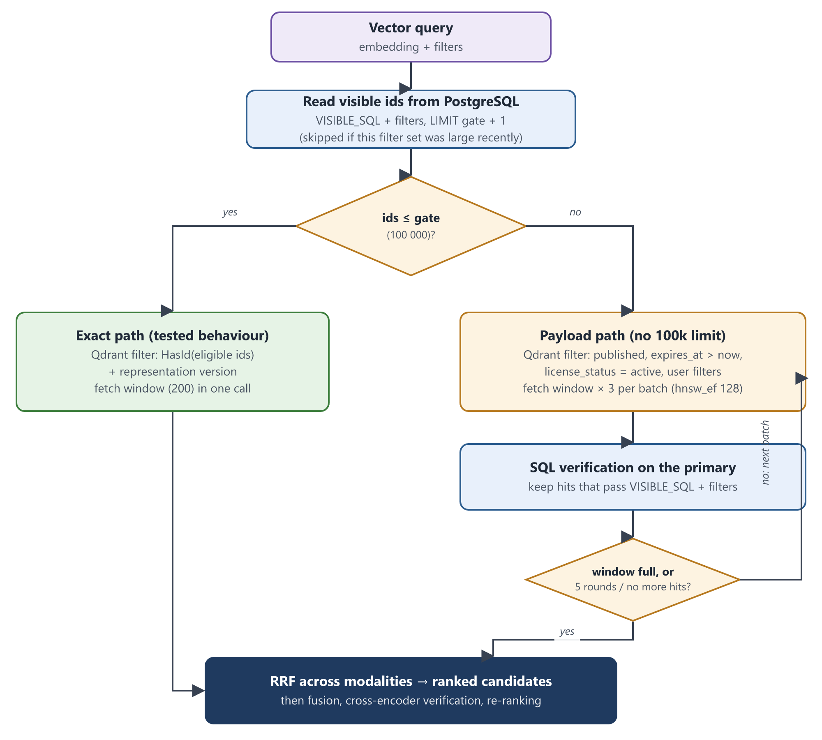
Figure 7.11a. Vector licence gate with the exact and payload paths (S1)
Description: Visible ids are read from PostgreSQL up to the gate (100 000). Below it, the tested exact path sends the id list to Qdrant. Above it, Qdrant filters on payload fields (published, expiry, licence status, user filters), every hit is verified in SQL on the primary, and further batches are fetched until the window is full or five rounds have run. Both paths then feed the existing fusion and ranking.
Functionality S1: Licence gate without the 100 000-id limit
Prerequisite | • Qdrant payloads contain published, expires_at and license_status (indexer, S10)  • Payload indexes created by the migration
Input | • Query vector(s), filters, window size, optional source document (similar items)
Process / activity | 1. Read up to gate + 1 visible ids (VECTOR_EXACT_GATE_MAX, default 100 000). A filter set found above the gate in the last 5 minutes skips this read.  2. If the set fits the gate, use the tested exact path: HasId(eligible ids).  3. Otherwise build a Qdrant payload filter: published = true, expires_at > now, license_status not other than active, plus the user filters (size and resolution too, once QDRANT_EXTENDED_PAYLOAD is enabled).  4. Fetch window × 3 hits per batch with hnsw_ef = 128, verify them against VISIBLE_SQL and the filters on the primary database, and fetch the next batch until the window is full, Qdrant has no more matches, or 5 rounds have run.  5. For the single-vector endpoint, report the exact Qdrant count of the same filter as the total.
Datastore | • D2 Qdrant (payload indexes: license_status, file_size, long_edge added)  • D1, D3 for the id read and verification
Technology / tools | • qdrant-client (FieldCondition, MatchExcept, HasIdCondition, SearchParams, count)  • SQLAlchemy (psycopg2)  • services/vector_search_service.py, utils/filters.py
Output | • Verified, ranked vector candidates for any catalogue size; no HTTP 422
Status | Implemented — needs to be tested with a real and large dataset

Equations
batch = max(200, offset + limit) × 3, rounds ≤ 5
result = { h ∈ Qdrant(filter) | VISIBLE(h) ∧ filters(h) }, stop when |result| ≥ window
Algorithm (pseudocode): Licence gate without the 100 000-id limit
function GATED_VECTOR_SEARCH(q, filters, window)
if LARGE_RECENTLY(filters) then E ← None
else E ← SELECT file_id WHERE filters ∧ VISIBLE LIMIT gate+1
if |E| > gate then E ← None; REMEMBER_LARGE(filters, 5 min)
if E ≠ None then ▷ exact path (tested)
return QDRANT(q, HasId(E), limit = window)
F ← published ∧ expires_at > now ∧ ¬(license_status ≠ active) ∧ filters
kept ← []; offset ← 0
repeat at most 5 times
H ← QDRANT(q, F, limit = 3·window, offset, hnsw_ef = 128)
kept ← kept ++ [h ∈ H | h.id ∈ SQL_VISIBLE(ids(H), filters)]
if |kept| ≥ window or |H| < 3·window then break
offset ← offset + 3·window
return first window of kept
end function

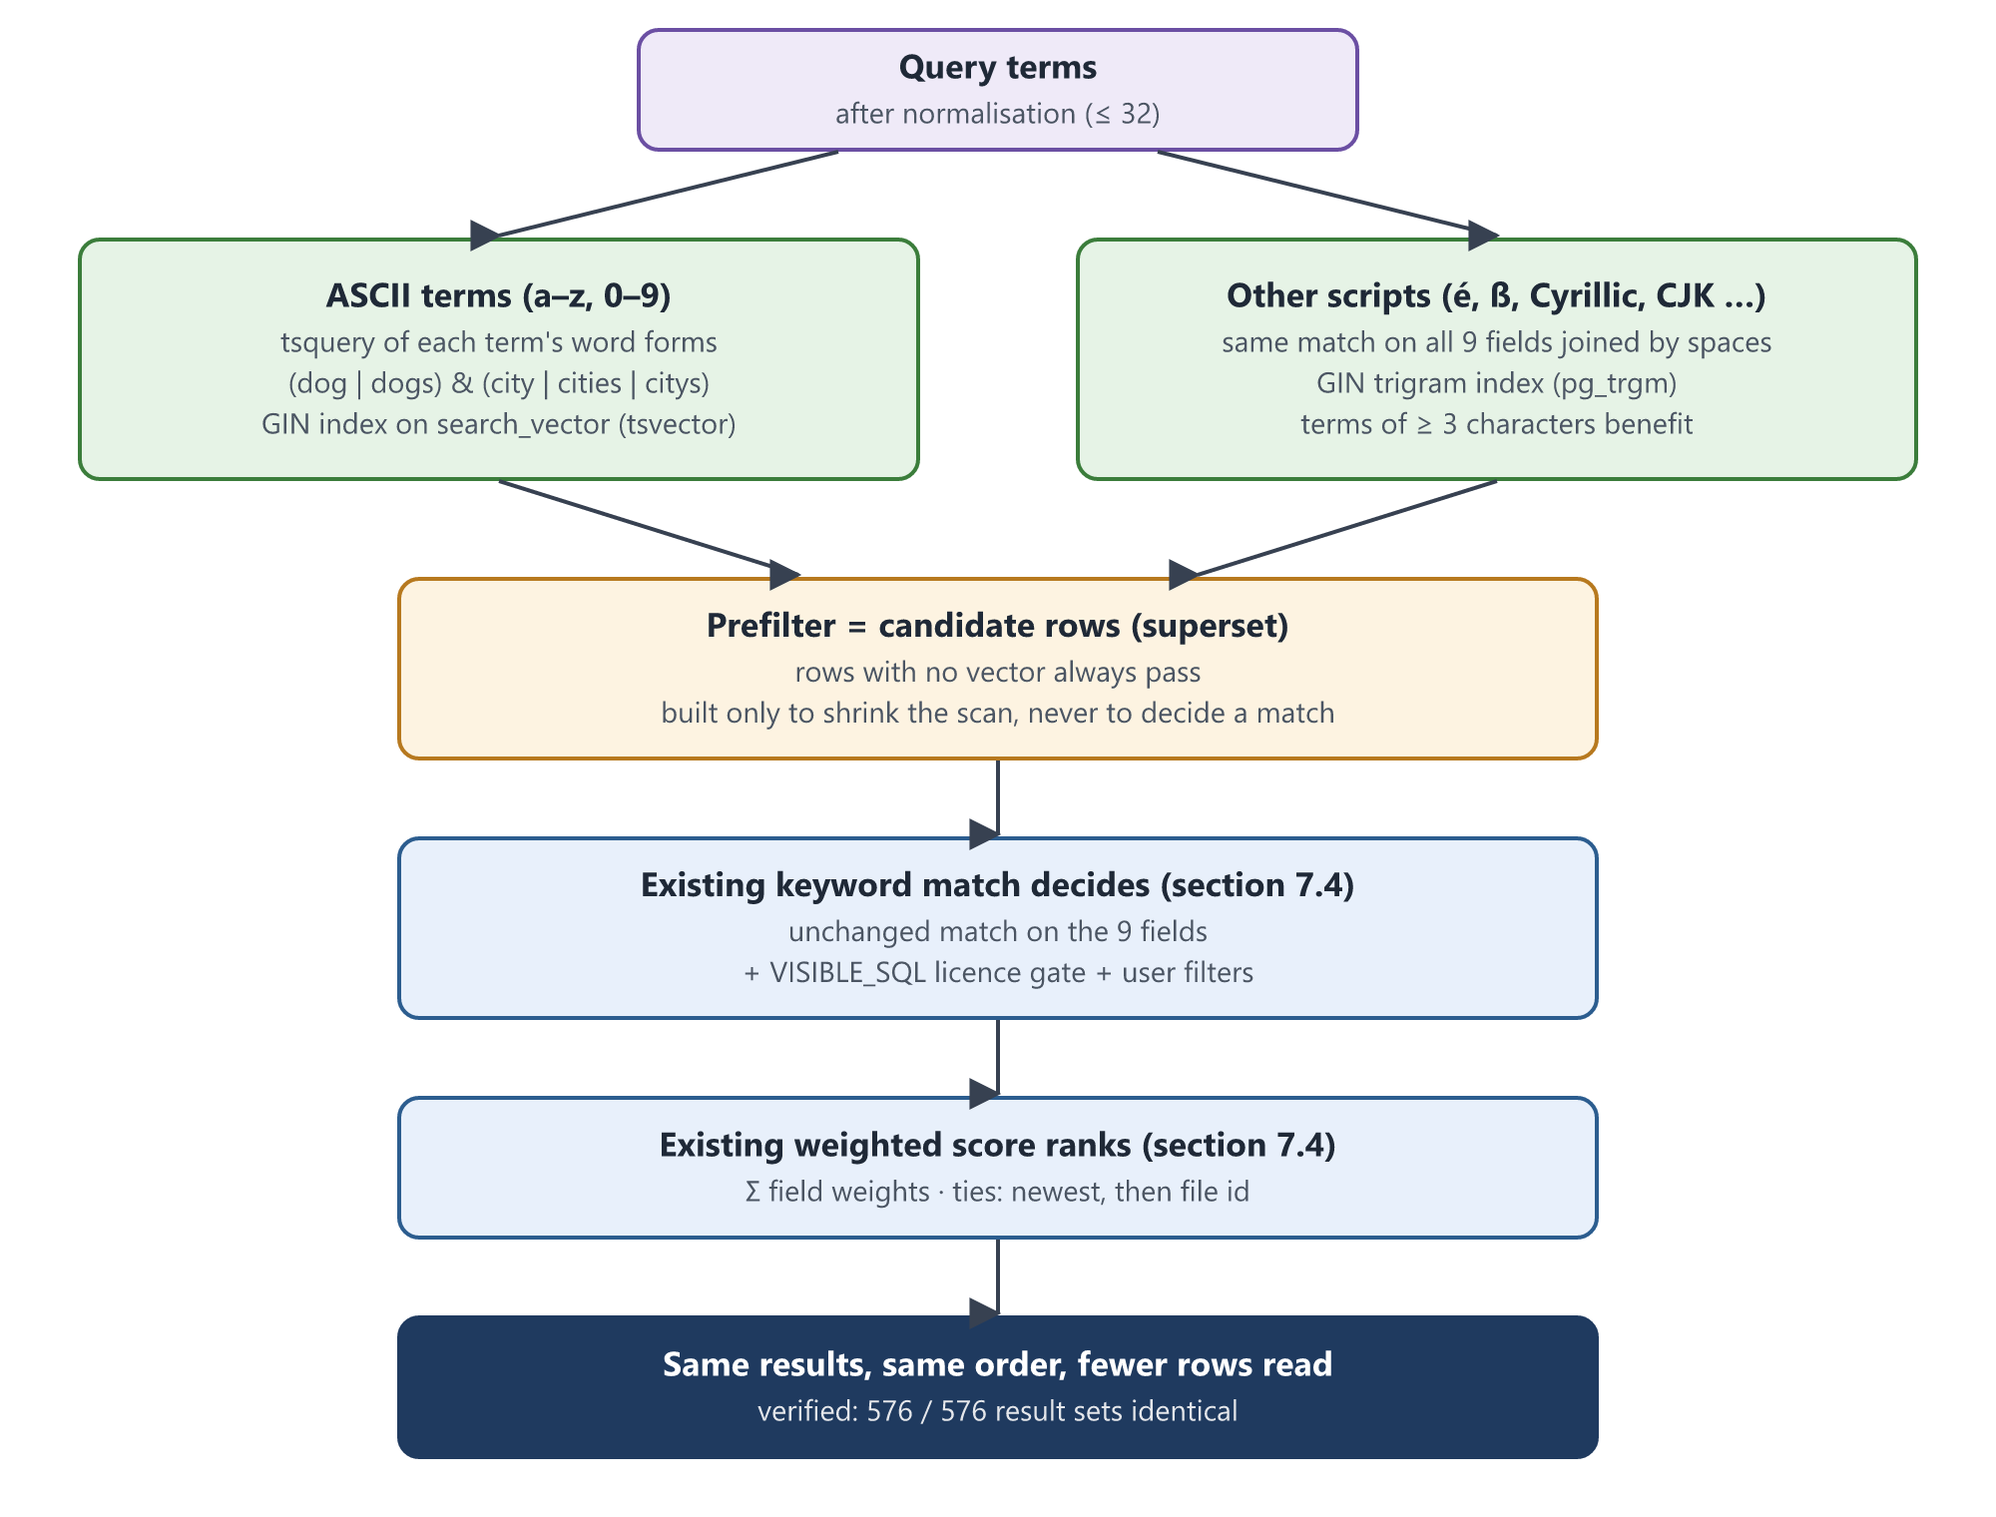
Figure 7.11b. Index-backed keyword prefilter (S2)
Description: Plain ASCII terms are looked up in a GIN index on a tsvector column; terms in other scripts use a GIN trigram index over all nine keyword fields joined by spaces. The combined condition only narrows the rows to examine: the existing keyword match and weighted score from section 7.4 still decide which documents match and in what order.
Functionality S2: Index-backed keyword prefilter
Prerequisite | • Migration run: search_vector column, refresh trigger, backfill, GIN indexes  • pg_trgm extension available for the trigram index (optional)
Input | • Normalised tokens, AND (text mode) or OR (hybrid) semantics
Process / activity | 1. At startup detect the column, trigger and trigram index; enable each prefilter only if present (SEARCH_FTS_PREFILTER can disable it).  2. For ASCII terms build a tsquery of each term's word forms, e.g. (dog | dogs) & (city | cities | citys), matched against search_vector.  3. For other terms add the same match over the nine fields joined by spaces, which PostgreSQL serves from the trigram index.  4. Rows without a vector (written before the migration, or text too large for a tsvector) always pass.  5. Add the prefilter in front of the unchanged keyword match and score of section 7.4.
Datastore | • D1 search.file_metadata.search_vector (tsvector, kept by trigger)  • Indexes: file_metadata_search_vector_idx (GIN), file_metadata_search_vector_missing_idx, file_metadata_search_text_trgm_idx (GIN pg_trgm)
Technology / tools | • PostgreSQL full-text search (to_tsvector 'simple', to_tsquery), pg_trgm, PL/pgSQL trigger  • file_repository.fts_prefilter, scripts/migrate_integration.py
Output | • The same results in the same order, from fewer rows read
Status | Implemented — needs to be tested with a real and large dataset

Equations
search_vector(d) = strip(to_tsvector('simple', regexp_replace(lower(text(d)), '[^[:alnum:]]+', ' ')))
Prefilter(d) ⊇ Match(d) (every row the keyword match keeps also passes the prefilter)
Algorithm (pseudocode): Index-backed keyword prefilter
function PREFILTER(tokens, mode)
A ← [t ∈ tokens | t matches [a-z0-9]+]; O ← tokens \ A
parts ← []
if A ≠ ∅ then
Q ← JOIN(mode = AND ? " & " : " | ", ["(" + JOIN(" | ", VARIANTS(t)) + ")" for t ∈ A])
parts += (search_vector IS NULL) ∨ (search_vector @@ to_tsquery('simple', Q))
if O ≠ ∅ and TRIGRAM_INDEX then
parts += [JOINED_FIELDS ~* WORD_PATTERN(t) for t ∈ O]; O ← ∅
if mode = AND then return AND(parts) ▷ any subset is still a superset
if O ≠ ∅ then return TRUE ▷ OR mode cannot drop a term
return OR(parts)
end function

Functionality S3: Lightweight candidates and single-pass counts
Prerequisite | • None beyond sections 7.4 and 7.8
Input | • Search request (text mode) or download-plan request
Process / activity | 1. Text mode reads only the requested page (LIMIT limit OFFSET offset) and keeps the global keyword rank (offset + position).  2. Totals come from COUNT(*) OVER () in the same query instead of a second COUNT query.  3. Text-mode download planning reads only (file_id, file_size) in the search order, never full rows.  4. Facet entries with equal counts are ordered by value, so every replica returns the same list.
Datastore | • D1 search.file_metadata
Technology / tools | • SQLAlchemy window functions (search_service.py, file_repository.py)
Output | • Identical pages, totals and plans with far less data read
Status | Implemented — needs to be tested with a real and large dataset

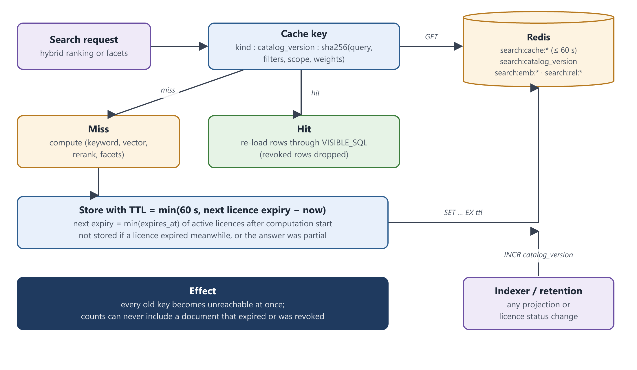
Figure 7.11c. Result and facet cache with invalidation (S4)
Description: Each cache key includes the catalogue version, which the indexer and retention job increment on every change, so all old entries become unreachable at once. Entries also expire no later than the next licence expiry, and a hit re-loads rows through the licence gate, so a cached answer can never show or count a document that has since become invisible.
Functionality S4: Result and facet cache
Prerequisite | • Shared Redis (REDIS_FALLBACK_MEMORY = false)  • Indexer increments search:catalog_version
Input | • Hybrid search parameters (query, filters, k, weights) or facet scope
Process / activity | 1. Build the key: kind : catalogue version : sha256(query, filters, scope, weights).  2. On a hit, take the cached ranking and re-load the rows through VISIBLE_SQL, dropping anything revoked since.  3. On a miss, compute; then store with lifetime min(60 s, next licence expiry − now), where the next expiry is the earliest active expires_at after the computation started.  4. Do not store if a licence expired during the computation, the expiry lookup failed, or the answer was partial (S6).
Datastore | • D5 Redis: search:cache:*, search:catalog_version  • D3 license_entitlements (next expiry, index idx_entitlements_expiry)
Technology / tools | • redis.asyncio, hashlib, SQLAlchemy async (services/search_cache.py, facet_service.py, hybrid_search_service.py)
Output | • Repeated searches and facets served from cache with exact counts
Status | Implemented — needs to be tested with a real and large dataset

Equations
key = kind ‖ version ‖ SHA-256(query, filters, scope, weights)
TTL = min(60 s, ⌊ min{ e.expires_at | e active, e.expires_at > t₀ } − now ⌋), no entry if TTL < 1 s
Algorithm (pseudocode): Result and facet cache
function CACHED(kind, parts, COMPUTE)
v ← REDIS.GET(catalog_version)
if REDIS.GET(key(kind, v, parts)) = value then
return RELOAD_THROUGH_GATE(value)
t0 ← now; value ← COMPUTE()
if not partial(value) then
next ← MIN(expires_at) OF active licences WHERE expires_at > t0
ttl ← min(60, floor(next − now))
if ttl ≥ 1 then REDIS.SET(key(kind, v, parts), value, ex = ttl)
return value
end function

Functionality S5: Qdrant collection layout and alias migration
Prerequisite | • Three-node Qdrant cluster for replication (deploy/integration/search-scale.yml)
Input | • Layout settings: QDRANT_SHARD_NUMBER (6), QDRANT_REPLICATION_FACTOR (2), HNSW m (16), ef_construct (128), hnsw_ef (128), QDRANT_QUANTIZATION (int8)
Process / activity | 1. Create new collections with the configured layout (vector_store.layout_config).  2. Resolve every collection name through aliases in the indexer, AI worker, observability and migration.  3. To change an existing collection: create a new physical collection, copy points (vectors and payloads) by scroll and upsert without re-embedding, run a catch-up pass, check counts, then switch the alias atomically.  4. Use gRPC when QDRANT_PREFER_GRPC is set; apply hnsw_ef and int8 rescoring per query.
Datastore | • D2 Qdrant collections and aliases
Technology / tools | • qdrant-client (create_collection, scroll, upsert, update_collection_aliases)  • scripts/migrate_vector_collection.py, modules/shared/vector_store.py
Output | • Sharded, replicated collections reachable through a stable alias
Status | Implemented — needs to be tested with a real and large dataset

Equations
shard(point) = hash(point id) mod 6
copies per shard = replication factor = 2
Algorithm (pseudocode): Qdrant collection layout and alias migration
procedure MIGRATE(alias)
src ← RESOLVE(alias); dst ← alias + "__s6_" + timestamp
CREATE dst WITH layout_config(); CREATE payload indexes on dst
COPY_ALL(src → dst) ▷ scroll + upsert, vectors unchanged
COPY_ALL(src → dst) ▷ catch-up pass for late writes
if COUNT(dst) < COUNT(src) then abort
ATOMIC { delete alias; create alias → dst }
end procedure

Functionality S6: Graceful degradation
Prerequisite | • Hybrid mode
Input | • Hybrid search request while Qdrant or the relevance model is failing or slow
Process / activity | 1. Run the vector branch with a timeout (VECTOR_TIMEOUT_SECONDS, 10 s); keyword errors still fail the request.  2. If the vector branch fails, answer from the keyword branch and mark the component 'vector' as degraded.  3. After 5 consecutive vector failures open a circuit breaker and skip Qdrant for 30 s.  4. If the relevance verification model fails, keep only documents containing every query term (stricter, never looser) and mark 'rerank' as degraded.  5. Return partial_results and degraded_components; the frontend shows a notice; partial answers are never cached.
Datastore | • None added
Technology / tools | • asyncio.wait_for, circuit breaker (hybrid_search_service.py), React notice (SearchTiming.jsx)
Output | • A labelled partial answer instead of an error
Status | Implemented — needs to be tested with a real and large dataset

Algorithm (pseudocode): Graceful degradation
function HYBRID_WITH_FALLBACK(query)
kw ← KEYWORD(query) ▷ errors propagate
if BREAKER.open then vec ← FAILED
else vec ← try VECTOR(query) within 10 s, on failure BREAKER.failure()
if vec = FAILED then degraded += "vector"; vec ← []
fused ← RRF(kw, vec)
try fused ← VERIFY(fused)
except fused ← [d ∈ fused | all query terms occur in d]; degraded += "rerank"
return fused, partial = (degraded ≠ ∅)
end function

Functionality S7: Connection pooling and read replica
Prerequisite | • PgBouncer 1.20 or later (track_extra_parameters = search_path)  • Optional streaming replica
Input | • DATABASE_URL via PgBouncer, DB_STATEMENT_CACHE_SIZE = 0, optional DATABASE_READ_URL
Process / activity | 1. Disable asyncpg and SQLAlchemy prepared-statement caches so transaction pooling is safe.  2. Send keyword ranking and facet queries to the read replica when configured.  3. Re-check every returned page on the primary, so replica lag cannot show a revoked or expired document.  4. Keep licence checks, result rows and all writes on the primary.
Datastore | • D1, D3 on the primary; D1 copy on the replica
Technology / tools | • PgBouncer (transaction mode), SQLAlchemy async engines (db/postgres.py, core/dependencies.py)
Output | • Fewer server connections; read load moved to the replica
Status | Implemented — needs to be tested with a real and large dataset

Functionality S8: Shared caches and monitoring
Prerequisite | • Shared Redis; Prometheus (deploy/integration/monitoring.yml)
Input | • Query text (embeddings), (query, passage) pairs (relevance scores), request metrics
Process / activity | 1. Cache CLIP and MiniLM query embeddings in Redis, keyed by model and SHA-256 of the text, behind the in-process LRU; vectors are stored as float32 so a hit and a miss score identically.  2. Share cross-encoder (query, passage) scores between replicas in Redis, keyed by model revision; the model is deterministic, so a shared score equals a recomputed one.  3. Expose /metrics on every replica: request and stage latency, degraded answers, cache hits, licence-gate path.  4. Scrape every replica through DNS service discovery; alert on p95 latency above 2 s, degraded answers, payload-path use and low cache hit rate.
Datastore | • D5 Redis: search:emb:*, search:rel:*
Technology / tools | • redis, numpy, hashlib, prometheus_client, Prometheus alert rules
Output | • Each embedding and pair score computed once across replicas; dashboards and alerts
Status | Implemented — needs to be tested with a real and large dataset

Equations
hit rate = hits / (hits + misses)
alert if p95(search_request_duration_seconds) > 2 s for 10 min
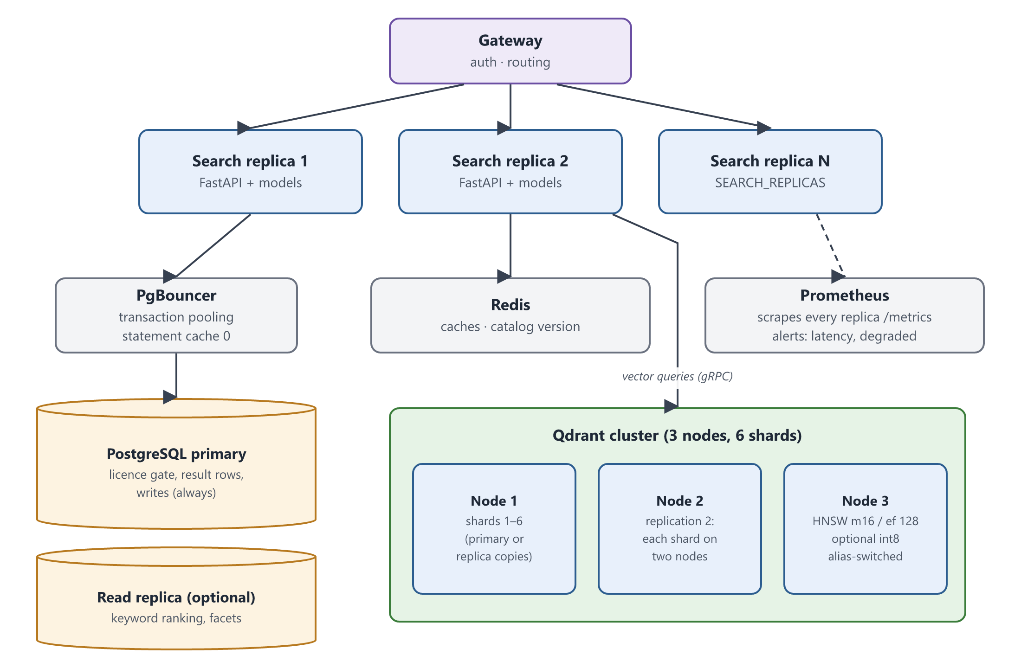
Figure 7.11d. Scaled deployment of the search module (S5, S7, S9)
Description: The gateway spreads requests over several stateless search replicas. Each replica reaches PostgreSQL through PgBouncer (licence checks and writes on the primary, optional read replica for ranking and facets), shares Redis for caches, and sends vector queries over gRPC to a three-node Qdrant cluster holding six shards with two copies each. Prometheus scrapes every replica. All replicas connect to every backend; one connection of each kind is drawn for clarity.
Functionality S9: Horizontal scaling of the search API
Prerequisite | • Stateless replicas (all shared state in PostgreSQL, Qdrant, Redis)
Input | • SEARCH_REPLICAS (default 3)
Process / activity | 1. Run several search replicas behind the gateway (deploy/integration/search-scale.yml).  2. Each replica loads its models once at startup; caches are shared through Redis.
Datastore | • D1–D5 shared
Technology / tools | • Docker Compose deploy.replicas, service DNS
Output | • Throughput that grows with the number of replicas
Status | Implemented — needs to be tested with a real and large dataset

Functionality S10: Licence-change propagation and payload backfill
Prerequisite | • Ingestion retention job; outbox worker for the ingestion schema
Input | • Licences that expire (retention job); existing points without the new payload fields
Process / activity | 1. When the retention job marks licences expired, queue one search-refresh delivery per affected document in the same transaction.  2. The outbox worker re-projects each document, updating license_status in Qdrant, and the indexer increments the catalogue version.  3. Run scripts/reindex_search_payloads.py once to add license_status, file_size and long_edge to existing points, then enable QDRANT_EXTENDED_PAYLOAD.
Datastore | • ingestion integration_outbox, D2 Qdrant payloads, D5 search:catalog_version
Technology / tools | • Transactional outbox, qdrant-client batch_update_points
Output | • Qdrant licence data that follows PostgreSQL within seconds
Status | Implemented — needs to be tested with a real and large dataset

7.11.2 Configuration
Setting | Default | Purpose
VECTOR_EXACT_GATE_MAX | 100000 | Largest id list sent to Qdrant (S1)
VECTOR_OVERFETCH, VECTOR_MAX_ROUNDS | 3, 5 | Batch size multiplier and rounds of adaptive fetching (S1)
QDRANT_EXTENDED_PAYLOAD | false | Filter size and resolution inside Qdrant after the backfill (S1, S10)
SEARCH_FTS_PREFILTER, SEARCH_TRIGRAM_INDEX | true, true | Enable the keyword prefilters / build the trigram index (S2)
SEARCH_CACHE_ENABLED, SEARCH_CACHE_TTL_SECONDS | true, 60 | Result and facet cache (S4)
QDRANT_SHARD_NUMBER, QDRANT_REPLICATION_FACTOR | 6, 1 (2 in the cluster) | Collection layout (S5)
QDRANT_HNSW_M, QDRANT_HNSW_EF_CONSTRUCT, QDRANT_HNSW_EF | 16, 128, 128 | HNSW graph and search width (S5)
QDRANT_QUANTIZATION, QDRANT_PREFER_GRPC | off, false | int8 quantisation with rescoring; gRPC transport (S5)
VECTOR_TIMEOUT_SECONDS, VECTOR_BREAKER_THRESHOLD, VECTOR_BREAKER_COOLDOWN_SECONDS | 10, 5, 30 | Degradation and circuit breaker (S6)
DATABASE_READ_URL, DB_STATEMENT_CACHE_SIZE | unset | Read replica; 0 behind PgBouncer (S7)
SEARCH_REPLICAS | 3 | Number of search API replicas (S9)

7.11.3 Verification done so far and testing still required
The following checks were run locally on synthetic data. They show that the changes keep results identical; they do not replace testing at production scale.
Check | Result
Unit tests (search scalability, scaling helpers, embedding cache, resolution) | 64 passed
Ingestion and repository-level unit tests (retention refresh, observability) | 119 passed, 2 skipped
Keyword prefilter vs original keyword match, PostgreSQL 16.10, 2 500 documents, 51 queries in 7 languages × 4 filter sets × AND/OR | 576 / 576 result sets byte-identical (results, totals, pages, plans, facets)
Prefilter superset check, 3 001 adversarial rows × 47 terms, two locales | No match missed
Cache lifetime with a licence expiring in 25 s | 24 s (bounded by the expiry)
API smoke test with and without a read replica | All endpoints return 200
Testing required with a real and large dataset:
- Recall of the payload path (S1) against the exact path on the same queries, at 1 M, 10 M and 50 M documents; tune hnsw_ef and VECTOR_OVERFETCH.
- p50 / p95 / p99 latency per mode and stage with and without the prefilters (S2) and caches (S4, S8).
- Index sizes and write cost of the tsvector and trigram indexes on real OCR and transcript text.
- Alias migration (S5) duration and correctness on a full collection; behaviour of the three-node cluster when one node fails.
- Degradation (S6) under injected Qdrant and model failures; PgBouncer and replica (S7) under concurrent load.
- Throughput as replicas are added (S9) and cache hit rates on real query logs.
- The existing integration suites against the acceptance catalogue.

7.11.4 Known limitations
- Above the exact gate, vector recall is approximate (HNSW with payload filters); every returned hit is still verified.
- Hybrid and vector modes still cap each branch at 200 candidates; only text mode is exhaustive.
- Non-Latin terms shorter than 3 characters, and scripts the database locale does not treat as letters, cannot use the trigram index; they fall back to a scan with correct results.
- The relevance verification model remains the main CPU cost per query.
- Qdrant licence payloads follow PostgreSQL asynchronously (seconds); any future licence re-activation path must also queue a search refresh.
- The first alias switch of a physical collection has a short gap; the cluster, PgBouncer and replica set-up has not yet been run on real infrastructure.

