./



Version Number:

Team Members :

Team No:

Module: Model Based System Engineering

|  |  |  |  |  |  |
| --- | --- | --- | --- | --- | --- |
| **Ver.Rel. No.** | **Release Date** | **Prepared. By** | **Reviewed By** | **Approved By** | **Remarks/Revision Details** |
|  | 20/2/2022 | Kavya Harigol |  |  |  |
|  |  |  |  |  |  |
|  |  |  |  |  |  |
|  |  |  |  |  |  |
|  |  |  |  |  |  |

**Document History**

# 

**Case Study: Smart Railway Gate System**

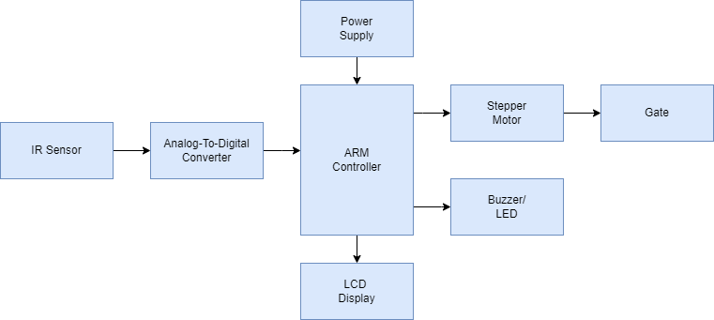

The Smart Railway Gate System is a simple embedded system which automatically opens and closes the gate whenever the train arrives. It consists of

* IR Sensor
* ADC
* ARM Controller
* Stepper Motor
* LCD Display
* Buzzer/LED

**IR Sensor**

An IR sensor is used to sense the arrival and departure of the train. An IR Sensor generally comprises of two components: an IR Transmitter and an IR Receiver. An IR Transmitter is a device that emits IR Rays. Similarly, an IR Receiver is a device that detects the IR Rays. Photo Diodes are the most commonly used IR receivers.

**ADC (Analogy-to-Digital Converter)**

The sensor value is read through the ADC. The 10-bit ADC values produces equivalent digital data with respect to the IR sensor’s output. With the help of digital data, the gate is being controlled

**ARM Controller**

An ARM processor is one of the best alternatives obtainable for embedded system designers. It comes in 16/32-bit ARM7TDMI Microcontroller in a tiny LQFP64 package. It has 40 kB of on-chip static RAM and 512 kB of on-chip flash memory with a high-speed 60 MHz operation.

**Stepper Motor**

A stepper motor is an electric motor whose main feature is that its shaft rotates by performing steps, that is, by moving by a fixed number of degrees. This allows to know the exact angular position of the shaft by simply counting how may steps have been performed, with no need for a sensor. To open the gate the motor rotates clock wise and rotates anti clock wise to close the gate.

**LCD Display and Buzzer**

A liquid-crystal display (LCD) is a flat-panel display that shows the status of the railway gate open or close section and warning message for road users. A Buzzer is also used to warn the road user about the approach of train.

**V-Model of the Smart Railway Gate System**

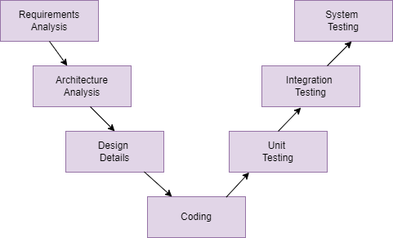

**Requirements:**

* High Level Requirements

|  |  |
| --- | --- |
| ID | Description |
| HLR1 | Initialing all the peripherals with ARM controller |
| HLR2 | It allows to sense the arrival and departure of the train |
| HLR3 | It allows to open the gate |
| HLR4 | It allows to close the gate |
| HLR5 | It allows to displays status on LCD |
| HLR6 | It allows to indicate through the Buzzer/LED |

* Low Level Requirements

|  |  |
| --- | --- |
| ID | Description |
| LLR1 | Power up the System |
| LLR2 | IR Sensor detects the arrival and departure of the train |
| LLR3 | The Steppers motors rotates clockwise to open the gate |
| LLR4 | The Steppers motors rotates ani clock wise to close the gate |
| LLR5 | Display information on LCD module |
| LLR6 | Alter the people through the buzzer/LED |

**Test Cases:**

|  |  |  |  |
| --- | --- | --- | --- |
| Test  ID | Test Case Object | Input  Data | Excepted  Data |
| TC_1 | Power up the System | Turning ON the system | Display “Welcome to Railway Gate System” |
| TC_2 | Arrival of the Train | Detecting IR Rays from the sensor | Closes the gate  Displays “The train has arrived”  Buzzer ON |
| TC_3 | Departure of the train | Detecting IR Rays from the sensor | Gate is opened  Displays “The train has left the station.”  Buzzer OFF |