CASE STUDY: PERSONAL EXPENSE ANALYSIS
(PYTHON MINI PROJECT)
Name: Kavya
UID: 25BCD10086
Section: 25BCD2'A'
CHANDIGARH UNIVERSITY

1. Problem Statement
Managing personal expenses is important for maintaining financial stability. However, people often make transactions across different categories such as food, travel, shopping, education, bills and entertainment without clearly understanding where most of their money is being spent.
This case study aims to analyze personal transaction data using Python, NumPy, Pandas, Matplotlib and Seaborn. The analysis will identify spending patterns, compare expenses across categories, examine monthly trends and identify unusually large transactions.
The objective is to use data analysis and visualization techniques to understand where, when and how much money is being spent.

2. Dataset Description
For this project, we use a personal transaction dataset containing 100 valid transaction records. The dataset contains the following variables:
Variable | Description | Data Type
Date | Date on which transaction occurred | DateTime
Category | Expense category | Object/String
Description | Description of the expense | Object/String
Amount | Amount spent in ₹ | Float
Payment_Mode | Method used for payment | Object/String

Expense Categories
The dataset contains categories such as:
- Food
- Travel
- Shopping
- Entertainment
- Education
- Bills
- Health

Example Records
Date | Category | Description | Amount | Payment_Mode
2026-01-05 | Food | Restaurant | ₹650 | UPI
2026-01-10 | Shopping | Stationery | ₹3126.05 | Debit Card
2026-02-12 | Travel | Cab | ₹450 | UPI
2026-03-16 | Shopping | Online Shopping | ₹3058.38 | Credit Card
2026-05-30 | Education | Study Material | ₹2427.78 | UPI
Note: these are illustrative example records; the attached CSV is the authoritative dataset (e.g., the 2026-01-10 Stationery and 2026-03-16 Online Shopping rows use UPI and Cash there).

Dataset Size
- Original records: 101
- Duplicate records: 1
- Final records after cleaning: 100
- Columns: 5
A few small data-quality issues were intentionally included in the dataset so that the Data Cleaning section can be demonstrated meaningfully: one duplicate row, one missing Payment_Mode value, and one category with inconsistent formatting (" food " with stray spaces and lowercase).

3. Data Cleaning Using Pandas
Data cleaning is performed before analysis to make sure the dataset is accurate and consistent.

3.1 Import Libraries
import pandas as pd
import numpy as np
import matplotlib.pyplot as plt
import seaborn as sns
Load the dataset:
df = pd.read_csv("personal_expense_dataset.csv")

print(df.head())
print(df.info())

3.2 Checking Missing Values
print(df.isnull().sum())
This checks whether any column contains missing values. For example, if Payment_Mode has missing values:
df["Payment_Mode"] = df["Payment_Mode"].fillna("UPI")
Here, missing payment modes are replaced with UPI for this sample dataset.

3.3 Removing Duplicate Records
print("Duplicate records:", df.duplicated().sum())

df = df.drop_duplicates()
The dataset initially contains 1 duplicate record, which is removed.

3.4 Correcting Data Types
Convert the date column:
df["Date"] = pd.to_datetime(df["Date"], errors="coerce")
Convert amount to numeric:
df["Amount"] = pd.to_numeric(df["Amount"], errors="coerce")

3.5 Removing Inconsistent Values
The category column may contain inconsistent formatting such as: Food, " food", FOOD. We can standardize it:
df["Category"] = df["Category"].astype(str).str.strip().str.title()
This converts all of them into: Food.

Complete Cleaning Code
# Load dataset
df = pd.read_csv("personal_expense_dataset.csv")

# Check missing values
print("Missing values:")
print(df.isnull().sum())

# Check duplicate records
print("Duplicate records:", df.duplicated().sum())

# Convert data types
df["Date"] = pd.to_datetime(df["Date"], errors="coerce")
df["Amount"] = pd.to_numeric(df["Amount"], errors="coerce")

# Standardize category values
df["Category"] = df["Category"].astype(str).str.strip().str.title()

# Fill missing payment mode
df["Payment_Mode"] = df["Payment_Mode"].fillna("UPI")

# Remove duplicates
df = df.drop_duplicates()

# Remove rows with missing important values
df = df.dropna(subset=["Date", "Category", "Amount"])

print("Final number of records:", len(df))

4. Data Analysis Using NumPy & Pandas

4.1 Mean
Mean represents the average amount spent per transaction.
mean_expense = np.mean(df["Amount"])

print("Mean Expense:", mean_expense)
Result: Average expense ≈ ₹935.25

4.2 Median
Median represents the middle value when all transaction amounts are arranged in order.
median_expense = np.median(df["Amount"])

print("Median Expense:", median_expense)
Result: Median expense ≈ ₹719.84. Since the mean is higher than the median, some relatively large transactions are increasing the average.

4.3 Standard Deviation
Standard deviation tells us how widely the transaction amounts vary around the average.
std_expense = np.std(df["Amount"])

print("Standard Deviation:", std_expense)
Formula (population standard deviation, as computed by np.std): σ = √( (1/N) · Σ (xᵢ − μ)² )
Result: The standard deviation is approximately ₹696–₹700. A relatively high standard deviation indicates that transaction amounts vary considerably.

4.4 Category-wise Grouping
We can calculate total spending for every category.
category_spending = df.groupby("Category")["Amount"].sum()

print(category_spending)
Category | Total Spending
Bills | ₹19,923.19
Shopping | ₹15,821.92
Education | ₹15,703.53
Entertainment | ₹12,319.49
Food | ₹10,877.78
Health | ₹10,624.31
Travel | ₹8,254.73
Important observation: Bills have the highest total spending, followed by Shopping and Education.

4.5 Monthly Spending
First extract the month:
df["Month"] = df["Date"].dt.to_period("M").astype(str)
Then calculate monthly spending:
monthly_spending = df.groupby("Month")["Amount"].sum()

print(monthly_spending)
Month | Spending
January | ₹12,067.11
February | ₹19,894.36
March | ₹12,999.73
April | ₹16,859.77
May | ₹22,845.96
June | ₹8,858.02
So May has the highest spending, while June has the lowest.

4.6 Finding Largest Expenses
largest_expenses = df.sort_values(
by="Amount",
ascending=False
).head(5)

print(largest_expenses[
["Date", "Category", "Description", "Amount"]
])
Top expenses include:
Category | Description | Amount
Shopping | Online Shopping | ₹3,306.83
Shopping | Stationery | ₹3,126.05
Shopping | Online Shopping | ₹3,058.38
Education | Study Material | ₹2,427.78
Education | Printing | ₹2,229.01

4.7 Sorting and Filtering
Expenses above average:
high_expenses = df[df["Amount"] > df["Amount"].mean()]

print(high_expenses)
This identifies transactions that are higher than the average expense (36 of the 100 transactions).
Sorting:
df.sort_values("Amount", ascending=False).head(10)
This displays the 10 largest transactions.

4.8 Correlation
Correlation helps determine whether two numerical variables have a relationship. For this dataset, we can create numerical variables such as:
df["Month_Number"] = df["Date"].dt.month
df["Day"] = df["Date"].dt.day
Then:
correlation = df[
["Amount", "Month_Number", "Day"]
].corr()

print(correlation)
You can visualize this using a heatmap. Computed result for this dataset:
 | Amount | Month_Number | Day
Amount | 1.000 | −0.007 | 0.061
Month_Number | −0.007 | 1.000 | 0.214
Day | 0.061 | 0.214 | 1.000
Important: correlation shows association, not causation. Here, Amount has a near-zero correlation with both month and day of month, so the date of a transaction does not predict its size.

5. Data Visualization
The following ten charts, produced from the cleaned dataset using the code shown with each, summarize the spending patterns visually.

A. Matplotlib — Line Chart (Monthly Spending Trend)
Purpose: shows how spending changes from month to month.
plt.figure(figsize=(9,5))

plt.plot(
monthly_spending.index,
monthly_spending.values,
marker="o"
)

plt.title("Monthly Expense Trend")
plt.xlabel("Month")
plt.ylabel("Total Spending (₹)")
plt.xticks(rotation=45)

plt.tight_layout()
plt.show()
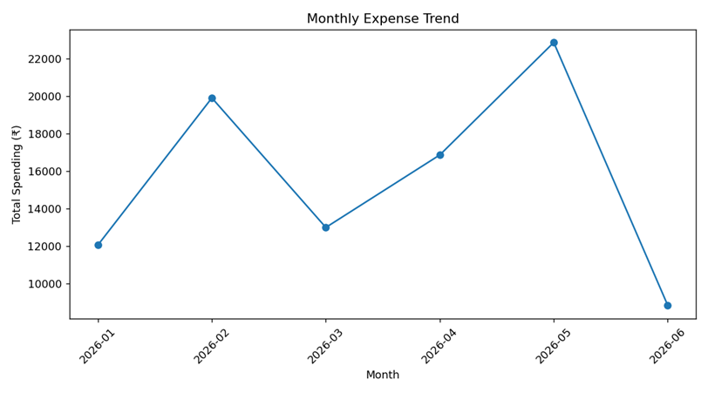
Figure 1: Monthly Expense Trend

B. Matplotlib — Bar Chart (Category-wise Spending)
This makes it easy to identify the category where the most money is spent.
category_spending = df.groupby("Category")["Amount"].sum()

plt.figure(figsize=(9,5))

plt.bar(
category_spending.index,
category_spending.values
)

plt.title("Category-wise Spending")
plt.xlabel("Category")
plt.ylabel("Total Spending (₹)")
plt.xticks(rotation=30)

plt.tight_layout()
plt.show()
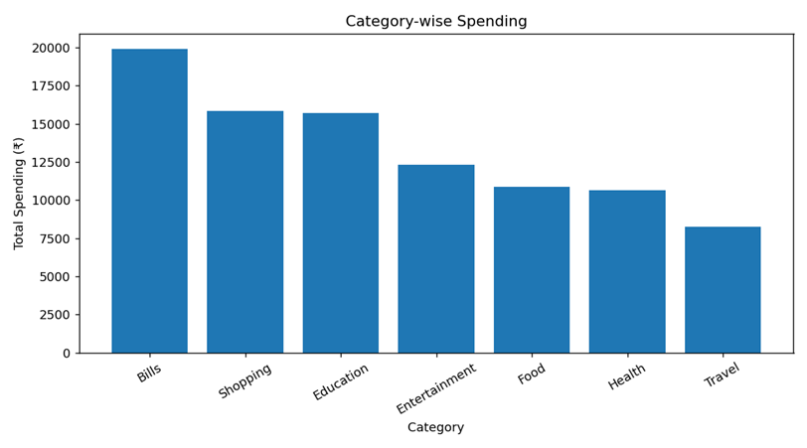
Figure 2: Category-wise Spending

C. Matplotlib — Histogram
Purpose: shows how frequently different expense amounts occur.
plt.figure(figsize=(8,5))

plt.hist(
df["Amount"],
bins=10,
edgecolor="black"
)

plt.title("Distribution of Individual Expenses")
plt.xlabel("Expense Amount (₹)")
plt.ylabel("Frequency")

plt.show()
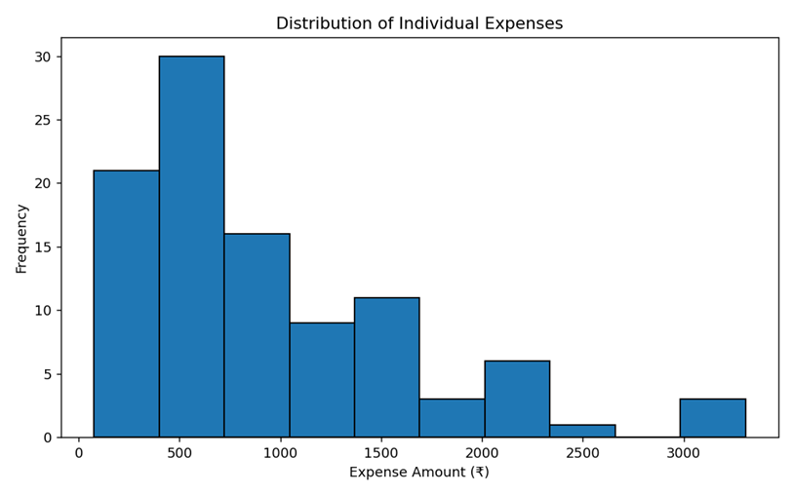
Figure 3: Distribution of Individual Expenses

D. Matplotlib — Pie Chart
This shows the percentage contribution of each category to total spending.
plt.figure(figsize=(7,7))

plt.pie(
category_spending,
labels=category_spending.index,
autopct="%1.1f%%"
)

plt.title("Percentage Share of Spending")

plt.show()
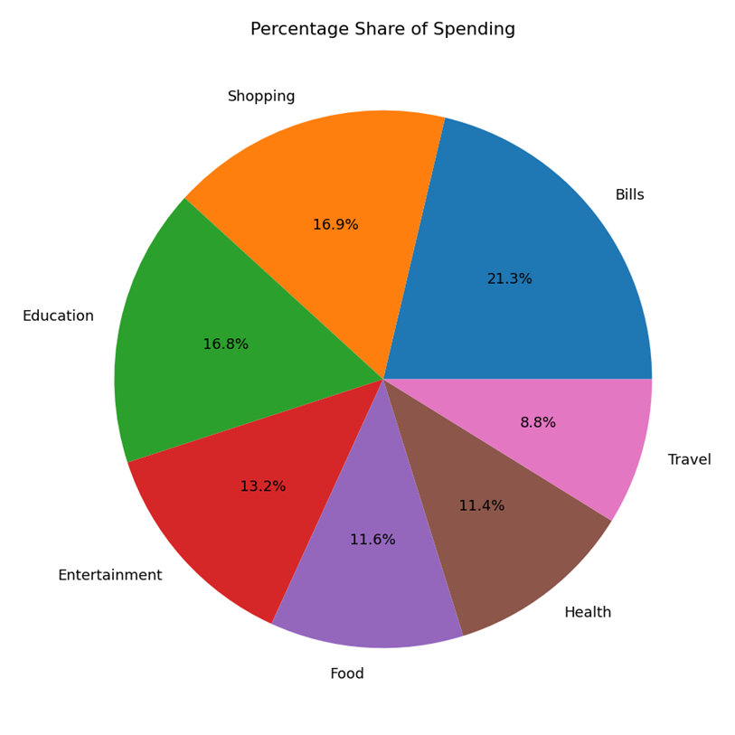
Figure 4: Percentage Share of Spending

E. Matplotlib — Scatter Plot
This helps identify unusually large transactions.
plt.figure(figsize=(8,5))

plt.scatter(
range(len(df)),
df["Amount"],
alpha=0.7
)

plt.title("Transaction Amount Distribution")
plt.xlabel("Transaction Number")
plt.ylabel("Amount (₹)")

plt.show()
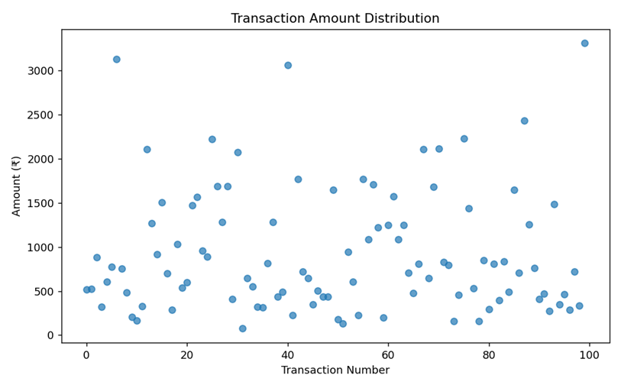
Figure 5: Transaction Amount Distribution

F. Seaborn — Box Plot
Shows the median, spread, minimum/maximum and potential outliers. Particularly useful for identifying categories with unusually large expenses.
plt.figure(figsize=(10,5))

sns.boxplot(
data=df,
x="Category",
y="Amount"
)

plt.title("Expense Distribution by Category")
plt.xticks(rotation=30)

plt.show()
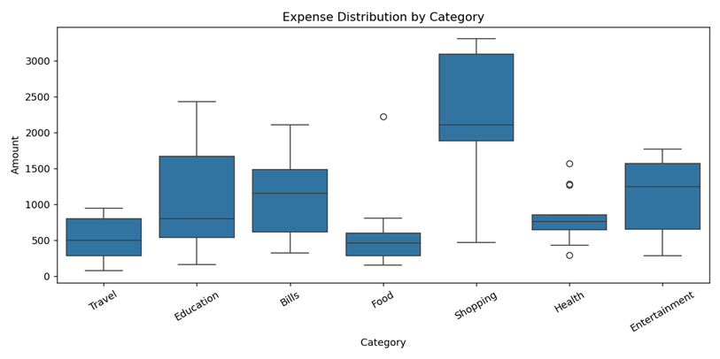
Figure 6: Expense Distribution by Category (Box Plot)

G. Seaborn — Violin Plot
A violin plot combines information about the distribution and density of expenses.
plt.figure(figsize=(10,5))

sns.violinplot(
data=df,
x="Category",
y="Amount"
)

plt.title("Expense Distribution by Category")
plt.xticks(rotation=30)

plt.show()
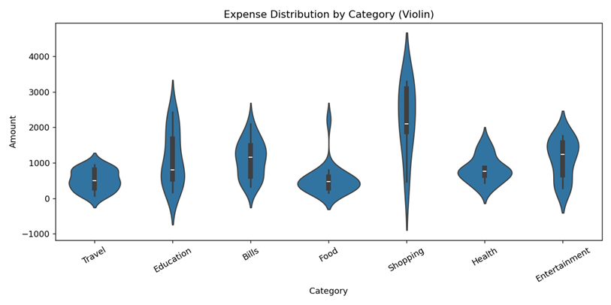
Figure 7: Expense Distribution by Category (Violin Plot)

H. Seaborn — Count Plot
This tells us which categories have the highest number of transactions. Note that this is different from total spending: Food has the most transactions (21) but Shopping has the highest average amount per transaction (₹2,260). This is a good point to discuss in a viva.
plt.figure(figsize=(9,5))

sns.countplot(
data=df,
x="Category"
)

plt.title("Number of Transactions by Category")
plt.xticks(rotation=30)

plt.show()
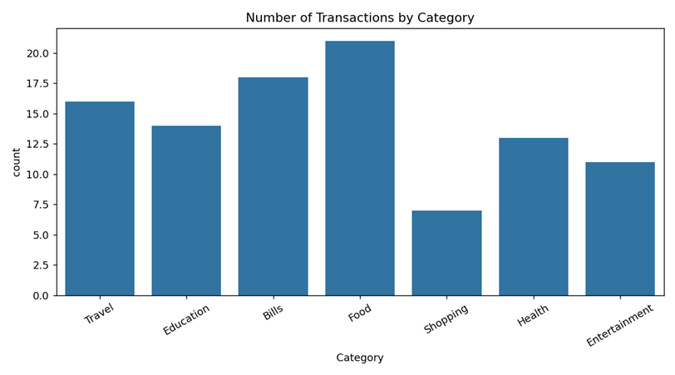
Figure 8: Number of Transactions by Category

I. Seaborn — Heatmap
The heatmap displays correlations between numerical variables.
numeric_df = df[[
"Amount",
"Month_Number",
"Day"
]]

plt.figure(figsize=(7,5))

sns.heatmap(
numeric_df.corr(),
annot=True,
cmap="coolwarm"
)

plt.title("Correlation Heatmap")

plt.show()
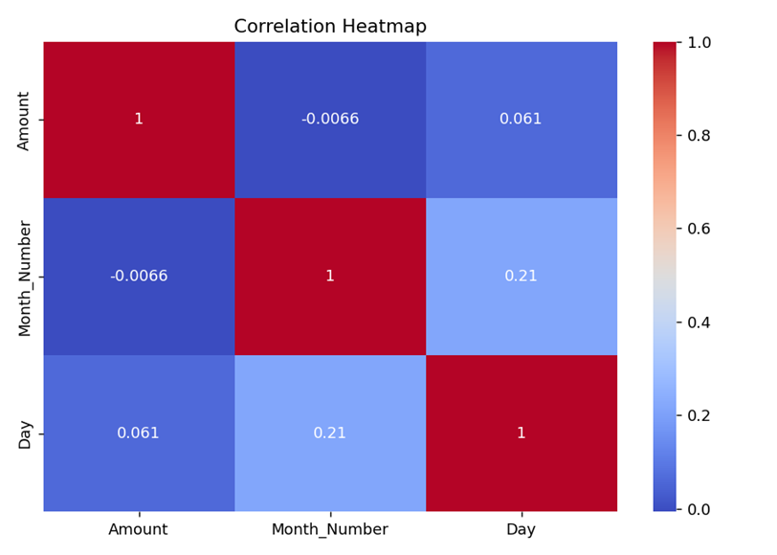
Figure 9: Correlation Heatmap

J. Seaborn — Pair Plot
A pair plot allows us to examine relationships between multiple numerical variables simultaneously.
pair_df = df[[
"Amount",
"Month_Number",
"Day"
]]

sns.pairplot(pair_df)

plt.show()
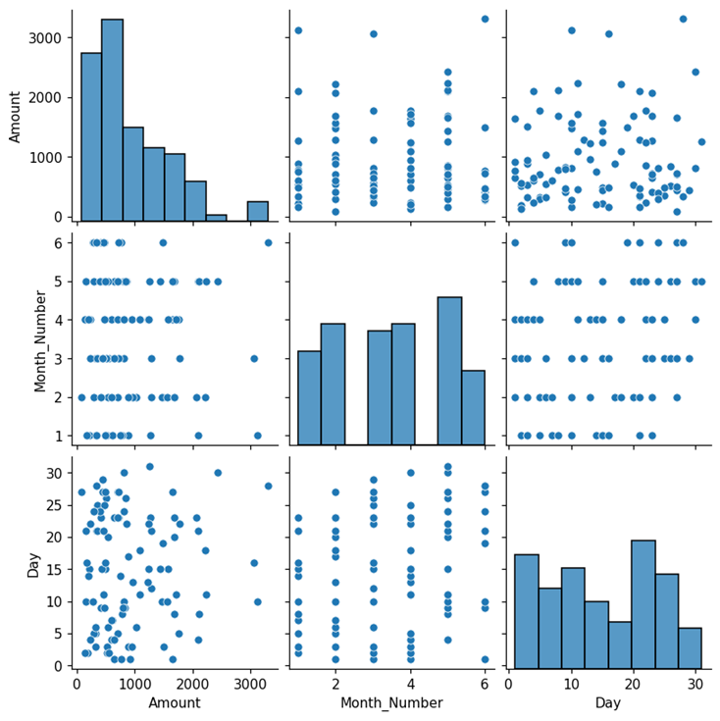
Figure 10: Pair Plot of Amount, Month_Number and Day

6. Findings

Finding 1
The Bills category has the highest total spending, with approximately ₹19,923, making it the largest contributor to overall expenses.

Finding 2
Travel has the lowest total spending, at approximately ₹8,255, indicating comparatively lower expenditure in this category.

Finding 3
The average transaction amount is approximately ₹935, while the median is approximately ₹720. The higher mean suggests that some large transactions increase the average.

Finding 4
May recorded the highest monthly expenditure, with approximately ₹22,846 spent during the month.

Finding 5
June recorded the lowest monthly expenditure, with approximately ₹8,858.

Finding 6
The largest individual transaction was an Online Shopping expense of approximately ₹3,307.

Finding 7
Shopping appears among the largest spending categories and also contains several of the largest individual transactions.

Finding 8
The relatively high standard deviation indicates that the transaction amounts vary considerably rather than remaining close to the average.

7. Conclusion
The analysis of personal transaction data provides useful insights into individual spending behavior. The results show that expenses are distributed across several categories, with Bills, Shopping and Education being major contributors to total spending.
Monthly analysis shows that spending is not consistent throughout the year, with May having the highest expenditure and June having the lowest. The mean and median comparison also indicates the presence of some relatively large transactions.
Data visualization using Matplotlib and Seaborn makes these patterns easier to understand through line charts, bar charts, histograms, pie charts, scatter plots, box plots, violin plots, count plots and heatmaps.
Overall, this case study demonstrates how Python-based data analysis can be used to understand personal spending patterns and support better financial decision-making.

Appendix A: Complete Python Script (personal_expense_analysis.py)
import pandas as pd
import numpy as np
import matplotlib.pyplot as plt
import seaborn as sns

# 1. Load dataset
df = pd.read_csv("personal_expense_dataset.csv")

# 2. Data cleaning
df["Date"] = pd.to_datetime(df["Date"], errors="coerce")
df["Amount"] = pd.to_numeric(df["Amount"], errors="coerce")
df["Category"] = df["Category"].astype(str).str.strip().str.title()

print("Missing values before cleaning:")
print(df.isnull().sum())

print("\nDuplicate records before cleaning:", df.duplicated().sum())

# Fill missing payment mode
df["Payment_Mode"] = df["Payment_Mode"].fillna("UPI")

# Remove invalid/incomplete rows and duplicates
df = df.drop_duplicates()
df = df.dropna(subset=["Date", "Category", "Amount"])

# 3. NumPy + Pandas analysis
print("\nBasic statistics:")
print("Mean expense:", np.mean(df["Amount"]))
print("Median expense:", np.median(df["Amount"]))
print("Standard deviation:", np.std(df["Amount"]))

category_spending = df.groupby("Category")["Amount"].agg(["sum", "mean", "count"])
category_spending = category_spending.sort_values("sum", ascending=False)
print("\nCategory-wise spending:")
print(category_spending)

monthly_spending = (
df.assign(Month=df["Date"].dt.to_period("M").astype(str))
.groupby("Month")["Amount"].sum()
)
print("\nMonthly spending:")
print(monthly_spending)

print("\nTop 5 largest expenses:")
print(df.sort_values("Amount", ascending=False)[
["Date", "Category", "Description", "Amount"]
].head(5))

print("\nExpenses above the overall mean:")
print(df[df["Amount"] > df["Amount"].mean()].sort_values("Amount", ascending=False))

print("\nCorrelation matrix:")
print(df[["Amount"]].corr())

# 4. Matplotlib visualizations

# Line chart - monthly trend
plt.figure(figsize=(9, 5))
plt.plot(monthly_spending.index, monthly_spending.values, marker="o")
plt.title("Monthly Expense Trend")
plt.xlabel("Month")
plt.ylabel("Total Spending (₹)")
plt.xticks(rotation=45)
plt.tight_layout()
plt.show()

# Bar chart - category-wise spending
plt.figure(figsize=(9, 5))
plt.bar(category_spending.index, category_spending["sum"])
plt.title("Category-wise Spending")
plt.xlabel("Category")
plt.ylabel("Total Spending (₹)")
plt.xticks(rotation=30)
plt.tight_layout()
plt.show()

# Histogram - expense distribution
plt.figure(figsize=(8, 5))
plt.hist(df["Amount"], bins=10, edgecolor="black")
plt.title("Distribution of Individual Expenses")
plt.xlabel("Amount (₹)")
plt.ylabel("Frequency")
plt.tight_layout()
plt.show()

# Pie chart - spending share
plt.figure(figsize=(7, 7))
plt.pie(category_spending["sum"], labels=category_spending.index, autopct="%1.1f%%")
plt.title("Percentage Share of Spending by Category")
plt.show()

# Scatter plot - transaction number vs amount
plt.figure(figsize=(8, 5))
plt.scatter(range(len(df)), df["Amount"], alpha=0.7)
plt.title("Transaction Amount Distribution")
plt.xlabel("Transaction Number")
plt.ylabel("Amount (₹)")
plt.tight_layout()
plt.show()

# 5. Seaborn visualizations

# Box plot
plt.figure(figsize=(10, 5))
sns.boxplot(data=df, x="Category", y="Amount")
plt.title("Expense Distribution by Category")
plt.xticks(rotation=30)
plt.tight_layout()
plt.show()

# Violin plot
plt.figure(figsize=(10, 5))
sns.violinplot(data=df, x="Category", y="Amount")
plt.title("Violin Plot of Expenses by Category")
plt.xticks(rotation=30)
plt.tight_layout()
plt.show()

# Heatmap
numeric_df = df[["Amount"]].copy()
numeric_df["Day"] = df["Date"].dt.day
numeric_df["Month_Number"] = df["Date"].dt.month
numeric_df["Category_Code"] = df["Category"].astype("category").cat.codes

plt.figure(figsize=(7, 5))
sns.heatmap(numeric_df.corr(numeric_only=True), annot=True, cmap="coolwarm")
plt.title("Correlation Heatmap")
plt.tight_layout()
plt.show()

# Count plot
plt.figure(figsize=(9, 5))
sns.countplot(data=df, x="Category")
plt.title("Number of Transactions by Category")
plt.xticks(rotation=30)
plt.tight_layout()
plt.show()

# Pair plot
pair_df = df[["Amount", "Category", "Date"]].copy()
pair_df["Month"] = pair_df["Date"].dt.month
pair_df["Day"] = pair_df["Date"].dt.day
sns.pairplot(pair_df[["Amount", "Month", "Day"]])
plt.show()

Appendix B: Personal Expense Dataset (personal_expense_dataset.csv)
Raw dataset as supplied (101 records, before cleaning). The final row is the duplicate; row 8 has a missing Payment_Mode; row 26 has the inconsistent category " food ".
# | Date | Category | Description | Amount | Payment_Mode
1 | 2026-01-02 | Travel | Auto | 516.8 | UPI
2 | 2026-01-03 | Travel | Cab | 524.2 | UPI
3 | 2026-01-03 | Education | Printing | 882.3 | UPI
4 | 2026-01-05 | Bills | Hostel Bill | 323.92 | Credit Card
5 | 2026-01-07 | Bills | Hostel Bill | 606.28 | UPI
6 | 2026-01-08 | Food | Food Delivery | 772.8 | UPI
7 | 2026-01-10 | Shopping | Stationery | 3126.05 | UPI
8 | 2026-01-14 | Health | Doctor | 755.21 | (blank)
9 | 2026-01-15 | Travel | Cab | 483.66 | Credit Card
10 | 2026-01-15 | Education | Printing | 208.55 | UPI
11 | 2026-01-16 | Education | Course | 163.63 | Cash
12 | 2026-01-21 | Food | Cafe | 329.48 | UPI
13 | 2026-01-21 | Shopping | Clothes | 2103.78 | UPI
14 | 2026-01-23 | Health | Medicine | 1270.45 | UPI
15 | 2026-02-01 | Entertainment | Streaming | 918.24 | UPI
16 | 2026-02-03 | Bills | Mobile Recharge | 1503.4 | UPI
17 | 2026-02-05 | Education | Course | 700.04 | Cash
18 | 2026-02-05 | Entertainment | Games | 287.78 | Debit Card
19 | 2026-02-06 | Bills | Subscription | 1029.44 | Debit Card
20 | 2026-02-06 | Bills | Electricity | 536.85 | UPI
21 | 2026-02-07 | Food | Food Delivery | 598.49 | Cash
22 | 2026-02-10 | Entertainment | Events | 1473.63 | UPI
23 | 2026-02-10 | Health | Health Checkup | 1567.28 | Cash
24 | 2026-02-13 | Bills | Internet Bill | 960.06 | Credit Card
25 | 2026-02-17 | Travel | Metro | 886.34 | Cash
26 | 2026-02-18 | food | Online Shopping | 2219.11 | UPI
27 | 2026-02-20 | Shopping | Stationery | 1686.65 | UPI
28 | 2026-02-21 | Education | College Supplies | 1283.26 | UPI
29 | 2026-02-23 | Entertainment | Concert | 1684.53 | UPI
30 | 2026-02-23 | Bills | Electricity | 410.47 | UPI
31 | 2026-02-23 | Shopping | Accessories | 2073.41 | UPI
32 | 2026-02-27 | Travel | Auto | 75.38 | UPI
33 | 2026-03-01 | Bills | Mobile Recharge | 645.8 | UPI
34 | 2026-03-02 | Food | Restaurant | 549.04 | Debit Card
35 | 2026-03-03 | Entertainment | Movies | 324.07 | UPI
36 | 2026-03-06 | Travel | Fuel | 314.55 | Credit Card
37 | 2026-03-10 | Health | Personal Care | 813.32 | UPI
38 | 2026-03-12 | Health | Pharmacy | 1281.13 | Debit Card
39 | 2026-03-15 | Health | Pharmacy | 432.84 | UPI
40 | 2026-03-16 | Education | Books | 487.91 | Debit Card
41 | 2026-03-16 | Shopping | Online Shopping | 3058.38 | Cash
42 | 2026-03-22 | Food | Snacks | 229.43 | Debit Card
43 | 2026-03-22 | Bills | Electricity | 1769.86 | Cash
44 | 2026-03-23 | Travel | Metro | 720.63 | Credit Card
45 | 2026-03-23 | Food | Groceries | 647.35 | Cash
46 | 2026-03-25 | Food | Restaurant | 345.96 | UPI
47 | 2026-03-26 | Bills | Subscription | 505.06 | UPI
48 | 2026-03-27 | Travel | Bus | 436.58 | UPI
49 | 2026-03-29 | Health | Medicine | 437.82 | UPI
50 | 2026-04-01 | Entertainment | Concert | 1645.48 | UPI
51 | 2026-04-02 | Food | Snacks | 180.07 | UPI
52 | 2026-04-02 | Travel | Auto | 131.01 | UPI
53 | 2026-04-03 | Travel | Cab | 944.44 | Cash
54 | 2026-04-04 | Food | Restaurant | 602.69 | Cash
55 | 2026-04-04 | Food | Snacks | 223.77 | UPI
56 | 2026-04-05 | Entertainment | Streaming | 1767.55 | UPI
57 | 2026-04-11 | Entertainment | Movies | 1088.06 | Cash
58 | 2026-04-11 | Bills | Electricity | 1709.61 | Cash
59 | 2026-04-13 | Bills | Electricity | 1221.6 | UPI
60 | 2026-04-14 | Travel | Bus | 198.48 | Cash
61 | 2026-04-15 | Bills | Mobile Recharge | 1245.37 | UPI
62 | 2026-04-15 | Bills | Subscription | 1570.43 | UPI
63 | 2026-04-18 | Bills | Hostel Bill | 1087.39 | Debit Card
64 | 2026-04-22 | Entertainment | Movies | 1244.78 | UPI
65 | 2026-04-23 | Education | Books | 709.4 | UPI
66 | 2026-04-25 | Food | Food Delivery | 479.13 | Credit Card
67 | 2026-04-30 | Health | Health Checkup | 810.51 | Credit Card
68 | 2026-05-04 | Bills | Mobile Recharge | 2103.8 | UPI
69 | 2026-05-04 | Health | Doctor | 649.03 | Debit Card
70 | 2026-05-08 | Education | College Supplies | 1678.27 | Cash
71 | 2026-05-08 | Education | Course | 2110.5 | Cash
72 | 2026-05-09 | Travel | Cab | 829.62 | UPI
73 | 2026-05-09 | Travel | Bus | 791.32 | UPI
74 | 2026-05-10 | Food | Food Delivery | 157.44 | Cash
75 | 2026-05-11 | Education | Books | 455.41 | Credit Card
76 | 2026-05-11 | Education | Printing | 2229.01 | Debit Card
77 | 2026-05-15 | Bills | Mobile Recharge | 1437.18 | UPI
78 | 2026-05-20 | Food | Cafe | 534.04 | UPI
79 | 2026-05-21 | Travel | Cab | 155.98 | UPI
80 | 2026-05-22 | Health | Doctor | 850.6 | Debit Card
81 | 2026-05-24 | Health | Medicine | 292.89 | Credit Card
82 | 2026-05-24 | Food | Snacks | 807.03 | UPI
83 | 2026-05-24 | Entertainment | Movies | 398.68 | UPI
84 | 2026-05-26 | Travel | Fuel | 838.11 | Debit Card
85 | 2026-05-27 | Food | Groceries | 490.85 | UPI
86 | 2026-05-27 | Education | Printing | 1648.41 | UPI
87 | 2026-05-27 | Health | Health Checkup | 703.34 | Credit Card
88 | 2026-05-30 | Education | Study Material | 2427.78 | Debit Card
89 | 2026-05-31 | Bills | Hostel Bill | 1256.67 | UPI
90 | 2026-06-01 | Health | Health Checkup | 759.89 | Cash
91 | 2026-06-09 | Travel | Bus | 407.63 | UPI
92 | 2026-06-09 | Shopping | Shoes | 466.82 | UPI
93 | 2026-06-10 | Food | Snacks | 274.54 | UPI
94 | 2026-06-19 | Entertainment | Concert | 1486.69 | Debit Card
95 | 2026-06-21 | Food | Restaurant | 345.03 | UPI
96 | 2026-06-21 | Food | Snacks | 465.35 | UPI
97 | 2026-06-24 | Food | Groceries | 288.41 | UPI
98 | 2026-06-27 | Education | Course | 719.06 | Cash
99 | 2026-06-28 | Food | Cafe | 337.77 | UPI
100 | 2026-06-28 | Shopping | Online Shopping | 3306.83 | UPI
101 | 2026-01-21 | Shopping | Clothes | 2103.78 | UPI

