Software Requirements Specification

For

TraceMap: A Web Privacy & Security Intelligence Platform for Detecting Third-Party Tracker Collusion Networks

October 2026 (Mid-Term)

Prepared by

Specialization | SAP ID | Name
CSF (B3) | 500119143 | Kavya Jain
DS (B1) | 500122776 | Krati Dhenkawat
CSF (B1) | 500123381 | Nityavardhan Singh Hartala
CSF (B1) | 500120979 | Kartik Arora
Guided by: Sumitra Ma'am


School Of Computer Science
UNIVERSITY OF PETROLEUM & ENERGY STUDIES,
DEHRADUN- 248007. Uttarakhand
Table of Contents
Topic |  | Page No
Table of Content |  | 2
Revision History |  | 3
1 | Introduction | 4
 | 1.1 Purpose of the Project | 4
 | 1.2 Target Beneficiary | 4
 | 1.3 Project Scope | 4
 | 1.4 References | 5
2 | Project Description | 6
 | 2.1 Reference Algorithm | 6
 | 2.2 Data/ Data structure | 7
 | 2.3 SWOT Analysis | 7
 | 2.4 Project Features | 8
 | 2.5 User Classes and Characteristics | 9
 | 2.6 Design and Implementation Constraints | 9
 | 2.7 Design diagrams | 10
 | 2.8 Assumption and Dependencies | 11
3 | System Requirements | 12
 | 3.1 User Interface | 12
 | 3.2 Software Interface | 13
 | 3.3 Database Interface | 14
 | 3.4 Protocols | 14
4 | Non-functional Requirements | 15
 | 4.1 Performance requirements | 15
 | 4.2 Security requirements | 15
 | 4.3 Software Quality Attributes | 15
5 | Other Requirements | 16
Appendix A: Glossary |  | 17
Appendix B: Analysis Model |  | 18
Appendix C: Issues List |  | 19
Revision History
Date | Change | Reason for Changes | Mentor Signature
07-10-2026 | Version 1.0: mid-term SRS | Requirements, design and status updated after the first-half implementation and the 50-site pilot

1 INTRODUCTION

1.1 Purpose of the Project
When you open a website, your browser quietly connects to many other companies at the same time: advertising companies, analytics companies, and services that record how you use the page. These companies can follow you from one website to another. Some of them can even read what you type into a form, such as your email or phone number, before you press the Submit button.
Problem statement. People, and often the website owners themselves, cannot easily see which companies receive their data, what is sent, or whether those companies share an ID that identifies the same person. Existing tools only give a list of trackers. They do not prove what was actually sent, and Indian websites have hardly been studied this way.
Why now. India's Digital Personal Data Protection (DPDP) Act was passed in 2023 and its Rules were notified in November 2025. The main duties for websites start around May 2027. If we measure Indian websites now, we get a "before" picture that cannot be taken later. Most Indian users browse on mobile phones, so we test websites the way a phone user sees them.
Purpose. TraceMap is a tool that opens a website like a phone user, lists every company the page contacts, types a fake email address and phone number into forms (without ever pressing Submit), and shows which companies received them. Every finding comes with proof: the exact message that left the browser. We are also using TraceMap to study Indian government, banking, health, shopping and education websites.

1.2 Target Beneficiary
Table 1: Target beneficiaries
Who benefits | How they benefit
Ordinary web users | Learn, through our published results, which websites share their data and with whom.
Website owners and privacy officers | See what their own website shares, and prepare for the DPDP Act before its duties apply.
Online shops and payment pages | Get a list of every outside script on their pages, which payment-card security rules now require.
Journalists and researchers | Get clear findings with proof that can be checked and published.
Tracker-list maintainers | Receive our list of Indian tracking companies that global lists miss.

1.3 Project Scope
What TraceMap does. It scans one website (or many in a batch) from a laptop and shows the results in a simple web page. It is meant for public web pages only.
Objectives.
- Find and name the outside companies and risky scripts a website loads.
- Show which companies share an ID that identifies the same visitor.
- Prove where personal data leaks, using a fake email and phone number.
- Explain every finding in plain English, with proof.
- Study Indian websites sector by sector (a 50-site pilot is done; about 1,500 sites next).
Deliverables. Done in the first half: the scanning tool, the web interface, a fake test website to check accuracy, automated tests, and the 50-site pilot. Second half: security checks on scripts, the full 1,500-site study, a tested risk score from 0 to 100, a downloadable proof report, and the final paper and dataset.
Not included. Pages behind a login, mobile apps, data that companies share later between their own servers (a browser cannot see this), and legal judgements. We describe gaps, not violations.

1.4 References
- S. Englehardt and A. Narayanan, "Online Tracking: A 1-million-site Measurement and Analysis," ACM CCS, 2016.
- P. Papadopoulos et al., "Cookie Synchronization: Everything You Always Wanted to Know But Were Afraid to Ask," WWW, 2019.
- A. Senol et al., "Leaky Forms: A Study of Email and Password Exfiltration Before Form Submission," USENIX Security, 2022.
- S. Englehardt, J. Han and A. Narayanan, "I Never Signed Up for This! Privacy Implications of Email Tracking," PETS, 2018.
- U. Iqbal, S. Englehardt and Z. Shafiq, "Fingerprinting the Fingerprinters," IEEE S&P, 2021.
- P. Agarwal et al., "Under the Spotlight: Web Tracking in Indian Partisan News Websites," ICWSM, 2021.
- M. Götze et al., "Measuring Web Cookies in Governmental Websites," ACM WebSci, 2022.
- The Markup, "Blacklight: A Real-Time Website Privacy Inspector," https://themarkup.org/blacklight, 2020.
- DuckDuckGo, Tracker Radar and autoconsent (open source), https://github.com/duckduckgo.
- Ministry of Electronics and IT, Government of India, Digital Personal Data Protection Act, 2023 and DPDP Rules, 2025.
- PCI Security Standards Council, PCI DSS v4.0.1 (requirements 6.4.3 and 11.6.1), 2024.

2 PROJECT DESCRIPTION

2.1 Reference Algorithm
TraceMap follows four simple procedures. Each is based on published research, which we cite, and is written here in plain steps.
Procedure 1: Visiting a website
- Check that the address is a public website.
- Open it in a Chrome browser set up to look like a mobile phone.
- Visit the home page and up to four inner pages, scrolling like a person.
- Record every message the page sends to any company, plus cookies and other stored values.
- If the website shows a "verify you are human" page, record it as blocked and stop. We never try to get around it.
Procedure 2: Telling a real user ID from noise
Websites send many random-looking values. To know which ones identify a person, we use the method of Englehardt and Narayanan (2016):
- Visitor A opens the website. Visitor B, a completely separate fresh browser, opens the same pages. Then visitor A comes back.
- A value that is the same both times for visitor A, but different for visitor B, is a user ID.
- If that same ID reaches two different companies, we mark that the two companies shared it.
Procedure 3: The fake email and phone test
- Create a new fake email address for each scan (and use a phone number owned by the team).
- Find email and phone boxes on the website and type the fake values, like a person would.
- Never press Submit. The tool blocks form submission completely.
- Check every message that leaves the browser for the fake values. Companies often scramble them (for example as a hash, a one-way code made from the email), so we also check about 48,000 scrambled versions.
- If a company received the fake value, record which company, how it was scrambled, and how many seconds after typing it happened.
Procedure 4: Naming the companies
- For each outside website contacted, look it up in public tracker lists maintained by DuckDuckGo, Ghostery, Disconnect and others.
- Use the company name from the first list that knows it, and decide its type (advertising, analytics, session recording and so on) by majority vote across the lists.
- Use our own list of Indian companies (such as CleverTap and MoEngage) because global lists often miss them.
How the data is stored.
Table 2: How TraceMap stores data
What | Simple description
Scan records | One file per scan holding everything the page sent, saved in a readable text format (JSON)
Lookup tables | Quick look-up of a company name from a website name
Search index | A structure that checks all 48,000 scrambled values in one pass, so the leak test stays fast
Company map | A simple network of companies and the IDs they share
Small database | A list of all scans (SQLite) so they can be opened again later

2.2 Data/ Data structure
Data we collect ourselves. For every website: the messages the page sends to other companies, cookies, and a screenshot of the home page. We only use fake values; no real person's data is ever collected.
Public data we use. Tracker lists from DuckDuckGo, Ghostery, Disconnect, EasyPrivacy, IndianList and AdGuard, plus our own list of Indian companies. For choosing websites to study, we use Google's Chrome popularity list for India.
How websites were chosen. For the pilot we picked 10 well-known websites in each of five sectors: government, banking, health, shopping and education. For the full study we will pick about 300 websites per sector at random from the Chrome popularity list, and two team members will check the sector of each site.
How results are analysed. For the pilot we report simple counts and medians (the middle value) per sector. For the full study we will use standard statistical tests to check whether the differences between sectors are real.
Table 3: Data sources
Data | Source | Amount
Scan records | Collected by TraceMap | Hundreds of messages per website
Pilot results | Collected by TraceMap | 50 websites, 10 per sector
Tracker lists | DuckDuckGo, Ghostery, Disconnect, EasyPrivacy, IndianList, AdGuard | Thousands of known tracking companies
Indian companies list | Made by our team | 23 companies (being checked)
Website list for the study | Chrome popularity list for India | About 1,500 websites to be picked

2.3 SWOT Analysis
Table 4: SWOT analysis (part 1)
Strengths | Weaknesses
Every finding comes with proof  The tool works end to end and is tested  Focused on Indian websites  Built on free, public data | Cannot see data shared later between companies' servers  Tested from one internet connection so far  Accuracy on real sites not yet measured

Table 5: SWOT analysis (part 2)
Opportunities | Threats
DPDP Act duties start around May 2027  Payment-card rules require script checks  Our Indian company list can help public lists | Some websites block automated browsers  Websites change often  Legal and ethical limits on testing forms

TraceMap's main strength is proof: it shows what actually left the browser, not just a list. We handle the threats openly: we record blocked websites instead of getting around them, and we wait for ethics approval before testing forms on real websites.

2.4 Project Features
Table 6: Project features
Feature | Status
Scan any public website as a phone user | Done
Handle cookie pop-ups three ways: leave them, accept all, reject all | Done
Name every outside company and mark the trackers | Done
Spot risky behaviour, such as device fingerprinting and session recording | Done
Fake email and phone test with proof of leaks | Done
Show which companies share a user ID | Done
Plain-English findings with a "Show proof" button | Done
Live progress while a scan runs | Done
Scan many websites in one batch and compare sectors | Done
Security checks on outdated or unsafe scripts | Second half
Risk score from 0 to 100, tested before it is shown | Second half
Downloadable proof report | Second half

Figure 1 shows who uses TraceMap and what they can do with it.
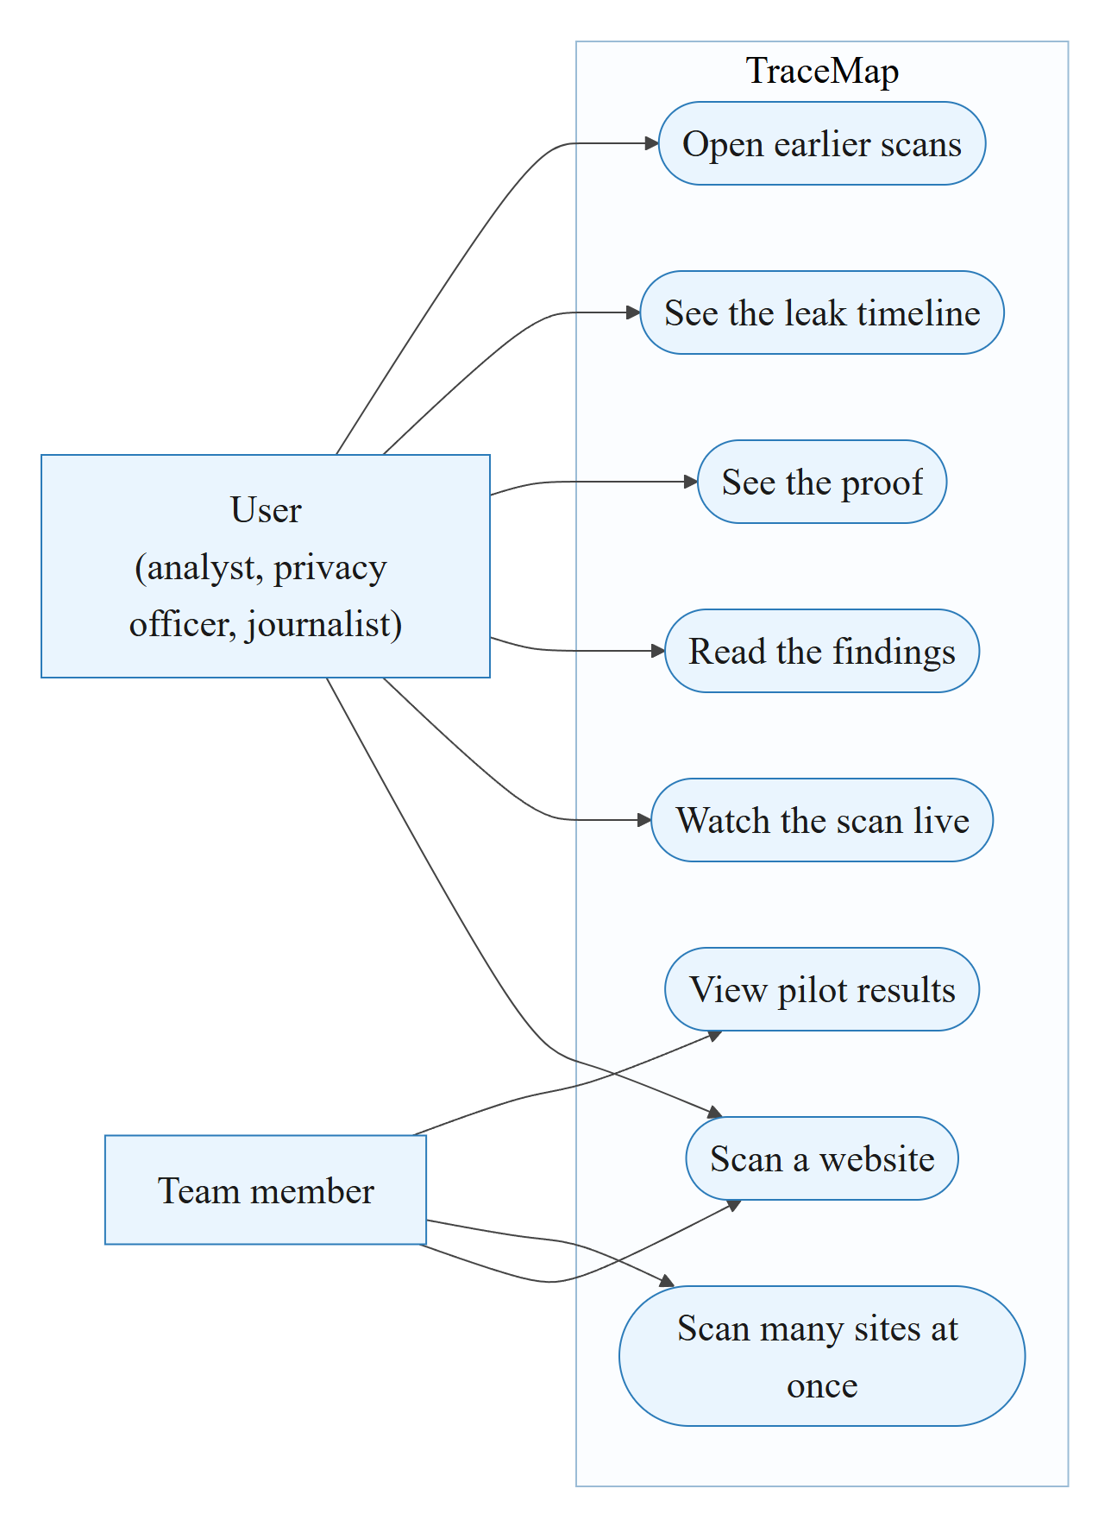
Figure 1: Use case diagram (Source: authors)
How to read it: the boxes on the left are the people who use TraceMap; each oval is something they can do.

2.5 User Classes and Characteristics
Table 7: User classes
User | What they need
Analyst or researcher | Runs scans and reads the detailed proof
Website owner or privacy officer | Clear findings about their own website
Journalist | Simple explanations and screenshots
Team member | Runs batches of websites and the pilot study

2.6 Design and Implementation Constraints
- Runs on a normal laptop. One website is scanned at a time.
- A quick scan takes under a minute; a thorough scan takes a few minutes. Every scan has a time limit so a slow website cannot stop the tool.
- Built with Python, the Chrome browser, and a React web page.
- Only public web pages; never logs in, never solves "verify you are human" checks.
- Only fake email addresses and team-owned phone numbers are typed, and forms are never submitted.
- Public tracker lists are free for non-commercial use, so our dataset must also be shared non-commercially.

2.7 Design diagrams
The use case diagram is Figure 1 in Section 2.4. The three diagrams below show how a scan works, how data moves, and how the parts of the system connect.
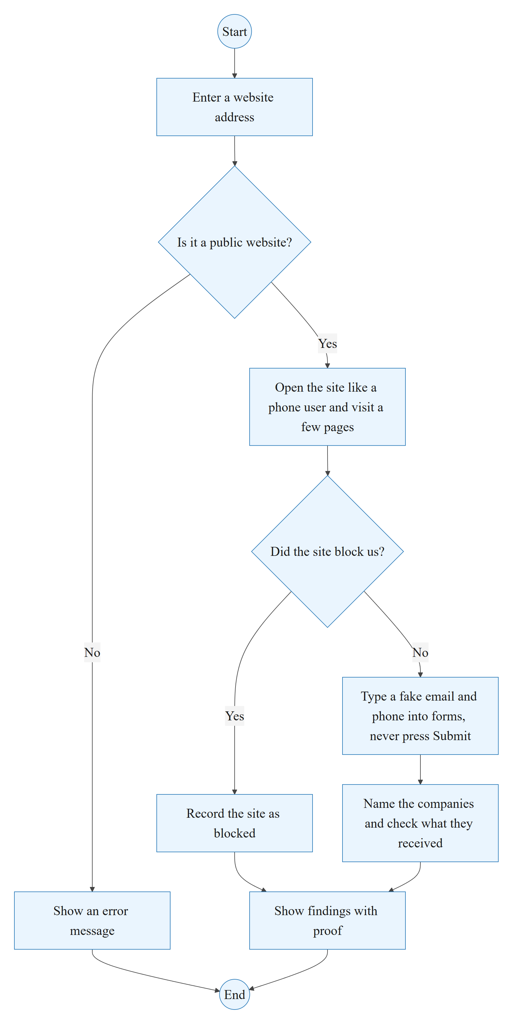
Figure 2: Activity diagram: steps of one scan (Source: authors)
How to read it: start at the top and follow the arrows. Diamonds are yes/no questions.
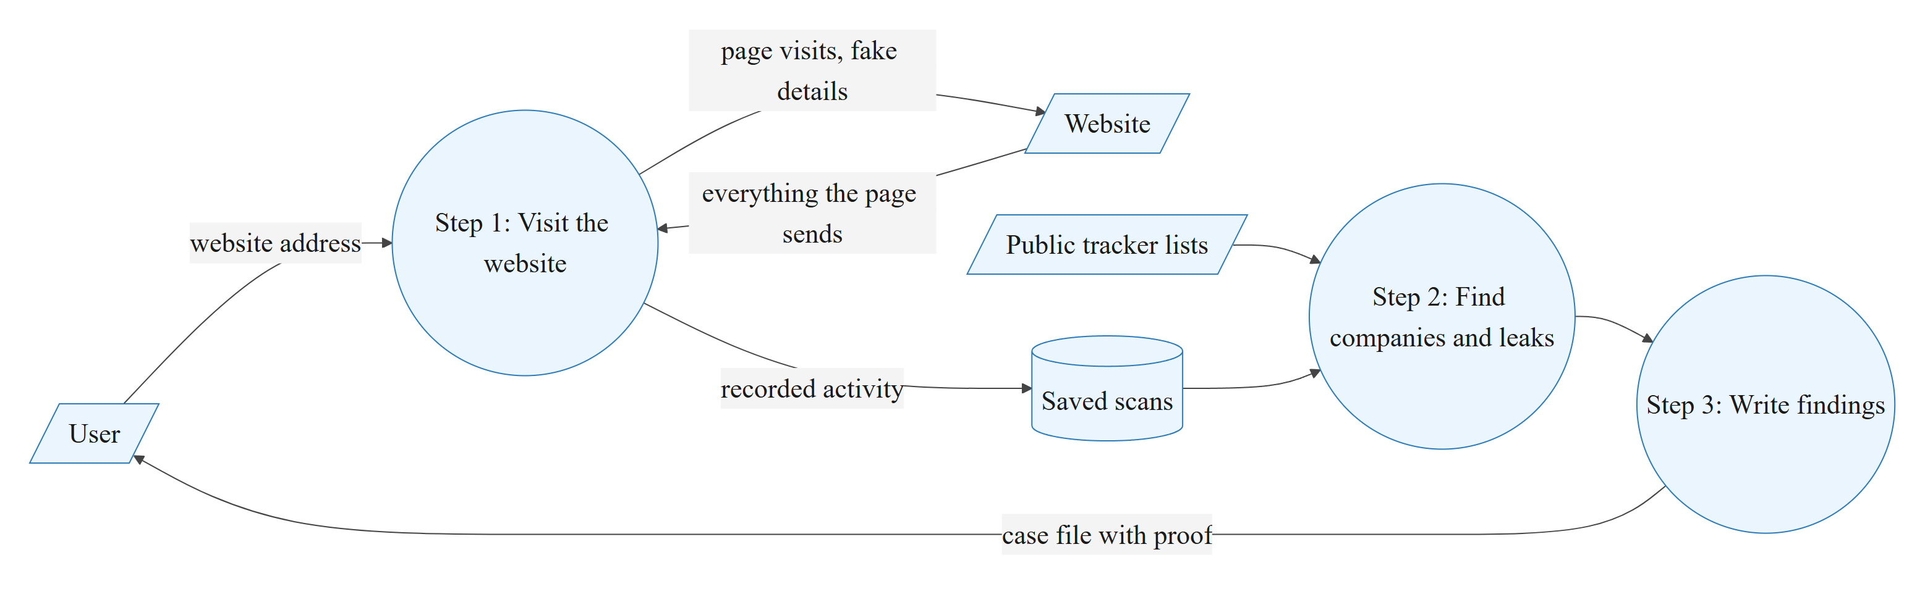
Figure 3: Data flow diagram (Source: authors)
How to read it: circles are the three main steps, the cylinder is where scans are saved, and the slanted boxes are things outside TraceMap.
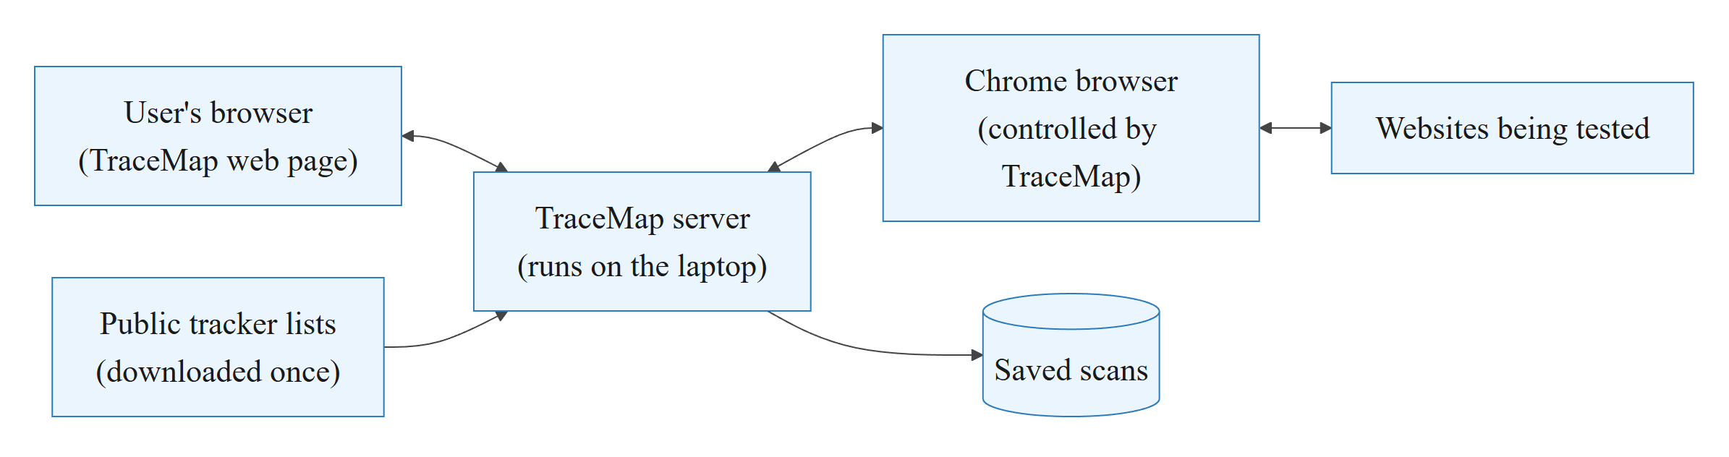
Figure 4: System overview (Source: authors)
How to read it: the user opens the TraceMap web page, the TraceMap server controls a Chrome browser, and that browser visits the websites being tested.

2.8 Assumption and Dependencies
- The websites being tested are public and can be opened from India.
- Google Chrome is installed on the laptop.
- The public tracker lists stay available and are mostly correct.
- The team gets ethics approval before testing forms on real websites.
- A browser cannot see data that companies share later between their own servers, so our numbers are a minimum.

3 SYSTEM REQUIREMENTS

3.1 User Interface
TraceMap is used through a web page that opens on the laptop. The main screens are shown below. The screenshots come from scanning our own fake test website.
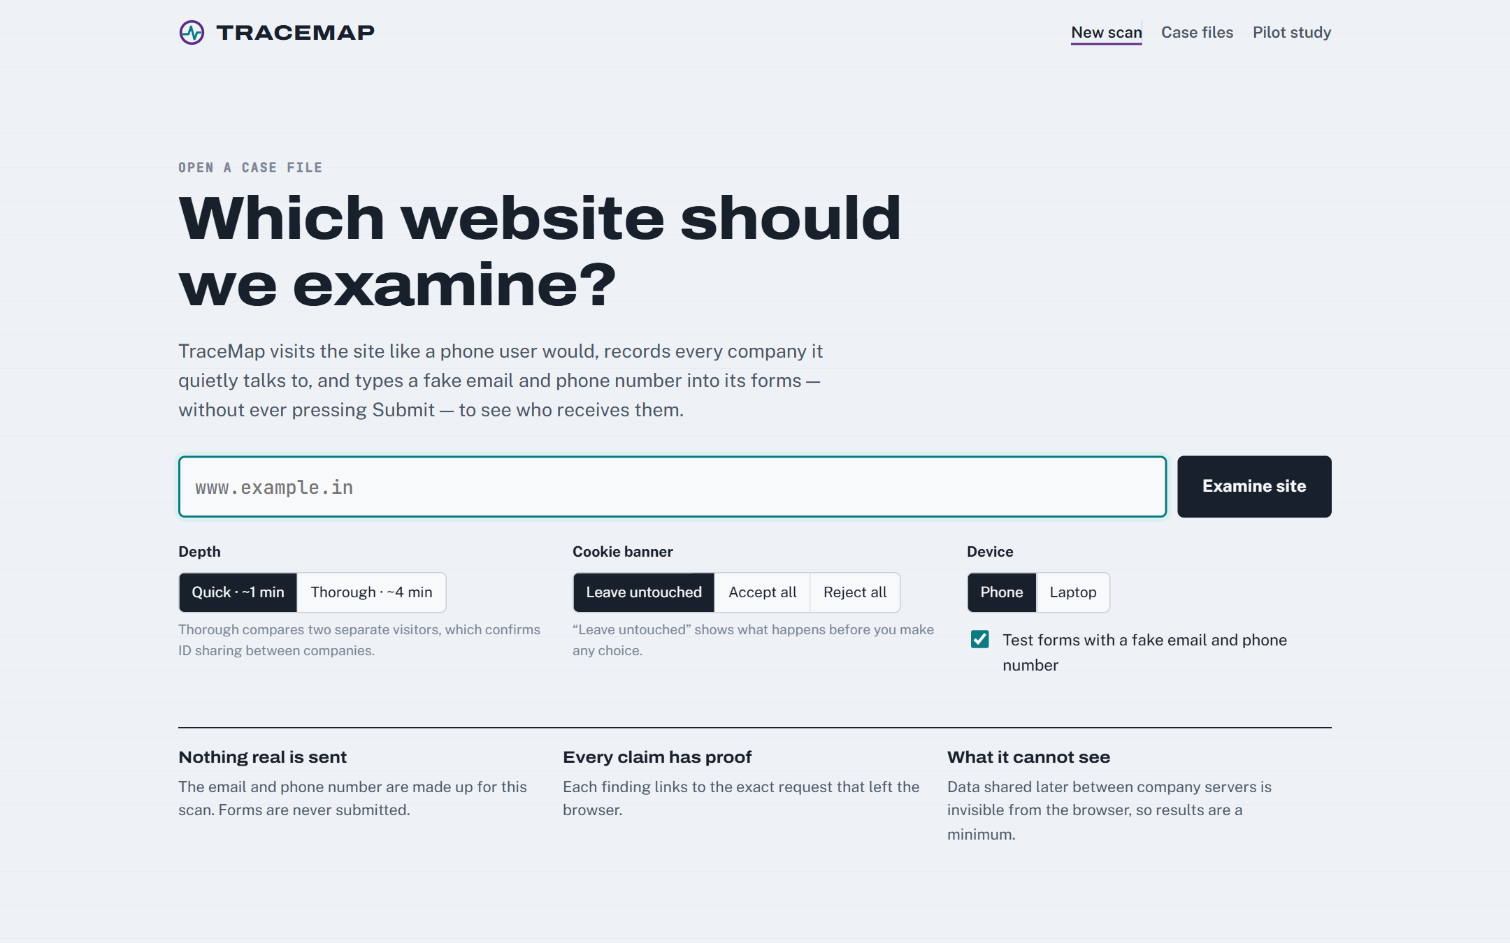
Figure 5: New scan screen: enter a website address and choose options (Source: authors, TraceMap application)
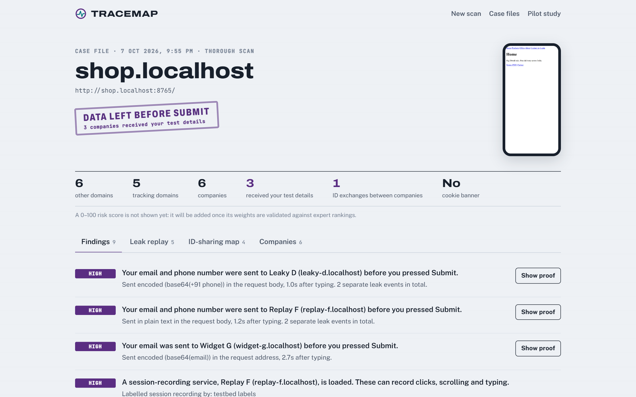
Figure 6: Case file: overall verdict, summary numbers and findings (Source: authors, TraceMap application)
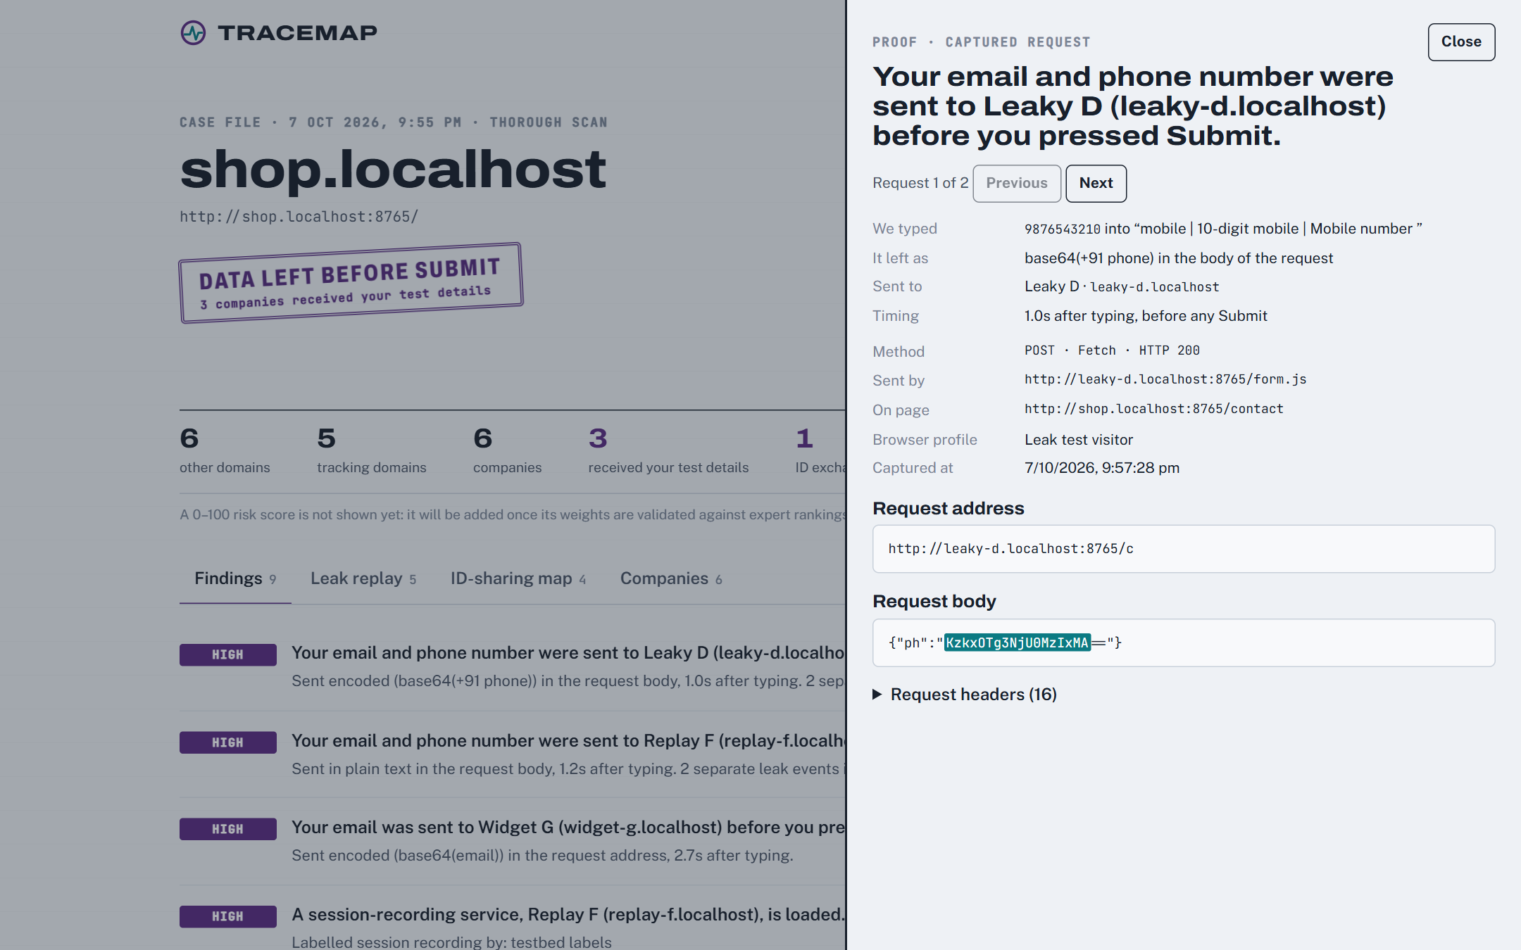
Figure 7: Proof: the exact message that carried the fake email (Source: authors, TraceMap application)
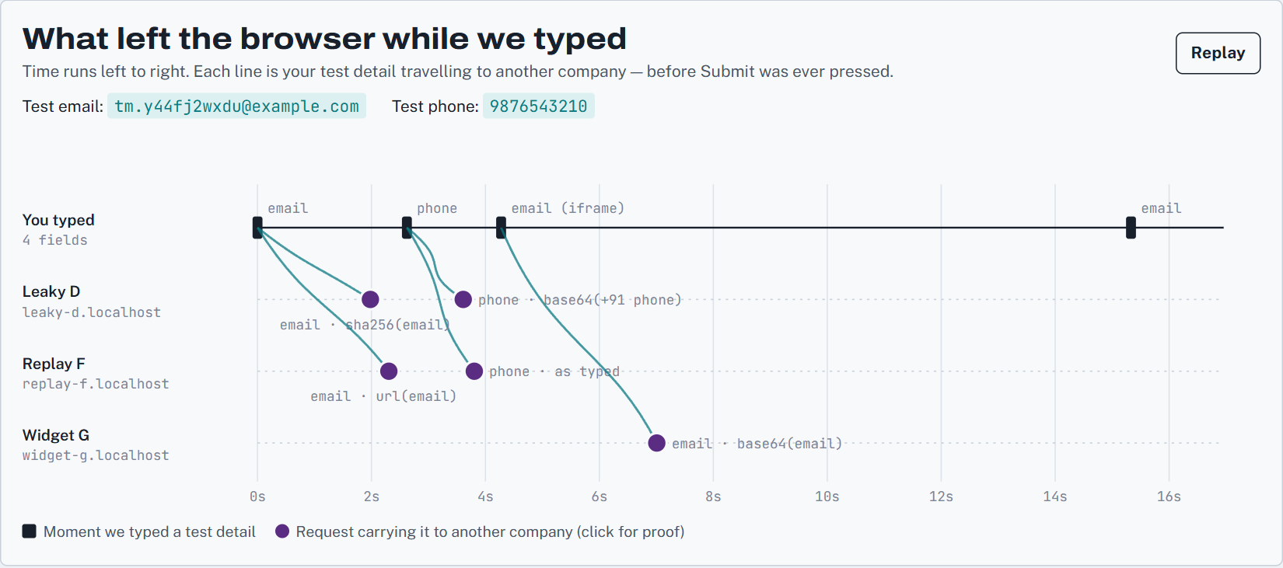
Figure 8: Leak timeline: when each company received the fake details (Source: authors, TraceMap application)

3.2 Software Interface
TraceMap has a few parts that pass information to each other in order:
Table 8: Main parts of TraceMap
Part | What it does
Scanner | Opens the website in Chrome and records everything the page sends
Company finder | Names each outside company using the tracker lists
Leak checker | Looks for the fake email and phone in what was sent
ID checker | Finds IDs shared between companies
Report writer | Turns the results into plain-English findings with proof
Server | Runs scans in the background and sends progress to the web page
Web page | Shows the screens above

The web page talks to the TraceMap server through a small set of web addresses (an API). For example, one address starts a scan, one gives live progress, and one returns the results. The team can also run everything from the command line.

3.3 Database Interface
Each scan is saved as a file on the laptop. A small database (SQLite, which needs no separate server) keeps a list of all scans so they can be opened again. For each scan the list stores: the scan number, the website address, the date and time, whether the scan finished, and the summary numbers.

3.4 Protocols
- Websites are opened over normal web connections (HTTP and HTTPS), one website at a time.
- The web page and the TraceMap server talk over a local web connection on the same laptop.
- No real personal data is handled, so nothing sensitive needs to be encrypted.
- The server refuses to scan private or internal network addresses, so it cannot be misused to look inside a private network.

4 NON-FUNCTIONAL REQUIREMENTS

4.1 Performance requirements
Table 9: Performance
Requirement | Target | Achieved
Quick scan of one website | Under 1 minute | About 23 seconds on average (pilot)
Thorough scan with the fake email test | Under 5 minutes | About 2 minutes on the test website
Checking the fake values in all messages | A few seconds | About 1.6 seconds
A slow or frozen website | Must not stop the tool | Every scan has a time limit

4.2 Security requirements
- Only fake email addresses are used; phone numbers only if the team owns them. No real person's data is ever typed or collected.
- Forms are never submitted, and password, OTP and card boxes are never touched.
- No logging in and no getting around "verify you are human" checks.
- The server will not scan private network addresses.
- Ethics approval will be obtained before testing forms on real websites.
- Serious leaks will be reported privately to the website first (and to CERT-In for government websites) before anything is published.

4.3 Software Quality Attributes
Table 10: Software quality attributes
Quality | How TraceMap meets it
Correctness | Tested on a fake website where we planted the answers; it found all of them and made no false claims
Reliability | Time limits stop slow websites from freezing the tool; failed sites are recorded
Usability | Findings in plain English, with proof one click away
Maintainability | Built as separate parts, each with one team owner and automated tests
Portability | Runs on Windows, Mac or Linux with Python and Chrome
Testability | 44 automated tests check the tool after every change

5 OTHER REQUIREMENTS
- Ethics and law: ethics committee approval and advice from the university's legal cell before testing forms on real websites.
- Fair wording: we say a company "shared an ID", not that it "colluded", because a shared ID is evidence, not proof of intent.
- Licences: public tracker data is free for non-commercial use, so our dataset will be shared non-commercially, with credit to each source.
- Hardware and software: a laptop with at least 8 GB of memory, Python, Google Chrome, and Node.js to build the web page.

APPENDIX A: GLOSSARY
Table 11: Glossary
Term | Meaning
Third party | Any company other than the website you are visiting
Tracker | A third party that follows or profiles visitors (advertising, analytics and similar)
Cookie | A small piece of data a website stores in your browser
User ID | A value that identifies the same visitor each time
Cookie syncing | Companies passing a user ID to each other to combine what they know about you
Fake (canary) value | A made-up email or phone number we type to see where it goes
Hash | A scrambled code made from a value; the same email always gives the same hash, so it still identifies you
Fingerprinting | Recognising a device from its settings and hardware, without cookies
Session recording | A service that records clicks, scrolling and typing on a page
Cookie pop-up | The banner asking you to accept or reject cookies
DPDP Act | India's Digital Personal Data Protection Act, 2023

APPENDIX B: ANALYSIS MODEL
How we check that TraceMap is correct. We built a fake shopping website on our own laptop with six fake companies, each doing something we know about. TraceMap is then scored against those known answers.
Table 12: Test website results
Planted on the test website | Planted | Found by TraceMap
Outside companies | 6 | 6
Leaks of the fake email or phone | 5 | 5
Wrong companies blamed | 0 | 0
Pair of companies sharing a user ID | 1 | 1
Fingerprinting script | 1 | 1
"Verify you are human" page | 1 | 1

We also searched the same traffic for an email we never typed, and TraceMap correctly found nothing.
Table 13: Pilot results by sector (7 October 2026)
Sector | Websites scanned | Typical number of trackers | Highest
Government | 10 of 10 | 2 | MyGov, 13
Banking | 10 of 10 | 10 | HDFC Bank, 19
Health | 10 of 10 | 13.5 | 17
Shopping | 9 of 10 | 15 | Croma, 42
Education | 10 of 10 | 16.5 | 18

Other pilot findings: 48 of 49 websites loaded trackers before the visitor made any cookie choice; 8 loaded a session-recording service (including a bank and two hospital groups); 19 used Indian marketing companies; and only 8 showed a cookie pop-up.

APPENDIX C: ISSUES LIST
Table 14: Open issues
No. | Open issue | Status
1 | Ethics approval for testing forms on real websites | To be submitted
2 | A team-owned email domain and phone number for the fake details | To be arranged
3 | Two team members to check our list of Indian companies | In progress
4 | About 9% of outside companies are on no public list; to be checked by hand | In progress
5 | Quick scans cannot confirm shared IDs; the full study will use thorough scans | Planned
6 | Security checks on scripts and the 0-100 risk score | Second half
7 | Data shared between company servers cannot be seen | Stated as a limitation

