**Assignment 7**

1. **check weather the number is palindrom or not.**

Save this script in a file (e.g., **palindrome.sh**), give it executable permissions (**chmod 777 palindrome.sh**), and then run it (**./palindrome.sh**). It will ask to enter a number, and then it will tell you whether the number is a palindrome or not.

1. Top of Form

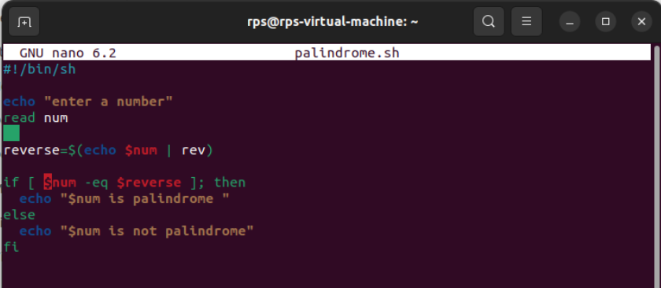

**Output:**

