**Assignment 1**

**1.Ensure the script checks if a specific file (e.g., myfile.txt) exists in the current directory. If it exists, print "File exists", otherwise print "File not found".**

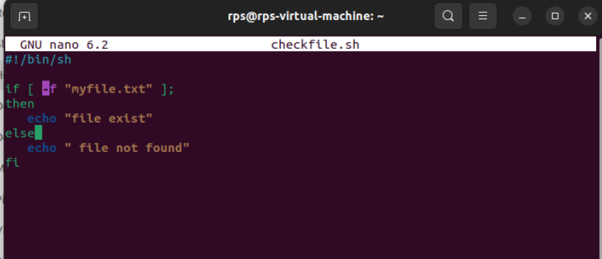

Save this script to a file, say **checkfile.sh**, and make it executable using the command **chmod +x checkfile.sh**. Then you can run it using **./checkfile.sh** in the terminal. If **myfile.txt** exists in the same directory as the script, it will print "File exists"; otherwise, it will print "File not found".

Top of Form