**Assignment2**

**1.Write a script that reads numbers from the user until they enter '0'. The script should also print whether each number is odd or even.**

Here's a shell script that reads numbers from the user until they enter '0' and prints whether each number is odd or even: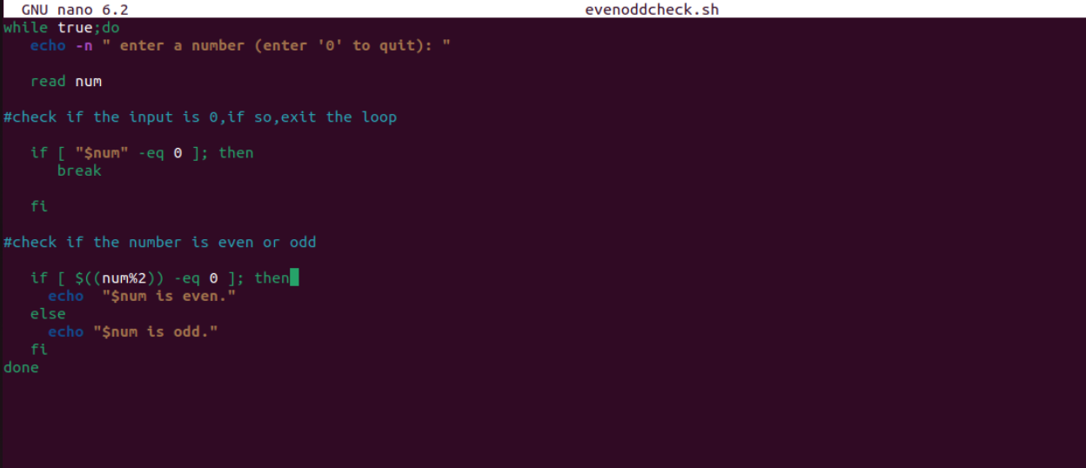

I Saved the script to a file, say **oddvencheck.sh**, and make it executable using the command **chmod 777 oddencheck.sh**. Then you can run it using **./oddencheck.sh** in the terminal. The script will prompt you to enter numbers, and it will print whether each number is odd or even until you enter '0' to quit.

Output:

