**Assignment 4**

1. **Craft a query using an INNER JOIN to combine 'orders' and 'customers' tables for customers in a specified region, and a LEFT JOIN to display all customers including those without orders.**

**1.create two tables name cutomers and orders**

Create table customers

(

customer_id number(10) primery key,

customer_name varchar2(30),

region varchar2(30)

);

* This sql commad create a table customers with tree columns customer id,customer name,region. Customer id is primary key

**2.Inserting the values to the customer table**

Insert into customers values(1,’subbu’,’ hyderabad’);

Insert into customers values(2,’siri’,’ shadnagar’);

Insert into customers values(3,’ramya’,’ kamareddy’);

Insert into customers values(4,’kavya’,’ siddipet’);

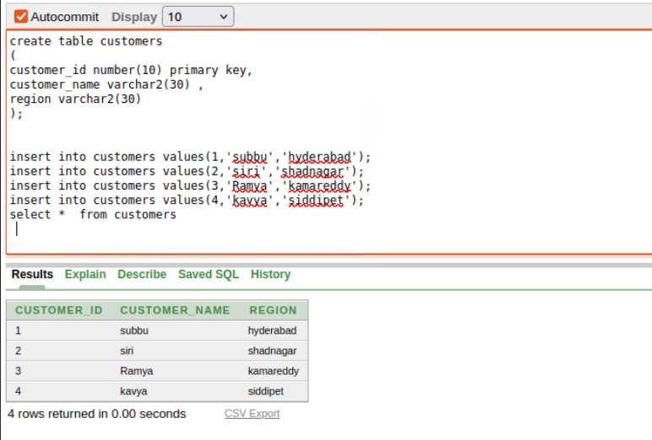

Create table orders

(

order_id number(10) primarykey,

customer_id number(10)

order_date varchar2(30)

);

* This sql commad create a table orders with tree columns order id,customer id,order date.order id is primary key

Insert into orders values(101, 4,’2-02-2024’);

Insert into orders values(102, 3,’5-04-2024’);

Insert into orders values(103, 42’3-05-2024’);

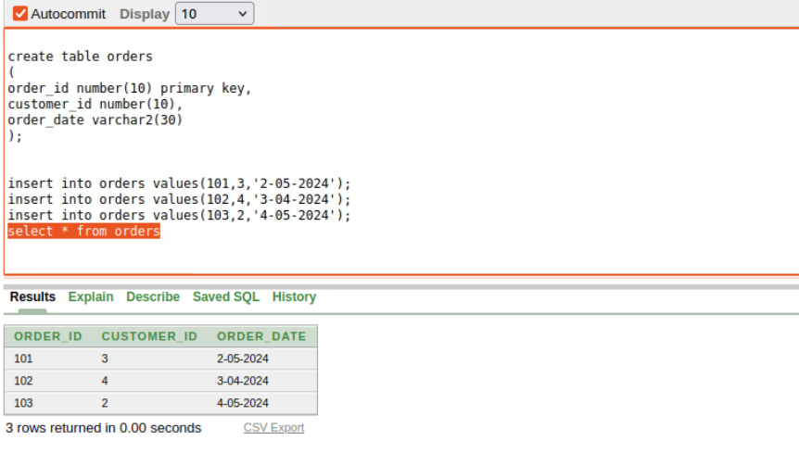

**3.LEFT JOIN to display all customers including those without orders.**

