**Assignment2**

**1.Branch Creation and Switching**

**Create a new branch named 'feature' and switch to it. Make changes in the 'feature' branch and commit them.**

1. **Create a new branch named 'feature':**



this command creates a new branch named 'feature' based on the current branch (typically 'main' or 'master').

2. **Switch to the 'feature' branch:**



This command switches to the 'feature' branch.

Alternatively, we combine the branch creation and switching into one command

3. **Make changes in the 'feature' branch:** we can make any changes you want to our files while we are on the 'feature' branch. For example, let's we want to modify the **example.txt** file:

Make your changes in the text editor.

**4.Add the changes:**



This stages the changes we made to **example.txt**.

1. **Commit the changes:**

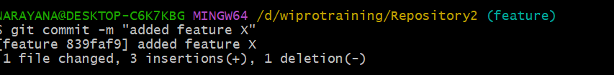

This commits the changes to the 'feature' branch with the message "Added feature X".

Now you have created a new branch named 'feature', switched to it, made changes, and committed them to the 'feature' branch.Top of Form

