**Assignment6**

**1.display all the directory names.**

To display the directory name we use the commad ls -d */ | awk -F’/’ ‘{print $1}’

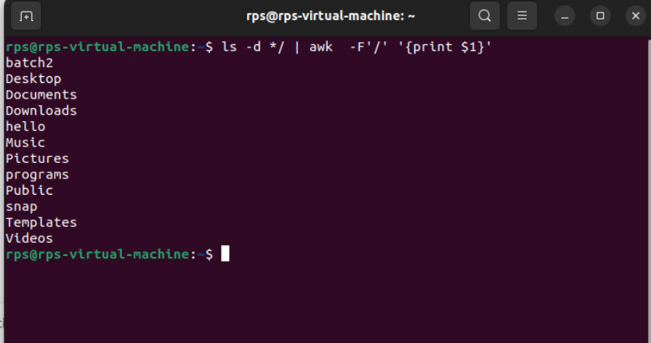

1. **ls -d */**: This lists all directories in the current directory. The **-d** flag tells **ls** to list directories themselves, not their contents, and the **\*/** part ensures that only directories are listed.
2. **awk -F'/' '{print $1}'**: This command takes each line of output from **ls -d */** and prints only the directory name. **-F'/'** sets the field separator to **/**, so **awk** can extract the directory name.

Save this script in a file, let's say **list_directories.sh**, and make it executable using **chmod +x list_directories.sh**. Then you can run it using **./list_directories.sh** in the directory where you want to list directories.