Sales Data Analysis Using Python and Pandas
1. Objective
To clean and analyze sales data using Excel and Python, identify top-performing products, compare sales across states and sales channels, and visualize the results.

2. Tools Used
- Microsoft Excel
- Python
- Pandas
- Matplotlib
- Jupyter Notebook

3. Dataset Description
The dataset contains 550 rows and 8 columns, including Customer Name, State, Product, Units Sold, Unit Price, Total Sale, Sale Date, and Sales Channel.

4. Data Cleaning
The dataset was checked for missing values and inconsistencies. Product and state names were standardized, dates were checked, numerical columns were formatted, and missing Sales Channel values were labelled as “Missing.” Other missing values were retained when reliable information was unavailable.

5. Sales Data Analysis
Python and Pandas were used to analyze the cleaned dataset. Calculated sales were obtained by multiplying Units Sold by Unit Price wherever both values were available. Sales were grouped by product, state, and sales channel to compare their performance.

6. Results and Visualizations
6.1 Sales by Product
The product-wise sales chart compares the calculated sales of different products and helps identify higher- and lower-performing products.
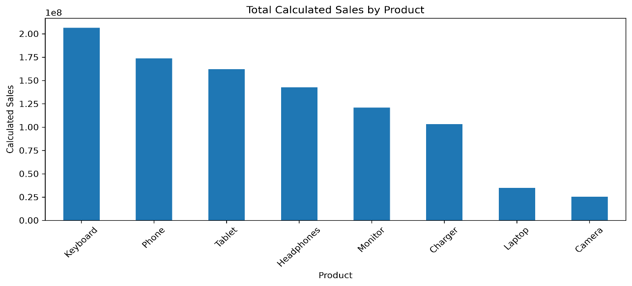
Figure 1: Total Calculated Sales by Product

6.2 Sales by State
The state-wise sales chart compares calculated sales across different states.
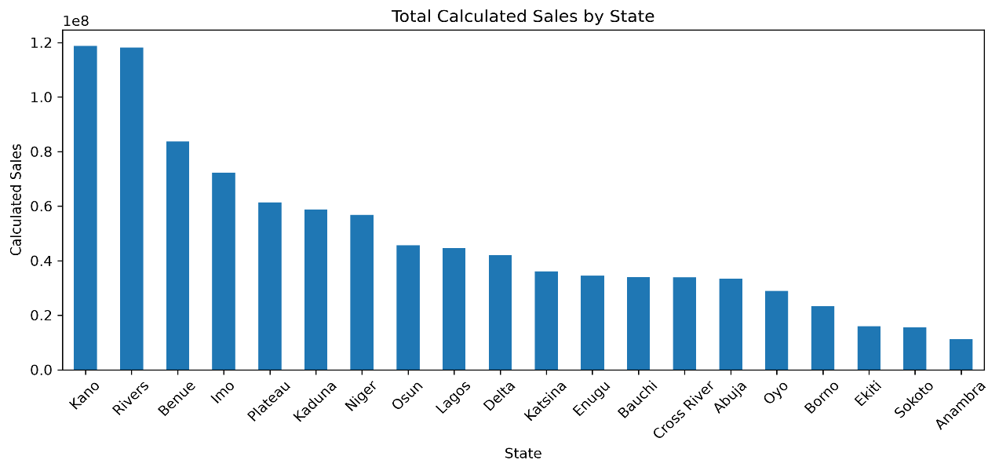
Figure 2: Total Calculated Sales by State

6.3 Sales by Channel
Sales were grouped by sales channel to compare the available records for Direct, Online, Retail, Wholesale, and Missing categories.
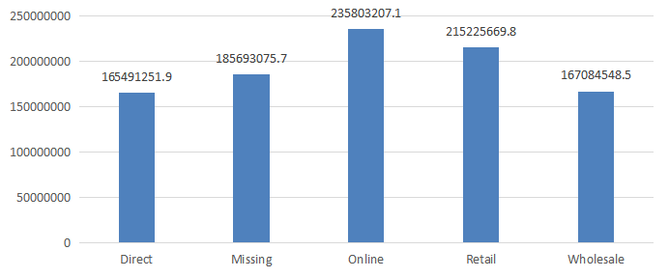

7. Limitations
Several records contain missing values. Calculated sales include only rows where both Units Sold and Unit Price are available, so the results do not represent the complete sales value of the dataset.

8. Conclusion
The dataset was cleaned using Excel and analyzed using Python, Pandas, and Matplotlib. Product-wise and state-wise bar charts were created to compare calculated sales. This task provided practical experience in data cleaning, data analysis, grouping, and visualization.

