Predictive Analytics for Sales Forecasting Using Historical Data

Code:
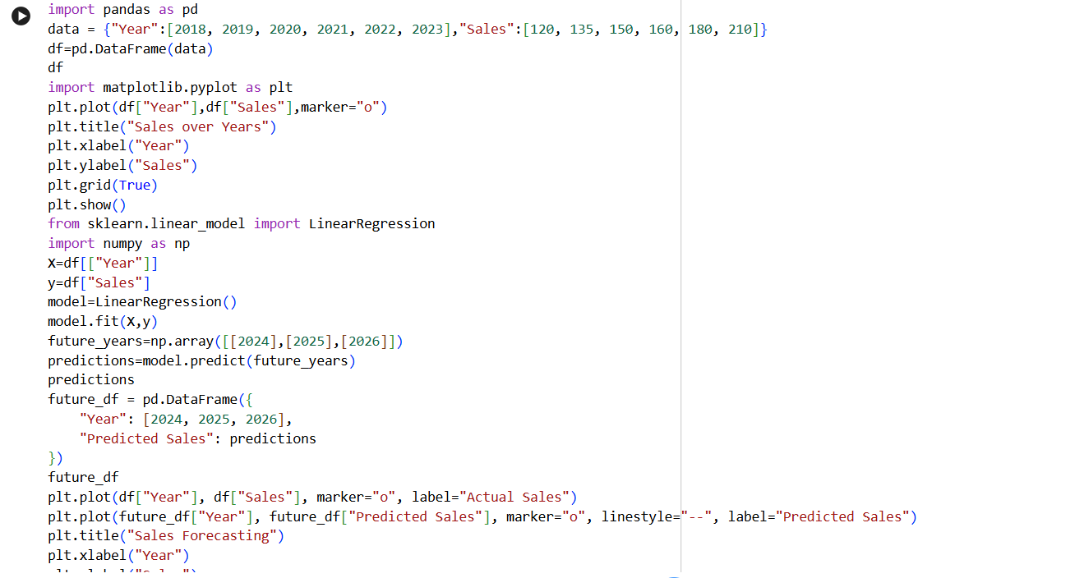
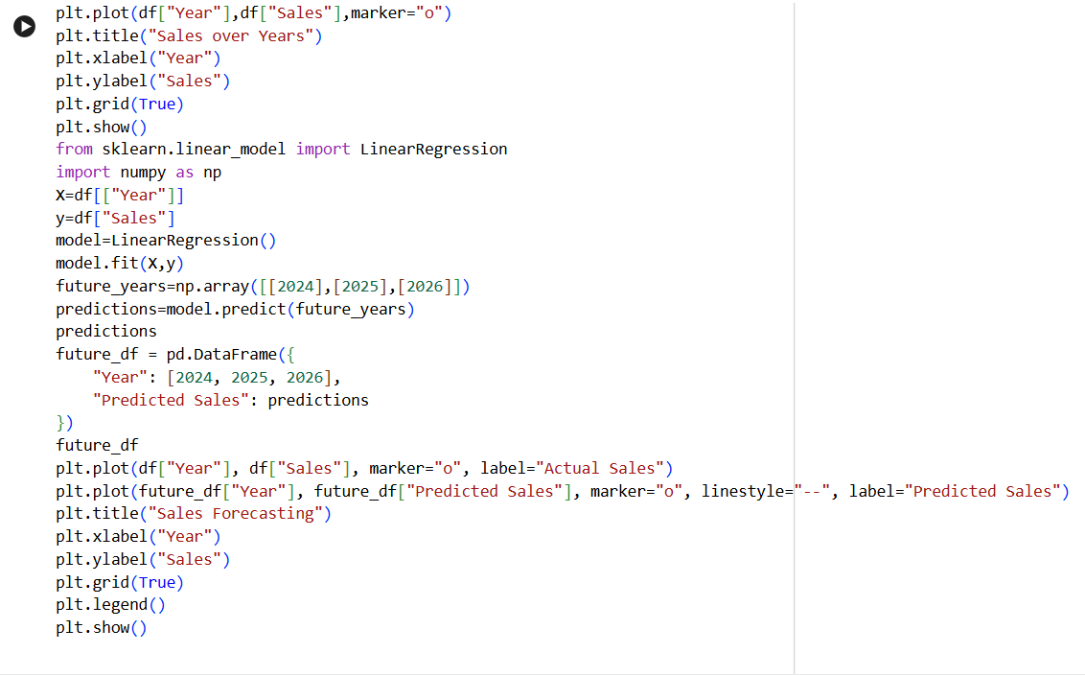

Output:
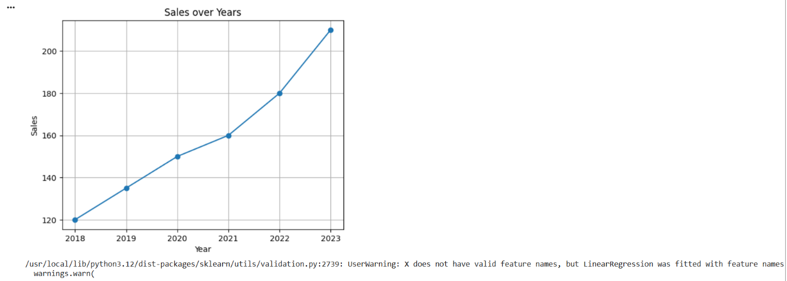
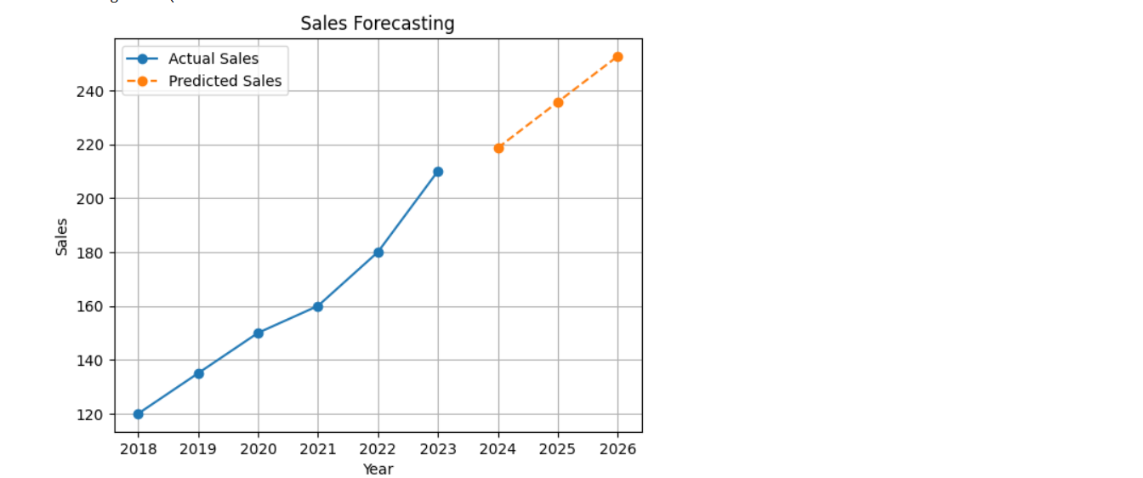

---

Submitted By:

Kavya Mani

B.Sc Computer Science

Project: Predictive Analytics Using Historical Data

Date: 15-05-2026

