REINFORCEMENT LEARNING
ASSIGNMENT 1
Markov Decision Processes — 4×4 Frozen Lake
Submitted by: Kavya Namburi
Roll Number: BT23CSE004
Includes Parts 1–5, implementation details, convergence plot, and numerical verification.

Executive Summary
This report formulates and solves a 4×4 Frozen Lake Markov Decision Process. It evaluates a uniform random policy using synchronous iterative updates, computes action values, finds an optimal policy with policy iteration and value iteration, verifies fixed-policy evaluation with a linear system, and studies changes to the discount factor and living reward.
Model clarification: the assignment states that the intended movement occurs with probability 0.25 but does not specify the remaining probability. To make the transition model complete, this report assumes that the remaining 0.75 probability corresponds to staying in the current cell. This is an explicit modelling assumption, not a rule stated in the handout.

Fixed Environment
S H F F
F F F H
H F F F
F F H G
State numbering:
0 1 2 3
4 5 6 7
8 9 10 11
12 13 14 15
Item | Definition
State space | S = {0, 1, ..., 15}
Start state | 0
Holes | {1, 7, 8, 14}
Goal | 15
Actions | {Left, Down, Right, Up}
Transition assumption | 0.25 intended movement; 0.75 stay; boundary movement remains in place
Rewards | −0.01 normal step/stay; −1 entering a hole; +1 entering the goal
Terminal states | {1, 7, 8, 14, 15}; future value represented as 0
Discount factor | γ = 0.9

Part 1 — Problem Setup

1.1 MDP tuple
The environment is represented by M = (S, A, P, R, γ).
- S = {0, 1, ..., 15}: the 16 grid cells numbered row-wise.
- A = {Left, Down, Right, Up}: the four actions.
- P(s′|s,a): for a non-terminal state, the intended move has probability 0.25 and staying has probability 0.75. If the intended move hits the boundary, the agent remains in the current cell.
- R(s,a,s′): +1 when entering the goal, −1 when entering a hole, and −0.01 for an ordinary transition including staying.
- γ = 0.9: the discount factor.

1.2 Is the MDP finite, episodic, and fully observed?
- Finite — Yes. There are 16 states and four actions, so both sets are finite.
- Episodic — Yes, under the terminal-state convention. An episode ends when a hole or the goal is entered. Staying in a non-terminal state can delay termination.
- Fully observed — Yes. The agent's current grid cell is known directly; there is no hidden state.

Part 2 — Policy Evaluation

2.1 Uniform random policy
The policy is π(a|s) = 0.25 for each of the four actions in every non-terminal state.

2.2 Bellman expectation equation
Vπ(s) = Σa π(a|s) Σs′ P(s′|s,a) [R(s,a,s′) + γ Vπ(s′)]
For iterative evaluation, use the old value vector to compute the new vector synchronously:
V_{k+1}(s) = Σa π(a|s) Σs′ P(s′|s,a) [R(s,a,s′) + γ V_k(s′)]
Initialize V₀(s)=0. After each sweep calculate Δ = max_s |V_new(s) − V(s)|, replace V with V_new, and stop when Δ < 10⁻⁸. One sweep updates all non-terminal states once.

2.3 Manual first two iterations for state 2
State 2 is immediately to the right of hole 1. At iteration zero, all values are zero.
For Left, the intended move enters hole 1 with probability 0.25, receiving −1; with probability 0.75 the agent stays at state 2, receiving −0.01. Thus Q₀(2,Left)=0.25(−1)+0.75(−0.01)=−0.2575. Down and Right have expected immediate reward −0.01. Up hits the top boundary and remains in state 2, giving −0.01.
V₁(2) = 0.25[−0.2575 − 0.01 − 0.01 − 0.01] = −0.071875
Using V₁(2)=V₁(3)=V₁(6)=−0.071875 and V₁(1)=0:
Q₁(2,Left) = 0.25(−1 + 0.9·0) + 0.75[−0.01 + 0.9(−0.071875)]
= −0.306015625
Q₁(2,Down) = Q₁(2,Right) = Q₁(2,Up) = −0.0746875
V₂(2) = 0.25[−0.306015625 − 3(0.0746875)] = −0.13251953125
These values provide a manual check for the implementation.

2.4 Converged value function
With γ=0.9, θ=10⁻⁸, synchronous updates, and the stated transition model, iterative evaluation converges in 94 sweeps.
-0.459740 0.000000 -0.457276 -0.459279
-0.459019 -0.455574 -0.447705 0.000000
0.000000 -0.447705 -0.396113 -0.115466
-0.459279 -0.457276 0.000000 0.000000

2.5 Convergence plot
The plot shows ||V_{k+1}−V_k||∞ versus sweep on a logarithmic y-axis. At sweep 94, the maximum change is below 10⁻⁸.
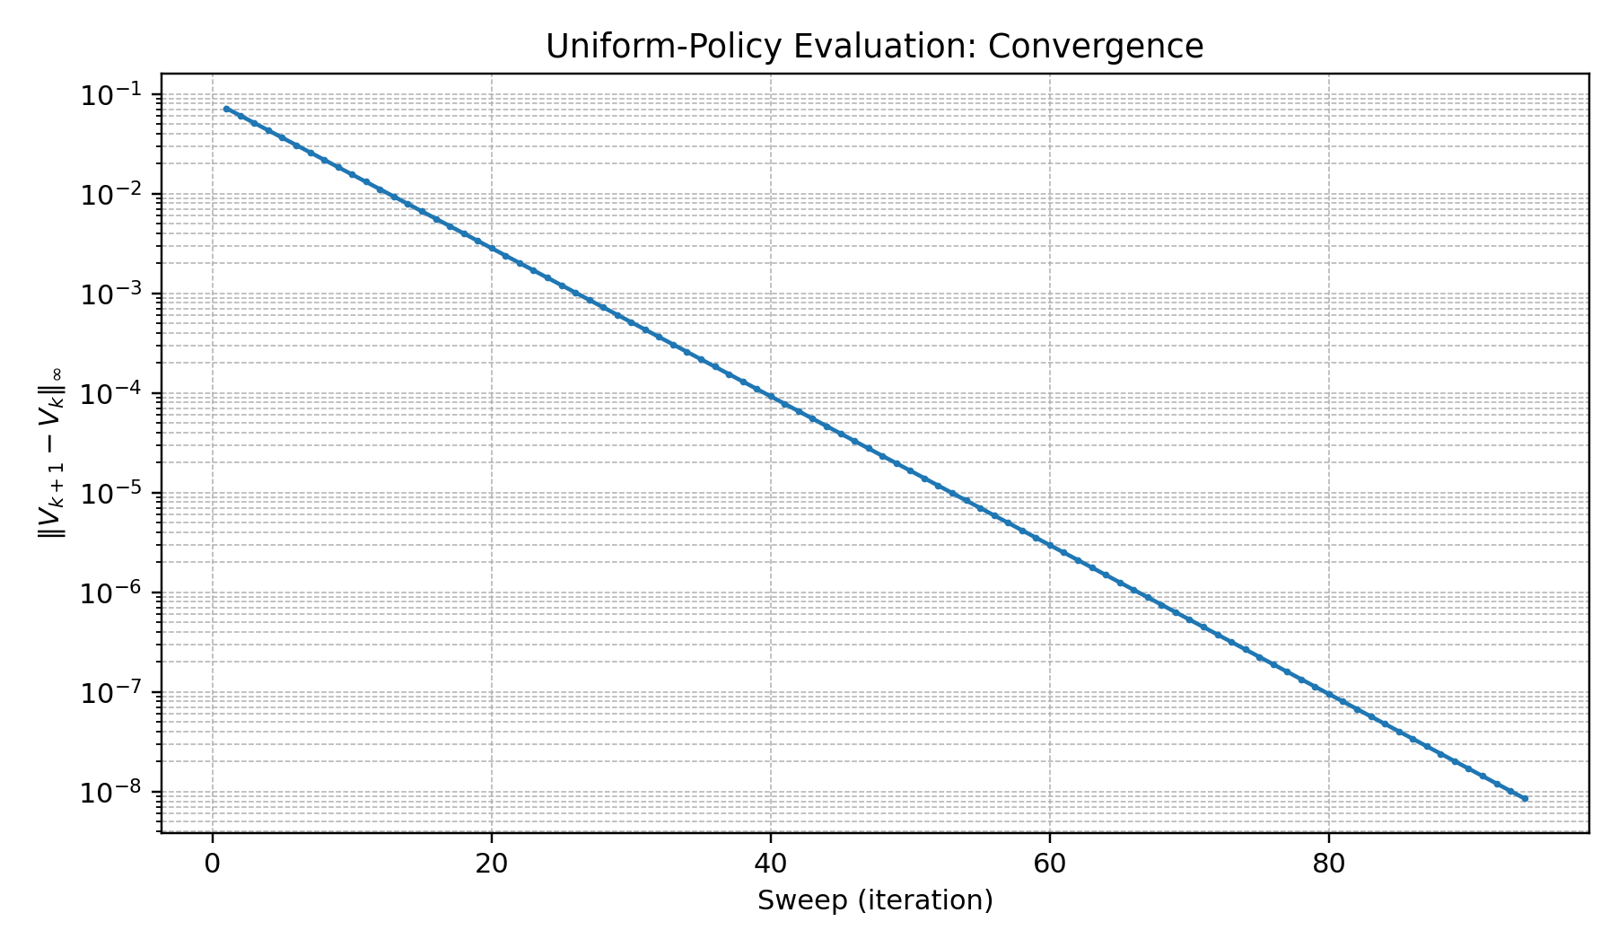

2.6 Action-value function Qπ(s,a)
After obtaining the converged Vπ, calculate Qπ(s,a)=Σs′P(s′|s,a)[R(s,a,s′)+γVπ(s′)]. The following table lists all state-action pairs in the order Left, Down, Right, Up. Terminal rows are displayed as zero by convention.
State | Type | Left | Down | Right | Up
0 | — | -0.423766 | -0.423604 | -0.567825 | -0.423766
1 | H | 0.000000 | 0.000000 | 0.000000 | 0.000000
2 | — | -0.566161 | -0.419395 | -0.421999 | -0.421548
3 | — | -0.422900 | -0.567513 | -0.423351 | -0.423351
4 | — | -0.423117 | -0.567338 | -0.422342 | -0.423280
5 | — | -0.420792 | -0.418246 | -0.418246 | -0.565013
6 | — | -0.414705 | -0.401326 | -0.559701 | -0.415088
7 | H | 0.000000 | 0.000000 | 0.000000 | 0.000000
8 | H | 0.000000 | 0.000000 | 0.000000 | 0.000000
9 | — | -0.559701 | -0.415088 | -0.401326 | -0.414705
10 | — | -0.378110 | -0.524876 | -0.303356 | -0.378110
11 | — | -0.177065 | 0.164561 | -0.113919 | -0.335439
12 | — | -0.423351 | -0.423351 | -0.422900 | -0.567513
13 | — | -0.421999 | -0.421548 | -0.566161 | -0.419395
14 | H | 0.000000 | 0.000000 | 0.000000 | 0.000000
15 | G | 0.000000 | 0.000000 | 0.000000 | 0.000000

Part 3 — Policy Iteration and Value Iteration

3.1 Policy iteration
Policy iteration alternates between policy evaluation and policy improvement. We begin with the uniform random policy. Once its value function is evaluated, we form Qπ(s,a) and greedily select the action with the largest value at each non-terminal state.
π_new(s) = argmax_a Σs′ P(s′|s,a)[R(s,a,s′) + γ Vπ(s′)]
With the fixed model, the successive policy evaluations take the following numbers of sweeps:
Policy evaluation check | Sweeps | Outcome
Initial uniform policy | 94 | Greedy improvement gives deterministic policy
Improved deterministic policy | 72 | Policy remains unchanged; stable
The policy stabilizes after two improvement checks. A policy is stable when another greedy improvement does not change any action. Policy evaluation itself is run to the specified value tolerance at each check.

3.2 Value iteration
Value iteration uses the Bellman optimality update, taking the maximum over actions on every sweep:
V_{k+1}(s) = max_a Σs′ P(s′|s,a)[R(s,a,s′) + γV_k(s′)]
At γ=0.9 and θ=10⁻⁸, value iteration converges in 72 sweeps. Its greedy policy matches the policy obtained by policy iteration.
Optimal value function from value iteration:
0.034569 0.000000 0.180767 0.094377
0.094377 0.180767 0.305553 0.000000
0.000000 0.305553 0.485799 0.746154
0.094377 0.180767 0.000000 0.000000
Greedy policy (L=Left, D=Down, R=Right, U=Up; H/G are terminal cells):
D H D L
R D D H
H R R D
R U H G

3.3 Contraction-property explanation
For a discounted MDP with bounded rewards and 0≤γ<1, both the Bellman expectation operator Tπ and Bellman optimality operator T are contractions in the infinity norm: ||TV−TU||∞ ≤ γ||V−U||∞. This guarantees convergence to their respective unique fixed points. Policy iteration explicitly evaluates a policy and then improves it, often needing relatively few improvement steps. Value iteration combines improvement with value updates and can require more sweeps. The contraction result guarantees convergence but does not universally guarantee fewer total computations for policy iteration.

Part 4 — Exact Solution Using Linear Algebra

4.1 Derivation
Vπ = Rπ + γPπVπ
(I − γPπ)Vπ = Rπ
Vπ = (I − γPπ)⁻¹ Rπ
Pπ(s,s′)=Σa π(a|s)P(s′|s,a) and Rπ(s)=Σa π(a|s)Σs′P(s′|s,a)R(s,a,s′). In code, np.linalg.solve is preferred over explicitly forming the inverse. Terminal values are constrained to zero.
The maximum absolute difference between iterative evaluation (θ=10⁻⁸) and the linear-system solution is 4.543663e-08. The small discrepancy is consistent with stopping the iterative method at a finite tolerance.

4.2 Why exact linear algebra does not scale
A dense n×n transition matrix requires O(n²) memory, and a general dense linear solve typically requires O(n³) computation. These costs become impractical for very large state spaces. Iterative methods, sampling-based model-free methods, sparse representations, and function approximation can avoid solving one large dense system.

Part 5 — Exploration Questions

5.1 Effect of the discount factor
γ | Value-iteration sweeps | V*(0)
0.5 | 24 | -0.019869444
0.9 | 72 | 0.034569003
0.999 | 105 | 0.750150069
At γ=0, only immediate rewards matter, so the agent is myopic. At γ=0.5, distant rewards are discounted substantially. At γ=0.999, future rewards receive much more weight. In these experiments, the greedy optimal policy remains unchanged, while values and convergence times differ. As γ approaches 1, the contraction bound becomes weaker and convergence can take more iterations. At γ=1, the standard discounted-MDP contraction guarantee no longer applies; additional conditions are needed, especially because the agent can stay in non-terminal states.

5.2 Change the living reward to zero
Living reward | Sweeps | V*(0)
−0.01 | 72 | 0.034569003
0 | 73 | 0.122335462
Changing the living reward from −0.01 to 0 removes the penalty for ordinary steps. In this grid, the start-state optimal value increases and the greedy policy remains unchanged. This outcome depends on the specific grid and transition model; it is not a universal rule.

5.3 If P and R are unknown
When P and R are unknown, the agent cannot compute exact Bellman expectations from a known model. It instead interacts with the environment and observes samples (s,a,r,s′). Model-free methods include TD(0), Q-learning, and SARSA. Q-learning updates Q(s,a) toward r+γ max_a′Q(s′,a′); SARSA uses the action actually selected at the next state. An exploration method such as ε-greedy selection helps the agent discover better actions.

Reproducibility and Implementation
The accompanying single Python file implements the model and all requested numerical experiments. It prints the policy-evaluation values, all 64 Qπ entries, policy-iteration results, value-iteration results, exact-solution error, discount-factor comparisons, and the living-reward comparison. It also writes the convergence plot to RL_Assignment1_Convergence_Plot.png.
Reproducibility settings: grid 4×4; holes {1,7,8,14}; goal 15; start 0; transition probability 0.25 intended and 0.75 stay; γ=0.9; normal reward −0.01; hole reward −1; goal reward +1; synchronous updates; θ=10⁻⁸.

