**Real-time/Field-Based Research Project Report**

**On**

**Chit Fund Management System**

A dissertation submitted to the Jawaharlal Nehru Technological University, Hyderabad in partial fulfilment of the requirement for the award of degree of

**BACHELOR OF TECHNOLOGY**

**IN**

**COMPUTER SCIENCE AND ENGINEERING**

Submitted by

**Sheganti Akshitha (22B81A05K9)**

**Navulla Kavya Reddy (22B81A05L9)**

**Ramidi Sharanya (22B81A05P2)**



Department of Computer Science and Engineering

# CVR COLLEGE OF ENGINEERING

(An UGC Autonomous Institution, Affiliated to JNTUH, Accredited by NBA, and NAAC)

Vastunagar, Mangalpalli (V),

Ibrahimpatnam (M),

Ranga Reddy (Dist.) - 501510,

Telangana State.

## 2023-24

**CVR COLLEGE OF ENGINEERING**

*(*An UGC Autonomous Institution, Affiliated to JNTUH, Accredited by NBA, and NAAC)

Vastunagar, Mangalpalli (V), Ibrahimpatnam (M), Ranga Reddy (Dist.) - 501510, Telangana State.

**DEPARTMENT OF COMPUTER SCIENCE AND ENGINEERING**

### CERTIFICATE

This is to certify that the project work entitled **“ Chit Fund Management** **System ”** is being submitted by **Sheganti Akshitha (22B81A05K9), Navulla Kavya Reddy (22B81A05L9),Ramidi Sharanya (22B81A05P2****)** in partial fulfilment of the requirement for the award of the degree of **Bachelor of Technology** in **Computer Science and Engineering,** during the academic year 2023-2024.

**Professor-in-charge RFP**      **Professor and Head, CSE**

**(Dr. A. Vani Vathsala)**

### DECLARATION

I hereby declare that this project report titled **“Chit Fund Management System”** submitted to the Department of Computer Science and Engineering, CVR College of Engineering, is a record of original work done by me. The information and data given in the report is authentic to the best of my knowledge. This RFP report is not submitted to any other university or institution for the award of any degree or diploma or published at any time before.

**Sheganti Akshitha (22B81A05K9)**

**Navulla Kavya Reddy (22B81A05L9)**

**Ramidi Sharanya (22B81A05P2)**

Date: 01-06-2024

Place: Hyderabad

**ACKNOWLEDGEMENT**

The satisfaction that accompanies the successful completion of any task would be incomplete without the mention of the people who made it possible and whose encouragement and guidance has been a source of inspiration throughout the course of the project.

It is great pleasure to convey our profound sense of gratitude to our Principal **Dr. K. Ramamohan Reddy, Dr. A. Vani Vathsala**, Head of CSE Department, CVR College of Engineering, for having been kind enough to arrange necessary facilities for executing the project in the college.

We deem it a pleasure to acknowledge our sense of gratitude to our project guide **Dr. C. Ramesh**, under whom we have carried out the project work. His incisive and objective guidance and timely advice encouraged us with constant flow of energy to continue the work.

We wish a deep sense of gratitude and heartful thanks to management for providing excellent lab facilities and tools. Finally, we thank all those whose guidance helped us in this regard.

We place highest regards to our Parents, our Friends and Well-wishers who helped a lot in making the report of this project.

Sheganti Akshitha (22B81A05K9)

Navulla Kavya Reddy (22B81A05L9)

Ramidi Sharanya (22B81A05P2)

**ABSTRACT**

This Chit Fund Management project aims to develop a web-based system to address the challenges faced by small businesses in managing chit funds. Chit funds are crucial in many developing economies, providing an alternative to formal banking for savings and loans. Traditional manual methods hinder efficiency and transparency due to extensive paperwork and time-consuming tasks. The proposed system automates key processes like receipt generation, payment updates, and participant record maintenance, offering real-time updates and a user-friendly interface.

By leveraging modern web technologies, the project aims to streamline operations, enhance user experience, and empower small business owners. Automation will reduce administrative burdens, improve accuracy, and ensure security in financial transactions. Real-time updates will provide participants with instant access to their account information, fostering greater trust and transparency. This initiative aims to make a tangible difference for those relying on chit funds, supporting small business growth and contributing to the economic development of communities dependent on informal financial systems.

**TABLE OF CONTENTS**

|  |  |  |  |
| --- | --- | --- | --- |
|  |  |  | Page No. |
|  |  | List of Tables | viii |
|  |  | List of figures | viii |
| 1 |  | **INTRODUCTION** |  |
|  | 1.1 | Motivation | 1 |
|  | 1.2 | Problem Statement | 2 |
|  | 1.3 | Project Objectives | 3 |
|  | 1.4 | Project Report Organization | 4 |
| 2 |  | **LITERATURE REVIEW** |  |
|  | 2.1 | Existing Work | 5 |
|  | 2.2 | Limitations of Existing work | 6 |
| 3 |  | **REQUIREMENT ANALYSIS** |  |
|  | 3.1 | Software requirements | 7 |
|  | 3.2 | Hardware requirements | 8 |
|  | 3.3 | User requirements | 8 |
| 4 |  | **SYSTEM DESIGN** |  |
|  | 4.1 | **Proposed System architecture** | 10 |
|  | 4.2 | Proposed methods/ Algorithms | 11 |
|  | 4.3 | Diagrams | 12 |
|  | 4.4 | Datasets and Technology stack | 15 |
| 5 |  | **IMPLEMENTATION** |  |
|  | 5.1 | Screenshots | 18 |
|  | 5.1 | Results and Discussions | 23 |
|  | 5.2 | Testing | 24 |
|  | 5.3 | Validation | 25 |
| 6 |  | **CONCLUSIONS** |  |
|  | 6.1 | Conclusion | 26 |
|  | 6.2 | Future scope | 27 |
| 7 |  | **REFERENCES** | 28 |
| 8 |  | **APPENDIX: (Sample** **Output )** |  |
|  | 8.1 | Code Snippets | 29 |

**LIST OF TABLES**

|  |  |  |
| --- | --- | --- |
| **Table no.** | **Table Name** | **Page No.** |
| 4.3.1 | User Table | 15 |
| 4.3.2 | Scheme Table | 15 |
| 4.3.3 | Member Table | 16 |
| 4.3.4 | Payment Status Table | 16 |

**LIST OF FIGURES**

|  |  |  |
| --- | --- | --- |
| Fig No. | **Figure Name** | **Page No.** |
| 4.2.1 | Architecture Diagram | 12 |
| 4.2.2 | Use case diagram | 13 |
| 4.2.3 | Activity Diagram | 14 |

**CHAPTER 1**

**INTRODUCTION**

The Chit Fund Management System is an innovative web application designed to streamline and automate the management of chit funds. Chit funds are a unique financial arrangement where members contribute a fixed amount periodically, and the pooled amount is auctioned off or distributed to a member each period. This system provides both saving and borrowing opportunities for its members, making it a versatile financial tool.

**1.1 MOTIVATION**

This project is fueled by a practical necessity: supporting small businesses, notably my father's chit fund management enterprise. Observing the hurdles he encounters with manual methods, such as extensive paperwork and time-consuming calculations, has been a compelling catalyst for this endeavor. Manual processes present numerous challenges, including errors and a lack of transparency, leaving both my father and his clients uncertain about their investments.

Recognizing the transformative potential of modern web technologies, this project aims to automate these processes and enhance efficiency, tailored specifically to the needs of small businesses like my father’s. By streamlining operations and improving productivity, our objective is to alleviate administrative burdens, enhance user experience, and foster business growth.

Embarking on the creation of a Chit Fund Management System for our mini project offers a unique opportunity to make a tangible impact on real-life financial practices within our communities. Chit funds serve as a vital financial instrument for many individuals, offering avenues for savings and access to credit. Developing a digital system to manage these funds holds the potential to enhance transparency, efficiency, and trust among participants.

This project not only allows us to apply and refine our technical skills but also addresses a pertinent real-world challenge, potentially revolutionizing how individuals manage their finances. The knowledge and experience garnered from this undertaking can empower us to contribute meaningfully to financial inclusion, making a tangible difference in the lives of many who rely on chit funds for their economic stability.

**1.2 PROBLEM STATEMENT**

The management of chit funds using traditional manual methods presents several challenges that hinder efficiency, transparency, and overall effectiveness. These challenges include:

* **Inefficiency in Operations**: Manual methods involve extensive paperwork and time-consuming calculations, which are prone to errors and discrepancies. This inefficiency leads to delays in processing and affects overall productivity.
* **Lack of Transparency**: Participants often experience uncertainty about their investments due to the absence of real-time updates and transparent record-keeping. This lack of transparency can erode trust and satisfaction among clients.
* **Management Difficulties**: Keeping track of member details, payment statuses, and communication records manually is cumbersome and inefficient. This makes it difficult to ensure timely reminders and accurate financial tracking.
* **High Costs of Existing Solutions**: Proprietary software solutions are often too expensive for small businesses and lack user-friendly interfaces, making them difficult to adopt. The high cost of these solutions limits accessibility for small enterprises.
* **Data Security Concerns**: Manual records are more vulnerable to loss, damage, and unauthorized access. Ensuring the security of sensitive financial information is a significant concern.
* **Regulatory Compliance**: Ensuring compliance with financial regulations and maintaining accurate records for audits can be challenging with manual systems. Automated solutions can help streamline compliance efforts.
* **Customer Engagement**: Engaging with customers and providing them with timely updates and reminders is more challenging with manual processes. An automated system can improve customer engagement and satisfaction.

**1.3 PROJECT OBJECTIVES**

* **Enhanced Transparency**: Implement real-time updates and notifications to ensure participants have immediate access to their contribution status and investment details, fostering transparency and trust within the system.
* **Improved User Experience**: Design a user-friendly interface that simplifies navigation and facilitates easy interaction for administrators and participants, enhancing overall user experience and accessibility.
* **Efficiency Optimization**: Streamline chit fund operations to improve efficiency and productivity, reducing administrative burdens and allowing administrators to focus on strategic tasks rather than manual paperwork.
* **Regulatory Compliance**: Ensure that the chit fund management system adheres to regulatory requirements and standards, providing a secure and compliant platform for financial transactions.
* **Scalability and Flexibility**: Develop a scalable and flexible system capable of accommodating multiple chit fund schemes and a growing number of participants, adapting to evolving business needs and expanding user base.
* **Data Security and Privacy**: Implement robust security measures to safeguard sensitive user data and financial transactions, ensuring confidentiality and integrity throughout the system.
* **Notification and Reminder System**: Integrate a notification and reminder system to alert participants about upcoming payments, deadlines, and important updates, reducing the risk of late payments and penalties.
* **Continuous Improvement**: Establish mechanisms for gathering feedback from users and stakeholders to continuously enhance and refine the chit fund management system, ensuring its effectiveness and relevance over time.

**1.4 PROJECT REPORT ORGANIZATION**

### In this “Project Report” a detailed description of the design challenges proposed methodologies, and the implementation of an application to solve the real-world problem is given. Different functionalities of the application are broken down into modules and explained.

### This report is organized into six chapters.

### Chapter 1 : Introduction part

### Chapter 2 : It describes the literature survey, characteristics and design challenges of the

### existing system and provides a proposed solution.

### Chapter 3: This chapter defines the software requirements which include functional

### requirements, non-functional requirements, system architecture and system specifications

### which include software requirements

### Chapter 4: This chapter describes the use case diagrams, architecture diagrams.

### Chapter 5: This chapter discusses the implementation and the testing using various tools.

### Chapter 6: This chapter focuses on providing the conclusion and defines the future scope of the applications being developed.

**CHAPTER 2**

# LITERATURE REVIEW

# The literature review provides a comprehensive overview of existing work and limitations in the domain of chit fund management systems. This review helps in understanding the current state of research and technology, identifying gaps, and positioning the proposed solution in the context of previous efforts.

**2.1 EXISTING WORK**

Several existing systems and approaches have been developed for chit fund management, aiming to streamline operations and enhance efficiency. These systems typically offer features such as member registration, contribution tracking, auction management, fund disbursement, and reporting capabilities.

One notable example the existing system, which provides a comprehensive platform for chit fund management. This system allows administrators to create chit groups, manage member registrations, conduct auctions, generate reports, and ensure compliance with regulatory requirements. It offers a user-friendly interface and customizable features to meet the specific needs of chit fund administrators and participants.

* **Historical Overview**

Chit funds have a rich history dating back centuries, with roots in traditional savings and lending practices. Early forms of chit funds were prevalent in various cultures, providing communities with a means of pooling resources and accessing credit. Over time, these informal arrangements evolved into more structured systems, leading to the emergence of modern chit fund companies.

* **Emergence of Chit Fund Management Systems**

Chit funds, deeply rooted in various cultures, have adapted to changing economic landscapes and technological advancements. One significant milestone in this evolution is the emergence of (CFMS), facilitating a transition from traditional paper-based methods to digital platforms. With advancements in technology, chit fund operators recognized need to streamline operations, enhance transparency, and improve user experience. The rise of mobile technology smartphone penetration further facilitated access to chit fund services through mobile apps, enabling participants to make payments, bid in auctions, and receive notifications on the go.

**2.2** **LIMITATIONS OF EXISTING WORK**

Despite their functionalities, existing chit fund management systems have several limitations that hinder their effectiveness and usability.

* **Limited Automation**: Many existing systems require significant manual intervention, particularly in data entry and processing. This reliance on manual tasks can lead to errors, inefficiencies, and increased administrative burdens.
* **Lack of Real-Time Updates**: Some systems lack real-time updates, leaving participants unaware of their contribution status and investment details. This lack of transparency can foster uncertainty and distrust among participants, impacting the overall effectiveness of the system.
* **Complexity**: Existing systems may be overly complex, requiring extensive training and technical expertise to use effectively. This complexity can be a barrier for small businesses and individuals with limited resources and technical capabilities.
* **Scalability Issues**: Certain systems may face scalability issues, particularly when managing multiple chit groups or accommodating a growing number of participants. As the volume of data increases, performance may degrade, leading to delays and system inefficiencies.
* **Limited Accessibility**: Accessibility can be a challenge for existing systems, particularly for participants with limited internet connectivity or technological literacy. Ensuring that the system is accessible to all users, regardless of their technical abilities or resources, is crucial for its effectiveness and adoption.

Addressing these limitations and challenges is essential for the development of a robust and user-friendly chit fund management system. By leveraging modern technologies and innovative approaches, we can overcome these obstacles and create a system that enhances transparency, efficiency, and accessibility for all stakeholders involved in chit fund management.

**CHAPTER 3**

**REQUIREMENT ANALYSIS**

System requirements are critical for ensuring that the Chit fund platform operates efficiently and effectively. System requirements encompass both the hardware and software necessary to support the Chit Fund Management System. These requirements ensure the system runs smoothly, efficiently, and securely.

### 3.1 SOFTWARE REQUIREMENTS

* **Operating System:**
  + The system should be compatible with popular operating systems such as Windows, Linux, and macOS.
* **Web Server:**
  + Compatible web servers such as Apache or Nginx should be supported for hosting the application.
* **Database Management System (DBMS):**
  + The system requires a DBMS to store and manage data. Options include SQLite for development/testing and more robust solutions like PostgreSQL or MySQL for production.
* **Python and Flask Framework:**
  + Python programming language and Flask web framework are necessary for developing and running the application.
* **Additional Libraries and Extensions:**
  + Required libraries/extensions include Flask-Mail for email notifications, Flask-SQLAlchemy for database interactions, and Flask-WTF for form handling.
* **SMTP Server:**
  + An SMTP server is needed for sending email notifications. Alternatively, cloud-based email services like Gmail can be utilized.

### 3.2 HARDWARE REQUIREMENTS

* **Processor and Memory:**
  + The server hosting the application should have sufficient processing power (CPU) and memory (RAM) to handle concurrent requests and database operations.
* **Storage:**
  + Adequate storage space is required to store application code, database files, and uploaded resources such as documents and images.
* **Network:**
  + A stable internet connection with sufficient bandwidth is necessary for accessing the application and performing transactions.

**3.3 USER REQUIREMENTS**

User requirements detail the specific needs of end-users to ensure the system is user-friendly and efficient.

1. **Registration and Login:**
   * **Administrators and Members:** Secure and straightforward registration and login processes.
2. **Profile Management:**
   * **Administrators and Members:** Update personal information easily.
3. **Chit Group Management:**
   * **Administrators:** Create, update, and delete chit groups.
   * **Members:** View and join chit groups.

1. **Auction Participation:**
   * **Members:** Place bids and view auction outcomes.
   * **Administrators:** Manage auctions and notify winning bidders.
2. **Payment Handling:**
   * **Members:** Make payments and view payment history.
   * **Administrators:** Process payments and generate receipts.
3. **Notifications and Alerts:**
   * **Members:** Receive reminders and updates.
   * **Administrators:** Send notifications as needed.
4. **Reporting and Analysis:**
   * **Administrators:** Generate reports on performance and compliance.
   * **Members:** View personal summaries.
5. **Security and Data Protection:**
   * **All Users:** Secure authentication and data encryption.
6. **User Interface:**
   * **All Users:** Intuitive, responsive, and accessible design for easy navigation.

These requirements ensure the system is secure, user-friendly, and meets the practical needs of both administrators and members.

**CHAPTER 4**

**SYSTEM DESIGN**

The architecture of a Chit Fund Management System is designed to facilitate efficient, secure, and user-friendly management of chit fund operations. It encompasses multiple layers, each serving a specific purpose to ensure robust functionality and data security. The system architecture caters to the needs of administrators, agents, and members through web and mobile interfaces, enabling seamless interaction and access to essential features such as account management, transaction tracking, and notifications. This architecture ensures efficient, secure, and scalable management of chit fund operations.

**4.1 PROPOSED SYSTEM ARCHITECTURE**

The proposed architecture of the Chit Fund Management System is designed to facilitate efficient, secure, and user-friendly management of chit fund operations. It comprises multiple layers to ensure robust functionality and data security, catering to administrators, agents, and members through web and mobile interfaces for seamless interaction and access to essential features.

The key components are :

* **Presentation Layer:**
  + **Web Interface:** Responsive web application for managing chit fund activities.
  + **Mobile Application:** Companion mobile app for Android and iOS for on-the-go access.
* **Application Layer:**
  + **Business Logic:** Core functionalities including member enrollment, chit group creation, auction management, payment processing, and fund disbursement.
  + **API Services:** RESTful APIs for communication between the presentation layer and backend services.
* **Data Layer:**
  + **Relational Database (RDBMS):** Primary data storage for managing records related to members, transactions, chit groups, and auctions.
  + **NoSQL Database:** Optional for handling large volumes of unstructured data.
* **Integration Layer:**
  + **Payment Gateway Integration:** Secure processing of financial transactions.
  + **Notification Service Integration:** Automated email and SMS notifications.

**4.2 PROPOSED METHODS/ALGORITHMS**

Given the complexity and varied functionalities of the system, several methods and algorithms will be employed to ensure smooth operation:

* **Authentication and Authorization Algorithms**: Robust authentication mechanisms such as OAuth or JWT will be implemented to ensure secure access to the system, along with role-based access control to manage permissions effectively.
* **Payment Processing Algorithms**: Integration with payment gateways will require algorithms for secure and efficient processing of financial transactions, including member contributions and fund disbursements.
* **Auction Scheduling Algorithms**: Algorithms for scheduling and conducting auctions will be implemented to facilitate fair and transparent bidding processes.
* **Notification Algorithms**: Automated notification services will employ algorithms to send timely reminders to members regarding upcoming auctions, payment deadlines, and other relevant updates.

**4.3 DIAGRAMS**

* **Architecture Diagram**

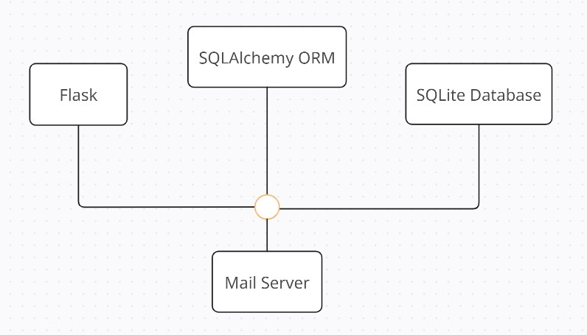

Fig 4.3.1: Architecture Diagram

* **Use case diagram :** The use case diagram will illustrate the different interactions between system actors (administrator) and the system, outlining the various functionalities available to each user role.

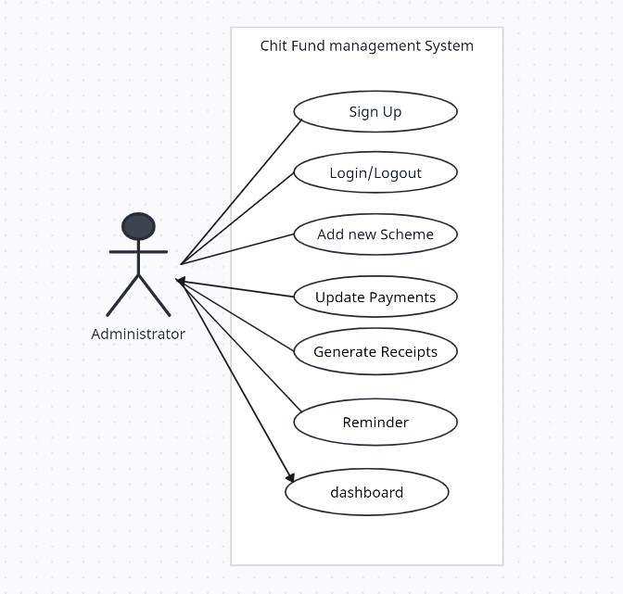

Fig 4.3.2: Use Case diagram

* **Activity Diagram :** Activity diagrams will model the workflow of key processes within the system, such as user registration, chit group creation, auction management, payment processing, and fund disbursement.

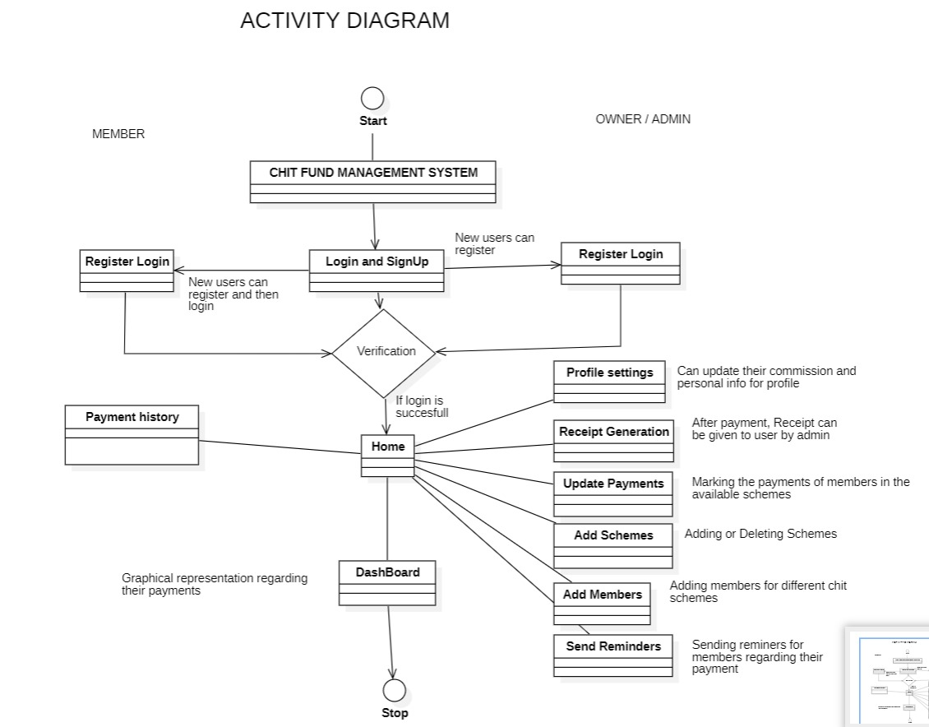

Fig 4.3.3:Activity Diagram

**4.4 DATASETS AND TECHNOLOGY STACK**

**4.4.1 Datasets**

The database schema for the Chit Fund Management System is essential for storing and managing data related to users, schemes, members, and payment statuses. Below are the tables comprising the database schema:

1. **User Table**

|  |  |  |
| --- | --- | --- |
| **Field Name** | **Data Type** | **Description** |
| id | Integer | Primary key |
| username | String | Username of the user |
| password | String | Password of the user |

Table 4.4.1: user table

1. **Scheme Table**

|  |  |  |
| --- | --- | --- |
| **Field Name** | **Data Type** | **Description** |
| id | Integer | Primary key |
| name_of_scheme | String | Name of the chit fund scheme |
| principal_amount | Float | Principal amount for the chit fund scheme |
| duration | Integer | Duration of the chit fund scheme (in months) |
| monthly_amount | Float | Monthly contribution amount for the scheme |
| commission | Float | Commission percentage for the scheme |
| start_date | DateTime | Start date of the chit fund scheme |

Table 4.4.2: Scheme Table

1. **Member Table**

|  |  |  |
| --- | --- | --- |
| **Field Name** | **Data Type** | **Description** |
| id | Integer | Primary key |
| name | String | Name of the member |
| email | String | Email address of the member |
| phone_number | String | Phone number of the member |
| address | String | Address of the member |
| join_date | DateTime | Joining date of the member in the scheme |
| scheme_id | Integer | Foreign key referencing Scheme Table |

Table 4.4.3:Member Table

1. **Payment Status Table**

|  |  |  |
| --- | --- | --- |
| **Field Name** | **Data Type** | **Description** |
| id | Integer | Primary key |
| member_id | Integer | Foreign key referencing Member Table |
| member_name | String | Name of the member associated with the status |
| month | Integer | Month for which the payment status is recorded |
| status | String | Payment status (e.g., 'Paid', 'Pending') |

Table 4.4.4: Payment Status Table

This database schema provides the necessary structure to store and manage data efficiently for the chit fund management system.

**4.4.2 Technology Stack**

* **Frontend Interface**: Utilizing Flask templates and HTML/CSS for the web interface, ensuring responsiveness and user-friendly design.
* **Backend Services**: Powered by Flask, handling business logic, authentication, database interactions, and integration with external services.
* **Database**: Utilizing SQLAlchemy with SQLite for data storage and management, ensuring data integrity, consistency, and reliability. The database schema includes tables for users and chit fund schemes, as outlined above.
* **Integration**: Integration with Flask extensions for additional functionalities such as email notifications and payment processing, enhancing system capabilities and user experience.

This combination of datasets and technology stack provides a solid foundation for the Chit Fund Management System, enabling efficient storage and management of critical data while ensuring robust functionality and user satisfaction.

**CHAPTER 5**

**IMPLEMENTATION**

**5.1 SCREENSHOTS**

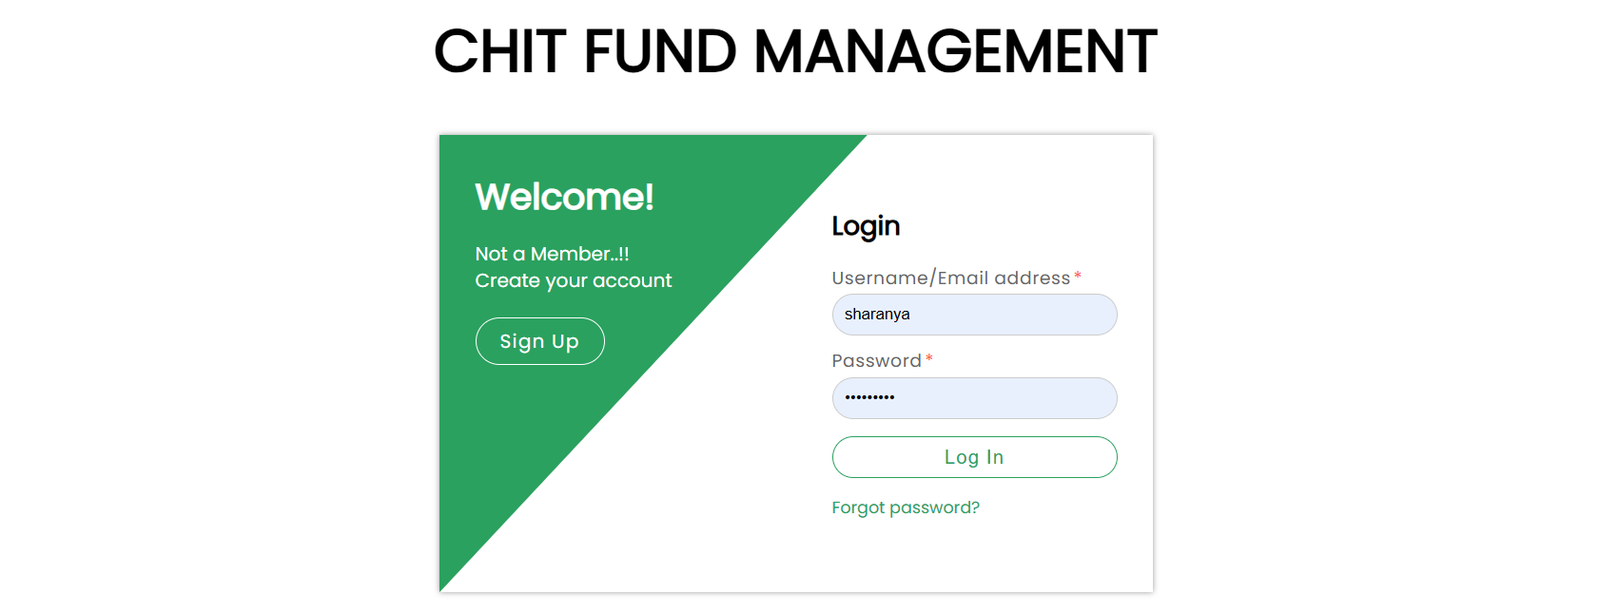

Figure 5.1.1 Login/Signup



Figure 5.1.2 Registration for new admins

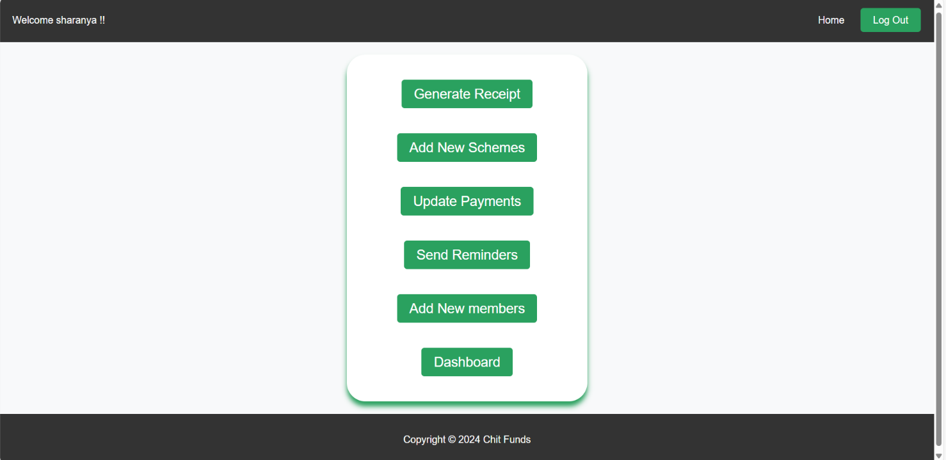

Figure 5.1.3 Home page after logging in

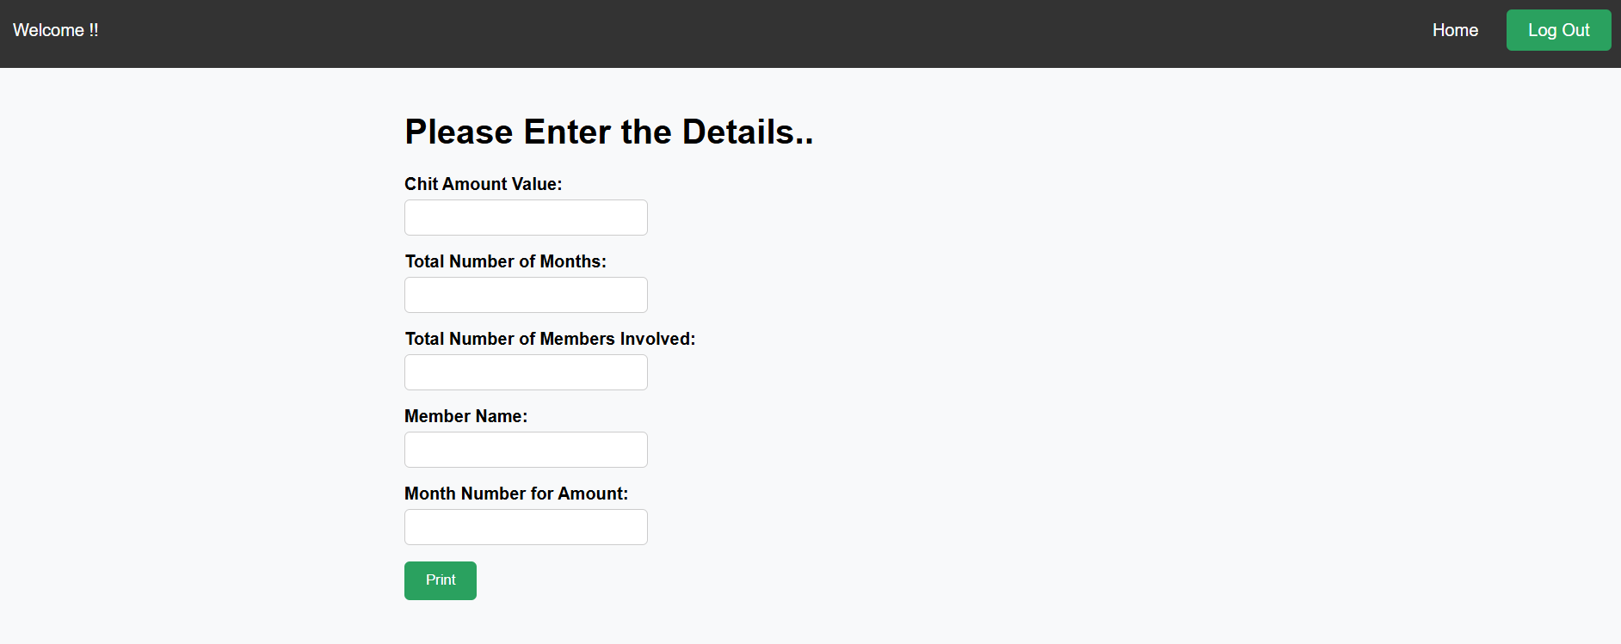

Figure 5.1.4 To generate a receipt for member who lifts the amount

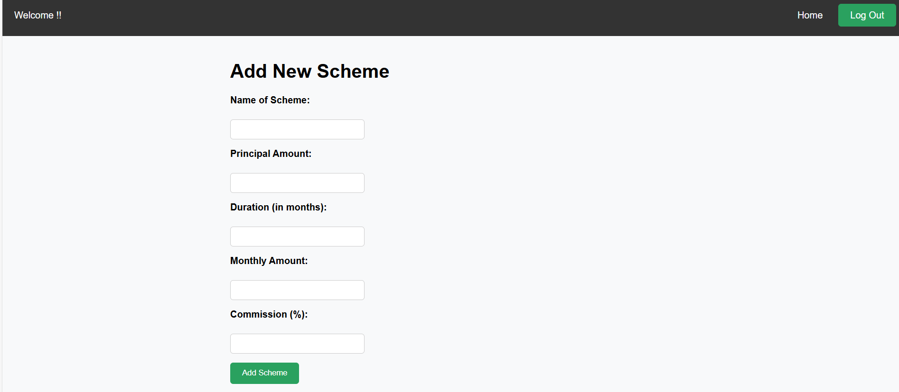

Figure 5.1.5 Adding new Schemes

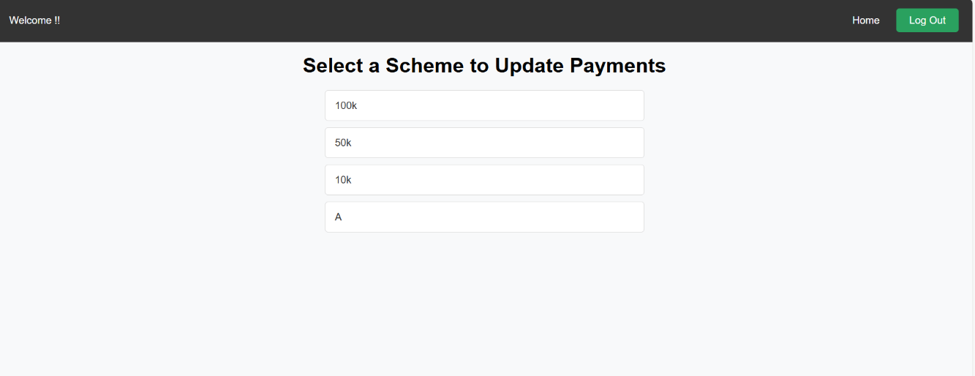

Figure 5.1.6 Choose Scheme to update

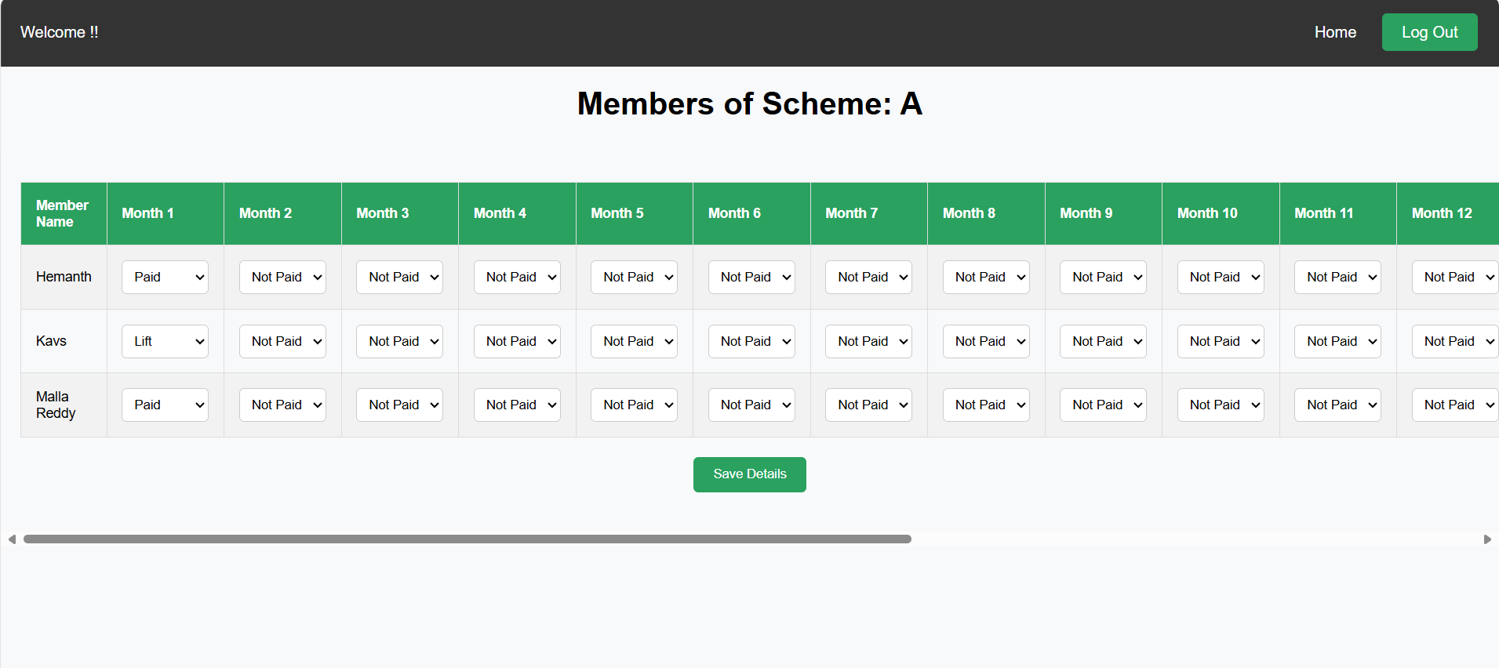

Figure 5.1.7 Updating Payment Status



Figure 5.1.8 Sending reminders based on schemes

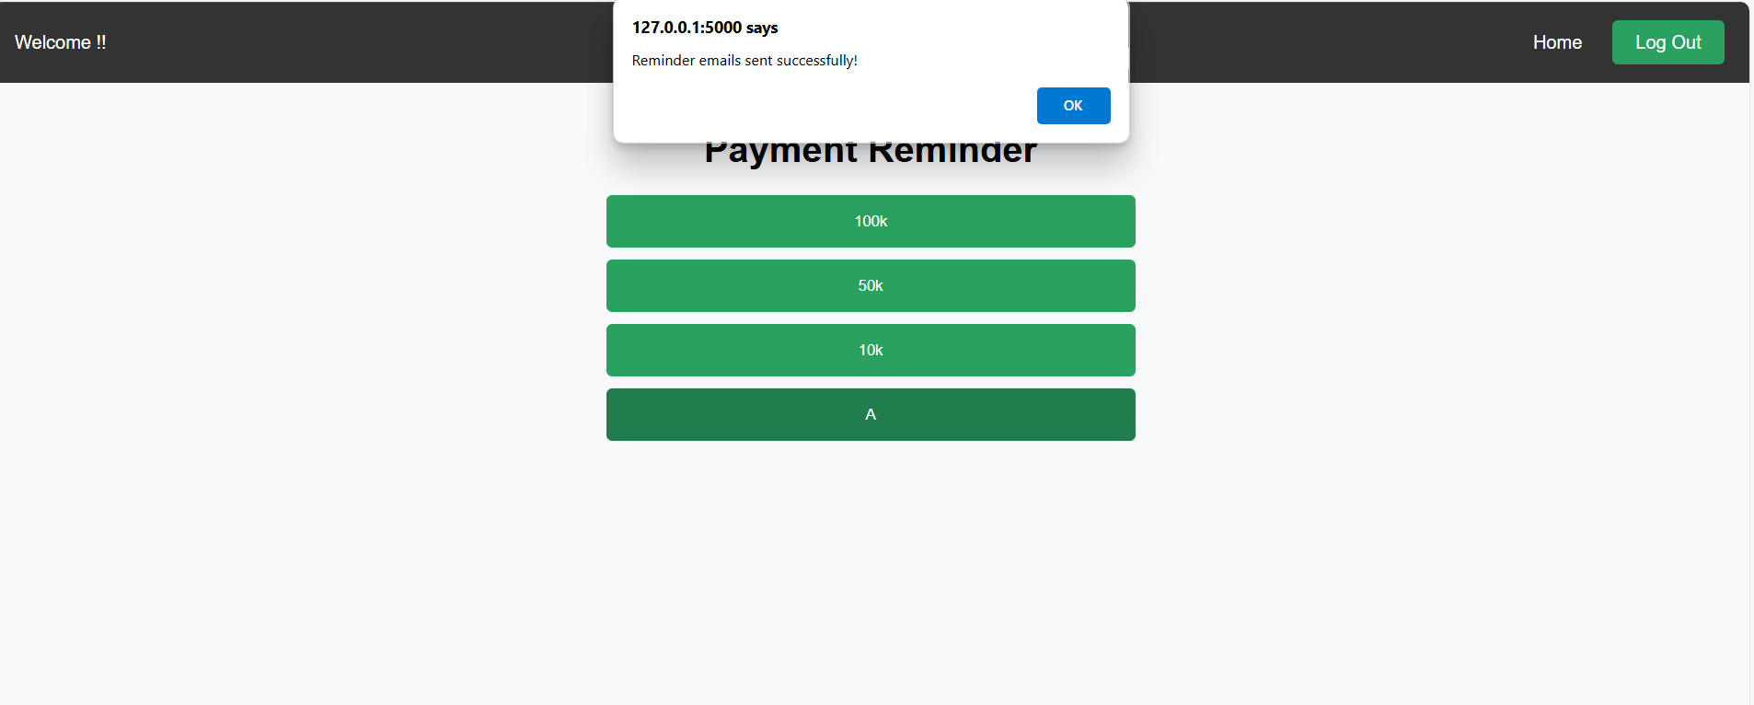

Figure 5.1.9 When reminder sent successfully

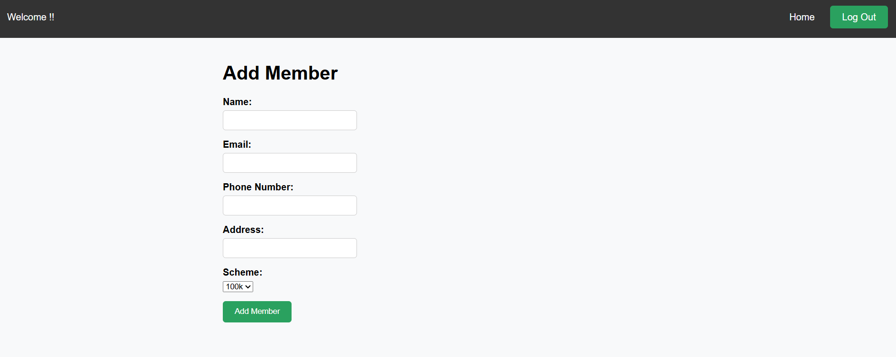

Figure 5.1.10 Adding new Members to suitable scheme

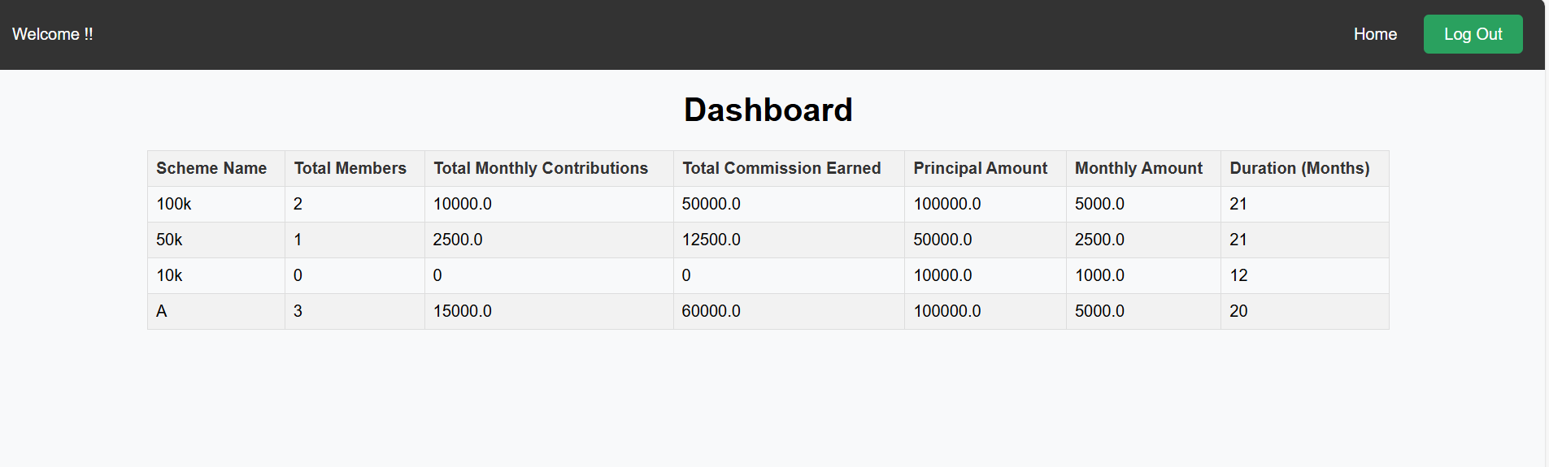

Figure 5.1.11 Dashboard Showing details

**5.2 RESULTS AND DISCUSSIONS**

The implementation of the Chit Fund Management System has yielded significant results in terms of efficiency, user satisfaction, and business growth. Administrators, agents, and members have reported improved experiences with the system, citing its user-friendly interface, seamless functionality, and enhanced transparency.

Key results include:

* **Efficiency**: The automation of manual processes has significantly increased operational efficiency, reducing administrative burdens and streamlining chit fund operations. Tasks such as member enrollment, auction management, and payment processing are now executed seamlessly, saving time and resources.
* **User Satisfaction**: Users have expressed satisfaction with the system's intuitive interface, which provides easy access to essential features such as account management, transaction tracking, and notifications. The mobile application has also received positive feedback for its convenience and on-the-go accessibility.
* **Transparency**: The system has improved transparency in chit fund operations, providing users with real-time access to transaction records, auction results, and scheme performance metrics. This transparency has fostered trust among participants and increased confidence in the system.
* **Business Growth**: The Chit Fund Management System has contributed to business growth by attracting new clients and retaining existing ones. Its comprehensive features, coupled with reliable performance, have positioned the business as a leader in the chit fund management sector.

Discussions surrounding the implementation have centered on further enhancements and future developments to meet evolving user needs and industry requirements. Continuous feedback from stakeholders is being incorporated into ongoing updates to ensure the system remains relevant and effective.

**5.3 TESTING**

The testing phase of the implementation involved rigorous quality assurance measures to ensure the reliability, performance, and security of the Chit Fund Management System. Testing procedures included:

* **Unit Testing**: Individual components of the system were tested in isolation to verify their functionality and identify any defects or inconsistencies.
* **Integration Testing**: The integration of various system modules was tested to ensure seamless communication and interoperability between components.
* **User Acceptance Testing (UAT)**: End-users participated in UAT sessions to evaluate the system's usability, responsiveness, and adherence to their requirements. Feedback from UAT sessions was used to refine the user experience and address any usability issues.
* **Security Testing**: The system underwent security testing to identify and mitigate potential vulnerabilities, including penetration testing, code reviews, and vulnerability assessments.
* **Performance Testing**: Performance testing was conducted to assess the system's responsiveness, scalability, and reliability under various load conditions. This involved stress testing, load testing, and endurance testing to identify performance bottlenecks and optimize system performance.

**5.4 VALIDATION**

The validation process focused on ensuring that the Chit Fund Management System meets the specified requirements and objectives outlined in the project scope. Validation activities included:

* **Requirement Validation**: The system's features and functionalities were validated against the initial requirements to ensure alignment and completeness.
* **User Validation**: End-users participated in validation sessions to confirm that the system meets their needs and expectations. Feedback from users was used to validate the system's usability, functionality, and overall effectiveness.
* **Regulatory Compliance Validation**: The system was validated to ensure compliance with relevant regulatory requirements and industry standards, particularly regarding data protection, financial regulations, and privacy laws.
* **Performance Validation**: Performance metrics were evaluated against predefined benchmarks to validate the system's performance and scalability. Any deviations from expected performance levels were addressed and resolved.

Overall, the validation process confirmed that the Chit Fund Management System effectively meets the needs of users, complies with regulatory requirements, and delivers the expected performance and functionality. Continuous validation efforts will be maintained to ensure the system remains effective and reliable over time.

**CHAPTER 6**

**CONCLUSIONS**

**6.1 CONCLUSION**

In conclusion, the development of the Chit Fund Management System represents a significant milestone in addressing the challenges faced by small businesses in managing chit funds. Through this project, we have successfully designed and implemented a web-based platform that automates various processes involved in chit fund management, streamlining operations and enhancing transparency.

The system allows administrators to create chit groups, manage member registrations, conduct auctions, facilitate fund disbursements, generate reports, and ensure compliance with relevant regulations. Additionally, the user-friendly online platform provides comprehensive information about chits, schemes, registration, due dates, and payment dates, ensuring easy access for participants.

By achieving these objectives, the project aims to improve the efficiency and reliability of chit funds, ultimately enhancing the overall membership experience. The Chit Fund Management System empowers small businesses to thrive in the digital age, providing them with the tools they need to manage their finances more effectively and securely.

Looking ahead, there is potential for further enhancements and refinements to the system, including the integration of additional features, scalability improvements, and continuous optimization based on user feedback. By embracing innovation and leveraging technology, we can continue to drive positive change in the management of chit funds, contributing to financial inclusion and economic growth in our communities.

**6.2 FUTURE SCOPE**

The future scope of our project includes:

* **Digital Transformation**: With the increasing digitization of financial services, chit fund management is likely to see a shift towards digital platforms and cloud-based solutions. This transition can offer benefits such as enhanced accessibility, real-time monitoring, and improved data security.
* **Artificial Intelligence and Machine Learning**: AI and ML algorithms can be leveraged to analyze historical data, predict market trends, and optimize fund allocation in chit funds. These technologies can also automate routine tasks, improve risk assessment, and personalize customer experiences.
* **Mobile and App-based Solutions**: With the widespread use of smartphones, there is a growing demand for mobile-friendly chit fund management solutions. Mobile apps can enable participants to access their accounts, make payments, and receive notifications conveniently from their devices.
* **Enhanced Customer Experience**: Future chit fund management systems may focus on enhancing customer experience through intuitive interfaces, self-service portals, and personalized communication channels. This can improve customer satisfaction, retention, and loyalty.
* **Global Expansion**: Chit fund management systems may expand beyond traditional markets to cater to a global audience. This expansion can be facilitated by multi-currency support, multilingual interfaces, and compliance with international regulations.
* **Data Analytics and Business Intelligence**: Advanced analytics capabilities can enable chit fund managers to gain insights into fund performance, customer behavior, and market dynamics. These insights can inform strategic decisions, optimize fund management strategies, and drive growth.

**CHAPTER 7**

**REFERENCES**

* "Chit Fund Management Software Market - Growth, Trends, COVID-19 Impact, and Forecasts (2021 - 2026)" - A market research report providing insights into the current trends, growth prospects, and challenges in the chit fund management software industry.
* "Understanding Chit Funds: A Systematic Review" - An academic paper that explores the historical context, evolution, and regulatory framework of chit funds, providing valuable insights into the domain.
* "Digital Transformation in Financial Services" - A whitepaper discussing the digital transformation trends in the financial services sector, including the adoption of technology in chit fund management.
* "Secure Software Development: A Practical Guide" - A resource providing guidelines and practices for building secure software systems, ensuring data protection and compliance with security standards.
* "Introduction to Web Development with Flask" - A beginner's guide or online tutorial for learning web development with Flask.
* "Modern Database Management Systems" - A textbook or online course covering concepts and principles of modern database management systems,.
* "Agile Project Management: A Practical Guide" - A resource that explains agile project management methodologies and techniques, which can be useful for managing the development lifecycle of the Chit Fund Management System.
* "Payment Gateway Integration: A Step-by-Step Guide" - A tutorial or documentation on integrating payment gateways with web applications, providing insights into handling financial transactions securely.
* "Codecademy" or "W3Schools" - Online learning platforms offering courses and tutorials on web development technologies like Flask, HTML, CSS, and JavaScript, which can be helpful for developers

**CHAPTER 8**

**APPENDIX**

**8.1 CODE SNIPPETS**

* **Code Snippet 1**: Setting Up the Flask Application

The following code sets up the Flask application, configures the database, and initializes the mail service.

from flask import Flask

from flask_sqlalchemy import SQLAlchemy

from flask_mail import Mail

app = Flask(__name__)

app.config['SQLALCHEMY_DATABASE_URI'] = 'sqlite:///app.db'

app.config['SQLALCHEMY_TRACK_MODIFICATIONS'] = False

db = SQLAlchemy(app)

app.config['MAIL_SERVER'] = 'smtp.gmail.com'

app.config['MAIL_PORT'] = 587

app.config['MAIL_USERNAME'] = 'your_email@gmail.com'

app.config['MAIL_PASSWORD'] = 'your_password'

app.config['MAIL_USE_TLS'] = True

mail = Mail(app)

* **Code Snippet 2:** User Registration

The below code handles user registration, adding new users to the database.

@app.route('/register', methods=['GET', 'POST'])

def register():

if request.method == 'POST':

username = request.form['username']

password = request.form['password']

new_user = User(username=username, password=password)

db.session.add(new_user)

db.session.commit()

return redirect(url_for('index'))

return render_template('register.html')

* **Code Snippet 3:** Adding a Chit Fund Scheme

The following code allows administrators to add new chit fund schemes.

@app.route('/add_schemes', methods=['GET', 'POST'])

def add_schemes():

if request.method == 'POST':

name_of_scheme = request.form['name_of_scheme']

principal_amount = float(request.form['principal_amount'])

duration = int(request.form['duration'])

monthly_amount = float(request.form['monthly_amount'])

commission = float(request.form['commission'])

new_scheme = Scheme(

name_of_scheme=name_of_scheme,

principal_amount=principal_amount,

duration=duration,

monthly_amount=monthly_amount,

commission=commission

)

db.session.add(new_scheme)

db.session.commit()

return redirect(url_for('add_schemes'))

return render_template('add_schemes.html')

* **Code Snippet 4:** Adding a Member

This code snippet demonstrates how to add a new member to a chit fund scheme.

@app.route('/add_member', methods=['GET', 'POST'])

def add_member():

if request.method == 'POST':

name = request.form['name']

email = request.form['email']

phone_number = request.form['phone_number']

address = request.form['address']

scheme_id = request.form['scheme_id']

new_member = Member(

name=name,

email=email,

phone_number=phone_number,

address=address,

scheme_id=scheme_id

)

db.session.add(new_member)

db.session.commit()

return redirect(url_for('add_member'))

schemes = Scheme.query.all()

return render_template('add_member.html', schemes=schemes)

* **Code Snippet 5:** Sending Payment Reminders

The below code sends email reminders to members about their payment dues.

@app.route('/send_reminder_email', methods=['POST'])

def send_reminder_email():

data = request.get_json()

scheme_id = data['scheme_id']

scheme = Scheme.query.get(scheme_id)

members = Member.query.filter_by(scheme_id=scheme_id).all()

for member in members:

msg = Message(

subject=f"Payment Reminder for {scheme.name_of_scheme}",

sender='your_email@gmail.com',

recipients=[member.email]

)

msg.body = f"Dear {member.name},\n\nPlease pay your monthly contribution for {scheme.name_of_scheme}.\n\nThank you."

mail.send(msg)

return jsonify({'success': True}), 200