**16.FORM PROCESSING USING PHP**

**Aim:**

Form Processing using PHP.

**Code:**

Code:

**Form:**

<html>

<body>

<form action="welcome.php" method="post"> NAME:<input type="text" name="name"><br> E-mail:<input type="text" name="email"><br>

<input type="submit">

</form>

</body>

</html>

**Welcome.php:**

<html>

<body>

welcome

<?php

echo $_POST["name"];

?><br>

Your e_mail address is:

<?php

echo $_POST["email"];

?>

</body>

</html>

**OUTPUT:**

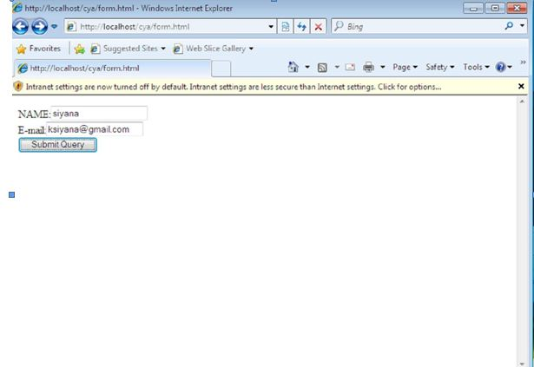

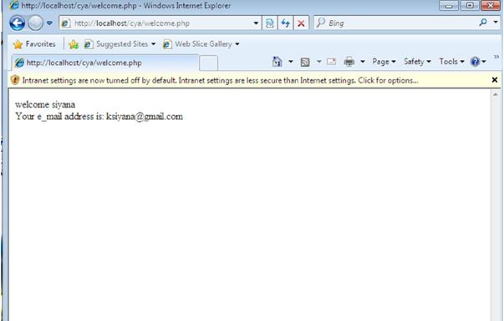

**17.FORM VALIDATION USING PHP**

**Aim:**

Form validation using PHP.

**Code:**

<!DOCTYPE HTML>

<html>

<head>

<style>

.error {color: #FF0000;}

</style>

</head>

<body>

<?php

// define variables and set to empty values

$nameErr = $emailErr = $genderErr = $websiteErr = "";

$name = $email = $gender = $comment = $website = "";

if ($_SERVER["REQUEST_METHOD"] == "POST")

{

if (empty($_POST["name"]))

{

$nameErr = "Name is required";

}

else

{

$name = test_input($_POST["name"]);

// check if name only contains letters and whitespace if (!preg_match("/^[a-zA-Z ]*$/",$name))

{

$nameErr = "Only letters and white space allowed";

}

}

if (empty($_POST["email"]))

{

$emailErr = "Email is required";

}

else

{

$email = test_input($_POST["email"]);

// check if e-mail address is well-formed

if (!filter_var($email, FILTER_VALIDATE_EMAIL))

{

$emailErr = "Invalid email format";

}

}

if (empty($_POST["website"]))

{

$website = "";

}

Else

{

$website = test_input($_POST["website"]);

// check if URL address syntax is valid (this regular expression also allows dashes in the URL)

if (!preg_match("/\b(?:(?:https?|ftp):\/\/|www\.)[-a-z0-9+&@#\/%?=~_|!:,.;]*[-a-z0-

9+&@#\/%=~_|]/i",$website))

{

$websiteErr = "Invalid URL";

}

}

if (empty($_POST["comment"]))

{

$comment = "";

}

Else

{

$comment = test_input($_POST["comment"]);

}

if (empty($_POST["gender"]))

{

$genderErr = "Gender is required";

}

else

{

$gender = test_input($_POST["gender"]);

}

}

function test_input($data)

{

$data = trim($data);

$data = stripslashes($data);

$data = htmlspecialchars($data);

return $data;

}

?>

<h2>PHP Form Validation Example</h2>

<p><span class="error">* required field.</span></p>

<form method="post" action="<?php echo htmlspecialchars($_SERVER["PHP_SELF"]);?>"> Name: <input type="text" name="name" value="<?php echo $name;?>">

<span class="error">* <?php echo $nameErr;?></span>

<br><br>

E-mail: <input type="text" name="email" value="<?php echo $email;?>">

<span class="error">* <?php echo $emailErr;?></span>

<br><br>

Website: <input type="text" name="website" value="<?php echo $website;?>">

<span class="error"><?php echo $websiteErr;?></span>

<br><br>

Comment: <textarea name="comment" rows="5" cols="40"><?php echo $comment;?></textarea>

<br><br> Gender:

<input type="radio" name="gender" <?php if (isset($gender) && $gender=="female") echo

"checked";?> value="female">Female

<input type="radio" name="gender" <?php if (isset($gender) && $gender=="male") echo

"checked";?> value="male">Male

<span class="error">* <?php echo $genderErr;?></span>

<br><br>

<input type="submit" name="submit" value="Submit">

</form>

<?php

echo "<h2>Your Input:</h2>";

echo $name; echo "<br>"; echo $email; echo "<br>"; echo $website; echo "<br>"; echo $comment; echo "<br>"; echo $gender;

?>

</body>

</html>

**Output:**

