# InstaResz Business Services Pvt.Ltd

# (AI Assignment)

## **Introduction**

The goal of this project was to design and develop a **fully automated system** that can intelligently analyze a company's internal documents (such as strategic reports or vision statements), research the company and its broader industry environment, identify current market trends, and **generate customized AI/ML/GenAI use cases**.

Furthermore, the system connects each proposed use case to **real-world datasets** to enable immediate experimentation. The entire workflow is presented to users via a **modern, chat-based web interface** built with Streamlit, offering an intuitive and engaging user experience.

## **Methodology**

The solution follows a **modularized, agent-based architecture** to maximize scalability, reusability, and clarity:

**a. Input Phase**

* **User Interaction**: The user uploads a **PDF document** (e.g., a strategy plan) through the Streamlit web application.
* **Optional Fields**: Users can optionally input the **company name** or provide **manual text input** in case the file is unavailable.

b. **Processing Pipeline (Orchestration Layer)**

The main automation happens through **auto_pipeline.py**, which orchestrates the following steps:

1. **Text Extraction**
   * Extract full textual content from the uploaded PDF using efficient parsing libraries.
2. **Summarization**
   * Summarize extracted text using **HuggingFace** transformer models (e.g., BART or T5) to create a concise version suitable for analysis.
3. **Company Research**
   * Perform a **web search** via **SerpAPI** to find:
     + Key product offerings
     + Strategic focus areas
     + Industry classification
     + Company mission and vision
4. **Market Trend Analysis**
   * Analyze the latest **AI/ML/GenAI trends** in the identified industry using **OpenAI’s GPT models**, generating brief, actionable insights.
5. **Use Case Generation**
   * Based on the researched industry and market trends, automatically generate tailored **AI/ML/GenAI use cases**.
6. **Dataset Search**
   * Search for datasets related to each generated use case across:
     + **Kaggle**
     + **HuggingFace Datasets Hub**
     + **GitHub repositories** (datasets tagged)
7. **Bundling Results**
   * Collect all outputs (summary, research, trends, use cases, datasets) into a unified response structure.

**Knowledge Base Agent** (knowledge_base_agent.py)  
Provides a simpler, standalone service to **just read and summarize PDFs**, useful for building a local knowledge repository.

**c. Frontend User Interface (Streamlit)**

* **Chat-Style Interaction**: Users interact with an **assistant-like conversational interface**.
* **Visual Output Organization**:
  + Summarized Document View
  + Company Research Findings
  + Industry Trends
  + AI/ML/GenAI Use Case Ideas
  + Dataset Resources (Expandable Sections)
* **Technical Details**:
  + Maintains chat history via st.session_state.messages.
  + Uses Markdown and expanders for clear sectioned display.

**d. Optional Backend (Flask API)**

A lightweight **Flask server** exposes a /predict endpoint for:

* Text summarization or classification tasks (Optional enhancement).
* Offers flexibility to plug into different systems beyond Streamlit.

**Architecture Flowchart**

The system architecture is summarized below:

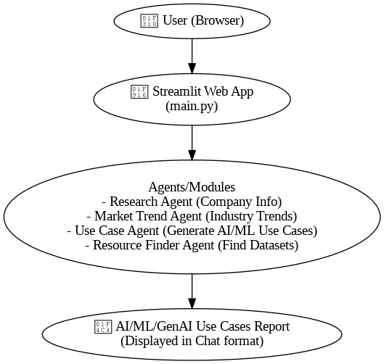

# **Results**

* Successfully deployed an **end-to-end AI/ML discovery pipeline**.
* Achieved **high modularity** by dividing logic into reusable agents.
* Integrated **state-of-the-art APIs**:
  + - **OpenAI** for GPT-based trend analysis
    - **SerpAPI** for real-time web research
    - **Kaggle**, **HuggingFace**, **GitHub** for dataset discovery
* Delivered an intuitive **chat-based user experience**.
* Ensured **robust fallback strategies**:
  + - Defaults to manual user input if company research fails.
    - Provides clear messaging if no datasets are found.
* Implemented **error resilience**:
  + - Graceful handling of unknown industries.
    - Session state preserved throughout conversation.
* Built-in **future extensibility** via modular agent design.

**Key Observations & Improvements**

| **Issue** | **Observation** | **Action Taken / Future Suggestion** |
| --- | --- | --- |
| **API Input Mismatch** | "input_text" vs "text" mismatch between Flask and Streamlit | Standardized key names across all components. |
| **Duplicated Headers** | Dataset resources header appeared twice | Modularized resource display via helper functions. |
| **Text Slicing Issue** | Trends were cut mid-sentence if under 200 characters | Improved logic to dynamically check length before truncating. |
| **Code Reusability** | Repeated code patterns in resource displays | Suggested writing centralized utility functions for resource handling. |
| **Unknown Industry Cases** | Minimal default suggestions for unknown industries | Expanded with more generalized AI/ML/GenAI use case ideas. |

**Conclusions**

This project demonstrates the **practical application** of **agent-based pipelines** combined with **LLMs** and **open APIs** to automate traditionally manual, research-heavy tasks in business strategy and data science.

By automatically:

* Understanding company vision and offerings,
* Researching market trends,
* Generating customized AI/ML use case ideas,
* Linking real datasets for experimentation,

the system empowers business leaders, data scientists, and consultants to **accelerate innovation cycles** and **initiate AI projects** with minimal effort.

# **Future Extensions**

* 📈 **Financial Analysis Agent**: Automate financial data collection and insights generation.
* 🌱 **ESG Trend Agent**: Analyze environmental, social, and governance trends.
* 📑 **Patent Research Agent**: Explore innovation trends via patent databases.

**Key Takeaway:  
Agent-based modular pipelines + LLMs + Open APIs = Powerful automation frameworks** for real-world domain-specific insights.