**Data Analysis:**

1. **Transform the margin column in two columns. 1 for Runs and another one for wicket**

Use the formula: =**IF(ISNUMBER(SEARCH("wickets",D2)),D2,"null")**

Use the formula: =**IF(ISNUMBER(SEARCH("runs",D2)),D2,"null")**

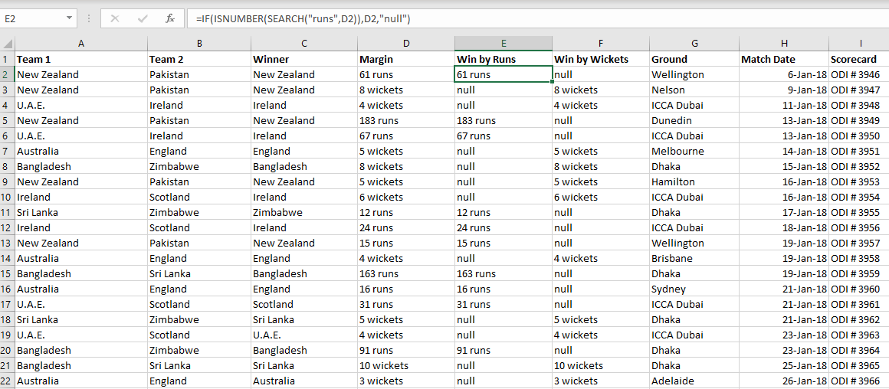

1. **Which country played the most ODI’s in 2018?**

We must count the number of matches played by each of the countries in both Team1 and Team2.

Formula = **=COUNTIF(B$2:C$129,J2)**

**(**select the range and the word you want to count in the range. Here I have taken the range of entire column of Team1 and Team2)

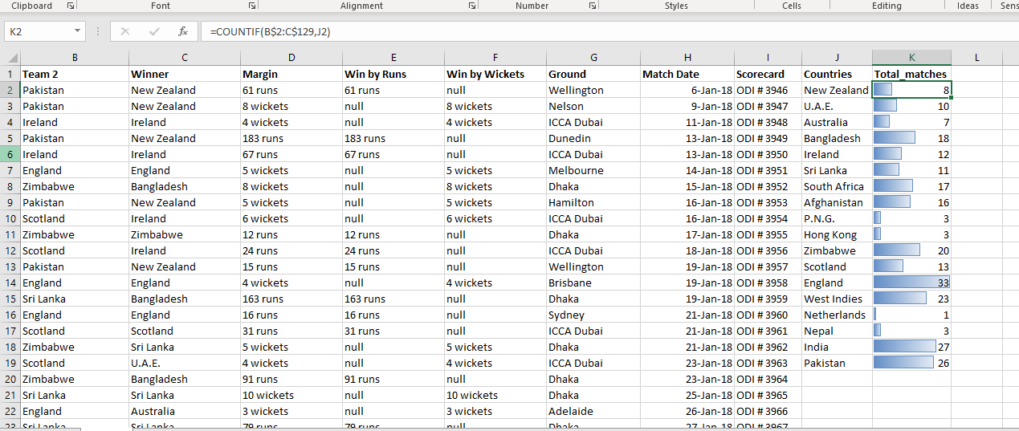

From the above screenshot, we can see that England has played most ODI’s in 2018.

1. **List the top 3 countries who won the most ODI’s**

Like the previous problem, the range selected here will be from the column winner!

Formula = **COUNTIF(C$2:C$129,L2)**

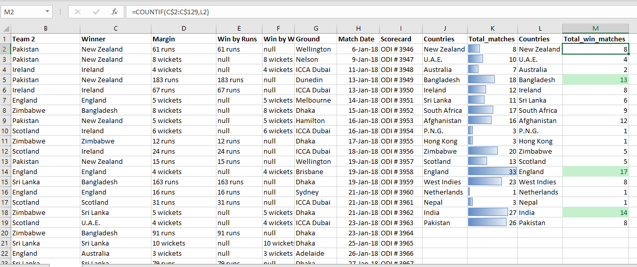

The top 3 countries who won the most ODI’s are Bangladesh, England, and India

1. **How was the performance of Sri Lanka?**

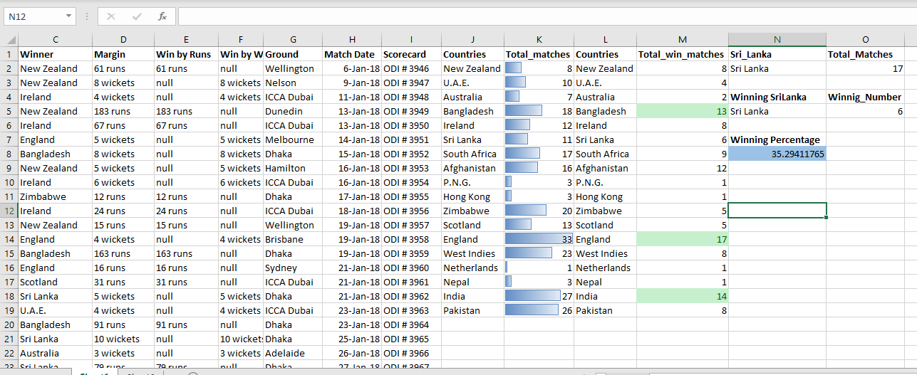

1. **On which ground, most games were played?**

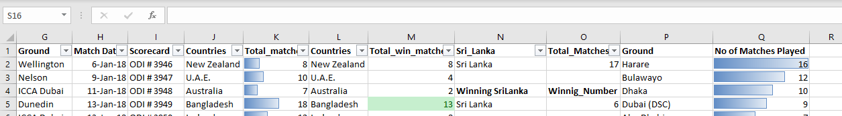

On the ground Harare, most games were played!