javax.swing

Class JFrame
java.lang.Object
java.awt.Component
java.awt.Container
java.awt.Window
java.awt.Frame
javax.swing.JFrame

An extended version of java.awt.Frame that adds support for the JFC/Swing component architecture.

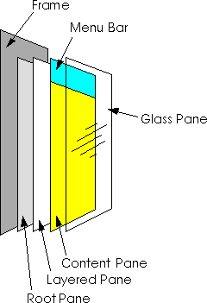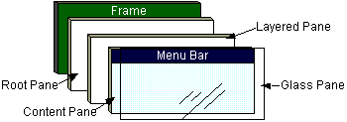
The JFrame class is slightly incompatible with Frame. Like all other JFC/Swing top-level containers, a JFrame contains a JRootPane as its only child. The content pane provided by the root pane should, as a rule, contain all the non-menu components displayed by the JFrame. This is different from the AWT Frame case. For example, to add a child to an AWT frame you'd write:
frame.add(child);

However using JFrame you need to add the child to the JFrame's content pane instead:
frame.getContentPane().add(child);
Unlike a Frame, a JFrame has some notion of how to respond when the user attempts to close the window. The default behavior is to simply hide the JFrame when the user closes the window. To change the default behavior, you invoke the method setDefaultCloseOperation(int). To make the JFrame behave the same as a Frame instance, use setDefaultCloseOperation(WindowConstants.DO_NOTHING_ON_CLOSE).
- DO_NOTHING_ON_CLOSE
- HIDE_ON_CLOSE
- DISPOSE_ON_CLOSE
- EXIT_ON_CLOSE

