Design of a Differential CMOS Comparator with Active Load

Special Assignment Report

4EC601ME25
Analog CMOS Integrated Circuits

By
T Kavya Srri
23BEC196



Department of Electronics and Communication Engineering,
Institute of Technology,
Nirma University,
Ahmedabad 382 481

October 2026

Abstract
A differential CMOS comparator is an important building block in analog and mixed-signal integrated circuits and is widely used in applications such as analog-to-digital converters, sensing circuits, data converters, and decision-making circuits. This work presents the design and simulation of a CMOS differential comparator with an active current-mirror load using a 180-nm CMOS technology model. The comparator consists of a differential NMOS input pair, a PMOS current-mirror active load, an NMOS tail current source, and a CMOS output inverter. The circuit is designed and simulated using Cadence Virtuoso with the GPDK180 technology library.
The proposed design operates from a 1.8 V supply. DC operating-point analysis, DC sweep analysis, and transient analysis are performed to evaluate the comparator operation. During the DC sweep, the differential input voltage is varied around the switching point, and the output transitions between logic-low and logic-high states. Transient analysis is performed using complementary sinusoidal input signals to verify the dynamic decision-making capability of the comparator. The results demonstrate the ability of the proposed circuit to detect the relative magnitude of the differential input signals and generate a corresponding digital-like output.
After successfully completing the pre-layout simulations, the transistor-level layout was designed, followed by DRC and LVS verification to ensure design-rule compliance and layout-to-schematic consistency. Post-layout simulations were then performed to evaluate the circuit’s performance with layout parasitics.
The report presents the design methodology, transistor sizing, circuit operation, simulation results, and layout implementation in detail. The proposed design provides a compact CMOS implementation and demonstrates the fundamental design principles and practical implementation of differential comparators in analog integrated circuits.
Keywords:
CMOS comparator, differential pair, current-mirror active load, analog CMOS, GPDK180, Cadence Virtuoso, differential amplifier, voltage comparison, CMOS integrated circuits

Literature Survey
A comparator is a fundamental analog building block that determines which of two input voltages is larger and produces an output corresponding to this decision. Comparators are widely used in ADCs, zero-crossing detectors, memory circuits, sensor interfaces, and mixed-signal systems.
A conventional CMOS comparator can be constructed using a differential input stage followed by an active load and an output gain stage. The differential pair converts the input voltage difference into a difference in drain currents. An active load, commonly implemented using a PMOS current mirror, converts this differential current into a single-ended voltage signal. A subsequent CMOS inverter can provide additional gain and restore the output to well-defined logic levels.
3.1 Differential Input Stage
The differential pair is responsible for sensing the difference between the two input voltages:
$$V_{ID}=V_{INP}-V_{INN}$$
For a small differential input, the differential pair redistributes the tail current between the two branches. As the differential input increases, the current in one branch increases while the current in the other branch decreases.
3.2 Active Current-Mirror Load
The PMOS current-mirror load provides two important functions:
- It acts as an active load for the differential pair.
- It converts the differential current into a single-ended voltage.
Compared with a passive resistor load, a current-mirror active load can provide higher gain while occupying less silicon area.
3.3 Output Stage
The output inverter consists of a PMOS and NMOS transistor. Its purpose is to amplify and restore the internal signal produced by the differential stage. The inverter produces a rail-to-rail-like output, making the comparator output more suitable for subsequent digital circuitry.
3.4 Comparison with Other Comparator Architectures
Common CMOS comparator architectures include:
- Differential amplifier-based comparators
- Dynamic latch comparators
- StrongARM comparators
- Two-stage comparators
- Current-mode comparators
Dynamic comparators can provide high speed and low static power but generally require clocked operation. A static differential comparator, on the other hand, is structurally simpler and useful when continuous comparison and straightforward transistor-level analysis are required.
For the present work, a static differential comparator with a PMOS current-mirror active load is selected because it provides a simple transistor-level architecture suitable for analysis, simulation, and physical implementation in a 180-nm CMOS technology.

Limitations of Existing Technology
Different comparator architectures involve trade-offs between speed, power consumption, gain, offset, and circuit complexity.
Conventional differential comparator
The main limitations include:
- Static power consumption due to continuous bias current.
- Limited comparison speed compared with highly optimized dynamic comparators.
- Input offset caused by transistor mismatch.
- Sensitivity to transistor sizing and bias conditions.
- Finite voltage gain of the differential stage.
- Parasitic capacitances affecting transient response.
Dynamic comparators
Although dynamic comparators can achieve high speed and low average power, they generally require clocked operation and may experience:
- Kickback noise
- Input-dependent offset
- Clock feedthrough
- More complex transient behavior
Therefore, the selected architecture provides a useful compromise between circuit simplicity, continuous operation, gain, and ease of implementation.

Methodology
The design is a CMOS differential comparator with a PMOS current-mirror active load and CMOS inverter output stage.
The design consists of seven MOS transistors:
Transistor | Type | Function
M1 | NMOS | Differential input transistor
M2 | NMOS | Differential input transistor
M3 | PMOS | Diode-connected current-mirror transistor
M4 | PMOS | Current-mirror load transistor
M5 | NMOS | Tail current source
M6 | PMOS | Output inverter
M7 | NMOS | Output inverter

5.1 Circuit Operation
The two input signals are applied to the gates of M1 and M2:
$$V_{INP}→M1 \\ V_{INN}→M2$$
The sources of M1 and M2 are connected to the common tail node, which is biased through M5.
M3 and M4 form the PMOS current-mirror active load. M3 is diode-connected, while M4 mirrors the current to the other branch.
The resulting internal signal at V1 drives the gates of M6 and M7.
The output is taken from the common drain connection of M6 and M7:
$$V_{OUT}=f\left(V_{INP}-V_{INN}\right)$$
5.2 Design Flow
The overall design methodology is:

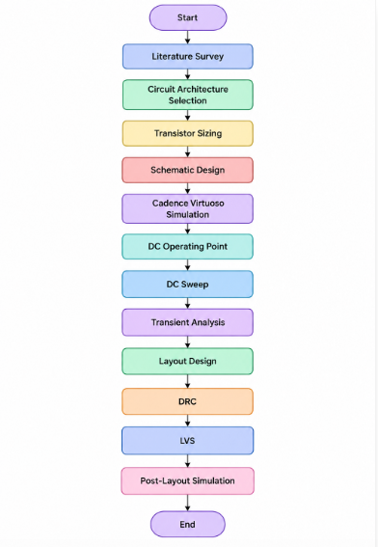

Fig. 1. Methodology

Specifications of the Design

S.No. | Parameter | Specification
1. | Technology | GPDK180
2. | CMOS Technology | 180nm
3. | Supply Voltage | 1.8V
4. | VBIAS_N | 0.7V
5. | VINN | 0.9V
6. | VINP DC sweep | 0.7-1.1V
7. | DC sweep step | 5mV
8. | Transient input frequency | 1 MHz
9. | Transient input amplitude | 50 mV
10. | Transient common-mode level | 0.9 V
11. | Transient simulation time | 5 us
12. | M1/M2 | W = 10 µm, L = 0.36 µm
13. | M3/M4 | W = 20 µm, L = 0.36 µm
14. | M5 | W = 10 µm, L = 0.72 µm
15. | M6 | W = 20 µm, L = 0.18 µm
16. | M7 | W = 10 µm, L = 0.18 µm

Schematic of the Design
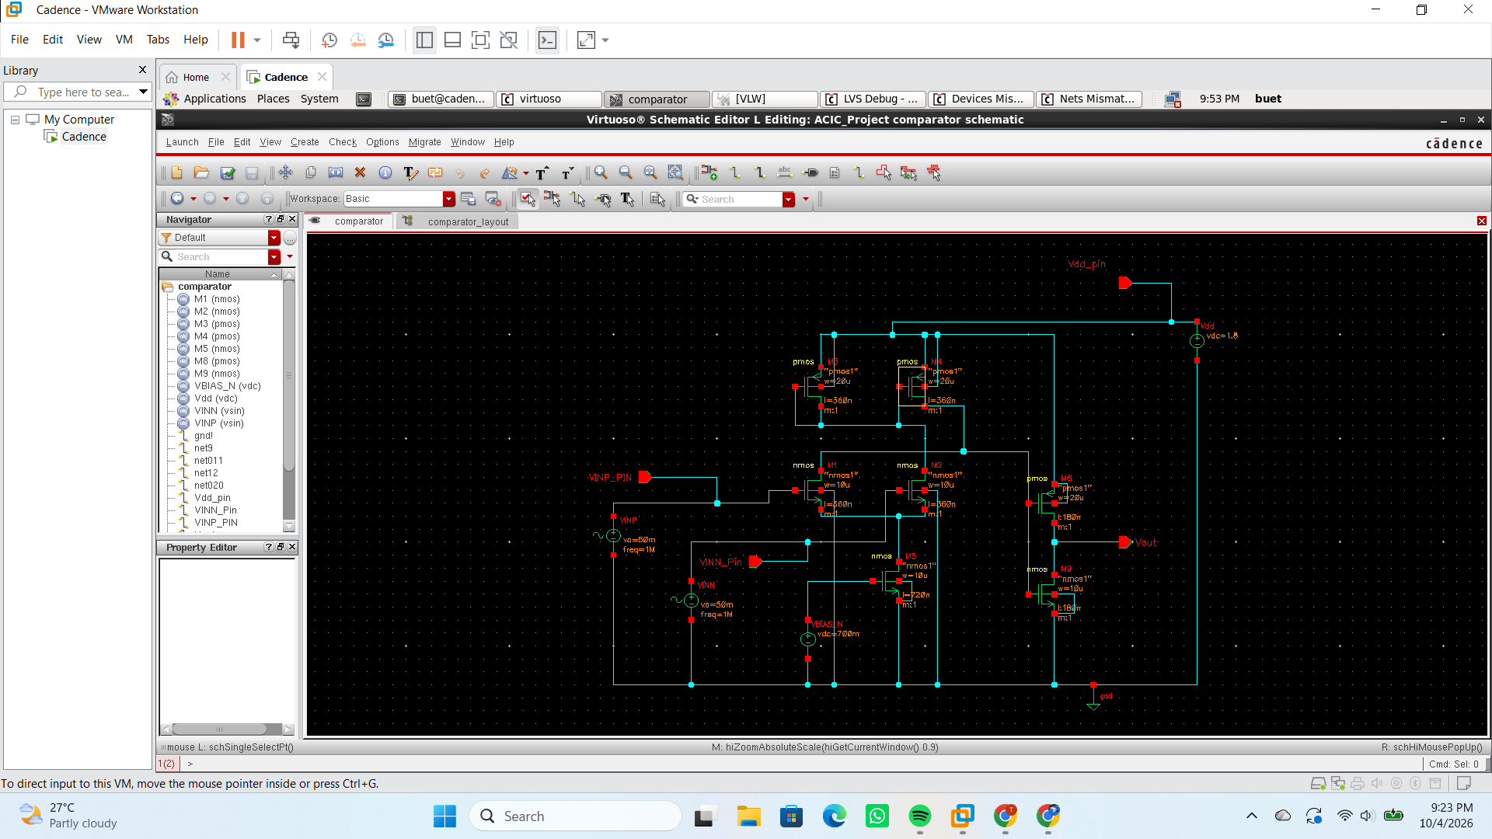
Fig. 2. Schematic of the CMOS differential comparator with active current-mirror load.

Results and Discussion
8.1 DC Operating Point
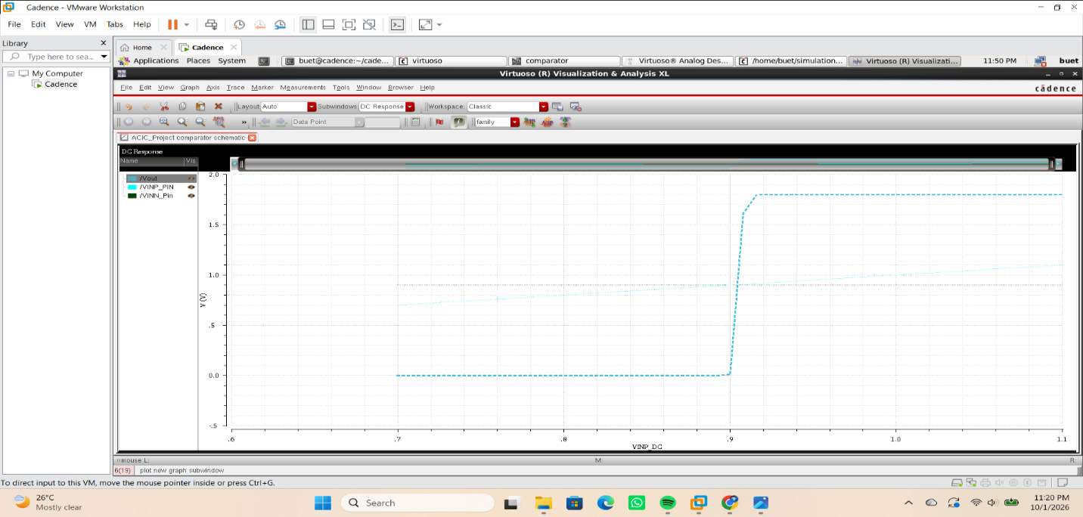
Fig. 3. DC Operating Point.
The DC operating-point analysis was performed to verify the bias conditions of the proposed comparator. A supply voltage of 1.8 V and a bias voltage of 0.7 V were applied. The operating-point analysis confirms that the MOS transistors are appropriately biased for comparator operation.
The table below shows the DC Operating points:
For M1/M2:
S.No. | Operating Point | Value
1. | VGS​ | 643.208mV
2. | VDS​ | 927.409mV
3. | ID​ | 50.9361u
4. | gm​ | 755.847u
5. | VTH​ | 585.368mV
6. | Operating region | 2
7. | Power | 47.2386uW

For M3/M4:
S.No. | Operating Point | Value
1. | VGS​ | -615.799mV
2. | VDS​ | -615.799mV
3. | ID​ | -50.9365u
4. | gm​ | 551.356u
5. | VTH​ | -479.892mV
6. | Operating region | 2
7. | Power | 31.3667uW

For M5:
S.No. | Operating Point | Value
1. | VGS​ | 700mV
2. | VDS​ | 256.792mV
3. | ID​ | 101.872u
4. | gm​ | 784.142u
5. | VTH​ | 494.873mV
6. | Operating region | 2
7. | Power | 26.1599uW

For M6:
S.No. | Operating Point | Value
1. | VGS​ | -615.799mV
2. | VDS​ | -1.78865V
3. | ID​ | -135.487u
4. | gm​ | 1.53823m
5. | VTH​ | -507.852mV
6. | Operating region | 2
7. | Power | 242.34uW

For M7:
S.No. | Operating Point | Value
1. | VGS​ | 1.1842V
2. | VDS​ | 11.3497mV
3. | ID​ | 135.486u
4. | gm​ | 149.667u
5. | VTH​ | 559.91mV
6. | Operating region | 2
7. | Power | 1.53773uW

8.2 DC Sweep Analysis
DC Sweep was obtained for:
$$V_{INP}=0.7\text{ V to }1.1\text{ V}$$
with:
$$V_{INN}=0.9\text{ V}$$
and step:
$$5\text{ mV}$$
The result showed that the output changes from approximately low to high around the input comparison point.
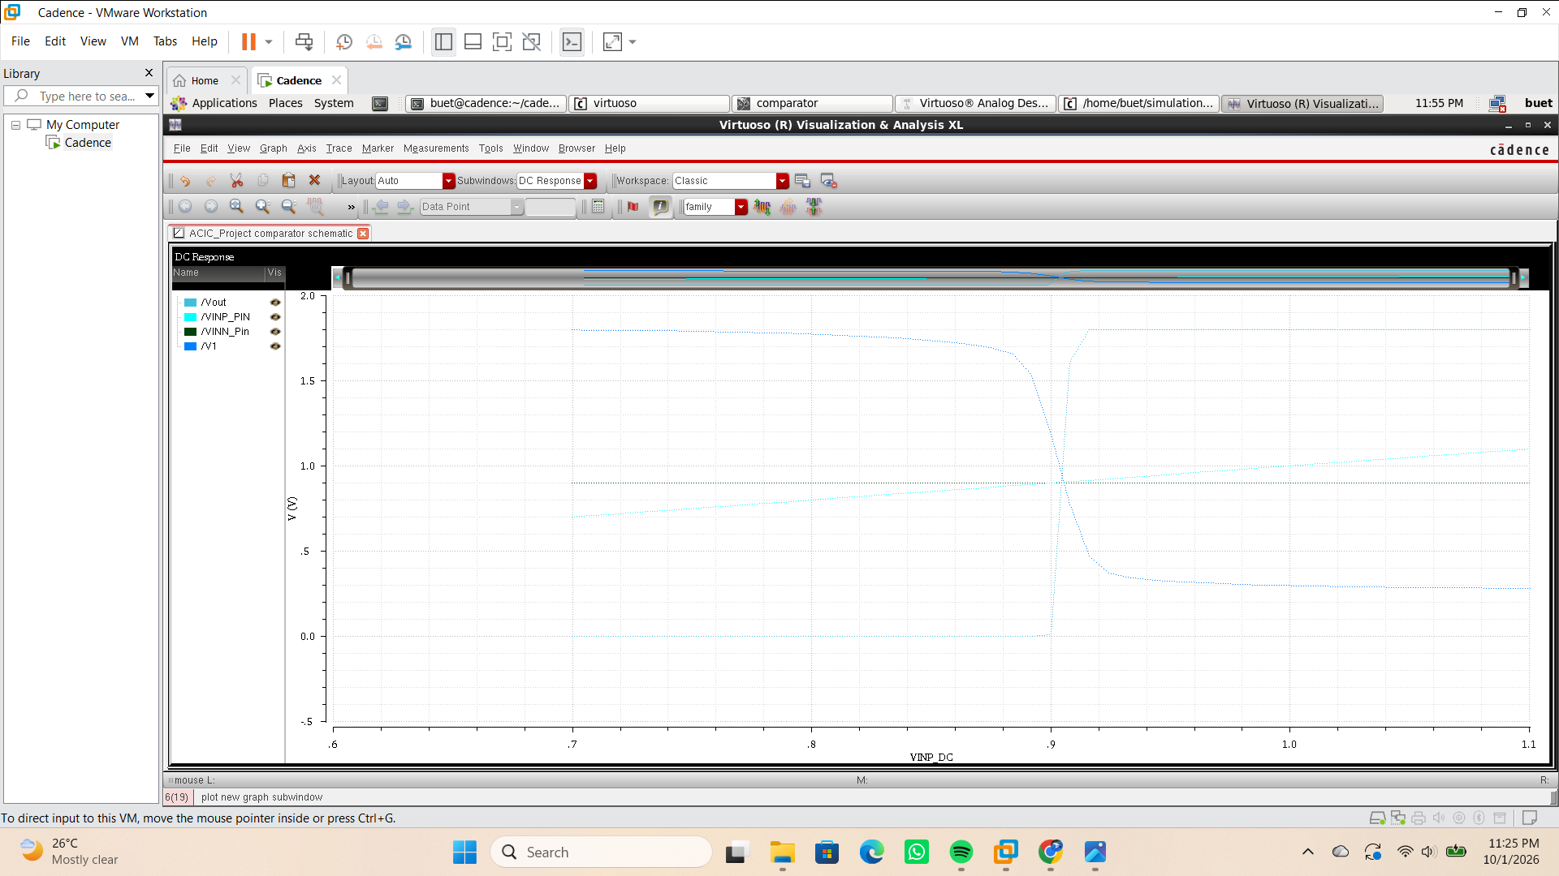
Fig. 4. DC transfer characteristic of the CMOS comparator.

The DC transfer characteristic demonstrates the comparison operation of the circuit. When $V_{INP}<V_{INN}$, the output remains in the low state. As $V_{INP}$approaches and exceeds $V_{INN}$, the output undergoes a sharp transition toward the high state. The switching behavior occurs around the differential input crossover region.

8.3 Transient Analysis
The transient test uses complementary inputs:
$$V_{INP}=0.9+0.05sin⁡\left(2π\left(1 MHz\right)t\right) \\ V_{INN}=0.9-0.05sin⁡\left(2π\left(1 MHz\right)t\right)$$
Therefore,
$$V_{INP}-V_{INN}=0.1sin⁡\left(2π\left(1 MHz\right)t\right)$$The two inputs have:
- Common-mode voltage = 0.9 V
- Amplitude = 50 mV
- Frequency = 1 MHz
- Opposite phase
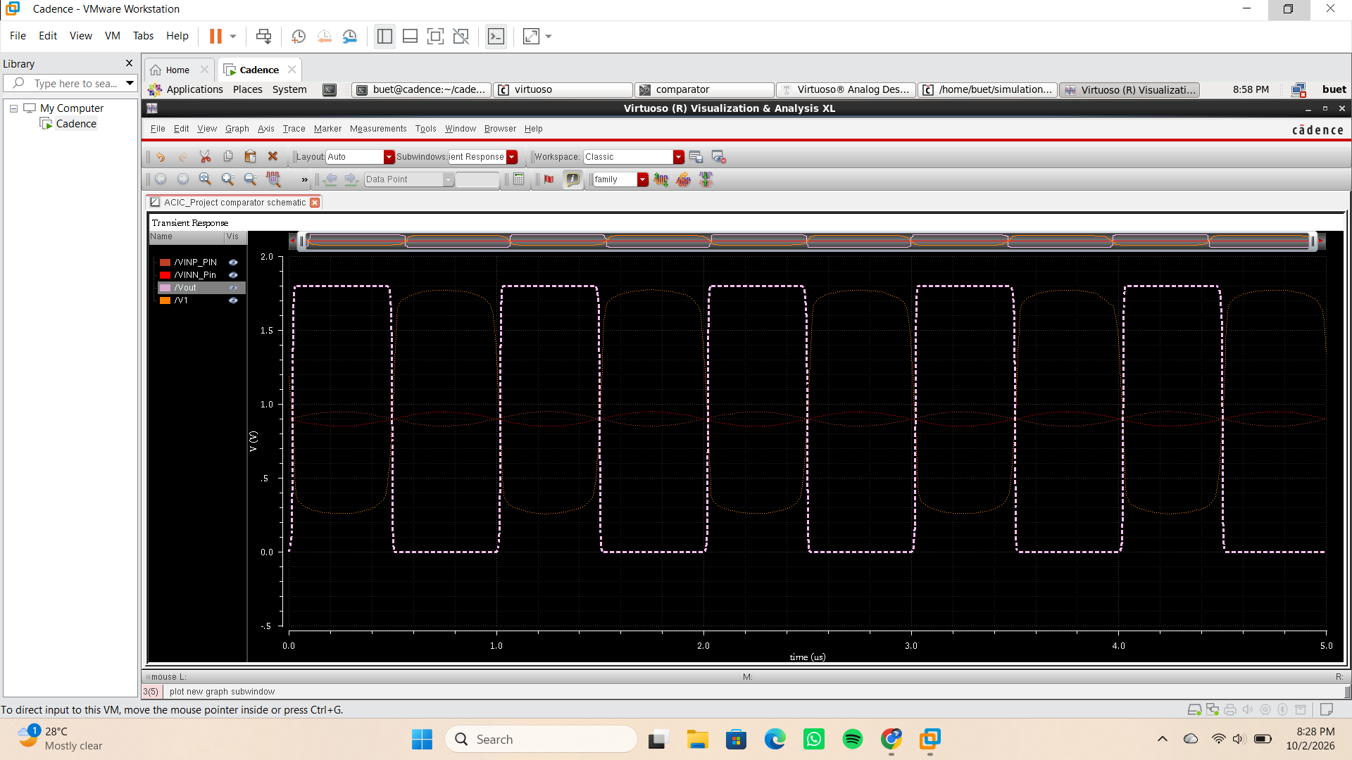
Fig. 5. Transient response of the CMOS differential comparator for complementary 1-MHz inputs.

The transient response was evaluated using complementary sinusoidal input signals with a frequency of 1 MHz and a common-mode voltage of 0.9 V. The input signals have equal amplitude and opposite phase. The output follows the differential input polarity, switching between the low and high output states as the polarity of $V_{INP}-V_{INN}$changes.
8.4 Layout
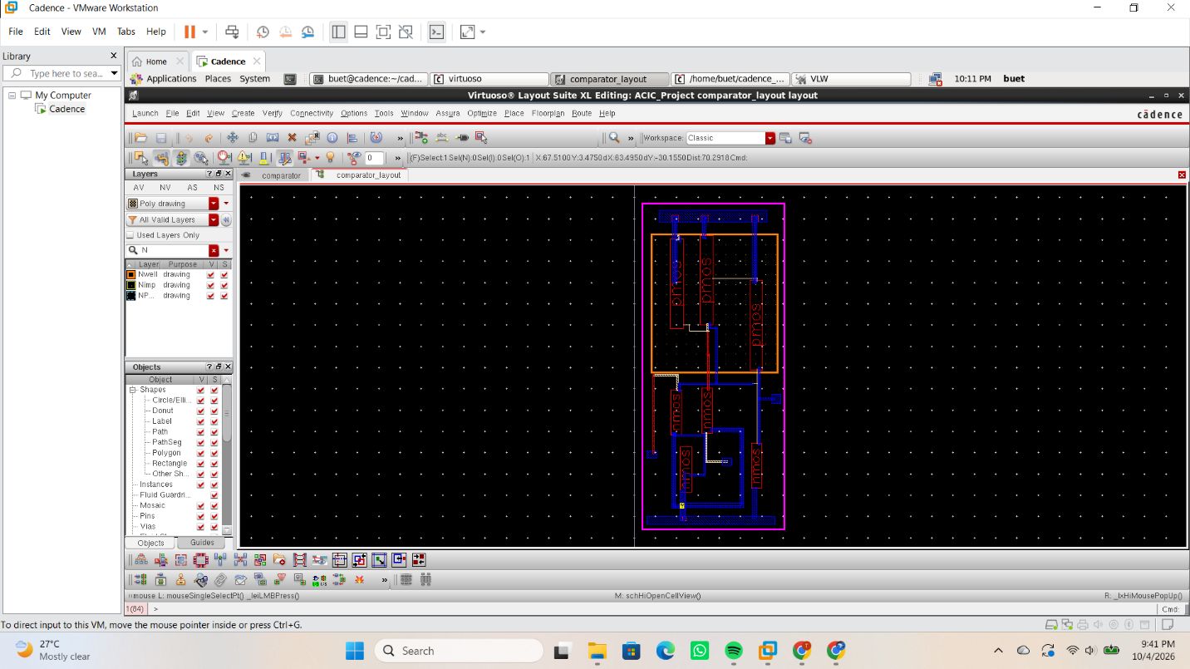

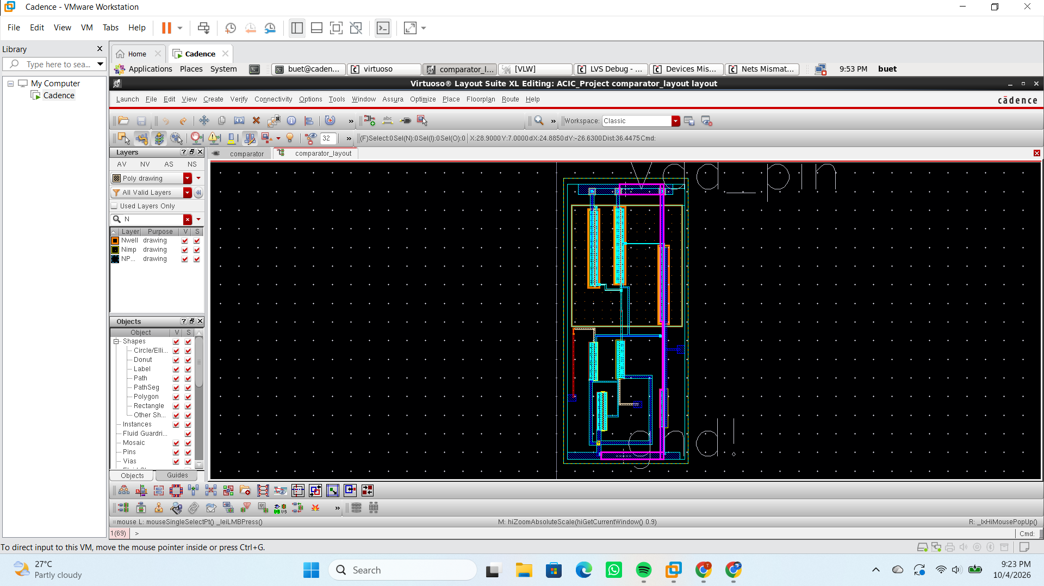

Fig. 6. Layout of the proposed CMOS differential comparator using GPDK180.
8.5 DRC and LVS
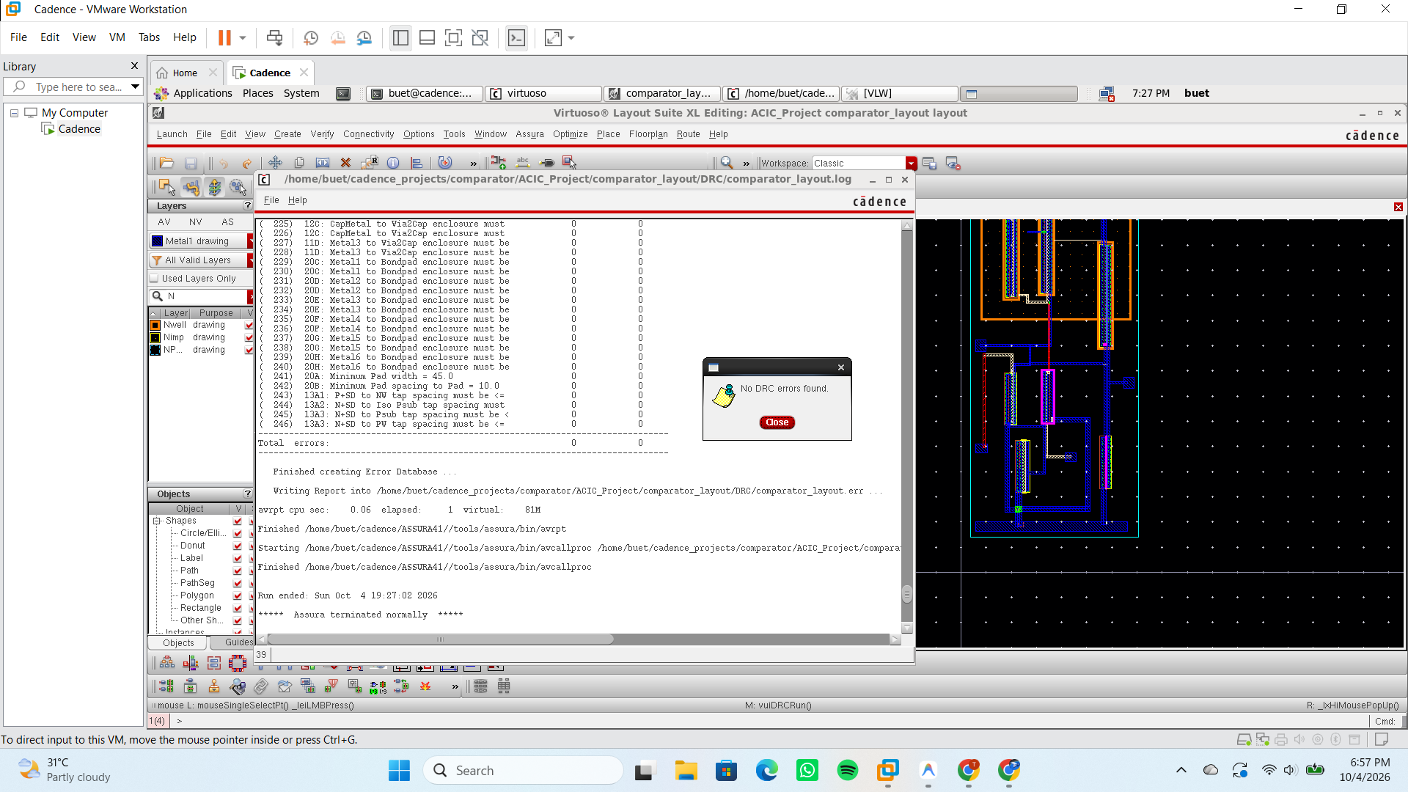
Fig. 7. DRC
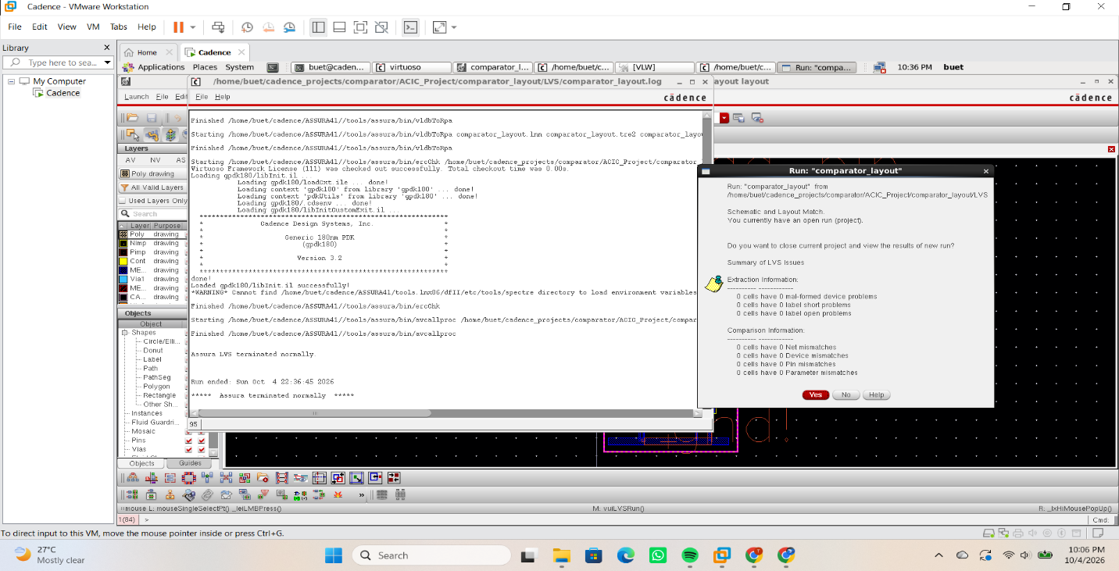
Fig. 8. LVS

8.6 RCX
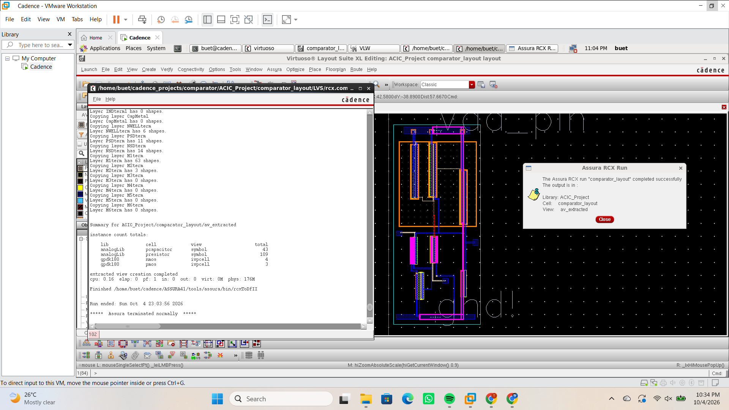
Fig. 9. RCX

Propagation delay:
tphl = -501.5 ns
tplh = -481.3 ns

Conclusion
The design and implementation of a CMOS differential comparator with a PMOS current-mirror active load was successfully completed using Cadence Virtuoso with the GPDK180 technology. The comparator was designed at the transistor level using a differential input pair, active current-mirror load, tail current source, and CMOS output inverter. The circuit was simulated under DC and transient conditions to verify its functional behavior.
The DC sweep analysis demonstrated a clear transition in the output voltage around the point where the differential input changes polarity, confirming the comparator's ability to distinguish between the two input voltages. The transient analysis further verified the dynamic switching behavior of the comparator for time-varying differential inputs. Following schematic-level verification, the transistor-level layout was implemented in Cadence Virtuoso Layout XL, followed by DRC and LVS verification to ensure that the physical layout satisfied design rules and maintained correspondence with the schematic.
Overall, the project provided practical experience in the complete custom CMOS IC design flow, from circuit architecture and transistor sizing to schematic simulation, physical layout, and verification. The completed design demonstrates the functionality of a differential CMOS comparator and provides a foundation for further optimization of parameters such as power consumption, propagation delay, and switching performance.

References
[1] Razavi, Behzad. "Design of analog CMOS integrated circuits." (2001).
[2] Dhandapani Vaithiyanathan, Rajat Mishra, Preeti Verma, Baljit Kaur,
Design and analysis of optimized dynamic comparator circuit for low-power and high-speed applications, e-Prime - Advances in Electrical Engineering, Electronics and Energy, Volume 10,
2024, 100858, ISSN 2772-6711.
[3] D. J. Allstot, "A precision variable-supply CMOS comparator," in IEEE Journal of Solid-State Circuits, vol. 17, no. 6, pp. 1080-1087, Dec. 1982, doi: 10.1109/JSSC.1982.1051864.
[4] B. Razavi and B. A. Wooley, "Design techniques for high-speed, high-resolution comparators," in IEEE Journal of Solid-State Circuits, vol. 27, no. 12, pp. 1916-1926, Dec. 1992, doi: 10.1109/4.173122.

[5] X. Tang et al., "An Energy-Efficient Comparator with Dynamic Floating Inverter Amplifier," in IEEE Journal of Solid-State Circuits, vol. 55, no. 4, pp. 1011-1022, April 2020, doi: 10.1109/JSSC.2019.2960485.

