POC- Bus Tracking System

**Problem statement:** Bus Tracking System: Monitor bus routes and schedules.

In Todays lifestyle people prohibit using public transport to save time as public transport doesn’t arrive in time,No proper Information about transport and comfort.

**Overview of the app:**

This app allows user to Monitor bus routes and schedules real-time of any location.This makes Easy for passengers for travelling and planning the timings according to their daily busy schedules.

This can be efficiently used in the populated areas where the traffic has been become a hectic problem nowadays for the public.This may encourage people interest towards using the public transport.

**Types of Challenges:**

1. Monitor bus routes and schedules.

2.Real-time GPS tracking

3.Passenger notification

4.Driver monitoring

5.Traffic Monitoring and optimization

6.Security and privacy

7.Bus Number

8.E-ticketing system

9.Offline access

10.FeedBack system

**Features of Apps:**

1.Lets begin out travel

2.Access location

3.Shows nearby bus stand.

4.Bus arrivals

5.Search for Bus Number/destination

6.E-ticket system

7.Passenger Notifications

8.Security and privacy

9.Feedback system

10.Schedule Travel

**Tech Stack used in the project :**

Frontend :

* HTML
* CSS
* Javascript
* React.js
* Material UI

Backend :

* Express.js
* Node.js

Database :

* MongoDB

Hosting Platforms :

* Frontend - Netlify or Vercel
* Backend – Heroku

**Flow diagram:**

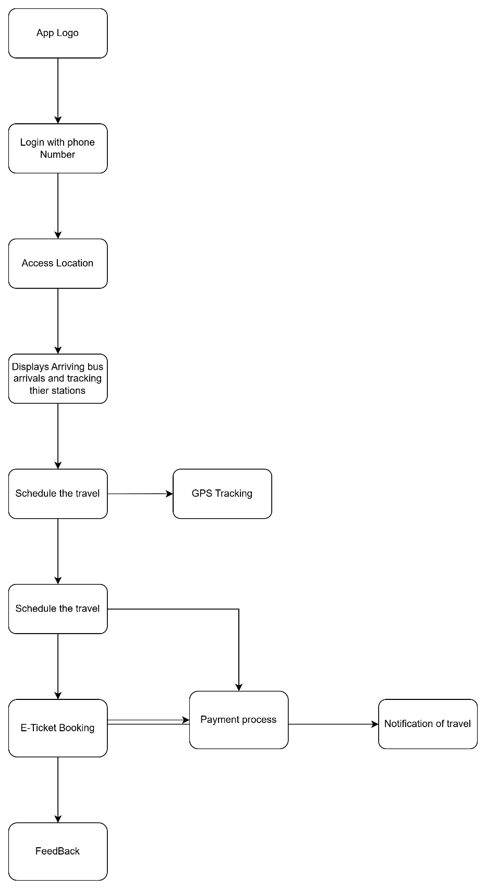

**Front-End Components:**

Login page:

* Login Page with Name,Mobile Number,age fields for authentication.

Display page:

* Displays logo and access the location

Bus Details page:

* Displays arriving bus schedule and tracks according to location.

Search page:

* Enter destination/Bus Number to get details

E-ticket system page:

* Enter details and process the payment.

Feedback page:

* Form for feedbacks about drivers and travel.

**Back-end Components:**

Real-time GPS tracking:

* Tracks the bus

Login Authentication

* Checks credentials

Payment Automation

* Process payment to UPI apps

**Database:**

* Bus Details
* User Details
* Payment details
* Ticket details