Assignment #2:

1. Create "weather" external table under /user/training/weather

CREATE EXTERNAL TABLE IF NOT EXISTS weather (WBANNO int, LST_DATE DATE, CRX_VN FLOAT, LONGITUDE FLOAT,LATITUDE FLOAT,T_DAILY_MAX FLOAT,T_DAILY_MIN FLOAT,T_DAILY_MEAN FLOAT, T_DAILY_AVG FLOAT,P_DAILY_CALC FLOAT, SOLARAD_DAILY String,SUR_TEMP_DAILY_TYPE FLOAT, SUR_TEMP_DAILY_MAX FLOAT,

SUR_TEMP_DAILY_MIN FLOAT,SUR_TEMP_DAILY_AVG FLOAT,RH_DAILY_MAX FLOAT, RH_DAILY_MIN FLOAT,RH_DAILY_AVG FLOAT,SOIL_MOISTURE_5_DAILY FLOAT,

SOIL_MOISTURE_10_DAILY FLOAT, SOIL_MOISTURE_20_DAILY FLOAT, SOIL_MOISTURE_50_DAILY FLOAT, SOIL_MOISTURE_100_DAILY FLOAT,

SOIL_TEMP_5_DAILY FLOAT, SOIL_TEMP_10_DAILY FLOAT, SOIL_TEMP_20_DAILY FLOAT, SOIL_TEMP_50_DAILY FLOAT, SOIL_TEMP_100_DAILY FLOAT)

COMMENT 'Weather Details'

ROW FORMAT DELIMITED

FIELDS TERMINATED BY ','

LINES TERMINATED BY '\n'

STORED AS TEXTFILE;

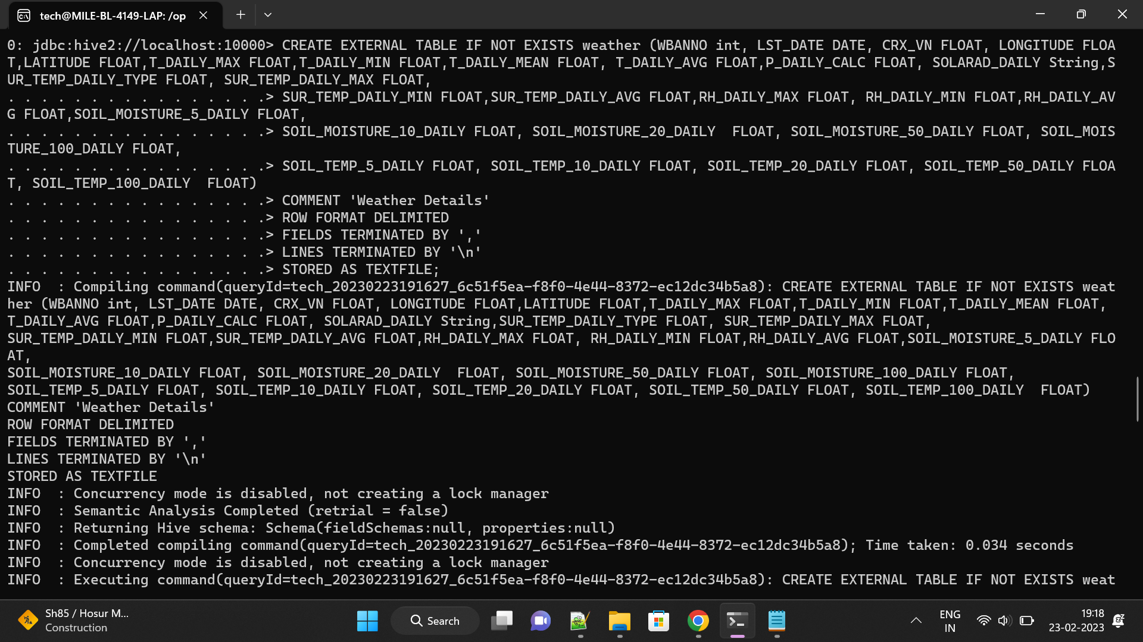

2. Load the data from ~/futurence_hadoop-pyspark/labs/dataset/weather to /user/training/weather

LOAD DATA LOCAL INPATH '/home/tech/modify1_weather.txt' INTO TABLE weather;

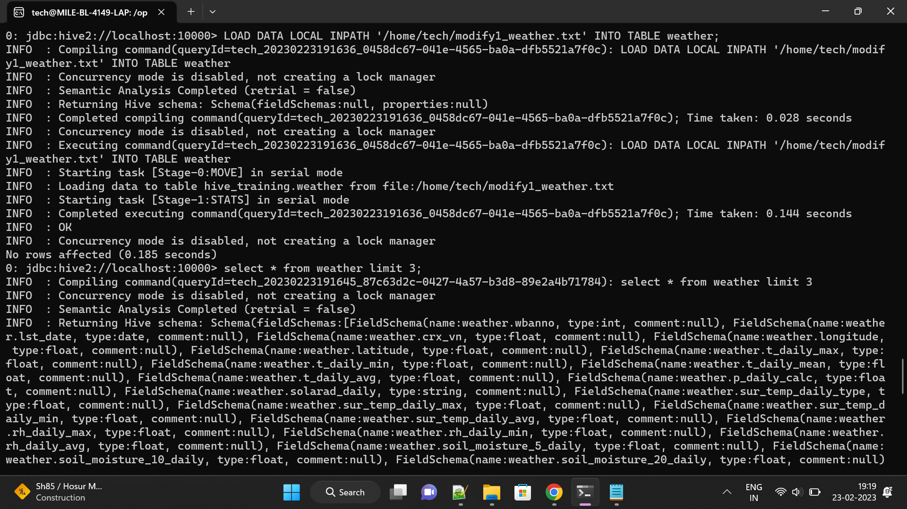

3. Display the weather

select * from weather;

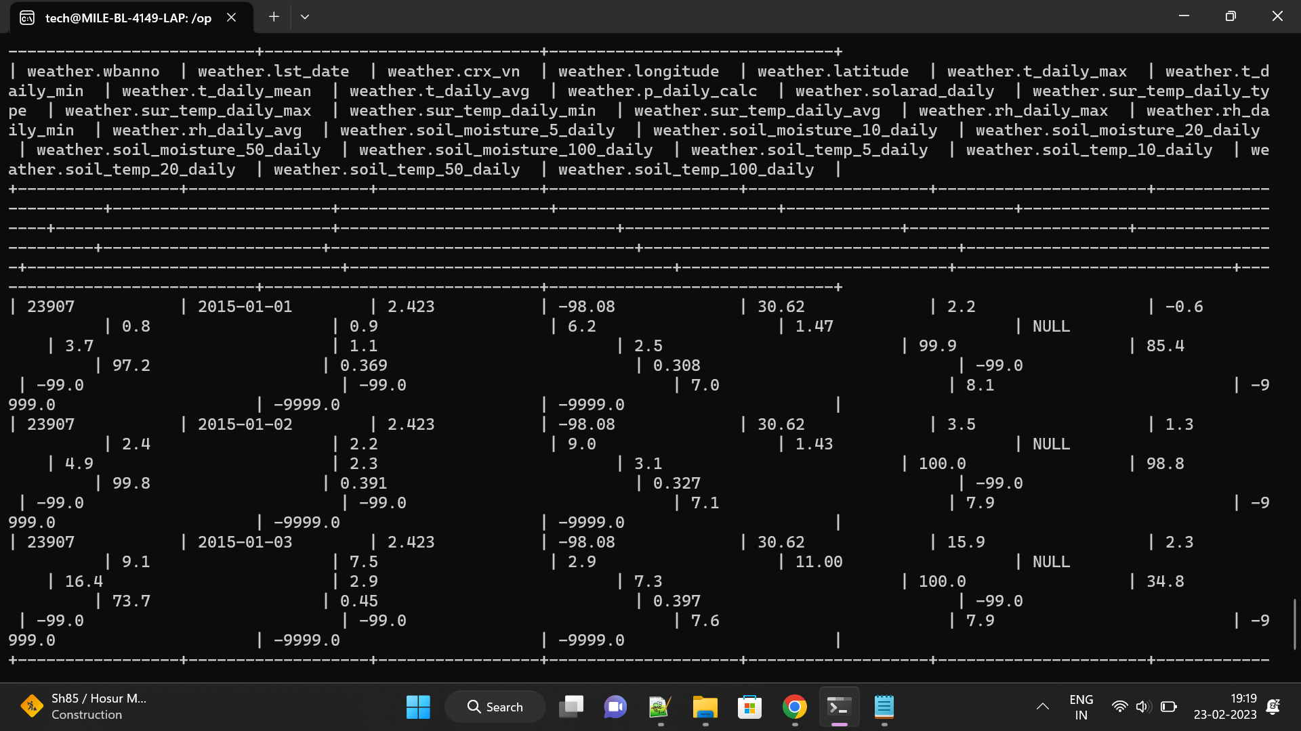

4. Display Max, Min weather

select max(t_daily_max),min(t_daily_min) from weather;

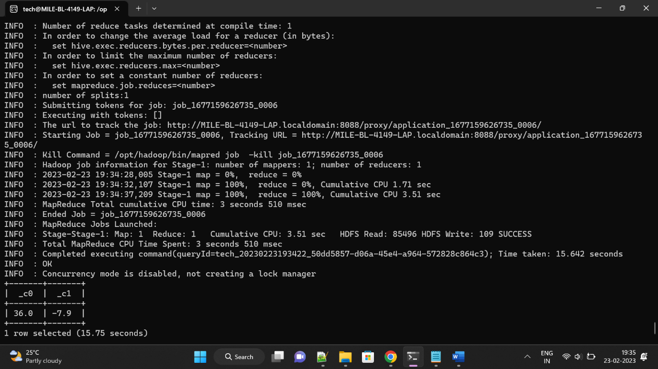

5. Display month wise Max and Min weather

select month(lst_date),max(t_daily_max) from weather group by month(lst_date);

