Assignment #3:

Create "customers" and "transactions" tables

Load the data from ~/futurence_hadoop-pyspark/labs/dataset/retail

Perform the analysis mentioned below

1) No of transactions by customer

2) Total transaction amount by customer

3) Get top 3 customers by transaction amount

4) No of transactions by customer and mode of payment

5) Get top 3 cities which has more transactions

6) Get month wise highest transaction

7) Get sample transactions

0: jdbc:hive2://> CREATE TABLE Customers(cust_id int,last_name String,first_name String,age int,profession String)

. . . . . . . . > comment "Customer details"

. . . . . . . . > ROW FORMAT DELIMITED

. . . . . . . . > FIELDS TERMINATED BY ","

. . . . . . . . > LINES TERMINATED BY "\n"

. . . . . . . . > STORED AS TEXTFILE;

OK

No rows affected (0.547 seconds)

0: jdbc:hive2://> load data local inpath '/home/tech/futurense_hadoop-pyspark/labs/dataset/retail/customers.txt' overwrite into table customers;

0: jdbc:hive2://> CREATE TABLE Transactions (trans_id int,trans_date String, cust_id int, amount double,category String,desc String,city String,state String,pymt_mode String)

. . . . . . . . > comment "Transactions details"

. . . . . . . . > ROW FORMAT DELIMITED

. . . . . . . . > FIELDS TERMINATED BY ","

. . . . . . . . > LINES TERMINATED BY "\n"

. . . . . . . . > STORED AS TEXTFILE;

OK

No rows affected (0.071 seconds)

0: jdbc:hive2://> load data local inpath '/home/tech/futurense_hadoop-pyspark/labs/dataset/retail/transactions.txt' overwrite into table transactions;

1) No of transactions by customer

0: jdbc:hive2://> SELECT c.cust_id,count(t.trans_id) FROM customers c join transactions t on c.cust_id = t.cust_id GROUP BY c.cust_id;

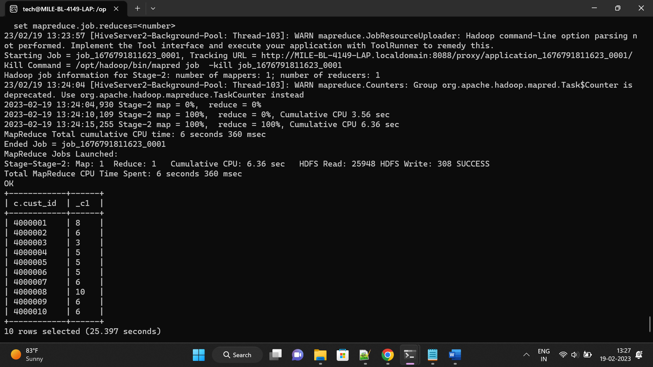

2) Total transaction amount by customer

0: jdbc:hive2://> SELECT c.cust_id, SUM(t.amount)

. . . . . . . . > FROM Customers c

. . . . . . . . > JOIN Transactions t

. . . . . . . . > ON c.cust_id = t.cust_id

. . . . . . . . > GROUP BY c.cust_id;

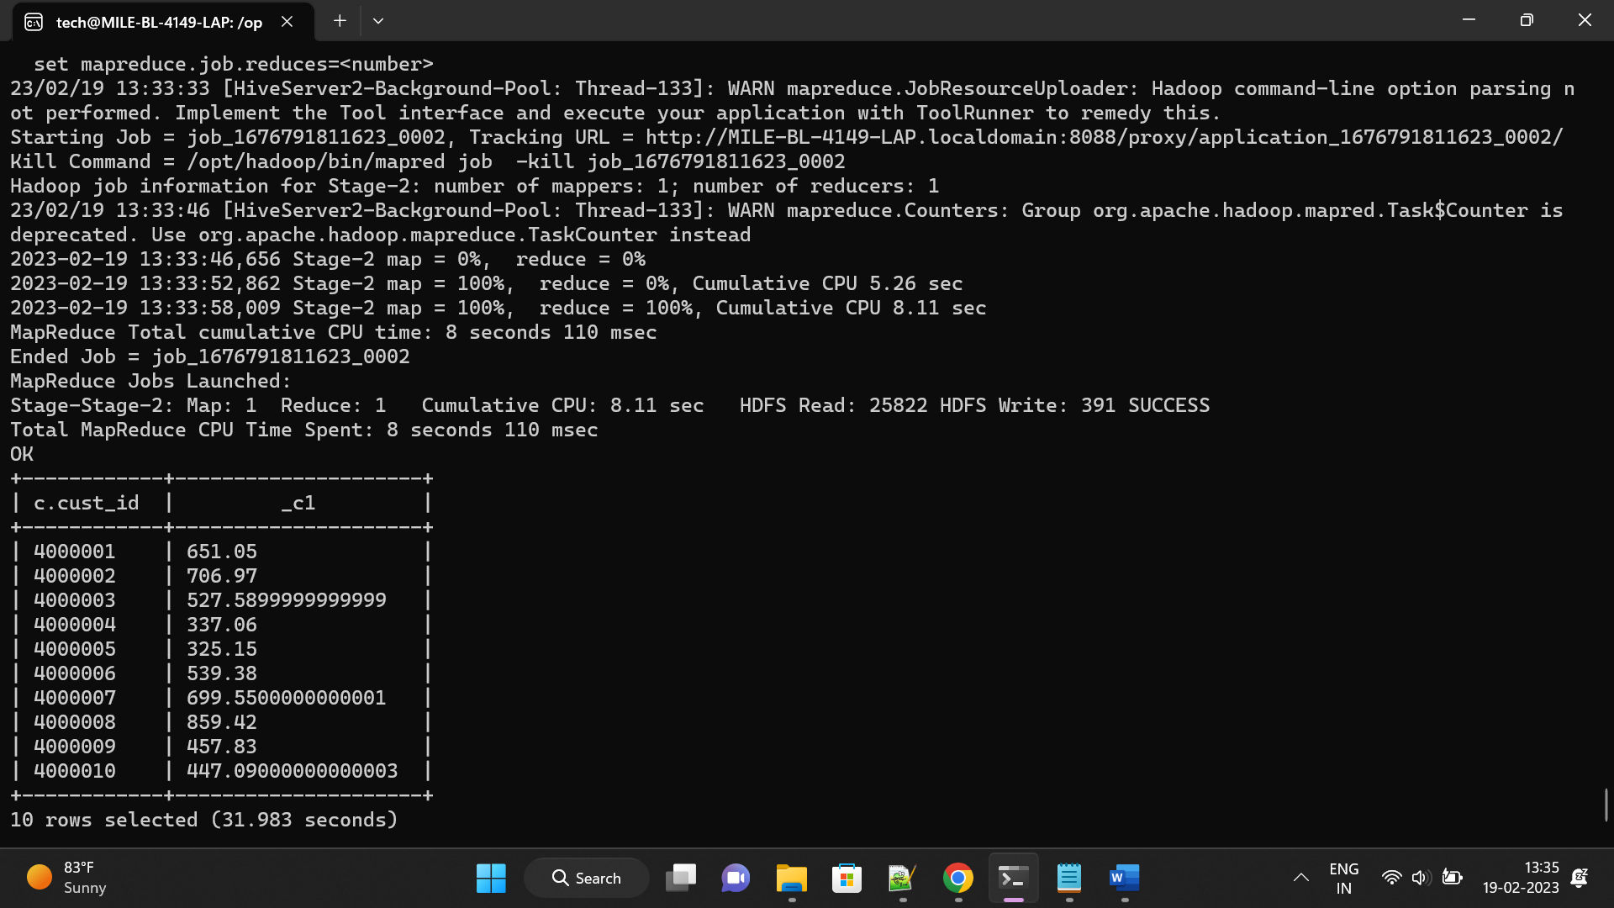

3) Get top 3 customers by transaction amount

0: jdbc:hive2://> SELECT c.cust_id, SUM(t.amount) AS Total_Amount

. . . . . . . . > FROM Customers c

. . . . . . . . > INNER JOIN Transactions t

. . . . . . . . > ON c.cust_id = t.cust_id

. . . . . . . . > GROUP BY c.cust_id

. . . . . . . . > ORDER BY Total_Amount DESC

. . . . . . . . > LIMIT 3;

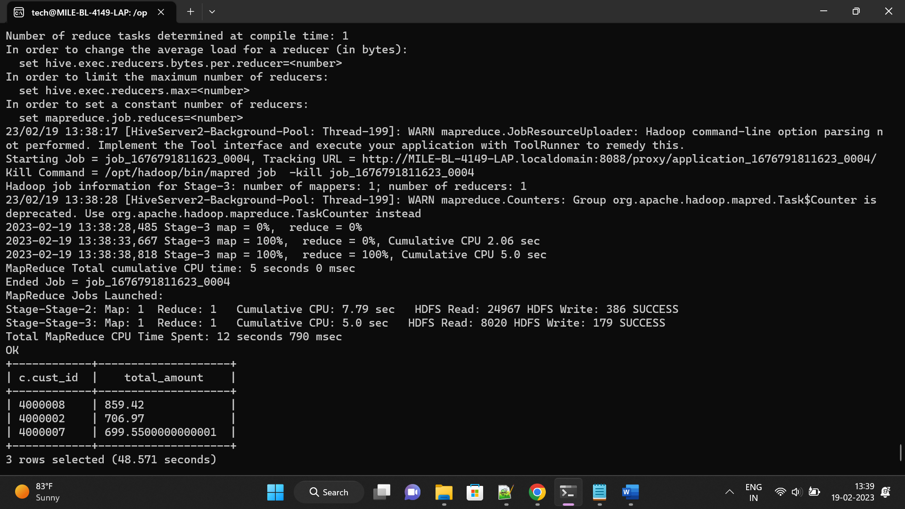

4) No of transactions by customer and mode of payment

0: jdbc:hive2://> SELECT cust_id, pymt_mode, COUNT(*) AS No_of_transactions

. . . . . . . . > FROM Transactions

. . . . . . . . > GROUP BY cust_id, pymt_mode;

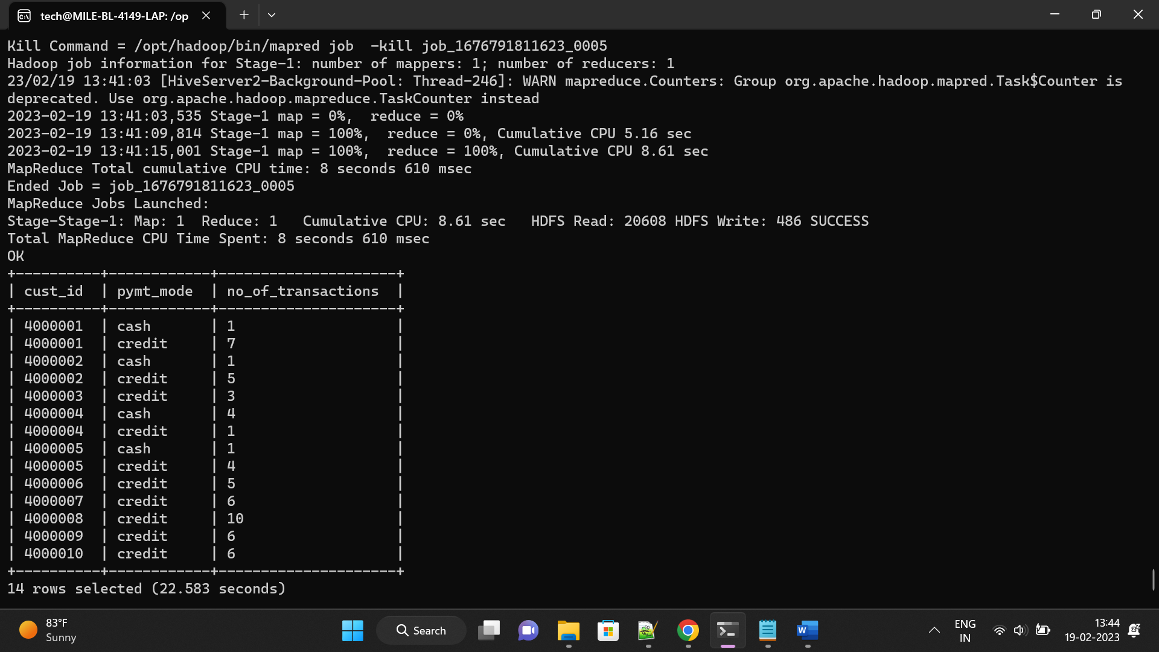

5) Get top 3 cities which has more transactions

0: jdbc:hive2://> SELECT city, COUNT(trans_id) as Transactions

. . . . . . . . > FROM Transactions

. . . . . . . . > GROUP BY city

. . . . . . . . > ORDER BY Transactions DESC

. . . . . . . . > LIMIT 3;

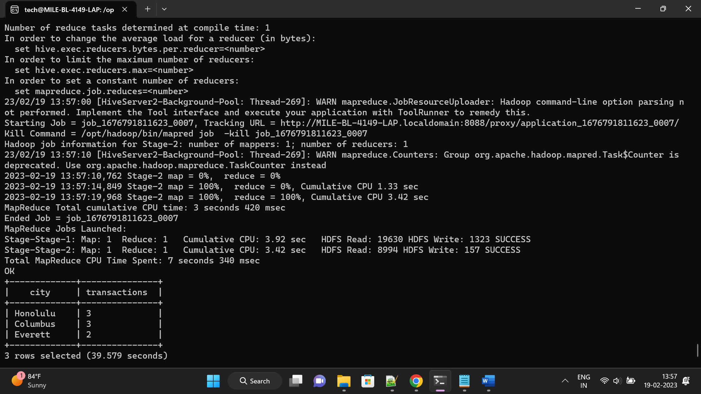

6) Get month wise highest transaction

0: jdbc:hive2://> CREATE TABLE mytime(trans_id int, trans_date date);

0: jdbc:hive2://> INSERT INTO TABLE mytime SELECT trans_id, from_unixtime(unix_timestamp(trans_date, 'MM-dd-yyyy')) FROM Transactions;

0: jdbc:hive2://> SELECT MONTH(mytime.trans_date), MAX(amount)

. . . . . . . . > FROM Transactions JOIN mytime ON Transactions.trans_id = mytime.trans_id

. . . . . . . . > GROUP BY MONTH(mytime.trans_date);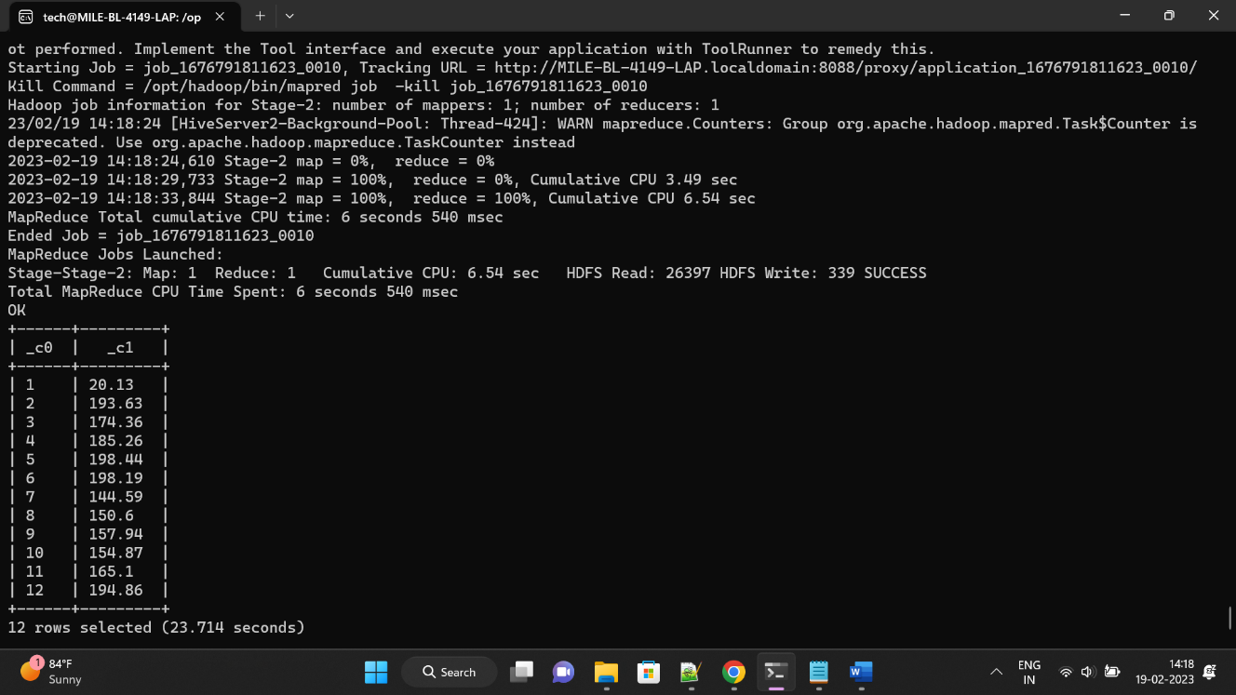

7) Get sample transactions

0: jdbc:hive2://> SELECT * FROM Transactions LIMIT 10;

OK

