Create pyspark application-bank-marketing-analysis.py

a) load bank marketing campaign data from csv file

b) get agegroup wise subscriptioncount

c) write the output in parquet file format

d) load the data from parquet file written above

e) show the data

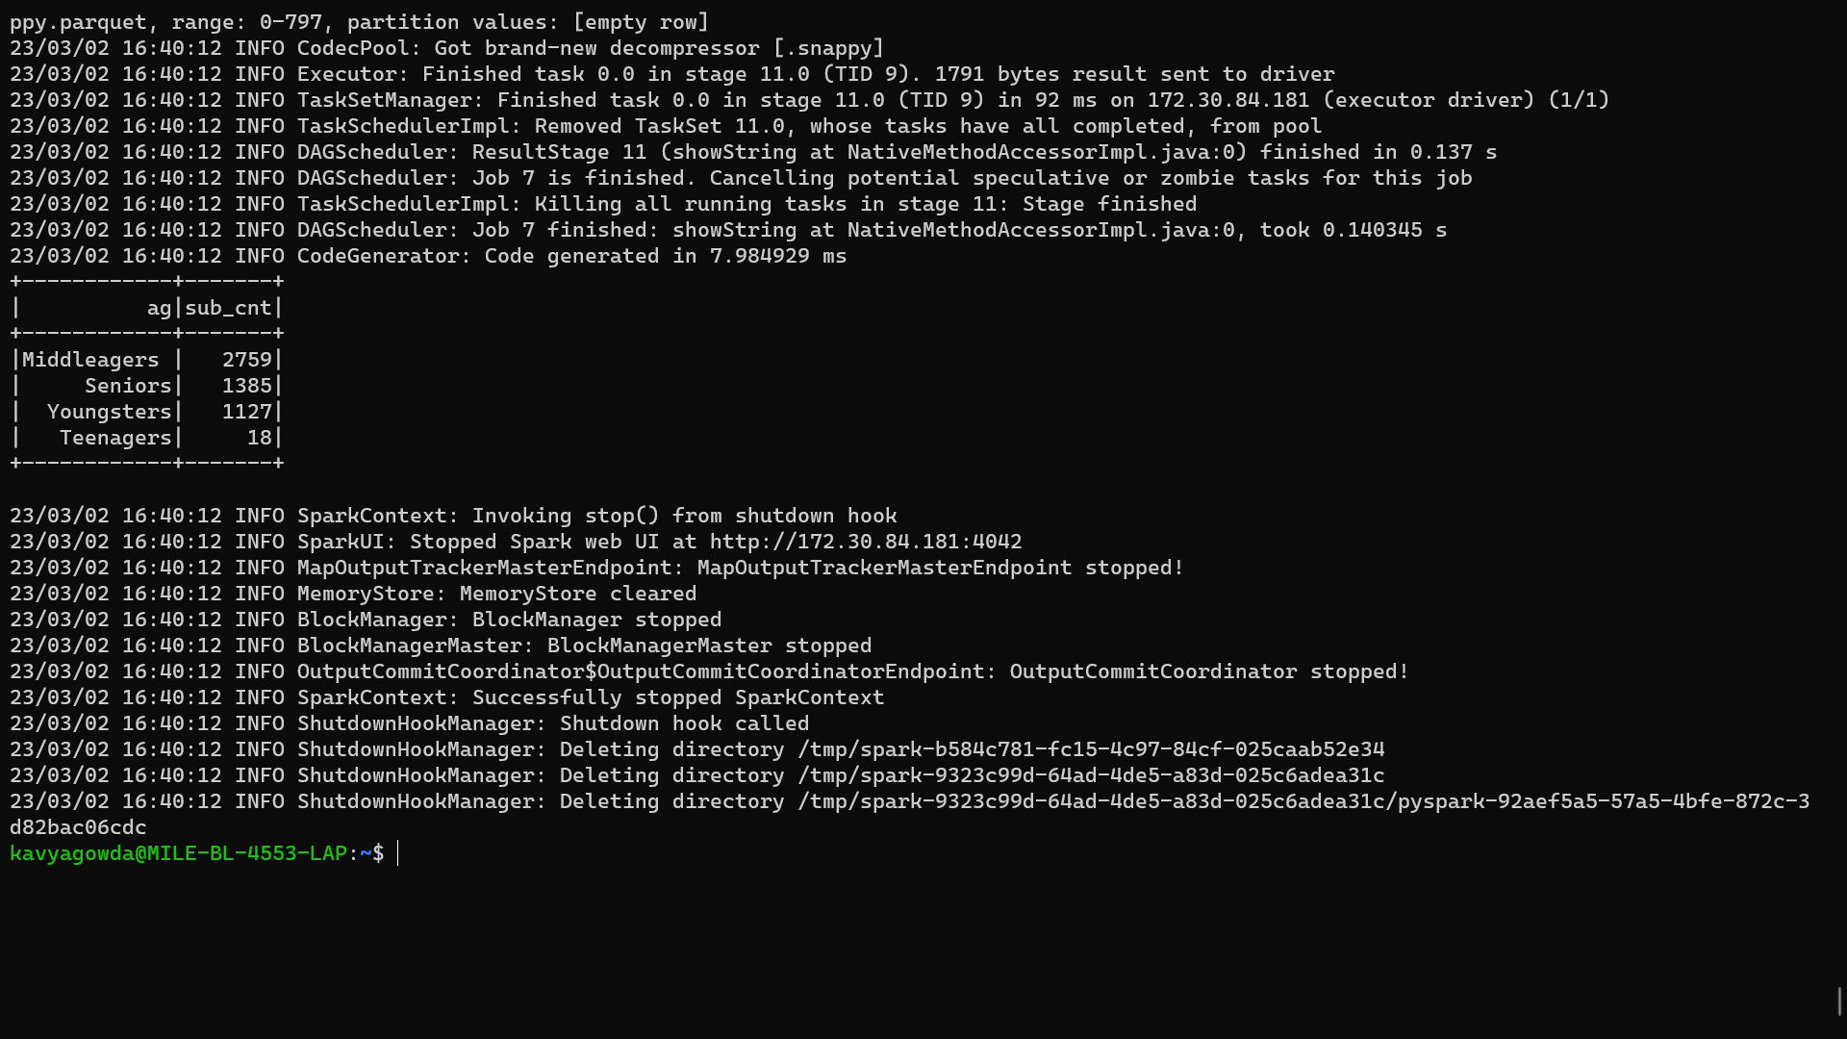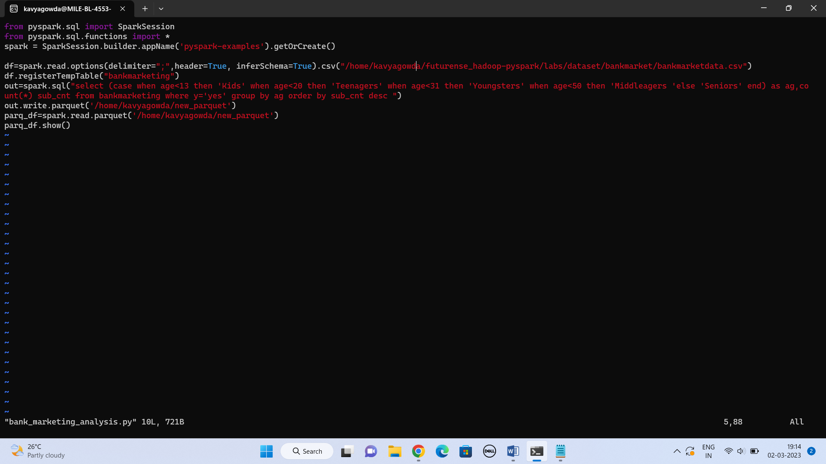

f) Filter AgeGroup with SubcriptionCount > 2000 and write into Avro file format

g) Load the data from avro file written above

h) Show the data

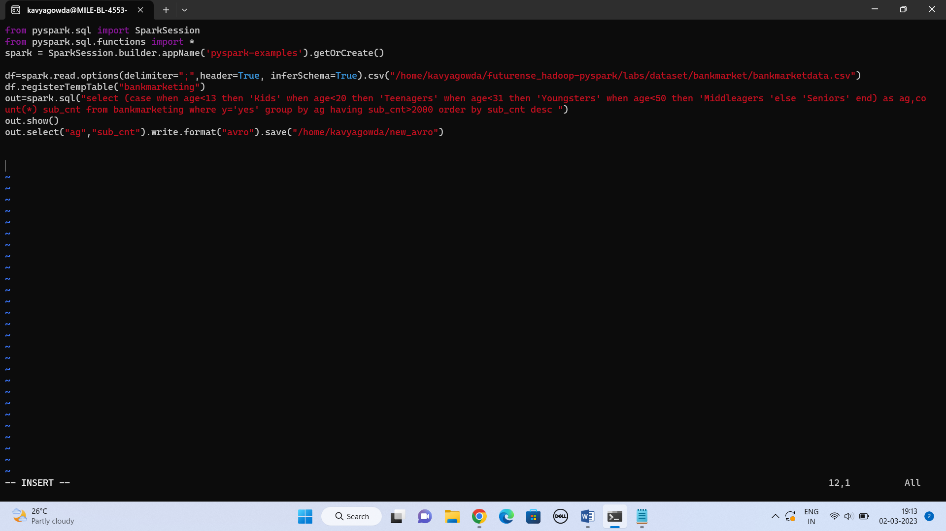

1] spark-submit bank-marketing-analysis.py => Runs in local mode

2] Run in cluster mode

3] Schedule to PySparkApplication to run every N mins

