DETECTION OF AMYOTROPHIC LATERAL SCLEROSIS USING SUPPORT VECTOR MACHINE

Kavya. Kamasani1, Deepa. Venna2, Harshitha. Badavathula3,

Namratha Ranga3

1,2,3,3Department of Computer Science and Engineering, Velagapudi Ramakrishna Siddhartha Engineering

College, Vijayawada Kanuru, 520007, India

**Abstract.** A neurological disease called Amyotrophic Lateral Sclerosis exists that damages brain and spinal cord nerve cells, causing muscular atrophy and eventually paralysis. Use a Support vector machine (SVM) for Amyotrophic Lateral Sclerosis diagnosis as part of machine learning to get the most accurate results for categorising health data. Early Amyotrophic Lateral Sclerosis diagnosis is essential for effective treatment. A supervised machine learning approach that excels in large-scale settings is the support vector machine. It is especially helpful in tackling complex problems with high-dimensional data where the characteristics and the goal variable have a non-linear relationship. In Some previous the functions are poorly connected and the use of classification models is appropriate for portable datasets that obscure key patient information are best suited for short dimensional spaces, according to previous research applying the Functional Rating Scale score for Amyotrophic Lateral Sclerosis yields the least trustworthy conclusions. The ALSFRS-R score function reveals discrepancies in the bulbar, limb, and respiratory functions. The accuracy of the diagnosis can be impacted by a number of factors that alter sEMG signals, including electrode location, muscle exhaustion, and movement artefacts. Our findings imply that ML-based techniques may enhance the speed and diagnostic precision of ALS identification, which may result in better outcomes for people with this crippling condition.

**Keywords:** Motor Neuron Disease Diagnosis, Support Vector Machine, Amyotrophic Lateral Sclerosis ALS Clinical Trials Database, Fasciculations, Pooled Resource Open-Access, Graphical User Interface.

**I Introduction**

Motor neurons in spinal cord and brain are impacted by progressive neurodegenerative diseases known as Amyotrophic Lateral Sclerosis, which causes weakness in the muscles. Early diagnosis of ALS is essential for immediate therapy initiation and better patient outcomes. However, early diagnosis of ALS is challenging due to the variability and complexity of its clinical presentation. The use of SVM algorithms provides a number of possible advantages for the identification and diagnosis of ALS. SVMs can effectively discriminate between classes with nonlinear borders and can handle high-dimensional data. SVMs are appropriate for use in medical diagnosis applications because they offer a high degree of accuracy and the ability to handle noisy data.

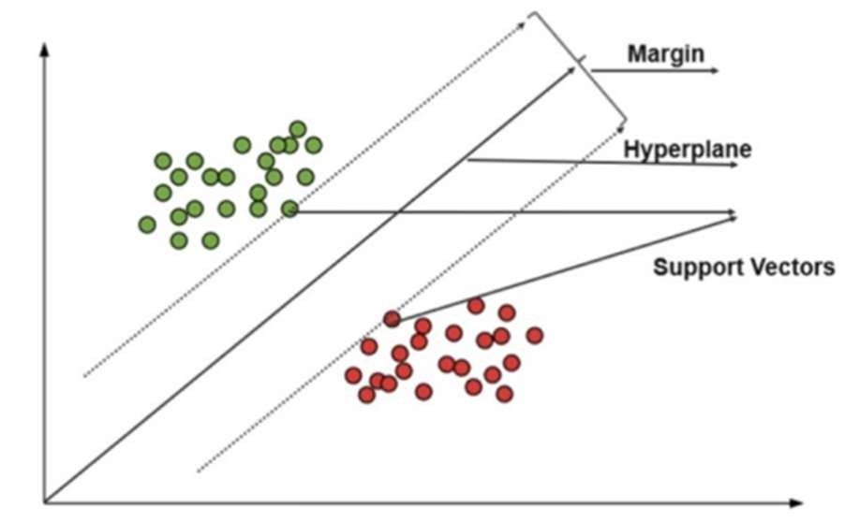

Figure 1 Support Vector Machine

# **Main Contributions of this work**

1. Early detection allows for timely medical intervention, which can help slow down the progression of the disease and manage symptoms effectively.

1. Detecting Amyotrophic Lateral Sclerosis early enables healthcare professionals to offer appropriate care and support to patients and their families.

# **II. Literature Survey**

The methodology [1] outlined by the researchers involves the utilization of various machine learning algorithms such as Random Forest, LightGBM, and XGBoost, alongside unsupervised learning techniques like UMAP and semi-supervised learning with Neural Networks, to delineate distinct subgroups within Amyotrophic Lateral Sclerosis (ALS). The primary aim is to compare the six clinical subtypes of ALS (Bulbar, Respiratory, Flail arm, Classical, Pyramidal, and Flail leg) as classified by Neurologists using the Chio classification system. This involves validating the Chio classification system through a data-driven approach. While advantageous in potentially enhancing the Chio classification method, a notable disadvantage arises from the use of the same patient cohort utilized in Chio and colleagues' 2011 study, potentially introducing bias into the analysis.

The methodology described in study [2] aims to develop an automated diagnostic method for Amyotrophic Lateral Sclerosis (ALS) utilizing surface electromyography (sEMG) signals. This involves extracting a range of features from the sEMG signal, including amplitude, frequency, time domain, shape, phase, and nonlinear characteristics, which are indicative of the signal's morphology. Machine learning techniques are then applied to classify the signals as either healthy or symptomatic of ALS. The feature set is optimized through feature selection algorithms and classifiers to enhance diagnostic accuracy. While offering the potential to reduce the need for invasive diagnostic procedures and improve speed and accuracy in diagnosis, there are drawbacks. Despite the use of morphology-based features to enhance diagnostic accuracy, there remains the possibility of false positives or false negatives, leading to erroneous diagnoses, akin to concerns raised in the methodology proposed by the researchers in [1].

In study [3], the methodology revolves around employing machine learning techniques to create and evaluate diagnostic models for early-stage Amyotrophic Lateral Sclerosis (ALS). The research involves the examination of 50 non-ALS patients and 100 ALS patients, where fasciculations in 15 muscles are recorded and studied for 10 seconds each. Hierarchical Clustering, Nominal Logistic Regression, and either Neural Networks or ensemble learning methods are utilized as machine learning techniques. The model is built using high-rank muscles, and various statistical tests such as T-tests, Fisher's exact tests, Pearson correlation coefficients, recall, precision, and area under the curve are employed for evaluation. Despite the simplicity and quick installation of the developed diagnostic approach, drawbacks include the requirement for a single operator to detect fasciculations on MUS, and the lack of evaluation of interrater reliability, which may affect the robustness and reliability of the diagnostic process.

In the methodology [4] outlined , the Amyotrophic Lateral Sclerosis Rating Functional Scale (ALSFRS-R) bulbar subscale and assessments of swallowing function were utilized to detect radiographic abnormalities in swallowing safety and overall pharyngeal performance in ALS patients. The research employed videofluoroscopic swallowing exams (VFSE), the Penetration and Aspiration Scale (PAS), and the Dynamic Imaging Grade of Swallowing Toxicity (DIGEST) for validation. Sensitivity and specificity of the ALSFRS-R bulbar subscale varied between 34% to 94% depending on score selection, with a classification accuracy of 9 for identifying pharyngeal dysphagia and swallowing risk. However, the study concluded that the ALSFRS-R subscale failed to adequately detect swallowing impairment validated by radiography. Despite the bulbar subscale's sensitivity in identifying dangerous swallowing, it fell short in detecting severe speech difficulties in ALS patients, highlighting suboptimal diagnostic accuracy.

In study [5], Surface electromyography (sEMG) is proposed as a diagnostic and monitoring tool for Amyotrophic Lateral Sclerosis (ALS), a neurodegenerative disease affecting neurons. Employing a systematic review methodology, the research aims to gather, evaluate, and synthesize relevant studies on the role of sEMG in ALS. Previous systematic reviews have investigated sEMG's diagnostic accuracy, prognostic value, and its potential in assessing disease progression and treatment response in ALS. Notably, a 2014 review demonstrated sEMG's sensitivity of 86% and specificity of 95% in ALS diagnosis. Recent reviews have further explored sEMG's utility in evaluating disease severity and monitoring treatment response in ALS patients. Despite its advantages as a non-invasive technique, providing painless muscle activity assessment, sEMG's reliability may be compromised by factors like electrode placement, patient positioning, and variations in muscle anatomy. Nevertheless, the systematic review approach has offered a comprehensive and evidence-based understanding of sEMG's evolving role in diagnosing, prognosticating, and managing ALS, thereby enhancing our knowledge of this debilitating condition.

The methodology [6] proposed aimed to investigate the rate at which speech abilities deteriorate in individuals with amyotrophic lateral sclerosis (ALS), focusing on speaking rate and speech intelligibility. The research assessed the correlation between clinical speech measurements and patient-reported indicators of ALS progression, considering factors such as onset location, sex, and age at onset. Involving 166 ALS patients, the study revealed that speech impairment progressed more rapidly in individuals with bulbar onset compared to those with spinal onset, with age and sex showing no significant impact on the rate of decline. Notably, even 60 months post-onset, most individuals with spinal onset retained functional speech abilities, while those with bulbar onset began to experience significant declines in speaking rate and speech intelligibility around 32 and 23 months, respectively. Intriguingly, clinical speech measurements were found to be more responsive to functional deterioration than patient-reported measures. These findings hold considerable implications for improving speech prognosis in ALS, identifying optimal intervention windows, providing tailored patient counseling, and monitoring functional improvements during drug trials. Despite its advantages in monitoring speech changes over time, the study's reliance on a sample size of 166 ALS patients raises concerns regarding its generalizability to the broader ALS population.

The methodology proposed in study [7] introduces a technology utilizing a supervised model for detecting bulbar movement and diagnosing Amyotrophic Lateral Sclerosis (ALS) using the Spanish phonological system. This approach is based on 50 characteristics derived from the phonatory system and Time-Frequency Representation (TFR), which is particularly adept at identifying severe conditions. Vowel recordings, known for their periodic components, are employed to generate sharp, powerful modulations and clearly defined harmonics. The supervised model operates as a gender-specific categorization model, with gender distinction being the most influential factor in the diagnosis process. The detection of bulbar involvement through this technology promises improved treatment, diagnosis, and prognosis, potentially slowing down disease progression. However, a drawback noted is that the spectrogram may yield inferior resolution results compared to Cohen class results. Despite this limitation, the approach presents promise in enhancing ALS diagnosis and management through advanced technological applications.

The methodology outlined in study [8] details the utilization of the ALS Functional Rating Scale-Revised (ALSFRS-R) to develop a model for assessing disease severity in Amyotrophic Lateral Sclerosis (ALS). This non-invasive yet costly method is employed to predict bulbar-related functions, limb-related functions, and respiratory functions. Researchers constructed models such as voice and accelerometer models and trained machine learning (ML) models using data from 109 individuals. Convolutional neural networks (CNNs) are employed in the voice model, which processes speech input from mobile phone users, while accelerometer measures from Actigraph GT3X devices are utilized for the accelerometer model. The study identifies strong correlations between bulbar, limb-related, and respiratory functions through ALSFRS-R analysis. However, limitations include the presence of uncorrelated bulbar, limb, and respiratory functions, as well as poor correlations observed in ALSFRS-R score progression analysis. Despite these drawbacks, the ALSFRS-R-based model offers a promising avenue for assessing ALS severity and understanding the interplay between different aspects of the disease.

# **III Proposed Methodology**

First, a dataset of measurements of muscle strength for Amyotrophic Lateral Sclerosis patients and healthy people is gathered and preprocessed to make sure data is accurate and normalized. The most crucial metrics of muscular strength for predicting ALS are then found using feature selection approaches. Subsequently, the dataset is partitioned into training and testing sets, where the training set is utilized to train the Support Vector Machine (SVM) model, and the testing set is employed to evaluate its efficacy. A grid search technique is implemented to train the SVM model and fine-tune the hyper-parameters. Performance metrics such as accuracy, precision, recall, and F1-score are employed to evaluate the model's performance. It is therefore necessary and we should interpret the SVM model in order to comprehend how it generates predictions and to determine the key indicators of muscle strength for predicting Amyotrophic Lateral Sclerosis. The SVM model is then used to predict out comes based on new information, enabling the early detection and diagnosis of ALS. To increase the precision and efficiency of the SVM model, the approach can be modified and refined iteratively.

## **A. System Architecture**

A theoretical representation of a system’s structure and conduct is called a framework design. A framework is formally spoken to it. System architecture can refer to either a model used to explain the system or a process used to create the system, depending on the context. Building a suitable system architecture aids in project analysis, particularly at the beginning. System architecture can refer to either a model or a description of the system, depending on the context. The Figure 5.1 shows us the architecture of the current proposed system methodology. It includes the input methods then the processing and the output format.



Figure 2 Architecture of the proposed System

## **Process Flow Diagram**

The proposed system allows the user to give the input as per specified region and implements the algorithms for the model and predicts with the final output. The output is a finely classified and segmented image of the pre-processed data.

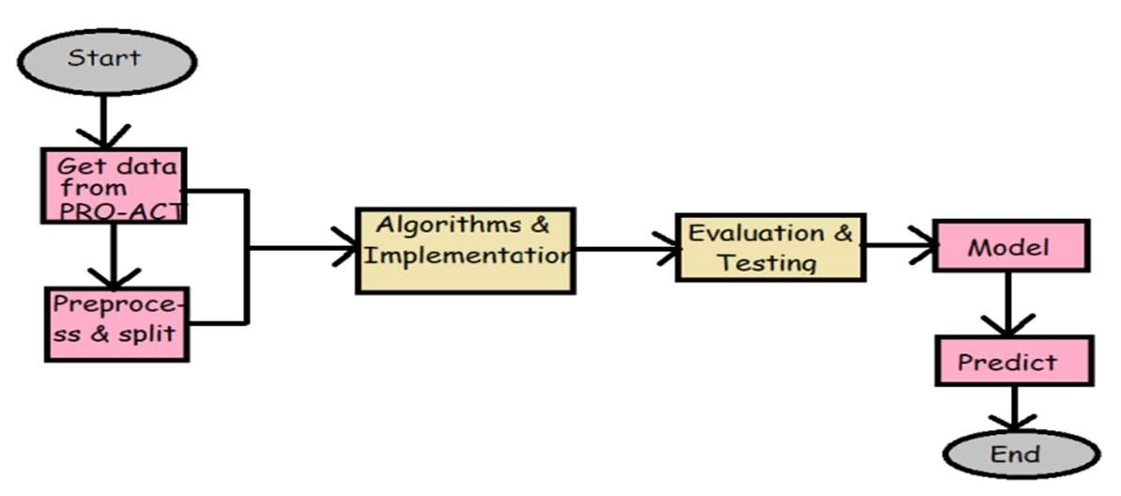

Figure 3 Process Flow Diagram

# **C. Algorithm**

**A. General Algorithm:**

Step-1: Install all the required packages.

Step-2: Import all the libraries required such numpy , pandas ,matplotlib, SVC , etc.

Step-3: Examine the data.

Step-4: Split the data into training and testing sets.

Step-5: Instantiate an Support Vector Machine classifier object with the desired hyper parameters.

Step-6: Train the Support Vector Machine classifier.

Step-7: Use classifier for making Predictions.

Step-8: Evaluate the model like finding accuracy, precision, recall and f1-score.

Step-9: Create Graphical User Interface.

**B. Training Algorithm:**

Step-1: Split the data into training and testing sample.

Step-2: Ratio considered here is 67: 33. Step-3: Take Number of epochs = 42

Step-4: Give the training data as the inputs. Step-5: Call the built model

## **IV Results and Discussion**

The Output obtained in this project is shown in this section. The project was successfully executed using support vector machine. After the data has been entered, the learned model will execute the program and give the predicted output. using the Support Vector Machine model, and classify based on features.

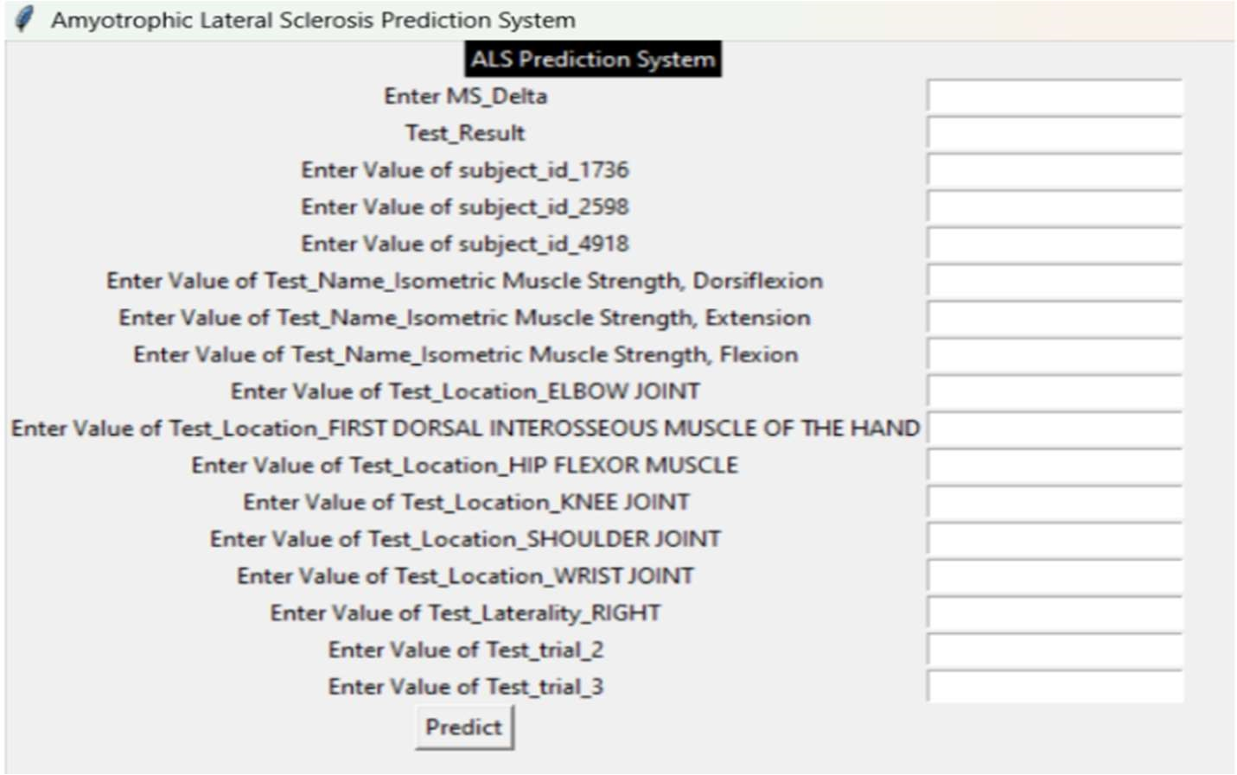

Figure 4 User Interface for predicting

The Figure 6.1 shows the GUI image produced on execution. Now the user should provide testing data and click on predict button All the set modules were implemented one after the other to obtain the correct output.

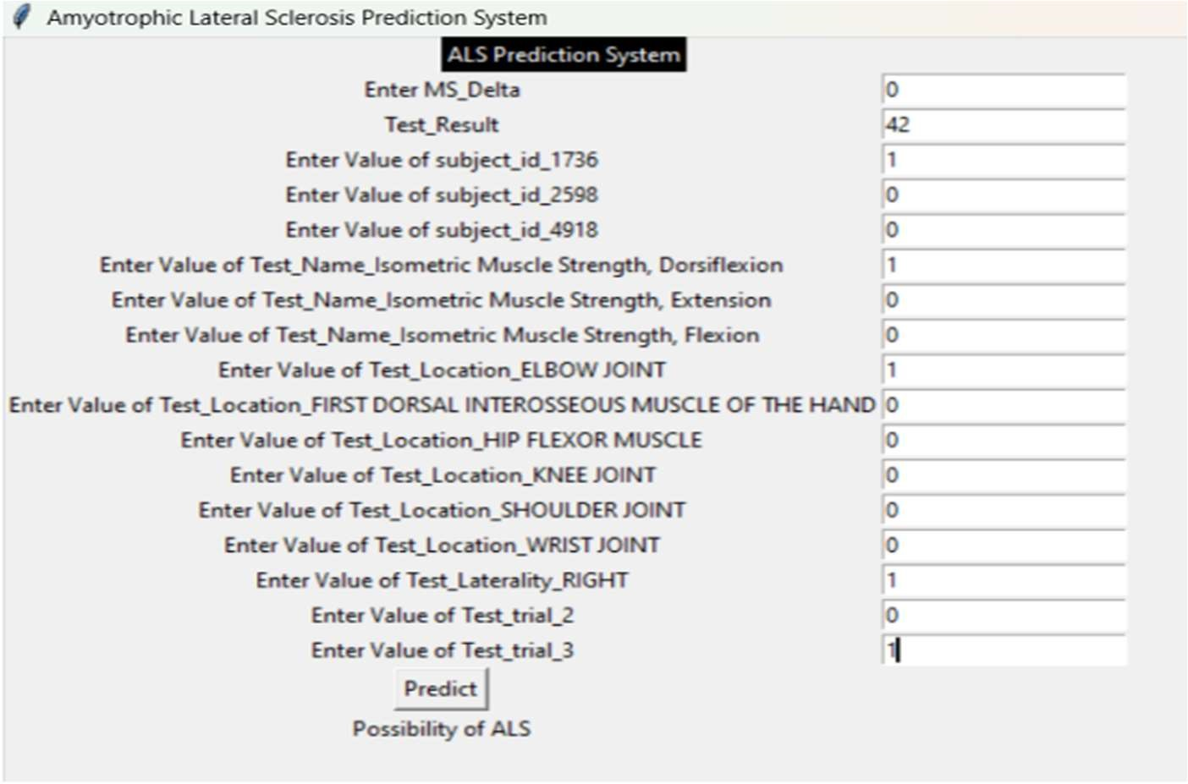

Figure 5 Output Image for the project

The Fig 5 Describes about Output Image for the project. In the above figure the proposed system predicts ALS and shows output as “Possibility of ALS” that means the patient with given data may have Amyotrophic Lateral Sclerosis.

This way the accuracy of the whole model is detected with good efficiency. A machine learning model’s efficiency and quality are assessed using performance measures. These metrics offer quantitative metrics that evaluate how well the model is working with specific task or dataset. Common metrics are Accuracy, Precision score, Recall, f1-score and AUC-ROC.

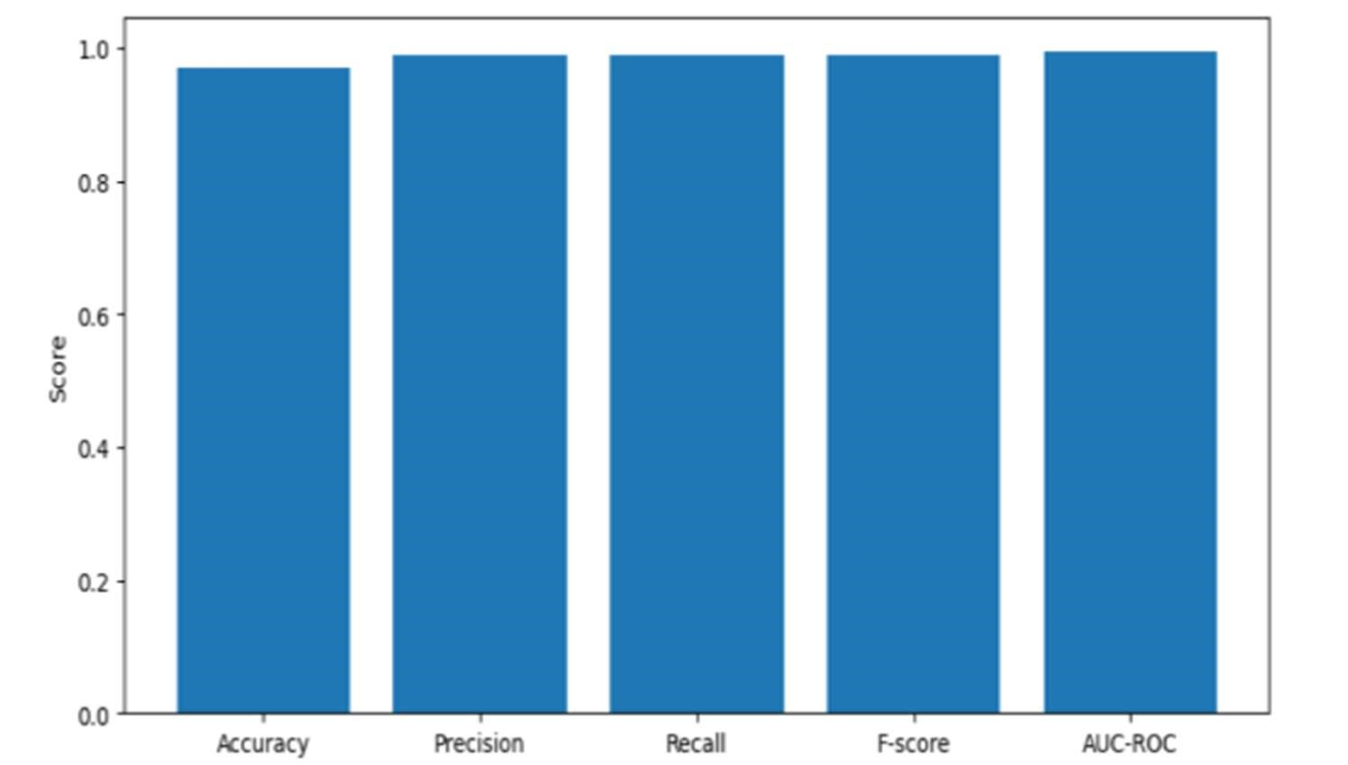

Figure 6 Plotting a graph of performance metrics

Fig 6 shows the graph between Accuracy, Precision, Recall, F-score and auc-roc scores.

## **V. Conclusions**

Patients with the dangerous condition known as Amyotrophic Lateral Sclerosis are helped by this project. In comparison to other models, the accuracy offered when utilising this model and learning procedures is high. Our initiative assists patients in beginning treatment by identifying the condition that causes Amyotrophic Lateral Sclerosis in its early stages.

## **VI Acknowledgments**

The research described in this paper was supported by the Velagapudi Ramakrishna Siddhartha Engineering College Vijayawada.

## **VII Conflict of Interest**

Future work of Amyotrophic Lateral Sclerosis can be done on using unsupervised Machine Learning and Ensemble Machine Learning Techniques which makes good accuracy and better predicted results to check whether applicant can suffering from Amyotrophic Lateral Sclerosis or not at early stages.

**VIII References**

[1]Anna Behler,Hans-Peter Muller,Albert C.Ludolph and Jan Kassubek " Diffusion Tensor Imaging in Amyotrophic Lateral Sclerosis: Machine Learning for Biomarker Development " Diffusion Tensor Imaging in Amyotrophic LateralSclerosis:Machine Learning for Biomarker Development" Int.J.Mol.Sci. 2023,24(3),1911;https://doi.org/10.3390/ijms24031911.

[2]Kristin J.Teplansky,Alan Wisler, Jordan R. Green, Daragh Heitzman, Sara Austin and Jun Wang "Measuring Articulatory Patterns in Amyotrophic Lateral Sclerosis Using a Data-Driven Articulatory Consonant Distinctiveness Space Approach" 2023,Journal of Speech, Language, and Hearing Research.

[3]Fırat Orhanbulucu & Fatma Latifoglu "Detection of amyotrophic lateral sclerosis disease from event-related potentials using variational mode decomposition method" 2022,Computer Methods in Biomechanics and BiomedicalEngineering,8https://doi.org/10.1080/10255842.2021.1983803.

[4]Koji Fukushima , Naoko Takamatsu , Yuki Yamamoto , Hiroki Yamazaki , Takeshi Yoshida , Yusuke Osaki , Shotaro Haji , Koji Fujita, Kazuma Sugie , Yuishin Izumi "Early diagnosis of amyotrophic lateral sclerosis based on fasciculations in muscle ultrasonography: A machine learning approach" August 2022, Clinical Neurophysiology ScienceDirect.

[5]Ernesto Iadanza,Rachele Fabbri,Francesco Goretti , Giovanni Nardo, Elena Niccolai ,Caterina Bendotti,Amedeo Amedei "Machine learning for analysis of gene expression data in fast- and slow-progressing amyotrophic lateral sclerosis murine models" 2022,Biocybernetics and Biomedical Engineering.

[6]Alberto Tena , Francesc Claria, Francesc Solsona and Monica Povedano "Detecting Bulbar Involvement in Patients with Amyotrophic Lateral Sclerosis Based on Phonatory and TimeFrequency Features" 2022 MDPI Sensors.

[7]Fernando G.Vieira ,Subhashini Venugopalan,Alan S. Premasiri, Maeve McNally, Aren Jansen, Kevin McCloskey , Michael P. Brenner and Steven Perrin proposed “A machine-learning based objective measure for ALS disease severity” vol.45, Issue.4173,Nature,2022,n.p.j digital medicine.

[8]Faraz Faghari, Fabian Brumn, Anant Dadu, PARALS consortium, ERRALS consortium Elisabetta Zucchi, Ilaria Martinelli, Letizia Mazzini, Rosario Vasta, Antonio Canosa, Cristina Moglia,Andrea Calvo, Michael A Nalls, Roy H Campbell,Jessica Mandrioli†, Bryan J Traynor†, Adriano Chio† "Identifying and predicting amyotrophic lateral sclerosis clinical subgroups: a population-based machine-learning study"Volume 4, Issue E359-E369,2022,Lancet digit health.

[9]Margarida Antunes,Duarte Folgado,Marília Barandas,André Carreiro,Carla Quintão,Mamede de Carvalho, Hugo Gamboa "A morphology-based feature set for automated Amyotrophic Lateral Sclerosis diagnosis on surface electromyography" 22 August 2022,Biomedical Signal Processing and Control.

[10]Makarious MB,Leonard HL, Vitale D, et al. GenoML: automated machine learning for genomics. arXiv 2021; published online March 4.https://arxiv.org/abs/2103.03221v1 (preprint).

[11]Jennifer L. Chapin,Lauren Tabor Gray,Terrie Vasilopoulos,Amber Anderson,Lauren DiBiase,Justine Dallal York,Raele Robison,James Wymer,Emily K. Plowman "Diagnostic utility of the amyotrophic lateral sclerosis Functional Rating Scale—Revised to detect pharyngeal dysphagia in individuals with amyotrophic lateral sclerosis" 2020,Public Library of Science (PLOS).

[12]Grollemund V, Chat GL, Secchi-Buhour MS, et al. Development and validation of a 1-year survival prognosis estimation model for amyotrophic lateral sclerosis using manifold learning algorithm UMAP. Sci Rep 2020; 10: 13378.

[13]Kaji R, Imai T, Iwasaki Y, Okamoto K, Nakagawa M, Ohashi Y, et al. Ultra-high-dose methylcobalamin in amyotrophic lateral sclerosis: a long-term phase II/III randomized controlled study. J Neurol Neurosurg Psychiatry 2019;90:451–7.https://doi.org/10.1136/jnnp-2018-319294.

[14]Kueffner R, Zach N, Bronfeld M, et al. Stratification of amyotrophic lateral sclerosis patients: a crowdsourcing approach. Sci Rep 2019; 9: 690.