K.Kavya
2503B09914
MCA

Set 1
- Q1. Write a Python function to calculate the factorial of a number. Use a coding assistant and document how you refine your prompt to ensure the function handles negative input and zeros.
(Each question carries 5 marks)
- Q2. Given a list of student marks, compute the mean and list all students above the mean. Demonstrate zero-shot, one-shot, and few-shot prompts to guide an AI tool to solve this. Summarize the differences in approach.
(Each question carries 5 marks)
Code: Q1
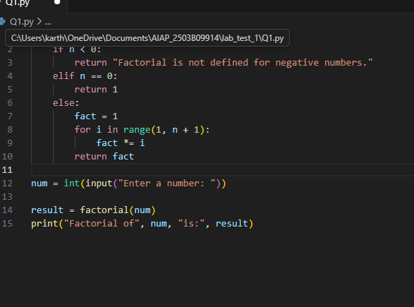
Output:
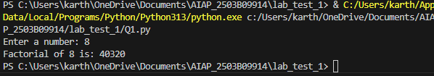

Code:Q2
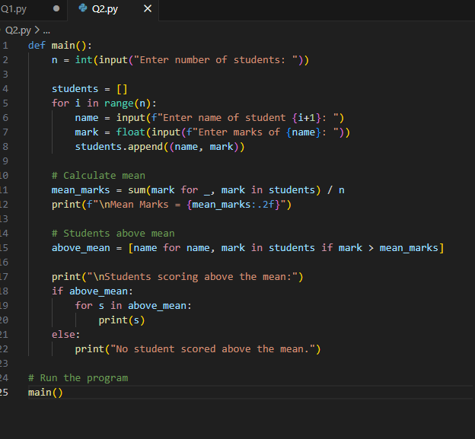
Output:
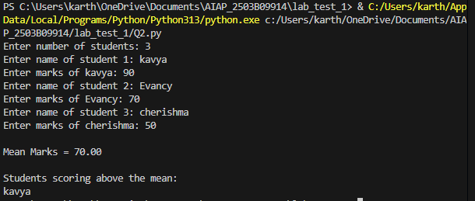

Explanation:
Zero-Shot Prompt:
One-Shot Prompt:How the AI behaves:
It interprets the instruction directly and produces an answer, but the format and logic may vary because no examples define how to respond.
Zero-Shot Prompt:
How the AI behaves:
It now has one pattern to follow. The output is usually more consistent with the example.
Few-Shot Prompt:
How the AI behaves:
With two examples, the model understands the format, tone, steps, and expected structure, giving highly accurate and consistent results.

