Lab assesment.3

Build a python application as per below instructions
- Read all the required data like PU,CU and Type of customer
- Calculate bill amount based on number of units consumed, type of customer and other charges
- Finally print the values of EC(Energy Charges),FC(Fixed Charges),CC(Customer Char-ges),ED(Electricity Duty Charges),bill as per expected output

Requirements:
- VS Code with Github Copilot and/or Google Colab with Gemini
- Students should bring power bill from their home
Deliverables:
- Print energy bill for given inputs and verify with bill taken by students

Prompt:
Generare a code for energy bill of student and verify bill by printing ,calculating its energy charges,fixed charges,customer charges for output.

CODE:

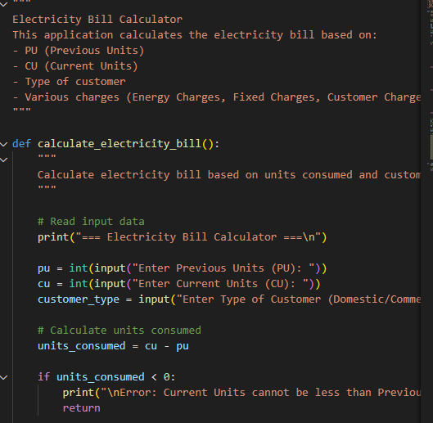

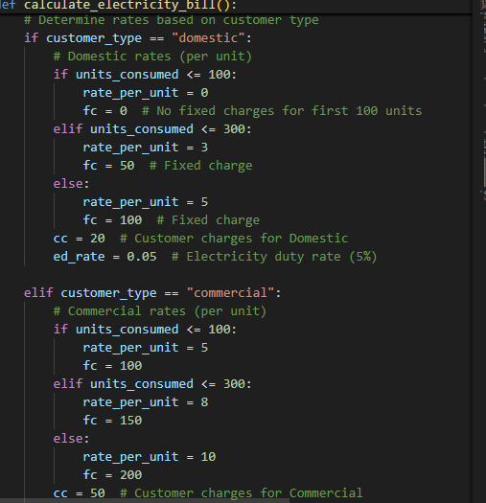

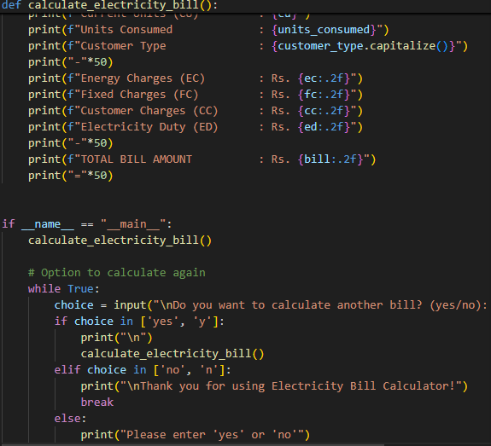

Output:
