Lab 2: Exploring Additional AI Coding Tools – Gemini (Colab) and Cursor AI

Task Description#1
- Use Google Gemini in Colab to write a function that reads a CSV file and calculates mean, min, max.
Expected Output#1
- Functional code with output and screenshot

Prompt:
Generate a function that reads a csv file and calculate mean,min,max.

CODE:
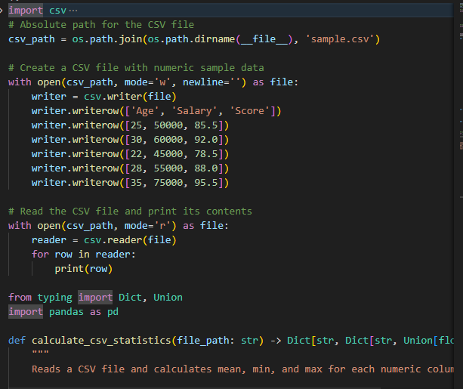

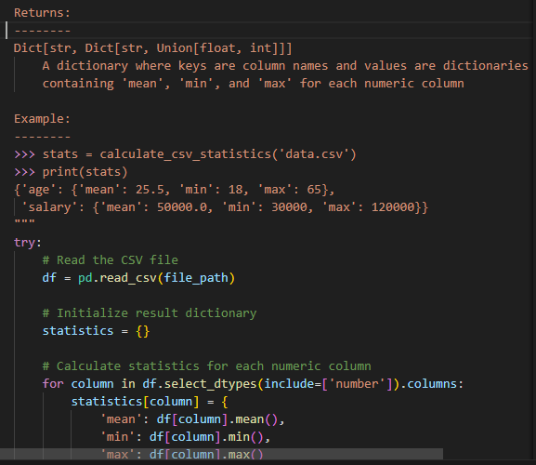
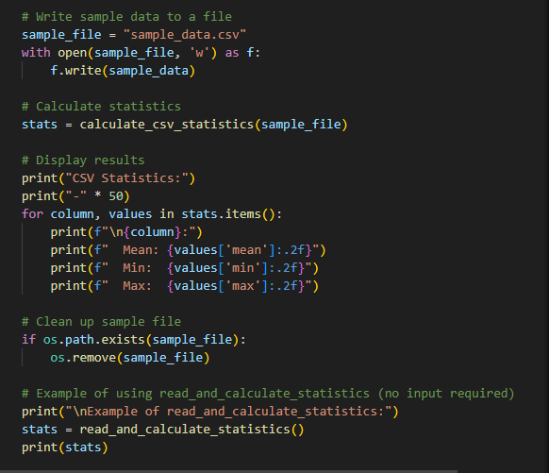

Output:
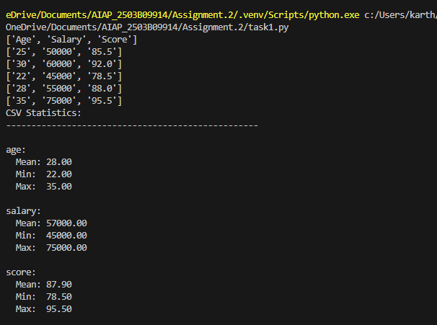
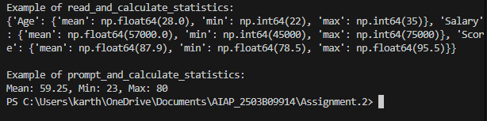

Task Description#2
- Compare Gemini and Copilot outputs for a palindrome check function.
Expected Output#2
- Side-by-side comparison and observations

Prompt:
Generate a palindrome function to compare gemini and copilot output.

CODE:
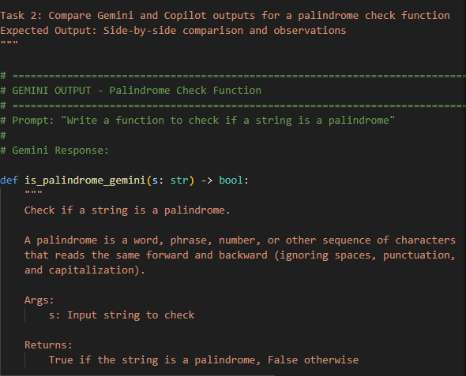
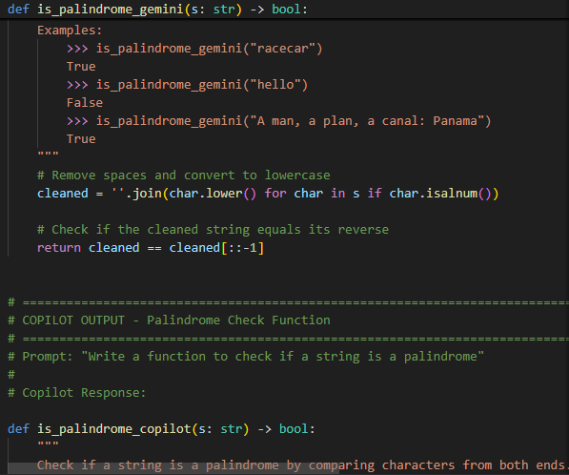

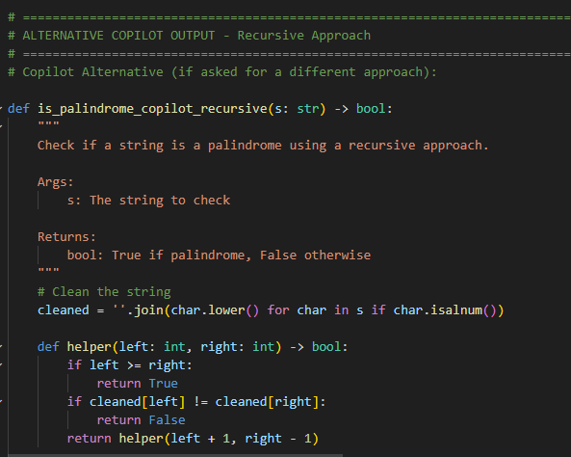
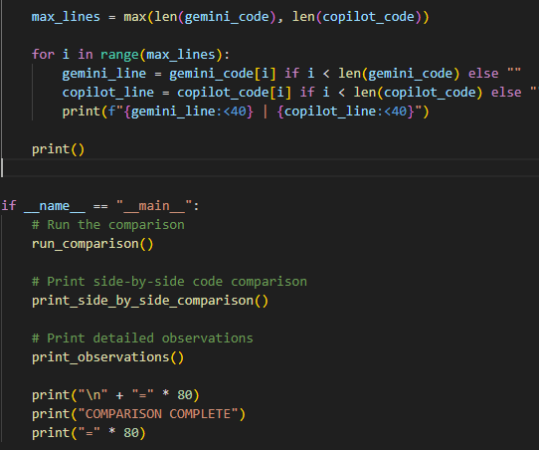

Output:
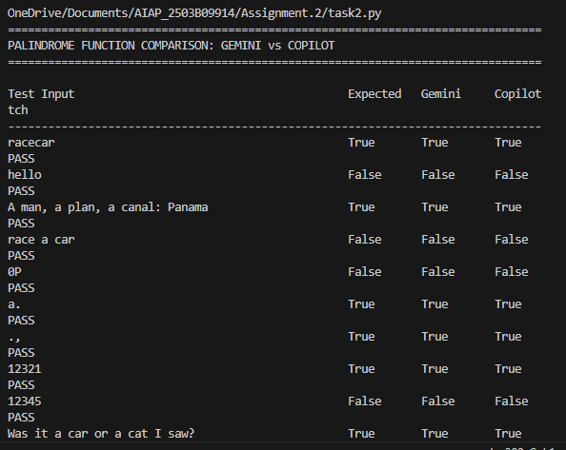
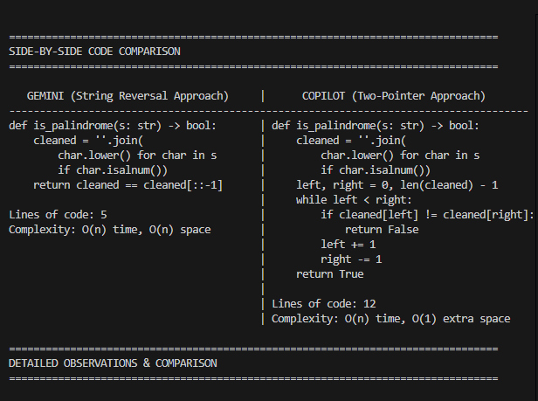

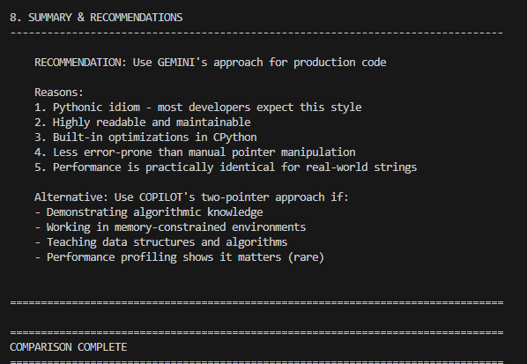

Task Description#3
- Ask Gemini to explain a Python function (to calculate area of various shapes) line by line..
Expected Output#3
- Detailed explanation with code snippet.

Prompt:
Generate a fuction in python to calculate area of various shapes.

CODE:

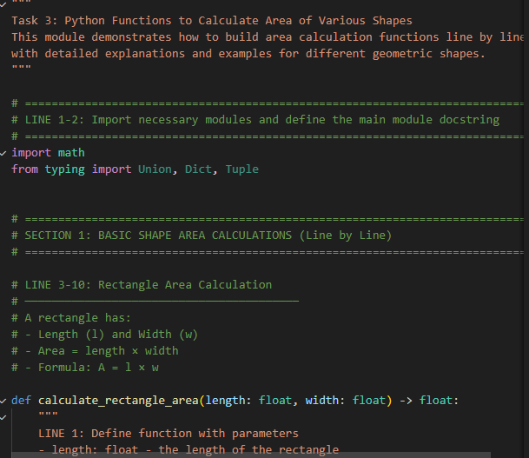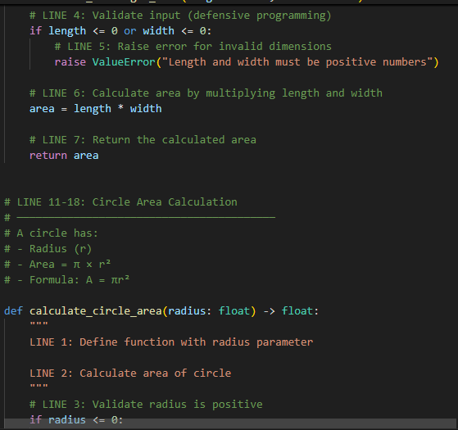

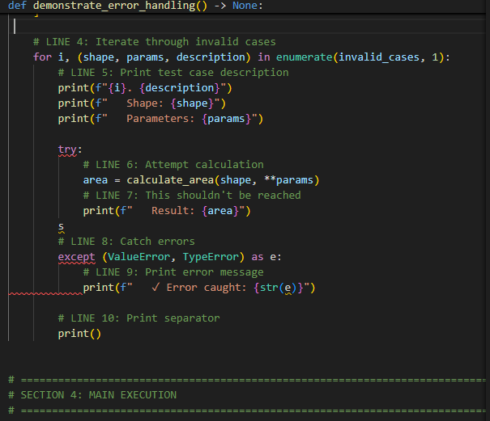

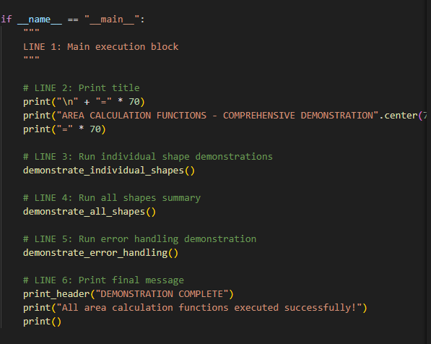

Output:
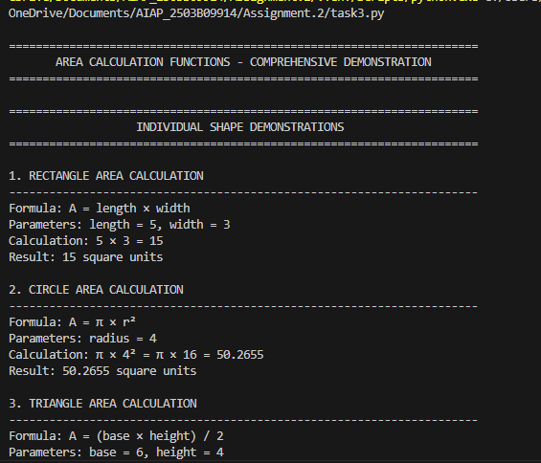

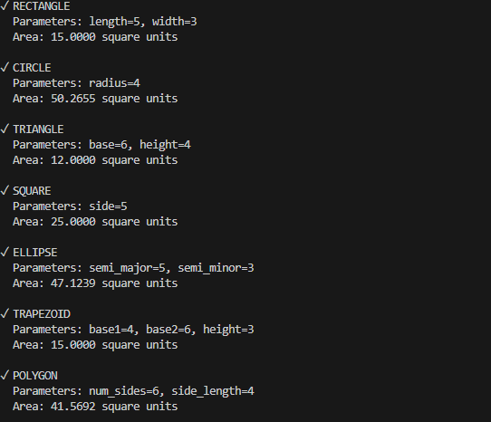

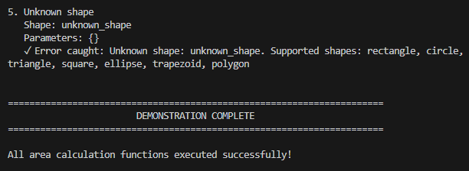

Task Description#4
- Install and configure Cursor AI. Use it to generate a Python function (e.g., sum of squares).
Expected Output#4
- Screenshots of working environments with few prompts to generate python code

Prompt:

Generate a function in python like sum of squares.

CODE:

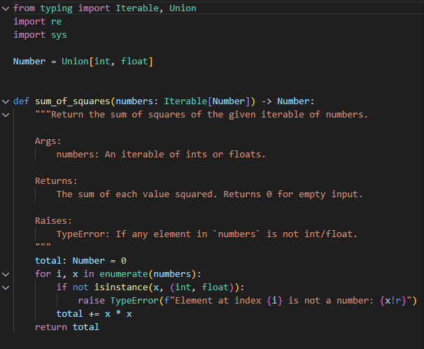

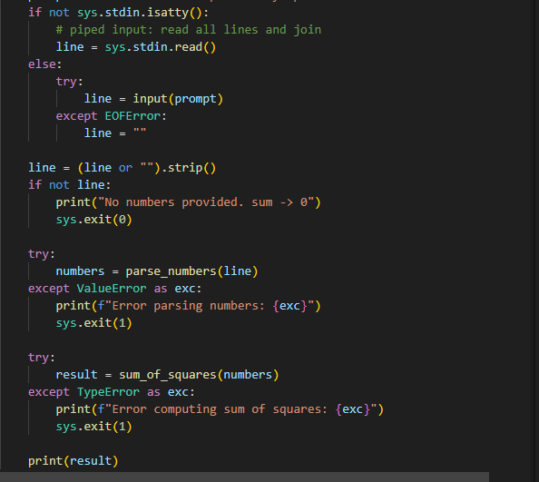

Output:
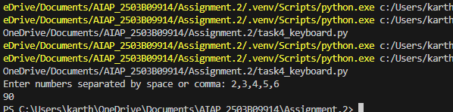

Task Description#5
- Student need to write code to calculate sum of add number and even numbers in the list
Expected Output#5
- Refactored code written by student with improved logic

Prompt:

Generate a code to calculate sum of odd number and even numbers in the list

CODE:

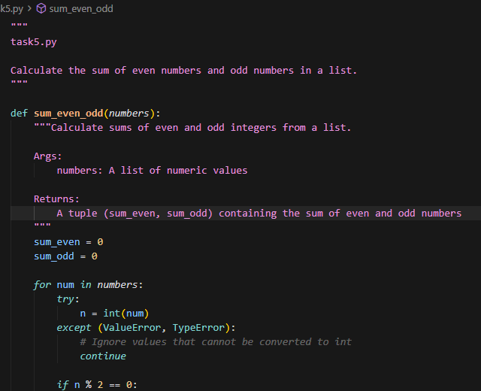

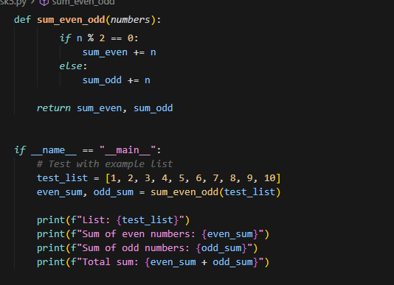

Output:
