Lab 4: Advanced Prompt Engineering – Zero-shot, One-shot, and Few-shot Techniques

Task Description#1
- Zero-shot: Prompt AI to write a function that checks whether a given year is a leap year.
Expected Output#1
- AI-generated function with no examples provided

Prompt:

Generate a code that checks whether a given year is a leap year or not.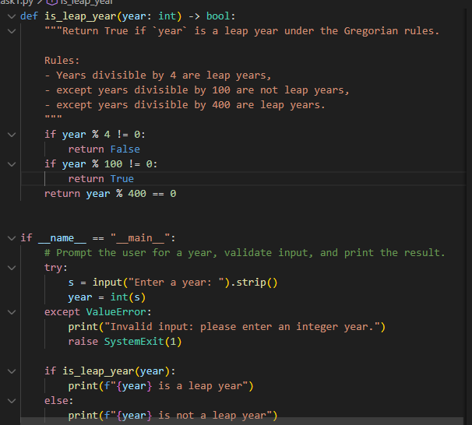

CODE:

Output: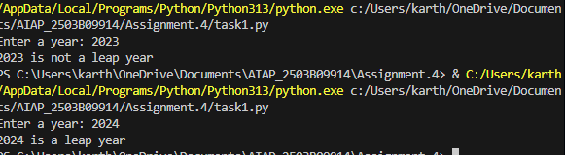

Task Description#2
- One-shot: Give one input-output example to guide AI in writing a function that converts centimeters to inches.
Expected Output#2
- Function with correct conversion logic

Prompt:
Generate a code that converts centimeters to inches.with one example

CODE:

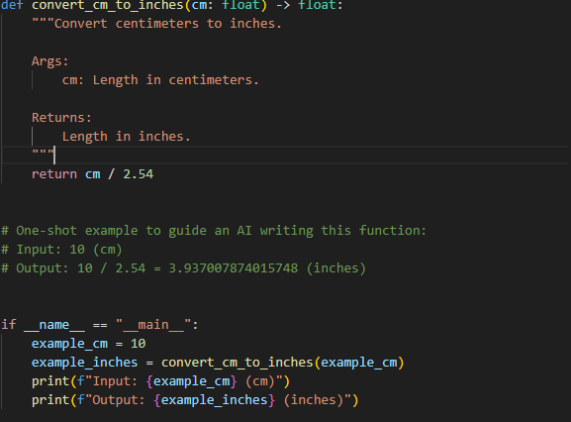

Output:

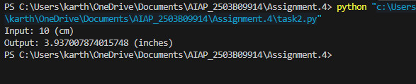

Task Description#3
- Few-shot: Provide 2–3 examples to generate a function that formats full names as “Last, First”.
Expected Output#3
- Well-structured function respecting the examples

Prompt:
Generate a code that can formats full names as “last,first”.

CODE:

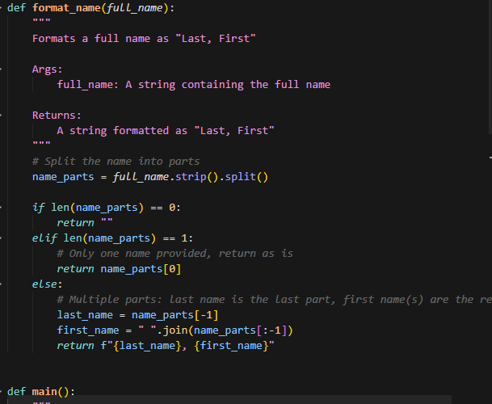

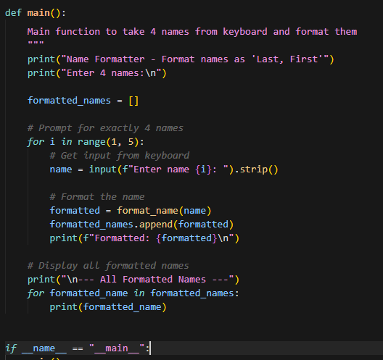

Output:

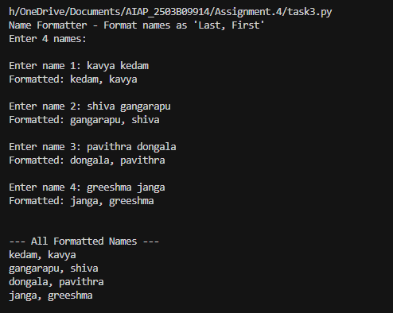

Task Description#4
- Compare zero-shot and few-shot prompts for writing a function that counts the number of vowels in a string.
Expected Output#4
- Functional output and comparative reflection

Prompt:
Generate a code that counts the number of vowels in a string.

CODE:

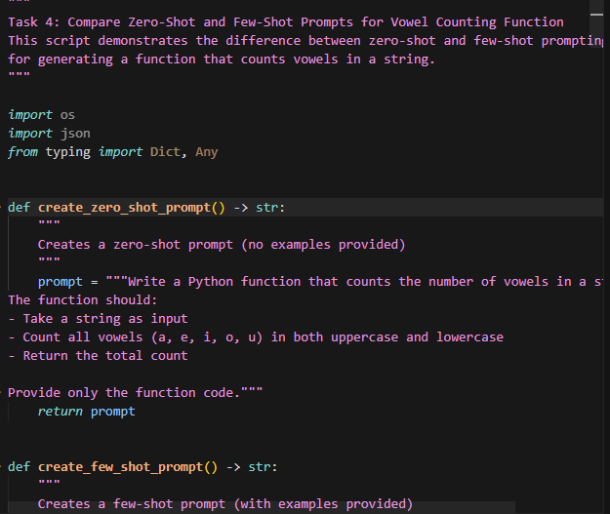

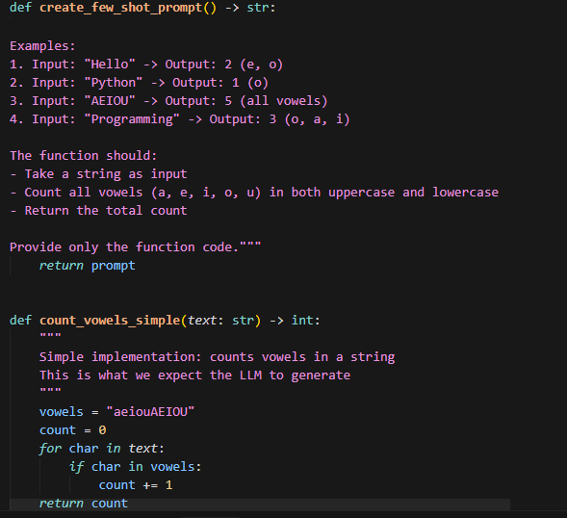

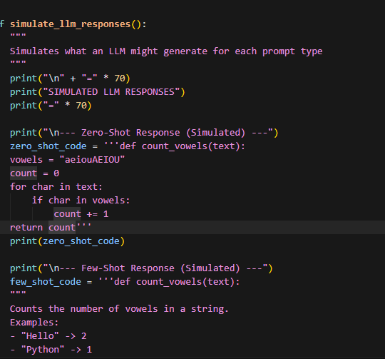

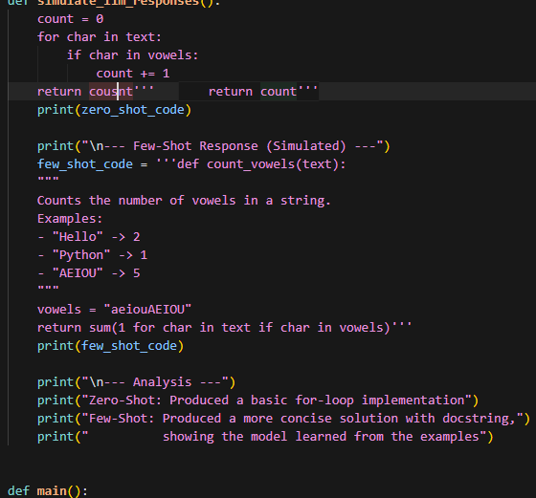

Output:
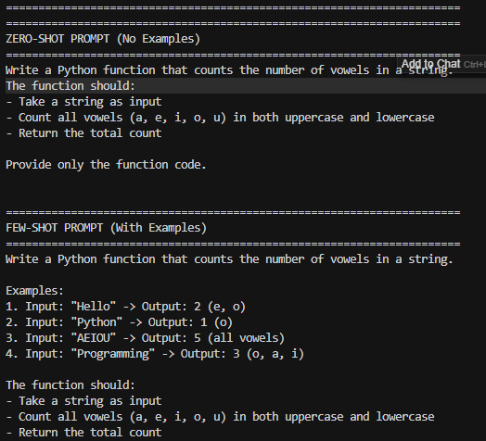

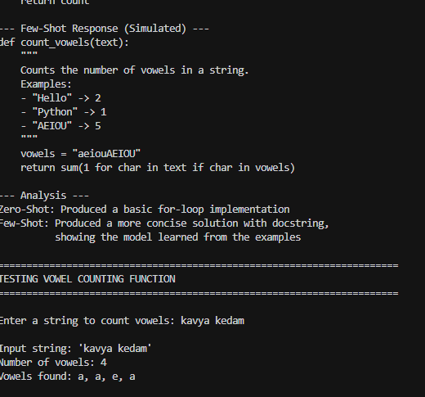
Task Description#5
- Use few-shot prompting to generate a function that reads a .txt file and returns the number of lines.
Expected Output#5
- Working file-processing function with AI-guided logic

Prompt:
Generate a code that reads a text file and returns the number of lines by using few-shot prompting

CODE:
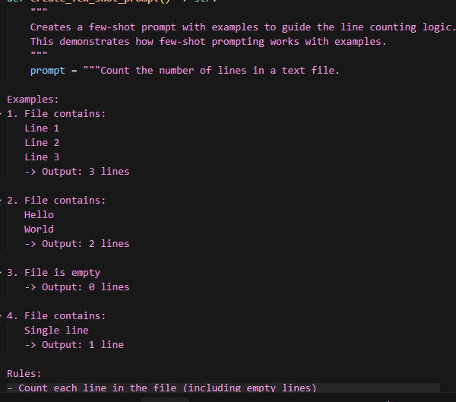

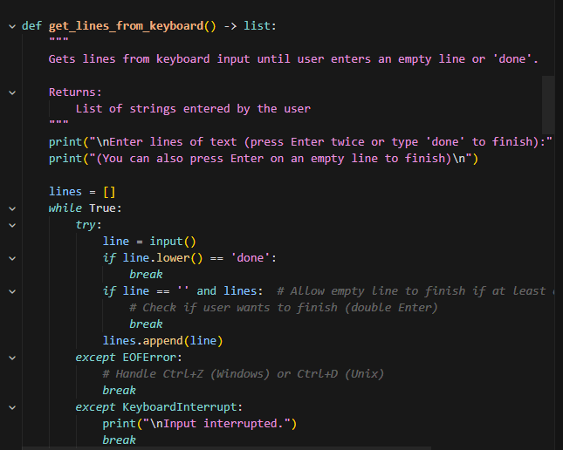

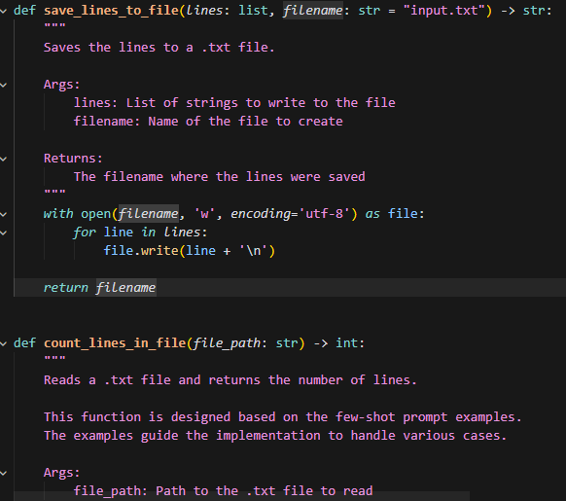

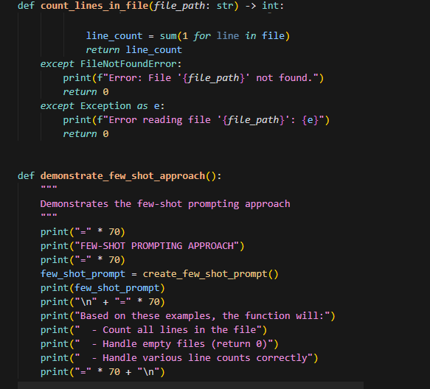

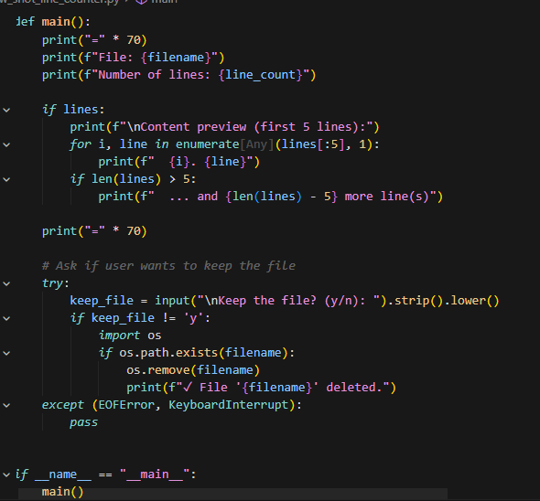

Output:
