AI Assisted Problem Solving Using Python

Name:k.kavya
H.No:2503B09914
Program:MCA

Task Description#2
●Use Copilot to generate a is_prime() Python function.
Expected Output#2
●Function to check primality with correct logic.

Prompt1:
Create a function named is_prime() to check primality.

Prompt2:
Now, update this code where the user can take the input from keyboard.

CODE:
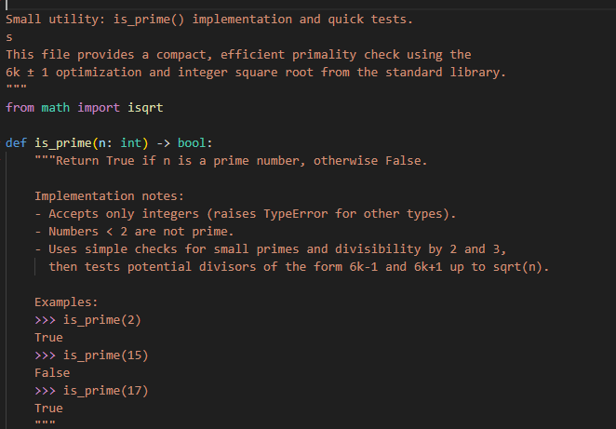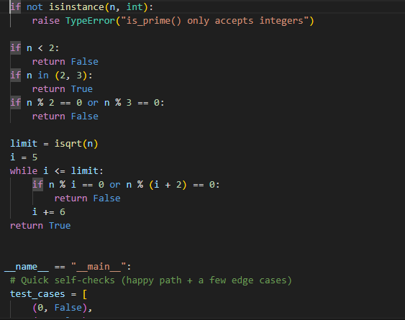

Output:

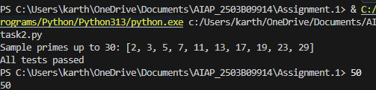

Task Description#3
●Write a comment like # Function to reverse a string and use Copilot to generate the function.
Expected Output#3
●Auto-completed reverse function

Prompt_1:
Create a function to reverse a string and provide the auto completed reverse function output.

CODE:
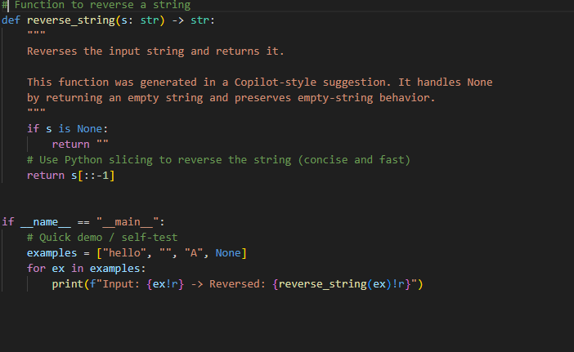

Output:

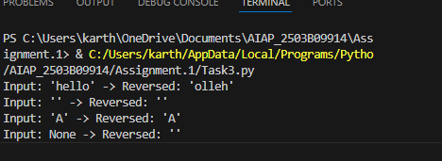

Task Description#4
- Generate both recursive and iterative versions of a factorial function using comments..
Expected Output#4
- Two working factorial implementations

CODE:

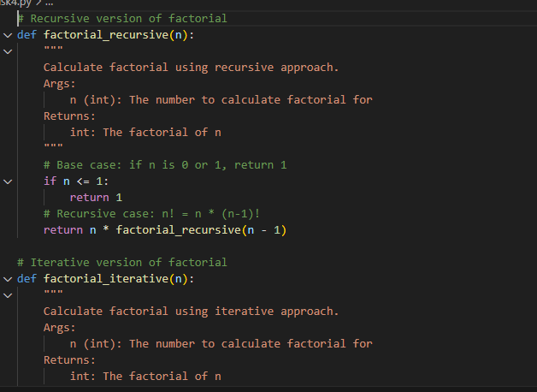

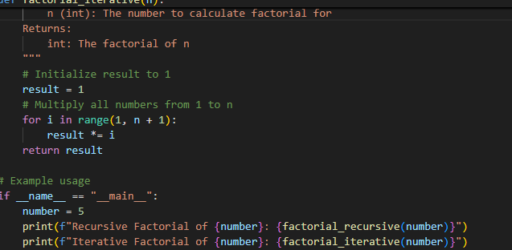

OUTPUT:
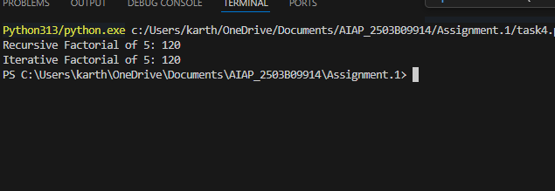

Task Description#5
- Use Copilot to find the largest number in a list. Assess code quality and efficiency.
Expected Output#5
- A valid function with your review

Prompt:
Create a function to find the largest number in a list where the list need to be taken from keyboard.

CODE: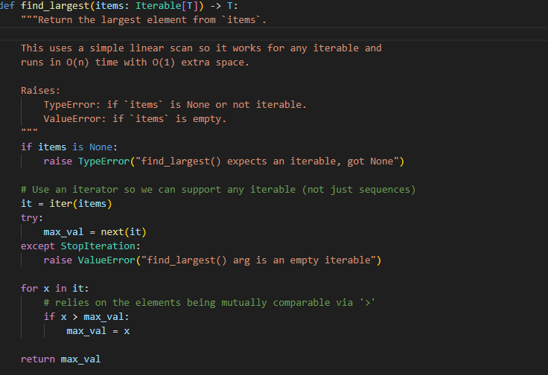

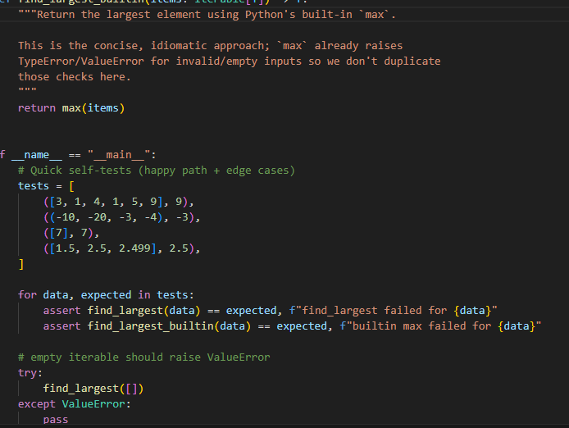

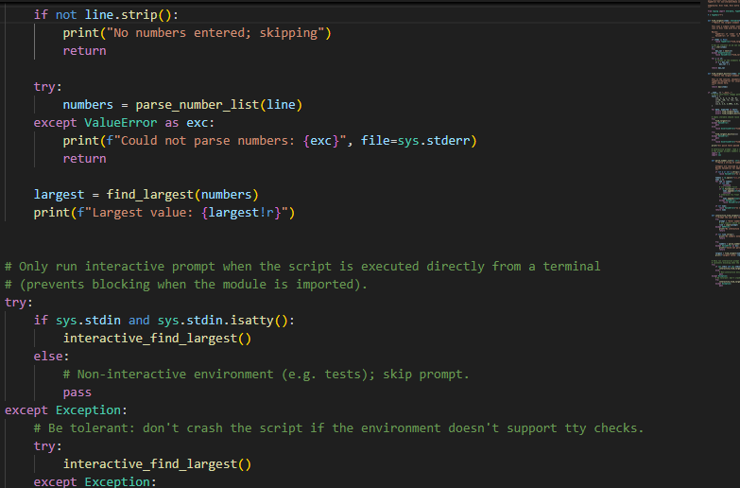

OUTPUT:
