Assignment-9
Lab Task: Round Robin CPU Scheduling (Time Quantum = 3 ms)
A system receives the following processes NOT in arrival order:
Process | Arrival Time (AT) | Burst Time (BT)
P1 | 4 | 7
P2 | 0 | 5
P3 | 6 | 3
P4 | 2 | 9
P5 | 1 | 4
Student Tasks
- Do NOT reorder by arrival time.
Simulate exactly as given.
- Apply Round Robin Scheduling with Time Quantum = 3 ms.
- Draw the complete Gantt Chart.
- Compute for each process:
  - Completion Time (CT)
  - Turnaround Time (TAT = CT − AT)
  - Waiting Time (WT = TAT − BT)
- Compute:
  - Average TAT
  - Average WT
- Write a C program that performs RR scheduling.
- Compare your manual result with the program output.

Code:

#include <stdio.h>

typedef struct {
char pid[5];
int at, bt, bt_remaining;
int ct, tat, wt;
int completed;
} Process;

int main() {
int n = 5;
int tq = 3;

Process p[] = {
{"P1", 4, 7, 7, 0, 0, 0, 0},
{"P2", 0, 5, 5, 0, 0, 0, 0},
{"P3", 6, 3, 3, 0, 0, 0, 0},
{"P4", 2, 9, 9, 0, 0, 0, 0},
{"P5", 1, 4, 4, 0, 0, 0, 0}
};

int time = 0, completed = 0;

printf("\nGantt Chart:\n");

while (completed < n) {
int executed_in_cycle = 0;

for (int i = 0; i < n; i++) {
if (p[i].at <= time && p[i].bt_remaining > 0) {
executed_in_cycle = 1;

printf("| %s (%d-%d) ", p[i].pid, time,
(p[i].bt_remaining >= tq ? time + tq : time + p[i].bt_remaining));

if (p[i].bt_remaining > tq) {
time += tq;
p[i].bt_remaining -= tq;
} else {
time += p[i].bt_remaining;
p[i].bt_remaining = 0;
p[i].ct = time;
p[i].completed = 1;
completed++;
}
}
}

if (!executed_in_cycle) {
int next_time = 100000;

for (int i = 0; i < n; i++) {
if (p[i].bt_remaining > 0 && p[i].at > time) {
if (p[i].at < next_time)
next_time = p[i].at;
}
}
printf("| Idle (%d-%d) ", time, next_time);
time = next_time;
}
}

printf("|\n");

float total_tat = 0, total_wt = 0;

printf("\n%-5s %-5s %-5s %-5s %-5s %-5s\n",
"PID", "AT", "BT", "CT", "TAT", "WT");
for (int i = 0; i < n; i++) {
p[i].tat = p[i].ct - p[i].at;
p[i].wt = p[i].tat - p[i].bt;

total_tat += p[i].tat;
total_wt += p[i].wt;

printf("%-5s %-5d %-5d %-5d %-5d %-5d\n",
p[i].pid, p[i].at, p[i].bt, p[i].ct, p[i].tat, p[i].wt);
}

printf("\nAverage TAT = %.2f", total_tat / n);
printf("\nAverage WT = %.2f\n", total_wt / n);

return 0;
}

Output:
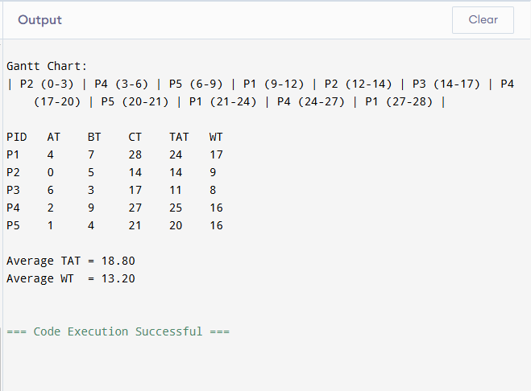

Round Robin exactly with arrival times
Time Quantum fixed as 3 ms
Prints full Gantt Chart
Computes:Completion Time (CT)
Turnaround Time (TAT)
Waiting Time (WT)
Computes Average TAT and Average WT

