Assignment 8

Q1. A process is a program in execution. In real CPU scheduling, processes do not always arrive at the same time.
The First Come First Serve (FCFS) algorithm schedules processes in order of arrival time.
Requirements:
- The program should accept:
  - Number of processes
  - Arrival Time (AT)
  - Burst Time (BT)
- The program must sort the processes in ascending order of arrival time.
- The CPU may become idle if the next process arrives later. Your logic must correctly handle idle time.
- Calculate for each process:
  - Completion Time (CT)
  - Turnaround Time (TAT = CT – AT)
  - Waiting Time (WT = TAT – BT)
- Display the result in a formatted table and print:
  - Total TAT and WT
  - Average TAT and WT
- Use non-preemptive FCFS.
Given System State
Consider the following processes:
Process | Arrival Time | CPU Burst Time
P1 | 2 | 4
P2 | 1 | 3
P3 | 0 | 1
P4 | 3 | 2

CODE:

#include <iostream>
#include <algorithm>
using namespace std;
struct Process { string pid; int at, bt; int ct, tat, wt; };
int main() { Process p[100]; int n;
cout << "Enter number of processes: ";
cin >> n;

for(int i = 0; i < n; i++) {
cout << "Enter Process ID: ";
cin >> p[i].pid;
cout << "Arrival Time: ";
cin >> p[i].at;
cout << "Burst Time: ";
cin >> p[i].bt;
}

// Sort by Arrival Time
sort(p, p + n, [](Process a, Process b) {
return a.at < b.at;
});

int time = 0;
int totalTAT = 0, totalWT = 0;

for(int i = 0; i < n; i++) {

// CPU idle if next process arrives later
if(time < p[i].at)
time = p[i].at;

time += p[i].bt;
p[i].ct = time;
p[i].tat = p[i].ct - p[i].at;
p[i].wt = p[i].tat - p[i].bt;

totalTAT += p[i].tat;
totalWT += p[i].wt;
}

cout << "\nFCFS Scheduling Result:\n";
cout << "PID\tAT\tBT\tCT\tTAT\tWT\n";
for(int i = 0; i < n; i++)
cout << p[i].pid << "\t" << p[i].at << "\t" << p[i].bt << "\t"
<< p[i].ct << "\t" << p[i].tat << "\t" << p[i].wt << "\n";

cout << "\nTotal TAT = " << totalTAT;
cout << "\nTotal WT = " << totalWT;
cout << "\nAverage TAT = " << (float)totalTAT/n;
cout << "\nAverage WT = " << (float)totalWT/n;

}

OUTPUT:
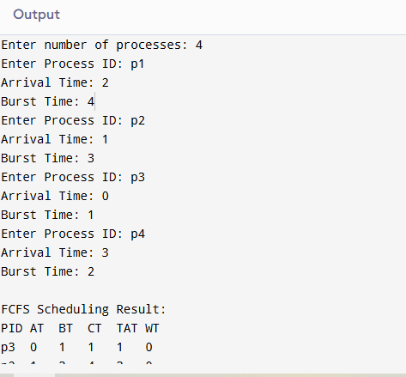
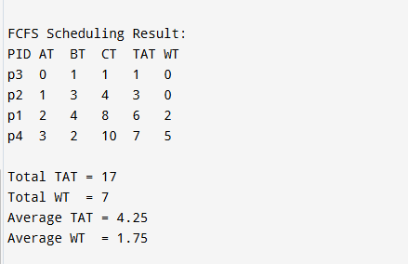

2.Assignment Question: Implement SJF (Shortest Job First) Scheduling Algorithm
A process is a program in execution. CPU scheduling determines which process gets the CPU next.
The Shortest Job First (SJF) algorithm selects the process with the smallest CPU burst time next.
SJF can be:
- Non-preemptive → process runs until completion
- Preemptive (SRTF) → process may be interrupted if a new shorter job arrives
In this assignment, consider Non-preemptive SJF.

Problem Statement
Given the following processes:
Process | Arrival Time | CPU Burst Time
P1 | 0 | 8
P2 | 1 | 4
P3 | 2 | 9
P4 | 3 | 5
Task:
Implement the Non-Preemptive SJF Scheduling Algorithm to calculate:
- Completion Time (CT)
- Waiting Time (WT)
- Turnaround Time (TAT)
- Average Waiting Time
- Average Turnaround Time
- Gantt Chart
CODE:
#include <iostream>
#include <vector>
#include <algorithm>
using namespace std;

struct Process {
string pid;
int at, bt;
int ct, wt, tat;
bool completed;
};

int main() {
vector<Process> p = {
{"P1", 0, 8, 0, 0, 0, false},
{"P2", 1, 4, 0, 0, 0, false},
{"P3", 2, 9, 0, 0, 0, false},
{"P4", 3, 5, 0, 0, 0, false}
};

int n = p.size();
int completed = 0, current_time = 0;
float avgWT = 0, avgTAT = 0;

vector<string> ganttChart;

while (completed != n) {
int idx = -1;
int mn = 1e9;

// Find process with minimum BT among arrived and not completed
for (int i = 0; i < n; i++) {
if (p[i].at <= current_time && !p[i].completed) {
if (p[i].bt < mn) {
mn = p[i].bt;
idx = i;
}
}
}

if (idx != -1) {
// Execute this process
ganttChart.push_back(p[idx].pid);

current_time += p[idx].bt;
p[idx].ct = current_time;
p[idx].tat = p[idx].ct - p[idx].at;
p[idx].wt = p[idx].tat - p[idx].bt;

p[idx].completed = true;
completed++;
} else {
// CPU idle
current_time++;
ganttChart.push_back("Idle");
}
}

// Print results
cout << "\nProcess\tAT\tBT\tCT\tTAT\tWT\n";
for (auto &pr : p) {
cout << pr.pid << "\t" << pr.at << "\t" << pr.bt << "\t"
<< pr.ct << "\t" << pr.tat << "\t" << pr.wt << endl;

avgWT += pr.wt;
avgTAT += pr.tat;
}

cout << "\nAverage Waiting Time = " << avgWT / n;
cout << "\nAverage Turnaround Time = " << avgTAT / n;

cout << "\n\nGantt Chart:\n";
for (auto &x : ganttChart) cout << x << " | ";
cout << endl;

return 0;
}

OUTPUT:
