MODERN OPERATING SYSTEMS AND COMPUTER NETWORKS
ASSIGNMENT-3
NAME : KAVYA KEDAM
HT.NO : 2503B09914
Program Name: MCA

Task:1
Problem-01:
A bit stream 1101011011 is transmitted using the standard CRC method. The generator polynomial is x4+x+1. What is the actual bit string transmitted?
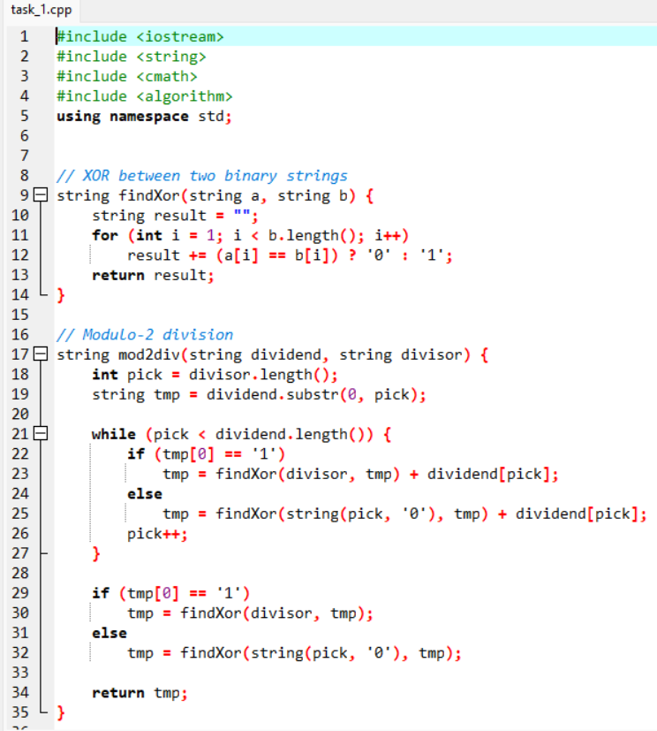
CODE AND COMPLICATION RESULTS:

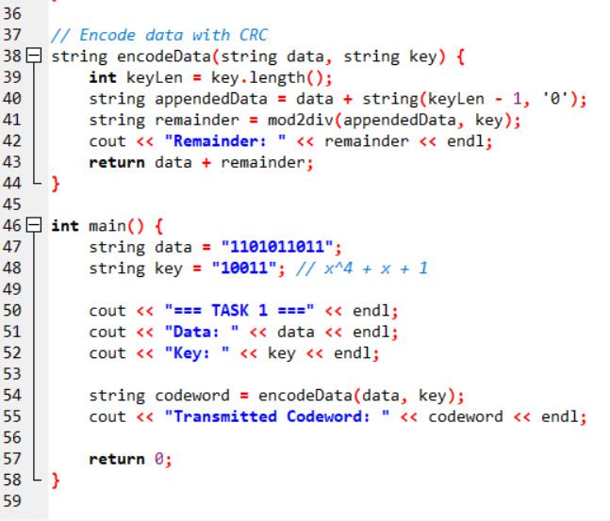
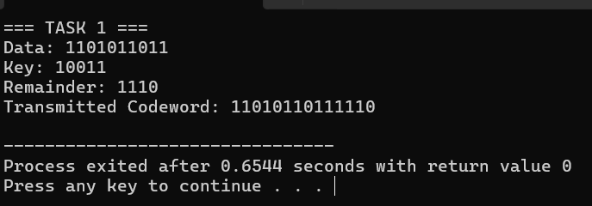
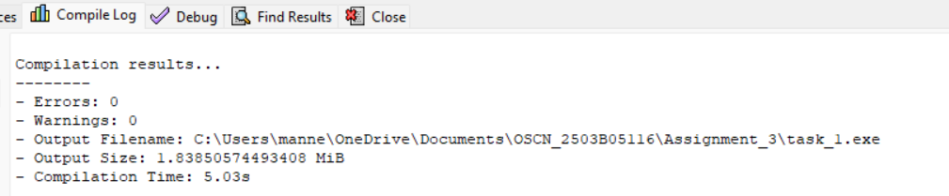

Task:2
Problem-02:
A bit stream 10011101 is transmitted using the standard CRC method. The generator polynomial is x³+1.

- What is the actual bit string transmitted?
- Suppose the third bit from the left is inverted during transmission. How will receiver detect this error?
CODE AND COMPILATION RESULTS:
