**Angular Developer Test**

**I solved the test using angular version 12.2.5**

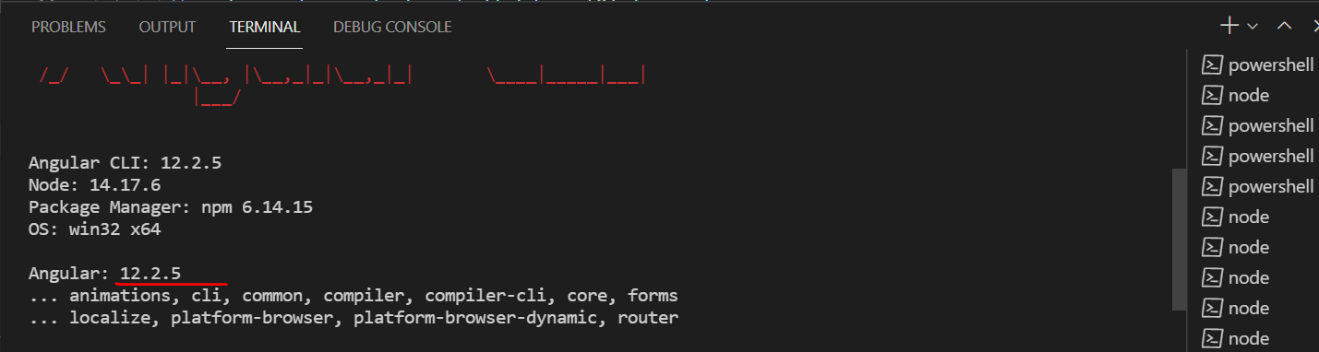

**Have formed below file structure to implement**

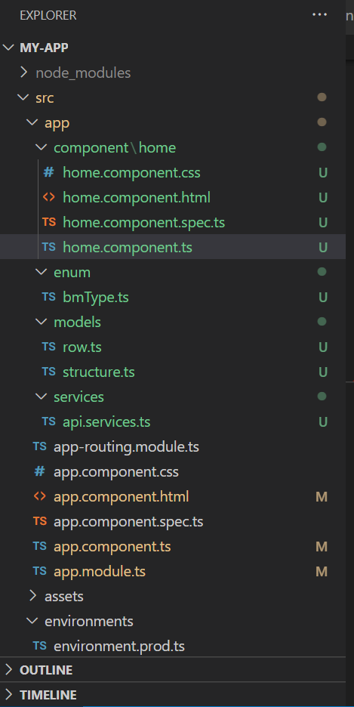

**On running the application, below screen will be displayed – Home page**

**Unique data is displayed on the screen, dint give much preference how it looks (UI) as per the test document.**

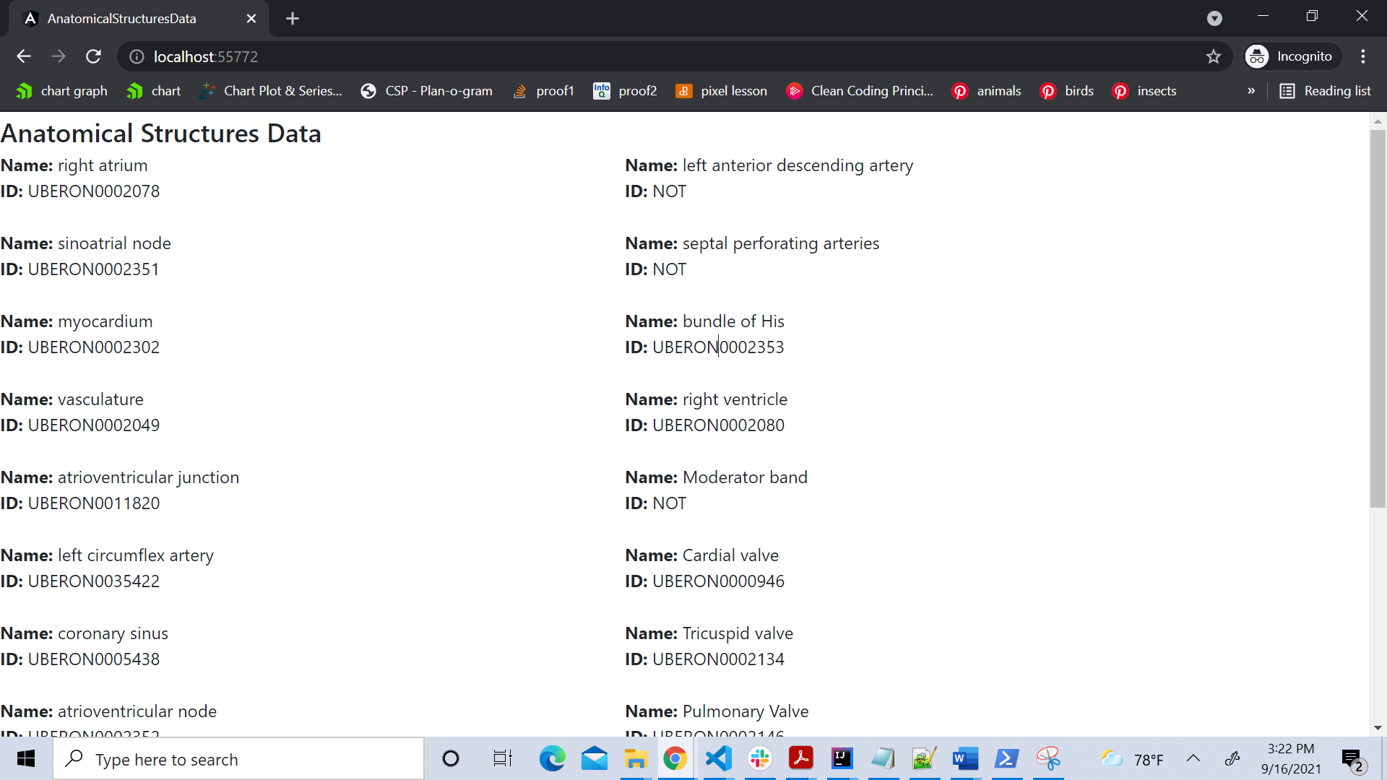

**On click of the data in the home page, appropriate details of it will be viewed in the popup, as below, Close and Ok button is given in the popup as per the document.**

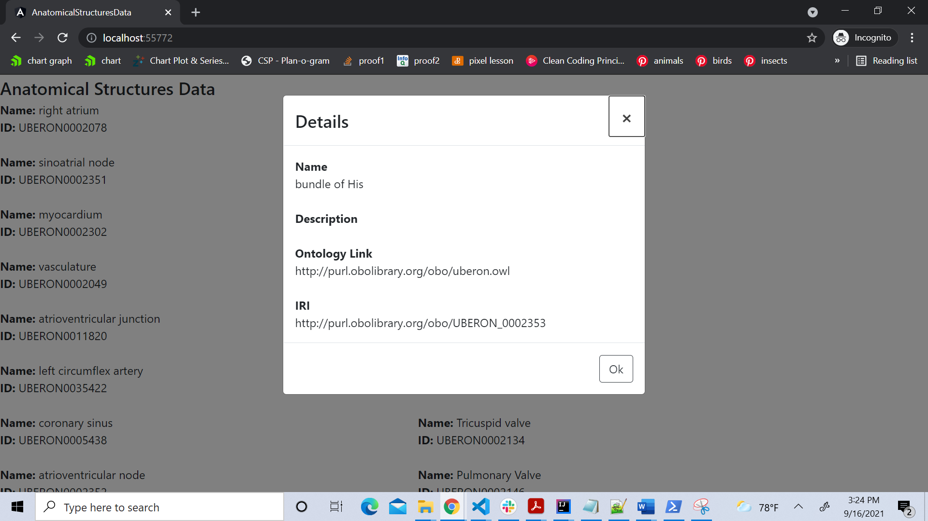

**If ID is not available then, below popup is displayed**

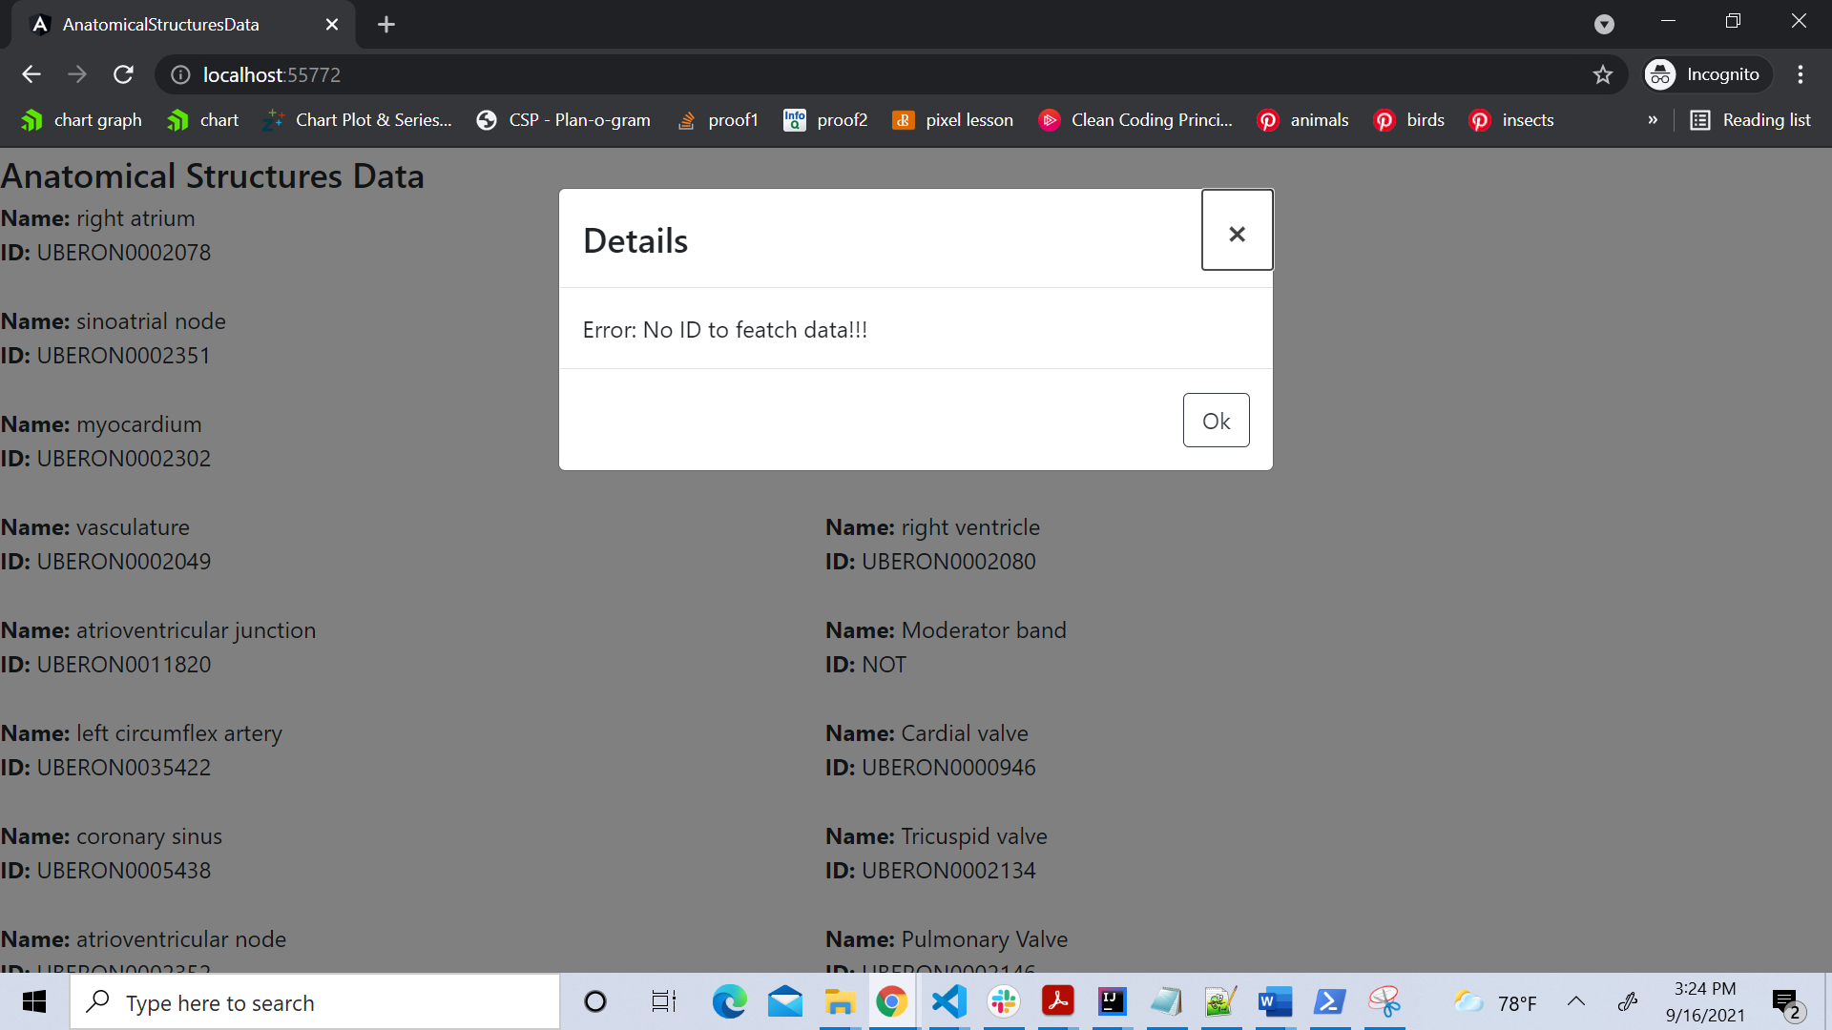

**@Injectible service is used as per the document**

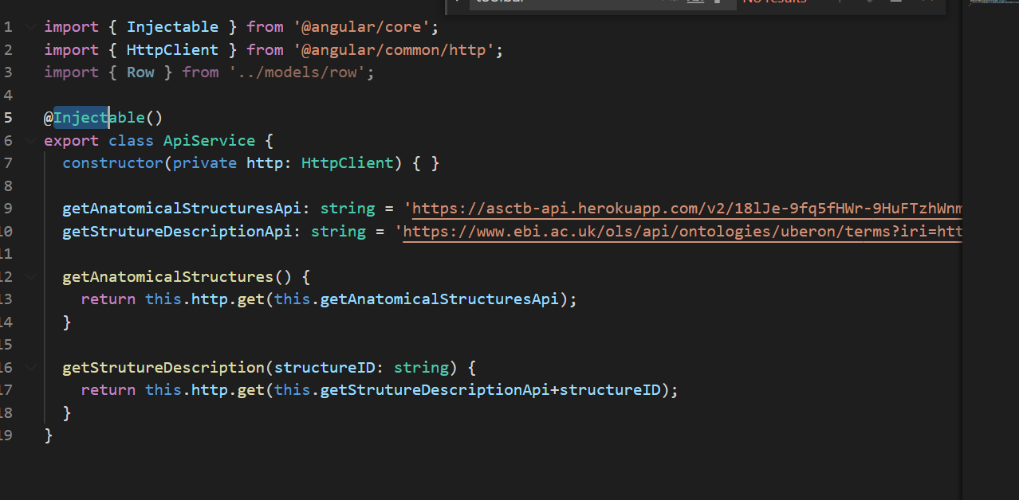

**Defined appropriate interfaces, classes, functions below**

