1. 3 clients connected to the server

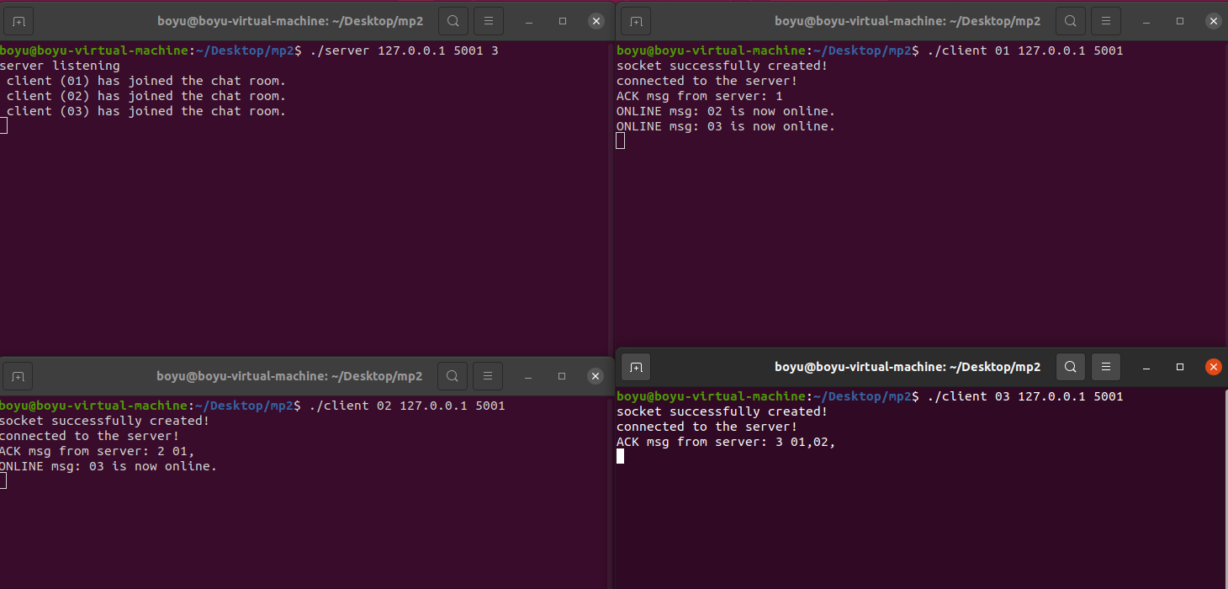

1. Chatting with each other

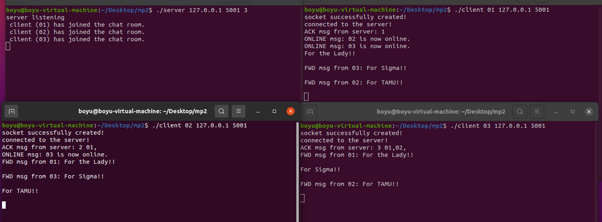

1. Same name joined, and refused

1. Join when full, and refused

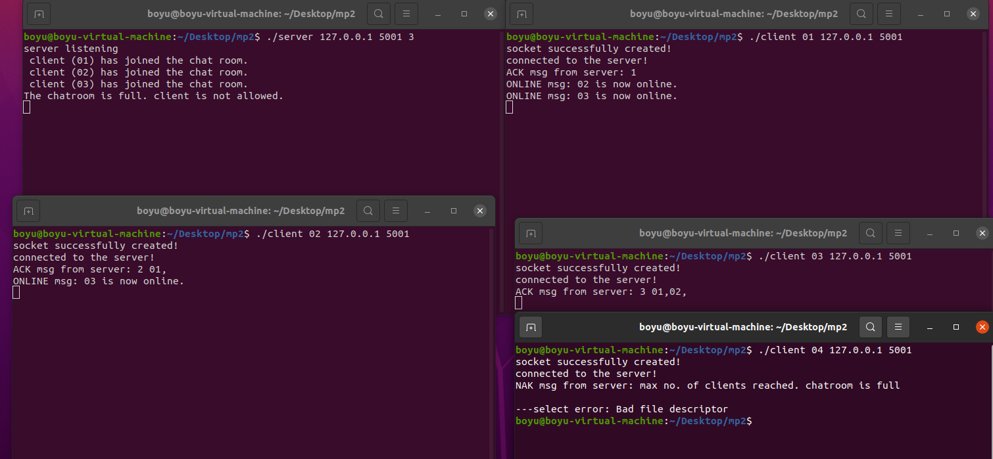

1. ONLINE, OFFLINE

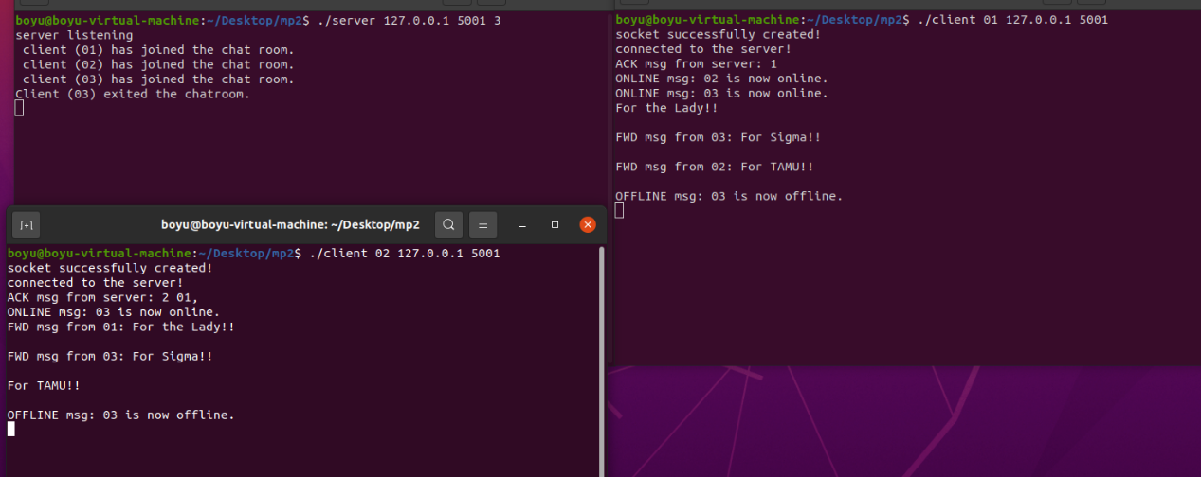

6.ACK , NAK

