**JUnit Basic Testing Exercises**

**Exercise 1: Setting Up JUnit**

import org.junit.Test;

import static org.junit.Assert.*;

public class CalculatorTest {

@Test

public void testAddition() {

int result = 2 + 3;

assertEquals(5, result);

}

}

**OUTPUT:**

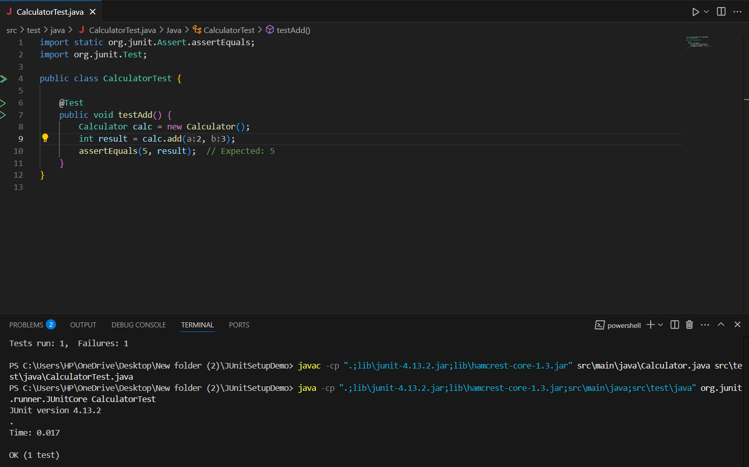

======================================================================

**Exercise 3: Assertions in JUnit**

import org.junit.jupiter.api.Test;

import static org.junit.jupiter.api.Assertions.*;

public class AssertionsTest {

Assertions calc = new Assertions();

@Test

public void testAllAssertions() {

assertEquals(5, calc.add(2, 3));

assertNotEquals(6, calc.add(2, 3));

assertTrue(calc.isPositive(10));

assertFalse(calc.isPositive(-5));

assertNull(calc.getNullString());

assertNotNull(calc.getNonNullString());

}

}

**OUTPUT:**

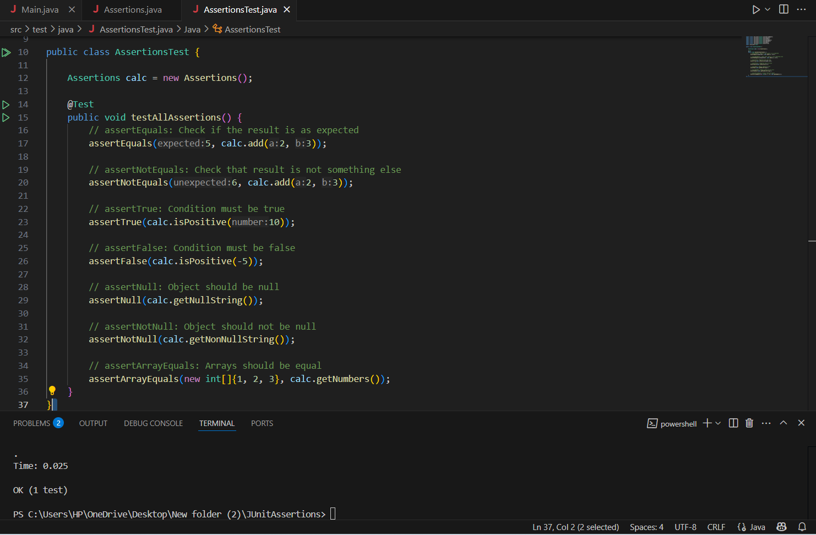

======================================================================

**Exercise 4: Arrange-Act-Assert (AAA) Pattern, Test Fixtures, Setup and Teardown Methods in JUnit**

import org.junit.After;

import org.junit.Before;

import org.junit.Test;

import static org.junit.Assert.assertEquals;

public class CalculatorTest {

private Calculator calculator;

@Before

public void setUp() {

calculator = new Calculator();

System.out.println("Setup complete.");

}

@After

public void tearDown() {

calculator = null;

System.out.println("Teardown complete.");

}

@Test

public void testAdd() {

int result = calculator.add(10, 5);

assertEquals(15, result);

}

@Test

public void testSubtract() {

int result = calculator.subtract(10, 3);

assertEquals(7, result);

}

}

**OUTPUT:**



