**Mockito Exercises**

**Exercise 1: Mocking and Stubbing**

**MyService.java**

public class MyService {

private final ExternalApi api;

public MyService(ExternalApi api) {

this.api = api;

}

public String fetchData() {

return api.getData();

}

}

**MyServiceTest.java**

import org.junit.jupiter.api.Test;

import static org.junit.jupiter.api.Assertions.assertEquals;

import static org.mockito.Mockito.*;

public class MyServiceTest {

@Test

public void testFetchData_returnsMockData() {

ExternalApi mockApi = mock(ExternalApi.class);

when(mockApi.getData()).thenReturn("Mock Data");

MyService service = new MyService(mockApi);

String result = service.fetchData();

assertEquals("Mock Data", result);

}

}

**OUTPUT:**

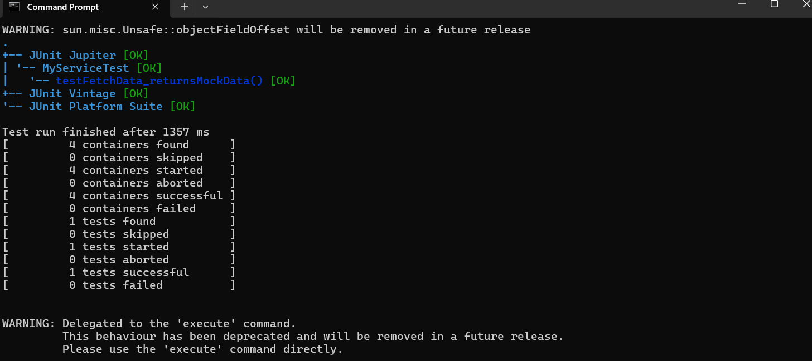

======================================================================

**Exercise 2: Verifying Interactions**

**MyService.java**

public class MyService {

private ExternalApi api;

public MyService(ExternalApi api) {

this.api = api;

}

public void fetchData() {

api.getData();

}

}

**MyServiceTest.java(Argument Verification)**

import static org.mockito.Mockito.*;

import org.junit.jupiter.api.Test;

public class MyServiceTest {

@Test

public void testVerifyArguments() {

ExternalApi mockApi = mock(ExternalApi.class);

MyService service = new MyService(mockApi);

service.fetchData();

verify(mockApi).getData("user123", 10);

}

}

**OUTPUT:**



