**Spring Core and Maven HandsOn**

**Exercise 1: Configuring a Basic Spring Application**

**BookRepository.java:**

package com.library.repository;

public class BookRepository {

public void saveBook(String bookName) {

System.out.println("Book saved: " + bookName);

}

}

**BookService.java:**

package com.library.service;

import com.library.repository.BookRepository;

public class BookService {

private BookRepository bookRepository;

public void setBookRepository(BookRepository bookRepository) {

this.bookRepository = bookRepository;

}

public void addBook(String bookName) {

System.out.println("Adding book: " + bookName);

bookRepository.saveBook(bookName);

}

}

**MainApp.java:**

import com.library.service.BookService;

import org.springframework.context.ApplicationContext;

import org.springframework.context.support.ClassPathXmlApplicationContext;

public class MainApp {

public static void main(String[] args) {

ApplicationContext context = new ClassPathXmlApplicationContext("applicationContext.xml");

BookService bookService = (BookService) context.getBean("bookService");

bookService.addBook("The Great Gatsby");

}

}

**OUTPUT:**

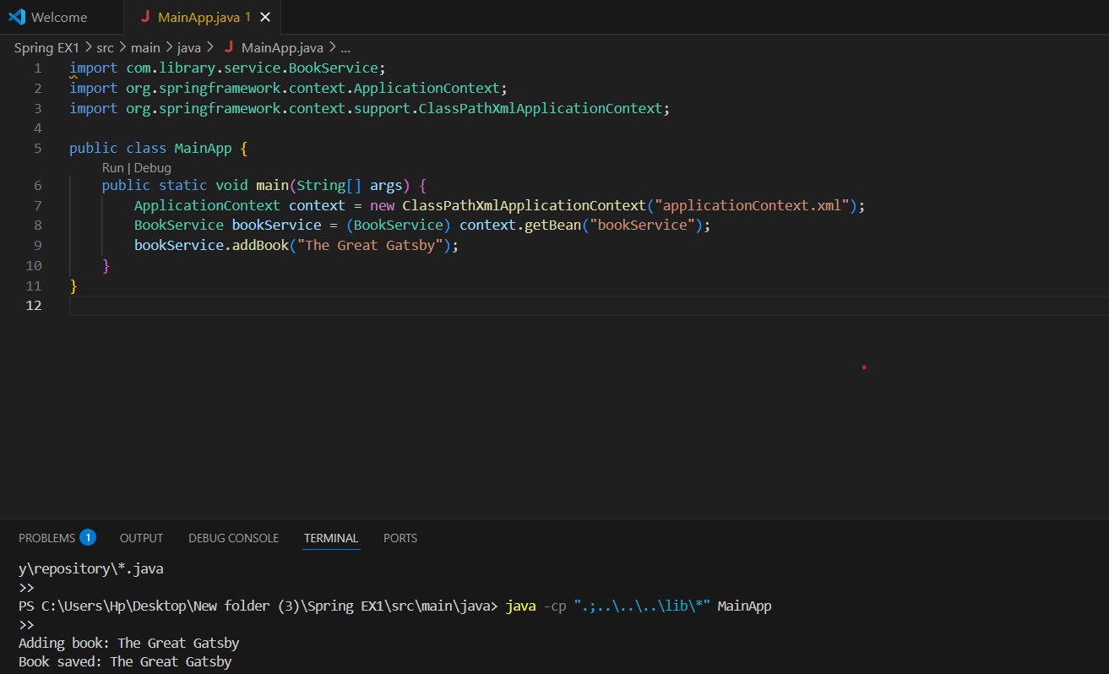

**Exercise 2: Implementing Dependency Injection**

**BookRepository:**

public class BookRepository {

public void saveBook(String bookName) {

System.out.println("Book saved: " + bookName);

}

}

**BookService:**

public class BookService {

private BookRepository bookRepository;

public void setBookRepository(BookRepository bookRepository) {

this.bookRepository = bookRepository;

}

public void addBook(String bookName) {

bookRepository.saveBook(bookName);

}

}

**LibraryManagementApplication:**

import org.springframework.context.ApplicationContext;

import org.springframework.context.support.ClassPathXmlApplicationContext;

public class LibraryManagementApplication {

public static void main(String[] args) {

ApplicationContext context = new ClassPathXmlApplicationContext("applicationContext.xml");

BookService bookService = (BookService) context.getBean("bookService");

bookService.addBook("Spring in Action");

}

}

**OUTPUT:**

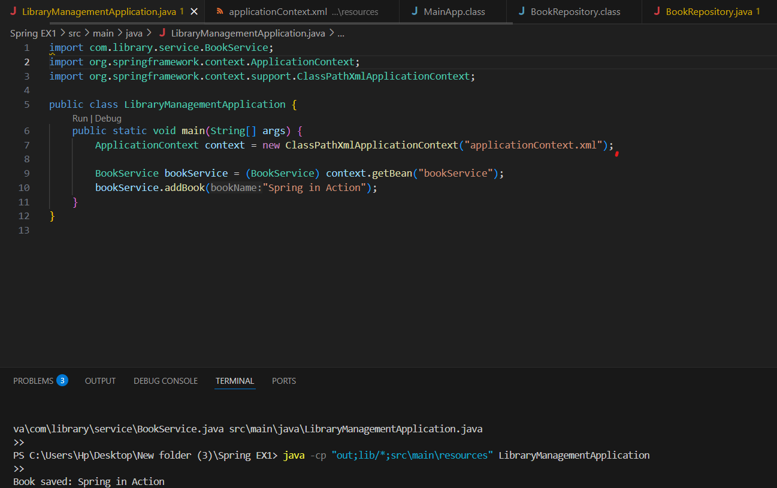

**Exercise 4: Creating and Configuring a Maven Project**

<project xmlns="http://maven.apache.org/POM/4.0.0"

xmlns:xsi="http://www.w3.org/2001/XMLSchema-instance"

xsi:schemaLocation="http://maven.apache.org/POM/4.0.0

http://maven.apache.org/xsd/maven-4.0.0.xsd">

<modelVersion>4.0.0</modelVersion>

<groupId>com.example</groupId>

<artifactId>LibraryManagement</artifactId>

<version>1.0-SNAPSHOT</version>

<properties>

<maven.compiler.source>1.8</maven.compiler.source>

<maven.compiler.target>1.8</maven.compiler.target>

</properties>

<dependencies>

<!-- Spring Context -->

<dependency>

<groupId>org.springframework</groupId>

<artifactId>spring-context</artifactId>

<version>5.3.36</version>

</dependency>

<!-- Spring AOP -->

<dependency>

<groupId>org.springframework</groupId>

<artifactId>spring-aop</artifactId>

<version>5.3.36</version>

</dependency>

<!-- Spring WebMVC -->

<dependency>

<groupId>org.springframework</groupId>

<artifactId>spring-webmvc</artifactId>

<version>5.3.36</version>

</dependency>

<!-- Optional: Servlet API -->

<dependency>

<groupId>javax.servlet</groupId>

<artifactId>javax.servlet-api</artifactId>

<version>4.0.1</version>

<scope>provided</scope>

</dependency>

</dependencies>

<!-- Maven Plugin Configuration -->

<build>

<plugins>

<plugin>

<artifactId>maven-compiler-plugin</artifactId>

<version>3.8.1</version>

<configuration>

<source>1.8</source>

<target>1.8</target>

</configuration>

</plugin>

</plugins>

</build>

</project>

**Output:**

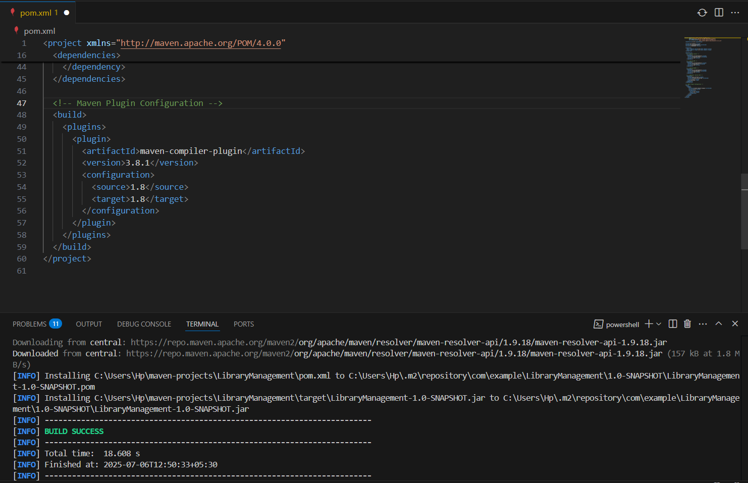

**Exercise 5: Configuring the Spring IoC Container**

**BookRepository.java:**

package com.example.repository;

public class BookRepository {

public String getBookTitle() {

return "Effective Java";

}

}

**BookService.java:**

package com.example.service;

import com.example.repository.BookRepository;

public class BookService {

private BookRepository bookRepository;

// Setter for dependency injection

public void setBookRepository(BookRepository bookRepository) {

this.bookRepository = bookRepository;

}

public void displayBookTitle() {

System.out.println("Book Title: " + bookRepository.getBookTitle());

}

}

#### LibraryManagementApplication.java:

import com.example.service.BookService;

import org.springframework.context.ApplicationContext;

import org.springframework.context.support.ClassPathXmlApplicationContext;

public class LibraryManagementApplication {

public static void main(String[] args) {

ApplicationContext context = new ClassPathXmlApplicationContext("applicationContext.xml");

BookService bookService = context.getBean("bookService", BookService.class);

bookService.displayBookTitle();

}

}

**OUTPUT:**

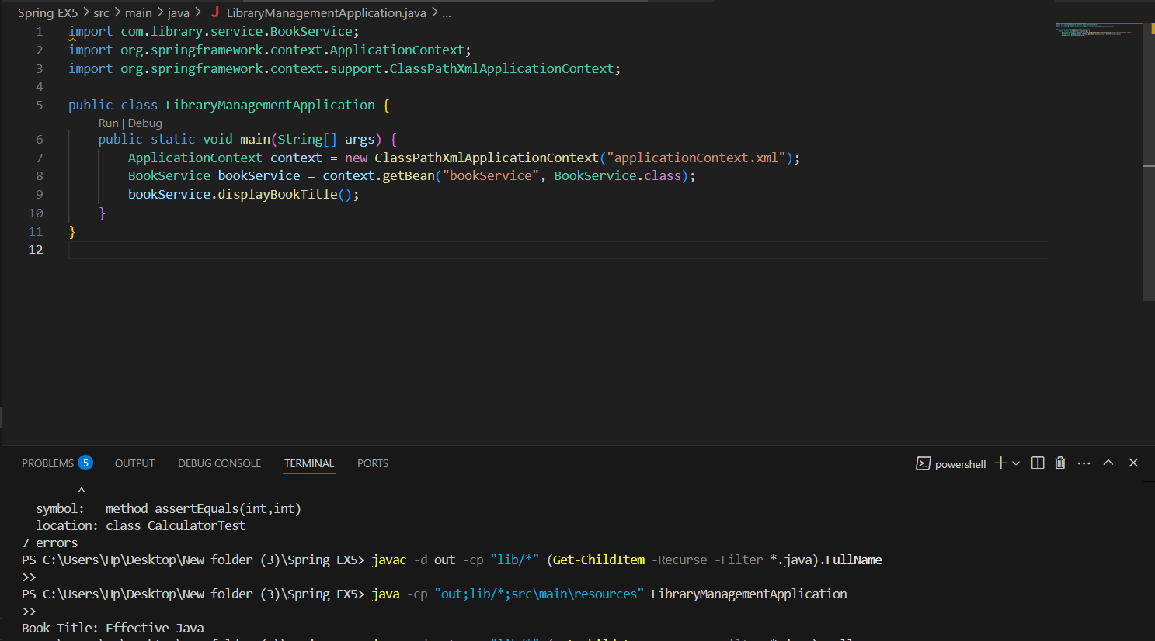

**Exercise 7: Implementing Constructor and Setter Injection**

**BookService.java:**

package com.library.service;

import com.library.repository.BookRepository;

public class BookService {

private BookRepository bookRepository;

public BookService(BookRepository bookRepository) {

System.out.println("Constructor Injection: BookRepository injected");

this.bookRepository = bookRepository;

}

public void setBookRepository(BookRepository bookRepository) {

System.out.println("Setter Injection: BookRepository injected");

this.bookRepository = bookRepository;

}

public void displayBookInfo() {

bookRepository.getBookDetails();

}

}

**BookRepository.java:**

package com.library.repository;

public class BookRepository {

public void getBookDetails() {

System.out.println("Book details fetched from repository.");

}

}

## **LibraryManagementApplication.java:**

import org.springframework.context.ApplicationContext;

import org.springframework.context.support.ClassPathXmlApplicationContext;

import com.library.service.BookService;

public class LibraryManagementApplication {

public static void main(String[] args) {

ApplicationContext context = new ClassPathXmlApplicationContext("applicationContext.xml");

BookService bookService = context.getBean("bookService", BookService.class);

bookService.displayBookInfo();

}

}

**OUTPUT:**

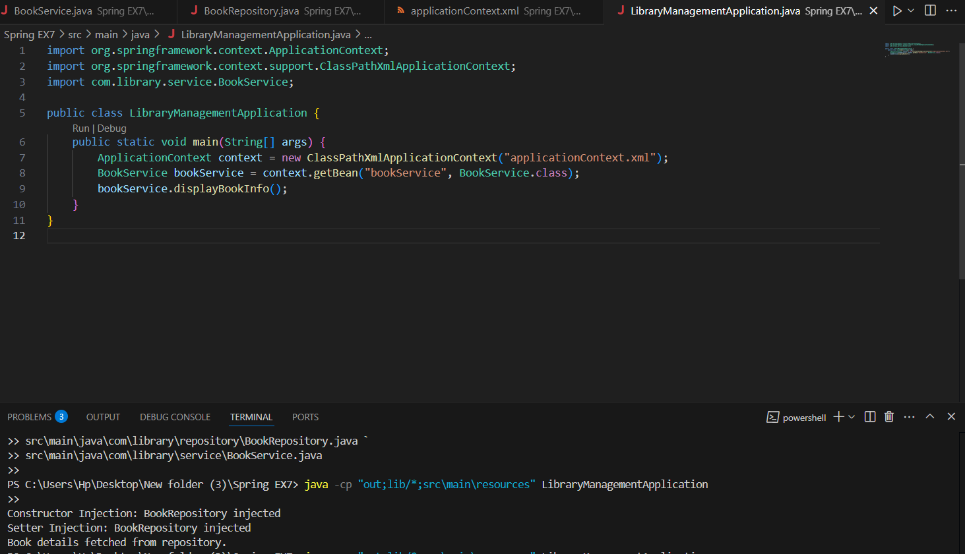

**Exercise 9: Creating a Spring Boot Application**

**Book Entity:**

package com.library.entity;

import jakarta.persistence.*;

@Entity

public class Book {

@Id

@GeneratedValue(strategy = GenerationType.IDENTITY)

private Long id;

private String title;

private String author;

private String genre;

public Long getId() { return id; }

public void setId(Long id) { this.id = id; }

public String getTitle() { return title; }

public void setTitle(String title) { this.title = title; }

public String getAuthor() { return author; }

public void setAuthor(String author) { this.author = author; }

public String getGenre() { return genre; }

public void setGenre(String genre) { this.genre = genre; }

}

**BookRepository Interface:**

package com.library.repository;

import com.library.entity.Book;

import org.springframework.data.jpa.repository.JpaRepository;

public interface BookRepository extends JpaRepository<Book, Long> {

}

BookController

package com.library.controller;

import com.library.entity.Book;

import com.library.repository.BookRepository;

import org.springframework.beans.factory.annotation.Autowired;

import org.springframework.web.bind.annotation.*;

import java.util.List;

@RestController

@RequestMapping("/api/books")

public class BookController {

@Autowired

private BookRepository bookRepository;

@GetMapping

public List<Book> getAllBooks() {

return bookRepository.findAll();

}

@PostMapping

public Book createBook(@RequestBody Book book) {

return bookRepository.save(book);

}

@GetMapping("/{id}")

public Book getBookById(@PathVariable Long id) {

return bookRepository.findById(id).orElse(null);

}

@PutMapping("/{id}")

public Book updateBook(@PathVariable Long id, @RequestBody Book updatedBook) {

return bookRepository.findById(id).map(book -> {

book.setTitle(updatedBook.getTitle());

book.setAuthor(updatedBook.getAuthor());

book.setGenre(updatedBook.getGenre());

return bookRepository.save(book);

}).orElse(null);

}

@DeleteMapping("/{id}")

public void deleteBook(@PathVariable Long id) {

bookRepository.deleteById(id);

}

}

**LibraryManagementApplication.java:**

package com.library;

import org.springframework.boot.SpringApplication;

import org.springframework.boot.autoconfigure.SpringBootApplication;

@SpringBootApplication

public class LibraryManagementApplication {

public static void main(String[] args) {

SpringApplication.run(LibraryManagementApplication.class, args);

}

}

**OUTPUT:**

