**Spring Data JPA HandsOn**

**Spring Data JPA - Quick Example**   
  
**Country.java:**

package com.cognizant.ormlearn.model;

import javax.persistence.Column;

import javax.persistence.Entity;

import javax.persistence.Id;

import javax.persistence.Table;

@Entity

@Table(name = "country")

public class Country {

@Id

@Column(name = "co_code")

private String code;

@Column(name = "co_name")

private String name;

public String getCode() {

return code;

}

public void setCode(String code) {

this.code = code;

}

public String getName() {

return name;

}

public void setName(String name) {

this.name = name;

}

@Override

public String toString() {

return "Country [code=" + code + ", name=" + name + "]";

}

}

**CountryRepository.java:**

package com.cognizant.ormlearn.repository;

import org.springframework.data.jpa.repository.JpaRepository;

import org.springframework.stereotype.Repository;

import com.cognizant.ormlearn.model.Country;

@Repository

public interface CountryRepository extends JpaRepository<Country, String> {

}

**CountryService.java:**

package com.cognizant.ormlearn.service;

import java.util.List;

import javax.transaction.Transactional;

import org.springframework.beans.factory.annotation.Autowired;

import org.springframework.stereotype.Service;

import com.cognizant.ormlearn.model.Country;

import com.cognizant.ormlearn.repository.CountryRepository;

@Service

public class CountryService {

@Autowired

private CountryRepository countryRepository;

@Transactional

public List<Country> getAllCountries() {

return countryRepository.findAll();

}

}

**OrmLearnApplication.java (Main App):**

package com.cognizant.ormlearn;

import java.util.List;

import org.slf4j.Logger;

import org.slf4j.LoggerFactory;

import org.springframework.boot.SpringApplication;

import org.springframework.boot.autoconfigure.SpringBootApplication;

import org.springframework.context.ApplicationContext;

import com.cognizant.ormlearn.model.Country;

import com.cognizant.ormlearn.service.CountryService;

@SpringBootApplication

public class OrmLearnApplication {

private static final Logger LOGGER = LoggerFactory.getLogger(OrmLearnApplication.class);

private static CountryService countryService;

public static void main(String[] args) {

ApplicationContext context = SpringApplication.run(OrmLearnApplication.class, args);

countryService = context.getBean(CountryService.class);

testGetAllCountries();

}

private static void testGetAllCountries() {

LOGGER.info("Start");

List<Country> countries = countryService.getAllCountries();

LOGGER.debug("countries={}", countries);

LOGGER.info("End");

}

}

**MySQL Table:**

CREATE SCHEMA ormlearn;

USE ormlearn;

CREATE TABLE country (

co_code VARCHAR(2) PRIMARY KEY,

co_name VARCHAR(50)

);

INSERT INTO country VALUES ('IN', 'India');

INSERT INTO country VALUES ('US', 'United States of America');

**OUTPUT:**

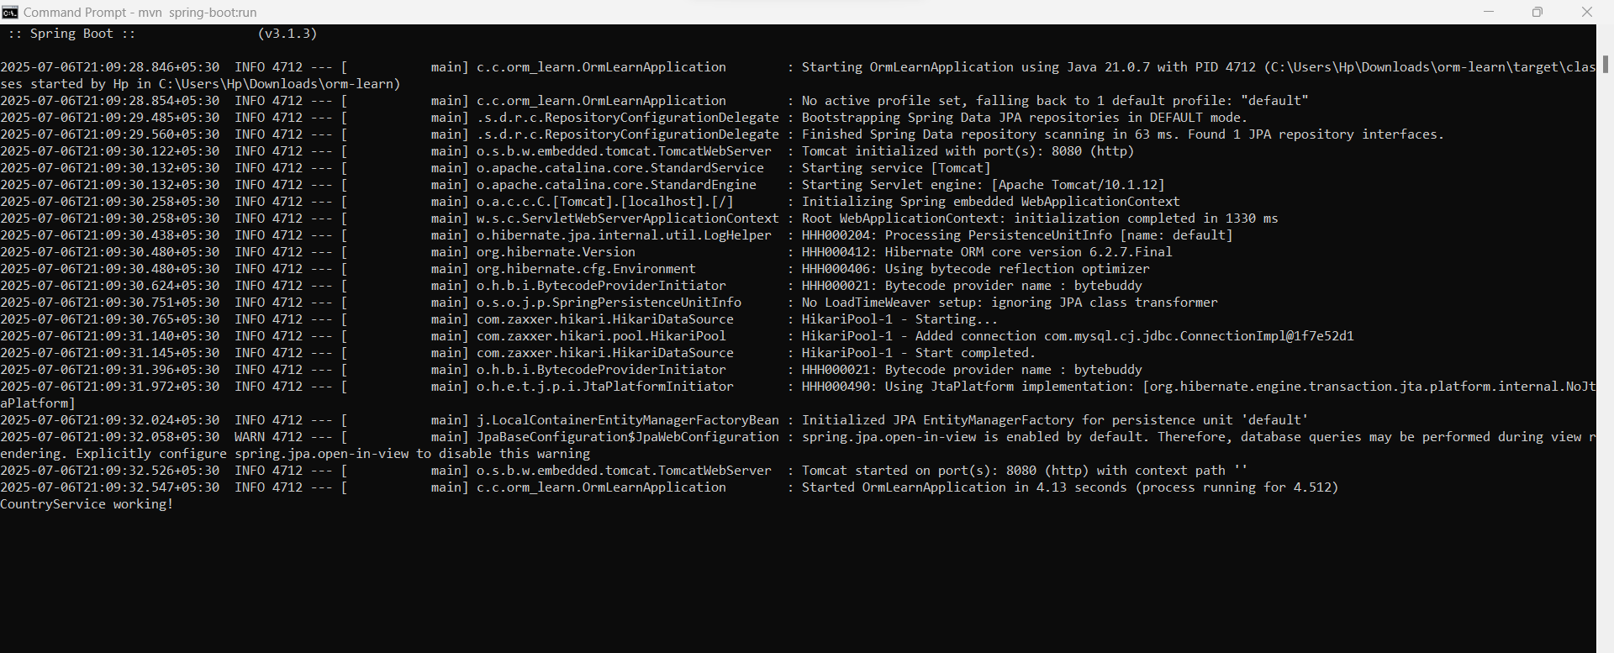

=====================================================================

**Difference between JPA, Hibernate and Spring Data JPA** 

**MySpringDataJpaApp.java:**

package com.example;

import org.springframework.boot.SpringApplication;

import org.springframework.boot.autoconfigure.SpringBootApplication;

@SpringBootApplication

public class MySpringDataJpaApp {

public static void main(String[] args) {

SpringApplication.run(MySpringDataJpaApp.class, args);

}

}

**EmployeeController.java:**

package com.example.controller;

import com.example.model.Employee;

import com.example.service.EmployeeService;

import org.springframework.beans.factory.annotation.Autowired;

import org.springframework.web.bind.annotation.*;

@RestController

@RequestMapping("/employees")

public class EmployeeController {

@Autowired

private EmployeeService employeeService;

@PostMapping

public Employee addEmployee(@RequestBody Employee employee) {

return employeeService.addEmployee(employee);

}

@GetMapping("/{id}")

public Employee getEmployee(@PathVariable Integer id) {

return employeeService.getEmployeeById(id);

}

}

**Employee.java:**

package com.example.model;

import javax.persistence.Entity;

import javax.persistence.GeneratedValue;

import javax.persistence.GenerationType;

import javax.persistence.Id;

@Entity

public class Employee {

@Id

@GeneratedValue(strategy = GenerationType.IDENTITY)

private Integer id;

private String name;

private String department;

}

**EmployeeRepository.java:**

package com.example.repository;

import com.example.model.Employee;

import org.springframework.data.jpa.repository.JpaRepository;

public interface EmployeeRepository extends JpaRepository<Employee, Integer> {

}

**EmployeeService.java:**

package com.example.service;

import com.example.model.Employee;

import com.example.repository.EmployeeRepository;

import org.springframework.beans.factory.annotation.Autowired;

import org.springframework.stereotype.Service;

@Service

public class EmployeeService {

@Autowired

private EmployeeRepository employeeRepository;

public Employee addEmployee(Employee employee) {

return employeeRepository.save(employee);

}

public Employee getEmployeeById(Integer id) {

return employeeRepository.findById(id).orElse(null);

}

}

**OUTPUT:**



