**Week-5 MICROSERVICES**

**Creating Microservices for account and loan**

**AccountController.java:**

package com.cognizant.account.controller;

import org.springframework.web.bind.annotation.*;

import java.util.Map;

@RestController

@RequestMapping("/accounts")

public class AccountController {

@GetMapping("/{number}")

public Map<String, Object> getAccountDetails(@PathVariable String number) {

return Map.of(

"number", number,

"type", "savings",

"balance", 234343

);

}

}

**OUTPUT:** http://localhost:8080/accounts/00987987973432

**Browser**

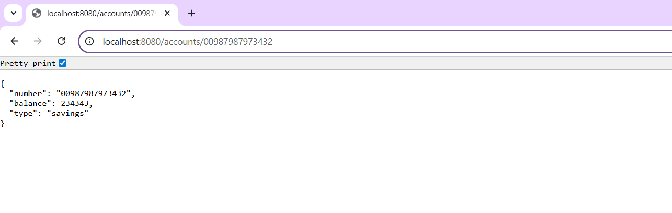

**Postman:**

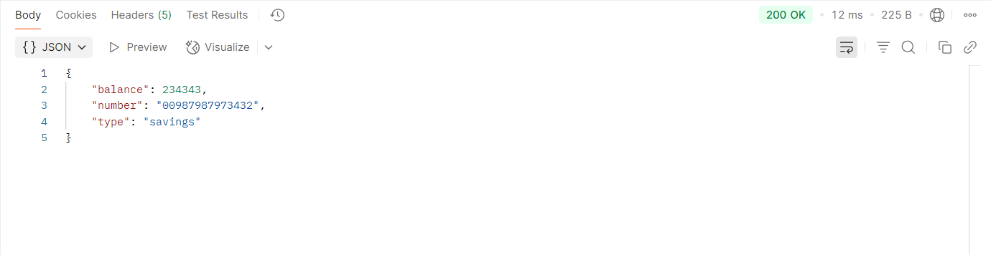

**LoanController.java:**

package com.cognizant.loan.controller;

import org.springframework.web.bind.annotation.*;

import java.util.Map;

@RestController

@RequestMapping("/loans")

public class LoanController {

@GetMapping("/{number}")

public Map<String, Object> getLoanDetails(@PathVariable String number) {

return Map.of(

"number", number,

"type", "car",

"loan", 400000,

"emi", 3258,

"tenure", 18

);

}

}

**OUTPUT:** http://localhost:8081/loan/H00987987972342

**Browser**

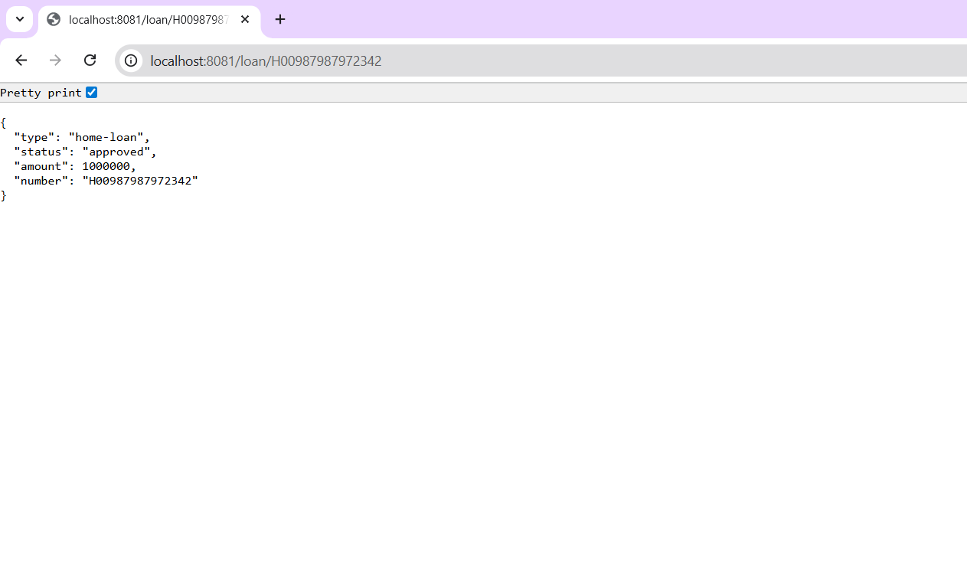

**Postman**

