**WEEK-6 REACT HANDS-ON**

**1.ReactJS-HOL**

**App.js:**

import React from 'react';

function App() {

return (

<div>

<h1>Welcome to the first session of React</h1>

</div>

);

}

export default App;

**OUTPUT:**

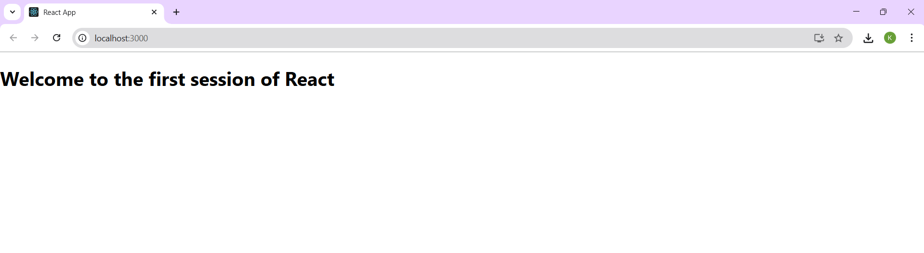

**2. ReactJS-HOL**

**Home.js:**

import React from 'react';

function Home() {

return (

<div>

<h2>Welcome to the Home page of Student Management Portal</h2>

</div>

);

}

export default Home;

**About.js:**

import React from 'react';

function About() {

return (

<div>

<h2>Welcome to the About page of the Student Management Portal</h2>

</div>

);

}

export default About;

**Contact.js:**

import React from 'react';

function Contact() {

return (

<div>

<h2>Welcome to the Contact page of the Student Management Portal</h2>

</div>

);

}

export default Contact;

**App.js:**

import React from 'react';

import './App.css';

import Home from './Components/Home';

import About from './Components/About';

import Contact from './Components/Contact';

function App() {

return (

<div className="App">

<h1>Student Management Portal</h1>

<Home />

<About />

<Contact />

</div>

);

}

export default App;

**OUTPUT:**

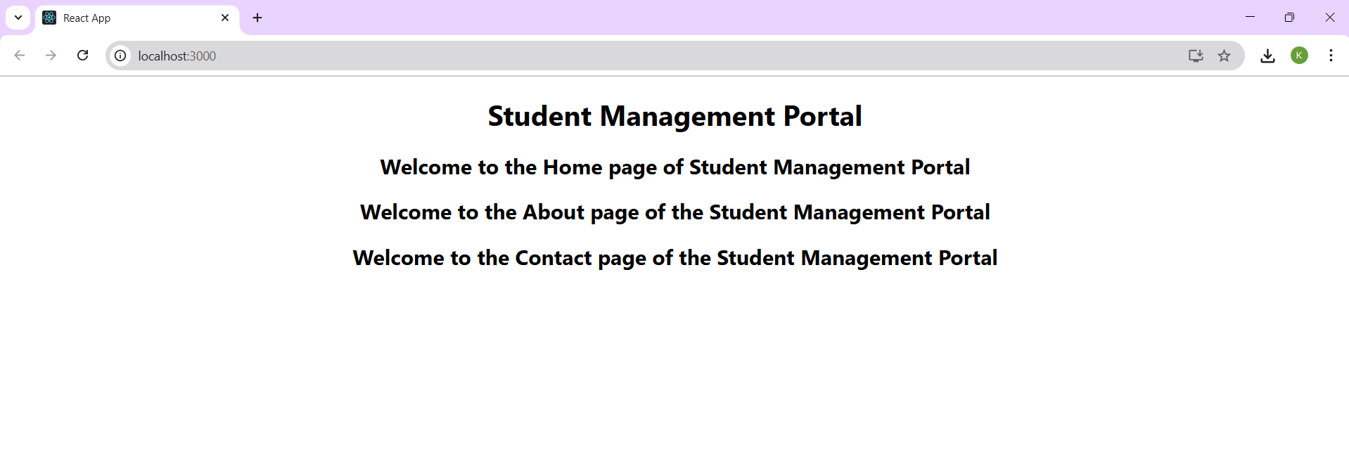

**3. ReactJS-HOL**

**CalculateScore.js:**

import './Stylesheets/mystyle.css';

const percentToDecimal = (decimal) => {

return (decimal.toFixed(2) + '%');

}

const calcScore = (total, goal) => {

return percentToDecimal(total / goal);

}

export const CalculateScore = ({ Name, School, total, goal }) => (

<div className="formatstyle">

<h1><font color="Brown">Student Details:</font></h1>

<div className="Name">

<b><span> Name: </span></b>

<span>{Name}</span>

</div>

<div className="School">

<b><span> School: </span></b>

<span>{School}</span>

</div>

<div className="Total">

<b><span>Total: </span></b>

<span>{total}</span>

<span> Marks</span>

</div>

<div className="Score">

<b>Score: </b>

<span>

{calcScore(total, goal)}

</span>

</div>

</div>

);

**mystyle.css:**

.Name {

font-weight: 300;

color: blue;

}

.School {

color: crimson;

}

.Total {

color: darkmagenta;

}

.formatstyle {

text-align: center;

font-size: large;

}

.Score {

color: forestgreen;

}

**App.js:**

import './App.css';

import { CalculateScore } from './Components/CalculateScore';

function App() {

return (

<div className="App">

<CalculateScore Name={"Arjun"}

School={"WPS"}

total={284}

goal={3}/>

</div>

);

}

export default App;

**OUTPUT:**

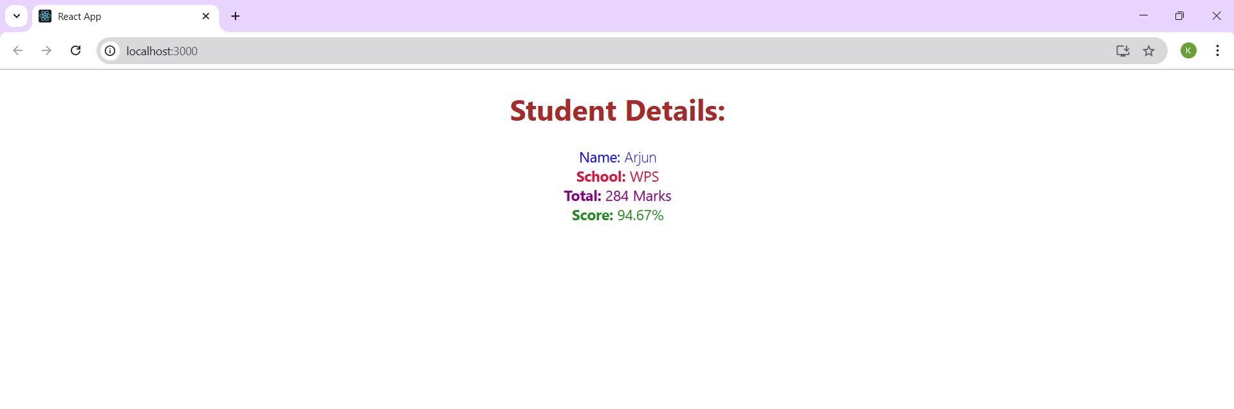

**4. ReactJS-HOL**

**Post.js:**

import React from 'react';

class Post extends React.Component {

render() {

const { title, body } = this.props;

return (

<div className="post">

<h2>{title}</h2>

<p>{body}</p>

</div>

);

}

}

export default Post;

**Posts.js:**

import React from 'react';

import Post from './Post';

class Posts extends React.Component {

constructor(props) {

super(props);

this.state = {

posts: [],

};

}

loadPosts = () => {

fetch('https://jsonplaceholder.typicode.com/posts')

.then(response => response.json())

.then(data => this.setState({ posts: data }))

.catch(error => alert("Error fetching posts: " + error));

};

componentDidMount() {

this.loadPosts();

}

render() {

const { posts } = this.state;

return (

<div>

<h1>Blog Posts</h1>

{posts.map(post => (

<Post key={post.id} title={post.title} body={post.body} />

))}

</div>

);

}

componentDidCatch(error, info) {

alert("Something went wrong: " + error);

}

}

export default Posts;

**App.js:**

import React from 'react';

import './App.css';

import Posts from './Posts';

function App() {

return (

<div className="App">

<Posts />

</div>

);

}

export default App;

**OUTPUT:**

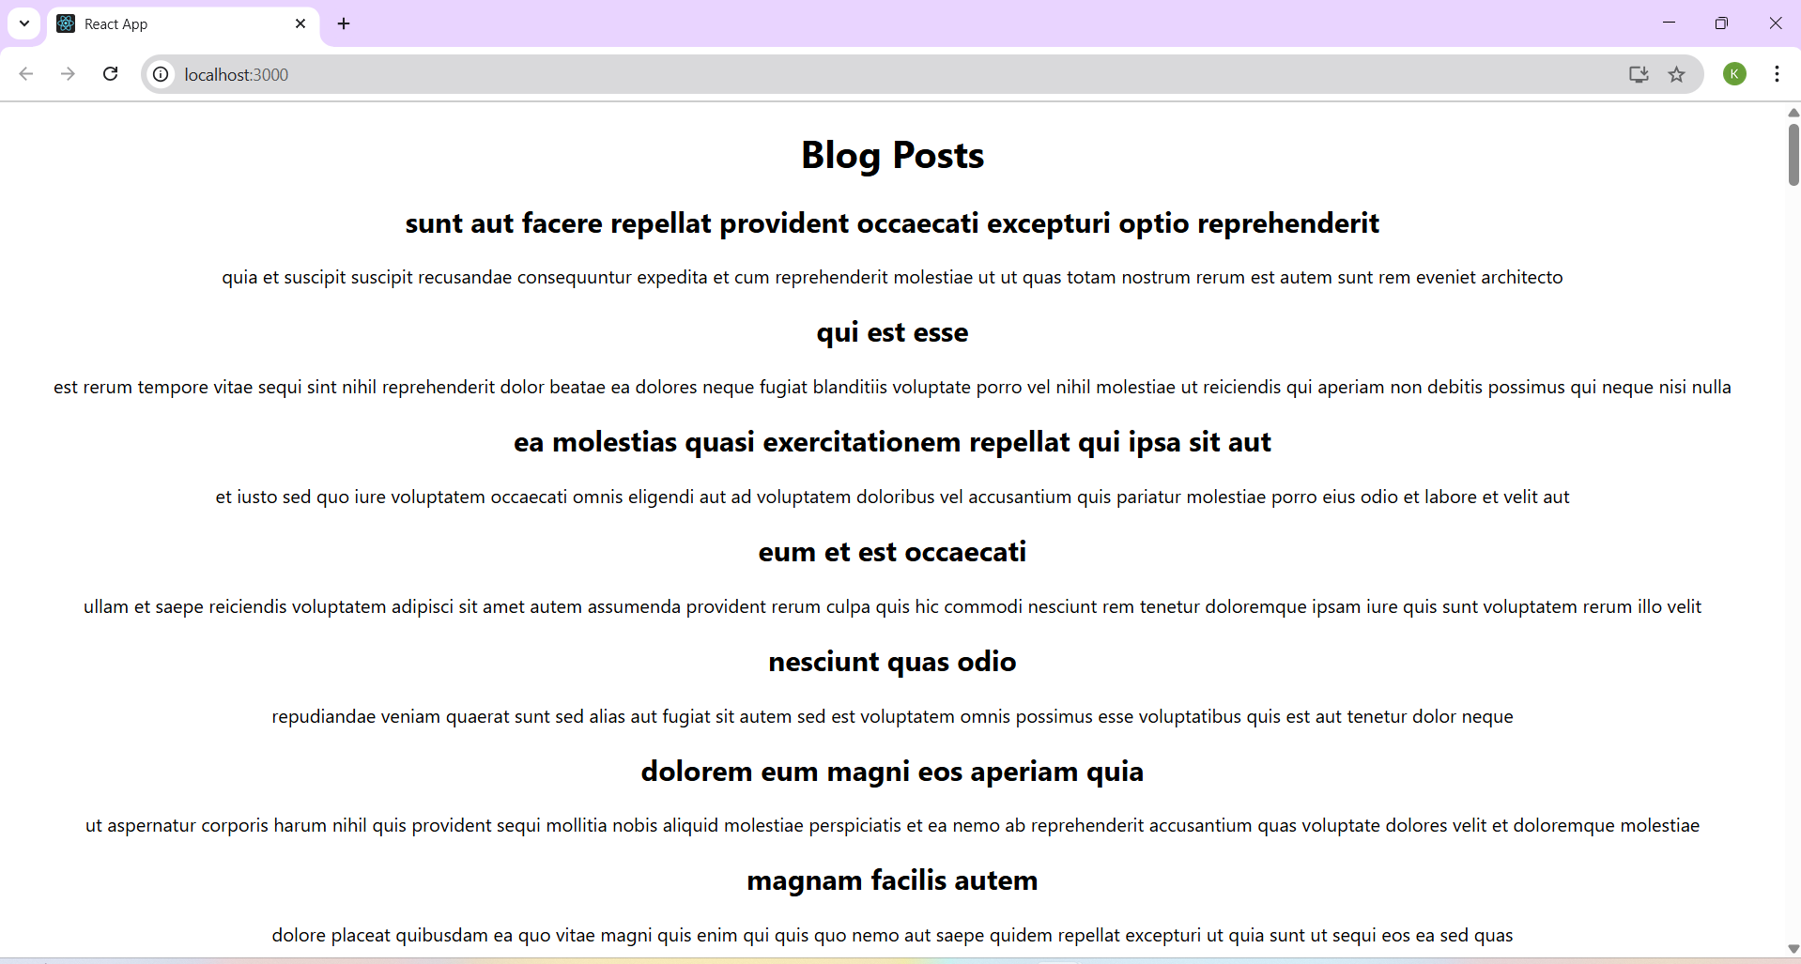

**5. ReactJS-HOL**

**CohortDetails.module.css:**

.box {

width: 300px;

display: inline-block;

margin: 10px;

padding: 10px 20px;

border: 1px solid black;

border-radius: 10px;

}

dt {

font-weight: 500;

}

**CohortDetails.js:**

import React from 'react';

import styles from './CohortDetails.module.css';

function CohortDetails({ props }) {

return (

<div className={styles.box}>

<h3 style={{ color: props.cohort.currentStatus === "Ongoing" ? "green" : "blue" }}>

{props.cohort.cohortCode}-

<span>{props.cohort.technology}</span>

</h3>

<dl>

<dt>Started On</dt>

<dd>{props.cohort.startDate}</dd>

<dt>Current Status</dt>

<dd>{props.cohort.currentStatus}</dd>

<dt>Coach</dt>

<dd>{props.cohort.coachName}</dd>

<dt>Trainer</dt>

<dd>{props.cohort.trainerName}</dd>

</dl>

</div>

);

}

export default CohortDetails;

**OUTPUT:**



